This version of Safer Together monitoring, evaluation and reporting framework has been prepared for use with screen reader software. The printed publication contains various design features that have been necessarily omitted from this version. In other respects this document contains identical text to that in the PDF version of the document which is available on the Safer Together website, here.

Safer Together monitoring, evaluation and reporting framework

Acknowledgment
We acknowledge and respect Victorian Traditional Owners as the original custodians of Victoria's land and waters, their unique ability to care for Country and deep spiritual connection to it. We honour Elders past and present whose knowledge and wisdom has ensured the continuation of culture and traditional practices.
We are committed to genuinely partner, and meaningfully engage, with Victoria's Traditional Owners and Aboriginal communities to support the protection of Country, the maintenance of spiritual and cultural practices and their broader aspirations in the 21st century and beyond.

Aboriginal people should be aware that this publication may contain images or names of deceased persons in photographs or printed material.

© The State of Victoria Department of Environment, Land, Water and Planning 2019

This work is licensed under a Creative Commons Attribution 4.0 International licence. You are free to re-use the work under that licence, on the condition that you credit the State of Victoria as author. The licence does not apply to any images, photographs or branding, including the Victorian Coat of Arms, the Victorian Government logo and the Department of Environment, Land, Water and Planning (DELWP) logo. To view a copy of this licence, visit http://creativecommons.org/licenses/by/4.0/
Disclaimer
This publication may be of assistance to you but the State of Victoria and its employees do not guarantee that the publication is without flaw of any kind or is wholly appropriate for your particular purposes and therefore disclaims all liability for any error, loss or other consequence which may arise from you relying on any information in this publication.

Contents
1 Introduction 4
1.1 Purpose and scope of the framework 4
1.2 About Safer Together 4
Safer Together program principles 5
1.3 Approach to framework development and implementation 6
2 Program logic 7
2.1 Program logic 7
2.2 Key program assumptions 9
3 Monitoring and evaluation 10
3.1 What is monitoring and evaluation? 10
3.2 Evaluation questions 10
Evaluation questions and subquestions 11
3.3 Indicators, data sources and collection methods 13
Evaluation questions and subquestions 13
4 Reporting and improvement 20
4.1 Reporting 20
Reporting and improvement definitions 20
Types of reports 21
4.2 Improvement 21
5 Glossary 22
Appendix 1: Enabling projects (2017-2019) 24
Appendix 2: Program logics for priority areas 27

1 Introduction

1.1 Purpose and scope of the framework
This document sets out the framework for cross-agency monitoring, evaluation and reporting (MER) of the Safer Together program. The program brings together agencies with land and fire responsibilities, partners and the community to reduce the risks of bushfires in Victoria. Bushfire management in Victoria is a shared responsibility, and no single government agency, organisation or group alone is responsible.
The purpose of the framework is to enable consistent MER of the Safer Together program to:
- continuously improve the program and its approach to bushfire management
- inform decision-making and future investments
- make investments more transparent and accountable
help agencies communicate the program’s achievements internally and externally.
The scope of the framework is the entire Safer Together program — as a whole program — and MER to determine the effectiveness of the program and its achievements. The framework does not address individual projects within the program; individual projects are responsible for their own MER. Nor does the framework address the full extent of MER and continuous improvement actions — monitoring programs, after-action reviews, lessons management, audits, observations, quality-assurance processes and tracking the implementation of recommendations — that agencies, partners and communities undertake to reduce bushfire risk. However, the framework can link to and draw on data and information gathered through these existing activities, while also contributing its own unique, informative insights.
The framework incorporates:
- the objectives of the program and its four priorities
- the Safer Together program logic and that of its four priorities, which link actions to intended outcomes
- evaluation questions
the data and information needed to respond to the evaluation questions.
The framework also sets out a continuous improvement pathway, so lessons learned through the evaluation feed back into the program design and ultimately into actions to reduce bushfire risk.

1.2 About Safer Together
Launched in November 2015, the Safer Together program builds on recommendations in the Inspector-General for Emergency Management’s 2015 Review of performance targets for bushfire management on public land (linked to https://www.igem.vic.gov.au/sites/default/files/embridge_cache/emshare/original/public/2017/07/d7/24d0ede21/Reviewofperformancetargetsforbushfirefuelmanagementonpublicland.pdf).
The program’s objective is that communities, agencies and partners collaborate to reduce bushfire risk through the delivery of capability building and on-ground projects.
Safer Together has four priorities:
- Community first
- Land and fire agencies working together
- Measuring success
Better knowledge = better decisions.
Each priority has its own objective, shown under ‘Priority objectives’ below. These objectives were developed to support the MER framework. Each objective aligns with a subquestion of evaluation question 2 — How effective has Safer Together been? — which is further explained in ‘3.2 Evaluation questions’.

Priority objectives
Community first priority
Priority objective 1) Collaborate with communities through appropriate and purposeful approaches to identify shared bushfire risk reduction solutions
Priority objective 2) Improve the community engagement capacity and capability of agencies and partners
Land and fire agencies working together priority
Priority objective 3) Build the capacity and capability of bushfire management agencies to work together to manage bushfire risk
Priority objective 4) Increasingly integrate partner and community perspectives and activities into our approach
Measuring success priority
Priority objective 5) Monitor, evaluate and report on the Safer Together program to improve its delivery and provide accountability; establish a strategy for long-term evaluation of the bushfire management and risk reduction approach
Better knowledge = better decisions priority
Priority objective 6) Knowledge is generated, used and shared to enable improved

Safer Together program principles
Five principles guide the Safer Together program. MER activities should take account of these principles, to the extent they apply to the particular (program or priority) program logic. The principles are:
- we will take a collaborative, cross-agency approach to everything we do
- we will consider the community and how we can involve it and use its contributions in all aspects of bushfire risk reduction
- establishing, building and continually strengthening relationships — within organisations, across organisations, with partners and with the community — and networks is essential to the work we do
- community-based processes are iterative and a long-term investment:
  - recognising individual community context and history is essential
  - not all communities are interested in or have the capacity for community-based initiatives
  - each community will work in its own way, in its own time; ‘steps’ in the logic may occur in different orders and/or along a different time scale, depending on the particular community
we will be open about learning from our actions, to continually refine and improve our approaches.
The program is undertaking projects under each priority. Appendix 1 explains the projects for 2017–19.

1.3 Approach to framework development and implementation
The framework’s development was guided by the following values:
- cross-agency integration and collaboration in developing and implementing the framework is essential
- we will take a participatory approach to evaluation
- evaluation and reporting will be holistic, fit-for-purpose and focused on being used, to ensure essential data and other information is gathered to tell a complete story
- we will have clear, realistic expectations about what can be expected from the program over time and about what the evaluation can show
we will be open about learning from our actions, and about what has and has not worked, to ensure we continually refine and improve our approach.
A cross-agency staff member, supported by an independent consultant, will lead the implementation of the framework. This will ensure a strong organisational connection while establishing a level of independence, which supports transparency and accountability.

2 Program logic

2.1 Program logic
A program logic sets out a program’s vision, objectives, activities, outputs and outcomes. By articulating the logic of the Safer Together program, we can better evaluate whether the program is working as intended.
Figure 1 shows the Safer Together program logic. The program logic applies to the whole program, not specifically to the four priorities or the projects under them. In many cases, multiple projects contribute to a particular activity in the program logic and consequently to the outcomes of that activity. Appendix 2 shows the program logic for each priority.
In Figure 1, longer-term outcomes are outside the green outline box. The framework does not address longer-term outcomes, because they are also the result of activities outside the Safer Together program: the framework only addresses outcomes that directly result from the program. As the figure shows, the highest-level outcome the framework addresses is ‘Decisions are better informed by evidence and values’.
Program logics are ‘living’ documents which should be updated and should evolve as a program does. Reviewing the program logic in Figure 1 will be an important evaluation activity.
Figure 1: Safer Together program logic
Note: Arrows indicate the continuous implementation of activities to sustain short-term outcomes, which enables longer-term outcomes to be achieved over time. Everything outside the green box is outside the scope of the MER framework.

2.2 Key program assumptions
A program logic has underlying assumptions about the changes we expect to happen as a result of our actions. Testing our logic and these assumptions is an important aspect of any program evaluation and can help to improve what we are doing.
The key Safer Together program logic assumptions are:
- agencies and staff are willing and able to work collaboratively
- working more effectively as one fire sector, with our partners and the community, will reduce bushfire risk
- communities want to be involved in decision-making
- research outputs, tools and models can inform decision-making and approaches to reducing bushfire risk
- monitoring and evaluation activities will effectively feed back into our actions and decision-making to improve how we work
we will value and use data and other information (such as from research, evaluation and the community) to inform what we do and how we work.
The above list of assumptions above is not exhaustive: they are the most-important assumptions to keep in mind and review as part of the evaluation process.

3 Monitoring and evaluation

3.1 What is monitoring and evaluation?
Monitoring is the planned, systematic and continuous collection and analysis of data and other information, to track the progress of Safer Together. Data and other information gathered by monitoring contribute to evaluation: the evaluation process integrates it with other data and information collected periodically.
Evaluation for the framework’s purposes is defined as ‘a planned and periodic assessment of the quality and value of a program, where a judgement is made about the achievement of or progress towards the program’s objectives and outcomes.’ This definition is from Markiewicz and Patrick (2016). Developing Monitoring and Evaluation Frameworks. Thousand Oaks, California, USA. Sage.
A program — in this case, Safer Together — is a set of planned activities and services, intended to achieve identified objectives.

3.2 Evaluation questions
The framework’s evaluation questions align with:
- the purpose and scope of the framework, explained in section 1.1
- the objectives of the Safer Together program and its priorities, explained in section 1.2
- the Safer Together program logic, shown in Figure 1
- the Department of Treasury and Finance’s (DTF) evaluation questions in ‘Attachment 9: Lapsing program requirements’ to Performance Management Framework for Victorian Government Departments (linked to https://www.dtf.vic.gov.au/sites/default/files/2018-01/Performance%20Management%20Framework%20-%20updated%20June%202017.pdf)
the evaluation domains of appropriateness, effectiveness, efficiency, impact and sustainability.
Below are the framework’s five evaluation questions and their subquestions, including their alignment with DTF’s lapsing program requirements questions and with the evaluation domains of appropriateness, effectiveness, efficiency, impact and sustainability. These questions, together with the program’s objective and logic, should guide data collection and focus the evaluation and any ensuing recommendations.
The subquestions for evaluation question 2 — How effective has Safer Together been? —directly align with the objectives of the program’s four priorities.

Evaluation questions and subquestions
References to a numbered PMF question refer to an evaluation question in ‘Attachment 9: Lapsing program requirements’ to Performance Management Framework for Victorian Government Departments.
Evaluation question 1 — What is the evidence of a continued need for the program and role for government in delivering this program?
This evaluation question aligns with PMF Q1. Domains are appropriateness and effectiveness.
Subquestion 1a) Is the underlying logic of the program still appropriate, given the changes since the program’s inception?
Subquestion 1b) Are there any gaps in how the program is being delivered (i.e. in the priorities) that would help it to more effectively achieve its objectives and address the need?
These subquestions can also address the PMF Q1 subquestions:
- to what extent does the program address a demonstrable need?
why is this the most appropriate way of addressing the need?
The question includes consideration of the program’s ongoing need and whether it has become business as usual.
Evaluation question 2 — How effective has Safer Together been?
This evaluation question aligns with PMF Q2 (progress towards objectives and outcomes)
Domains are effectiveness and impact.
Subquestion 2a) To what extent has Safer Together fostered collaboration with communities to manage bushfire risk using appropriate and purposeful approaches to identify shared solutions?
Subquestion 2b) To what extent has Safer Together improved the community engagement capacity and capability of agencies and partners?
Subquestion 2c) To what extent has Safer Together built the capacity and capability of bushfire management agencies to work together to manage bushfire risk?
Subquestion 2d) To what extent has Safer Together increasingly integrated partner and community perspectives and activities into our approach to reducing risk?
Subquestion 2e) To what extent has Safer Together monitored, evaluated and reported to improve delivery and provide accountability?
Subquestion 2f) To what extent has Safer Together generated, used and shared knowledge to improve the delivery of bushfire management and risk reduction?
Subquestion 2g) What other outcomes have there been from Safer Together?
These subquestions align with the objectives of the four priorities, to address whether they and their related outcomes have been achieved.
Evaluation question 3 — How well has the program been delivered?
This question excludes cost-effectiveness / cost-benefit analysis, which is out of scope.
This evaluation question aligns with PMF Q3a & Q3b. Domains are efficiency, impact and appropriateness.
Subquestion 3a) Has the program been delivered within its scope, budget and expected timeframe, and in line with appropriate governance and risk management practices?
Subquestion 3b) To what extent have partnerships been developed and improved through the delivery of the Safer Together program?
Subquestion 3c) To what extent has Safer Together been delivered efficiently?
The subquestions provide the opportunity to examine:
- delivery challenges
- partnerships / relationships and their role in the program
- PMF Q3 subquestions about efficiency and economy of delivery
strengths and opportunities in how the program is delivered.
Evaluation question 4 — What would be the impact of ceasing the program and what strategies have been identified to minimise negative impacts?
This evaluation question aligns with PMF Q4. Domains are sustainability and appropriateness.
Subquestion 4a) To what extent have the Safer Together outcomes (in relation to its objective) become business as usual for agencies?
Subquestion 4b) What need is there for ongoing support of new relationships with communities and related outcomes and behaviours?
The subquestions focus on:
- the long-term sustainability of the program and whether it has become business as usual
the risk of pulling out of community and multi-agency relationships and engagements.
Evaluation question 5 — What lessons are there from the Safer Together program?
This evaluation question relates to high-level lessons in relation to the program’s objectives (not outcomes). Domains are impact, appropriateness, efficiency, sustainability and effectiveness.
Subquestion 5a) What lessons are there about building the capability of agencies, partners and communities to work together?
Subquestion 5b) What lessons are there about building the capability of agencies, partners and communities to work together?
Subquestion 5c) What lessons are there about generating, using and sharing knowledge related to bushfire management and risk reduction?

3.3 Indicators, data sources and collection methods
Below are suggested indicators, data sources and collection methods to address the evaluation questions and subquestions.
The indicators suggest both quantitative and qualitative information. In many cases, the evaluation will draw on multiple lines of evidence to respond to an evaluation question rather than just one indicator or method. ‘Indicator’ is a broad term that includes numerical quantitative data and textual qualitative information useful for assessing progress towards an outcome or the achievement of it.
For question 2 and its subquestions, there is additional guidance for each subquestion by suggesting:
- one or more outcomes
the frequency of data collection: annual data collection will inform annual reporting, and periodic data collection will be as required for evaluation.
Data collection for questions 1, 3, 4 and 5 and their subquestions will be periodic, as needed for evaluation.

Evaluation questions and subquestions
Evaluation question 1 — What is the evidence of a continued need for the program and role for government in delivering this program?
Subquestion 1a) Is the underlying logic of the program still appropriate, given the changes since the program’s inception?
Indicators / issues: underlying rationale (i.e. relating to business case); extent to which the objectives have been addressed; feedback from key stakeholders about changing context and ongoing need; alignment between program objectives and ongoing need.
Data sources / methods: interviews with program staff (project control board and above); synthesis of findings from the evaluation (see 5a).
Subquestion 1b) Are there any gaps in how the program is being delivered (i.e. in the priorities) that would help it to more effectively achieve its objectives and address the need?
Indicators / issues: extent to which the objectives have been addressed; alignment between program objectives and ongoing need; feedback from stakeholders about changing context and ongoing need; review of program logic.
Data sources / methods: interviews with program staff (project control board and above); synthesis of findings from the evaluation (see 5a); revision of program logic.
Evaluation question 2 — How effective has Safer Together been?
Subquestion 2a) To what extent has Safer Together fostered collaboration with communities to manage bushfire risk using appropriate and purposeful approaches to identify shared solutions?
Outcomes: agency, partner and community relationships are established and strengthened; improved, fit-for-purpose and context-specific approaches to community-based engagement activities; better understanding within, among and between bushfire management agencies, partners and communities of roles, responsibilities and perspectives.
Indicator / issue: sample of engagement activities and their level of maturity / quality / appropriateness. This is not currently available and not an initial priority for development. It may be established over time if it is of cross-agency value. Data sources / methods are to be determined. Frequency is periodic.
Indicator / issue: agency staff perceptions of relationships and understanding of roles and responsibilities (through time). Data sources / methods are staff perceptions surveys. Frequency is periodic.
Indicators / issues: examples of community engagement done well – examples where there are opportunities to improve; case study of community members’ perceptions of relationships and understanding of roles and responsibilities in relation to bushfire risk reduction (noting changes over time if relevant). Data sources / methods are identified through staff perceptions surveys; follow-up collation of examples and case studies. Frequency is periodic.
Subquestion 2b) To what extent has Safer Together improved the community engagement capacity and capability of agencies and partners?
Outcomes: improved, fit-for-purpose and context-specific approaches to community-based engagement activities; agencies and partners have improved capacity and capability for collaboration with each other and communities.
Indicator / issue: sample of engagement projects and their relative level of maturity / quality / appropriateness. This is not currently available and not an initial priority for development. It may be established over time if it is of cross-agency value. Data sources / methods are to be determined. Frequency is periodic.
Indicators / issues: staff feedback about the efficacy of engagement approaches (engagement team perspectives); participation in and feedback about engagement activities (expected or actual # pre- and post-program); # community requests for engagement. Data sources / methods are to be determined. Frequency is periodic.
Indicator / issue: community perceptions of engagement appropriateness and whether their expectations were met (e.g. ability to provide input and affect decision-making, feeling heard, relationships with agencies). Data sources / methods are community perceptions surveys. Frequency is periodic.
Indicators / issues: examples of community engagement done well; examples of community engagement occurring. Data sources / methods are staff, community perceptions surveys plus follow-up collation and case study development. Frequency is annual.
Indicators / issues: # training events; # participants at events; feedback from participants (trainees); feedback from project staff / trainers. Data sources / methods are build capacity team. Frequency is annual.
Subquestion 2c) To what extent has Safer Together built the capacity and capability of bushfire management agencies to work together to manage bushfire risk?
Outcomes: agencies and partners have improved capacity and capability for collaboration with each other and communities; greater collaboration and integration of bushfire risk reduction activities.
Indicators / issues: # of training events; # of participants in events; feedback from participants (trainees): this is not currently available and not an initial priority for development. It may be established over time if it is of cross-agency value. Data sources / methods are joint training records. Frequency is annual.
Indicators / issues: # of CFA brigades leading planned burns; # of CFA brigades supporting planned burns. Data is not currently available, but could be potentially be available through CFA fire incident reporting in the future. Frequency is annual.
Indicators / issues: FFMVic / CFA alignment of training materials / competencies; description of projects / activities etc.; governance / management documents about improved systems and processes, integrated documents (e.g. shared doctrine); cross-agency and cross-tenure planning documents developed and implemented (e.g. strategic bushfire management planning strategies, joint fuel management plans). Data source / method is document review. Frequency is periodic.
Indicators / issues: feedback from project staff about the efficacy / barriers to / successes of their projects (and down the track key integrated planning processes and fuel management activities). Data sources / methods are project staff interviews. Frequency is periodic.
Indicators / issues: staff perceptions of working collaboratively (e.g. if they feel comfortable, supported, empowered; barriers removed; awareness and understanding of different agencies’ perceptions; alignment of organisational cultures including perceptions through time. Data sources / methods are staff perceptions surveys (initially Safer Together program staff, expanding as the approach becomes business as usual). Frequency is periodic.
Indicators / issues: examples of new projects / processes developed that work across agencies; examples of cross-agency collaboration. Data sources / methods are collation of examples and case studies, which may be identified through staff perceptions surveys. Frequency is annual.
Subquestion 2d) To what extent has Safer Together increasingly integrated partner and community perspectives and activities into our approach to reducing risk?
Outcomes: agencies and partners have improved capacity and capability for collaboration with each other and communities; greater collaboration and integration of bushfire risk reduction activities.
Indicators / issues: # of joint agency burns / activity (trend over time). Data sources / methods are fuel management report (MER Unit, DELWP). Frequency is annual.
Indicators / issues: planning documentation showing how other mitigation approaches are considered and incorporated. Data sources / methods are document review. Frequency is periodic.
Indicators / issues: examples of community knowledge / values incorporated into planning; examples of how other mitigation approaches are incorporated into agencies’ operations; examples of how other land managers are being involved in bushfire management; examples of FFMVic support to upskill CFA volunteers in planned burning (including endorsement). Data sources / methods are identified through staff perceptions surveys and interviews (additional follow-up may be required). Frequency is annual.
Indicators / issues: # actioned burn plans (public and private land; CFA data currently available as proposed / planned / completed). Data is currently not easy to access, and it could be incomplete. This should be further investigated over time, as the fuel management system is upgraded. Data sources / methods are fuel management system (which should be available once upgraded); CFA: SharePoint data. Frequency is annual.
Subquestion 2e) To what extent has Safer Together monitored, evaluated and reported to improve delivery and provide accountability?
Outcomes: improved understanding of outcomes and efficacy of processes and actions; evaluation and reporting continually informs and improves our approaches; program is transparent and accountable for public funds.
Indicator / issue: this document — Safer Together MER framework — indicating a framework is in place, it is guiding MER, and evaluation outcomes and related reporting are available internally and externally; progress and implementation of recommendations (such as action plans and tracking); evidence of lessons shared (from the evaluation); evidence of other evaluation within the Safer Together program taking place and being used to improve practice. Data sources / methods are document review and project staff interviews. Frequency is periodic.
Subquestion 2f) To what extent has Safer Together generated, used and shared knowledge to improve the delivery of bushfire management and risk reduction?
Outcomes: research conducted and tools, models and outputs are developed and available; effective knowledge transfer and sharing occurs; decisions are better informed by evidence and values.
Indicator / issue: description of research delivered; description of outputs from the program. Data sources / methods are document review, project lead interview. Frequency is periodic.
Indicators / issues: staff perceptions of output value / utility; feedback from key stakeholders about dissemination, communication and use. Data sources / methods are staff and stakeholder surveys, knowledge translation plans. Frequency is periodic.
Indicator / issue: examples of cross-agency collaboration in research and priority-identification; examples of how research has been used in practice; examples of how evidence informs risk reduction methods. Data sources / methods are staff and stakeholder surveys with additional follow-up as needed. Frequency is annual.
Indicator / issue: description of knowledge-translation activities and their extent. Data sources / methods are document review. Frequency is periodic.
Subquestion 2g) What other outcomes have there been from Safer Together?
Outcome: decisions are better informed by evidence and values.
Indicator / issue: examples of science, evaluation and community values being incorporated into decision-making; evaluation recommendations being implemented. Data sources / methods are project staff interviews, document review, staff and stakeholder surveys. Frequency is periodic.
Outcomes: agencies better understand community perspectives, values and knowledge; communities understand risk and management options.
Indicator / issue: changes in how communities are engaged; interactions between agency staff and community members; cooperation between agencies and communities; agencies and communities value each other’s roles and inputs; the community better understands their risk and their response to management options changes. Data sources / methods are community and staff perceptions surveys and staff interviews, plus follow-up to develop case studies and collate examples as appropriate. Frequency is periodic.
Outcome: more respectful and productive relationships among agencies, partners and communities.
Indicators / issues: greater trust, respect, understanding and valuing of roles and knowledge between agencies, partners and communities; new vs strengthened partnerships and working relationships; characterisation of nature of partnerships and relationships (e.g. formal / informal, networking, service provision, expertise, embedded). Data sources / methods are partnership, staff and community perceptions surveys. Frequency is periodic.
Evaluation question 3 — How well has the program been delivered?
Subquestion 3a) Has the program been delivered within its scope, budget and expected timeframe, and in line with appropriate governance and risk management practices?
Indicators / issues: extent of delivery within scope and/or any justification for scope changes; program budget and expenditure; program timelines and delivery and/or any justification for changes; other external factors outside agencies’ control; risk management framework in place and up-to-date; governance structure in place and evidence of use; feedback from program staff about the appropriateness of the scope, delivery, resourcing, governance and risk management; challenges and barriers identified by stakeholders / in documents.
Data sources / methods: review of relevant documents (e.g. program plans, governance group minutes / records, budget and expenditure documents); interviews with key program staff.
Subquestion 3b) To what extent have partnerships been developed and improved through the delivery of the Safer Together program?
Indicators / issues: partnerships reported by different levels of the program (organisational partnerships vs priority vs project-level; formal and informal partnerships); new partnerships vs strengthened partnerships / working relationships; characterisation of nature of partnerships (e.g. formal / informal, networking, service provision, expertise, embedded).
Data sources / methods: partnership surveys of project/program staff (and stakeholders, to be determined); interviews with key program staff; review of relevant project documents.
Subquestion 3c) To what extent has Safer Together been delivered efficiently?
Indicators / issues: outputs across the program compared to the financial costs of different activities; administration costs compared to delivery costs; observations / feedback of potential efficiency improvements.
Data sources / methods: interviews with key program staff; review of relevant program-level documents and budgets.
Evaluation question 4 — What would be the impact of ceasing the program and what strategies have been identified to minimise negative impacts?
Subquestion 4a) To what extent have the Safer Together outcomes (in relation to its objective) become business as usual for agencies?
Indicators / issues: perceptions of project and program staff (within Safer Together); perceptions of select, relevant agency staff outside Safer Together; documentation of processes / structures that will persist (e.g. SOPs, policies).
Data sources / methods: interviews with key program staff; surveys of project staff; interviews with select non-Safer-Together agency staff; review of relevant documents.
Subquestion 4b) What need is there for ongoing support of new relationships with communities and related outcomes and behaviours?
Indicators / issues: perspectives of project and program staff (within Safer Together); evidence from literature as to best practice community engagement, development and behaviour change.
Data sources / methods: interviews with relevant program staff; interviews with relevant project staff (i.e. community engagement projects); review of literature.
Evaluation question 5 — What lessons are there from the Safer Together program?
Subquestion 5a) What lessons are there about building the capability of agencies, partners and communities to work together?
Indicators / issues: lessons identified in project / program reporting; feedback from project and program staff; synthesis of findings from the evaluation.
Data sources / methods: interviews / surveys with program and project staff; review of relevant documents.
Subquestion 5b) What lessons are there about building the capability of agencies, partners and communities to work together?
Indicators / issues: As for 5a)
Data sources / methods: As for 5a)
Subquestion 5c) What lessons are there about generating, using and sharing knowledge related to bushfire management and risk reduction?
Indicators / issues: As for 5a)
Data sources / methods: As for 5a)

4 Reporting and improvement

4.1 Reporting
There are three types of reports under the MER framework:
- annual progress reports, that assess progress and highlight achievements
- evaluation reports, that respond to the evaluation questions and draw evaluative conclusions, identify lessons and recommend improvements to ensure outcomes are achieved
evaluation summaries, which are public-facing reports that summarise progress towards outcomes.
Annual progress reports and evaluation summaries are expected to be available on the Safer Together website (at https://www.safertogether.vic.gov.au/) and linked to the fuel management report website (at https://www.ffm.vic.gov.au/fuel-management-report-2017-18). All reports are cross-agency, reflecting the Safer Together program objective.

Reporting and improvement definitions
The following definitions are important, given the focus in some areas of emergency management on lessons management and the implementation of recommendations.
Term: evaluative conclusion. Definition: the result of what an evaluation discovers for each evaluation question. An overall conclusion should be made for the whole program.
Term: lesson. Definition: a generalisation about an experience from the program that identifies a course of action and which is based on evidence, observations and insights from an evaluation.
Term: recommendation. Definition: a suggestion for a prescriptive, viable course of action that either reinforces a positive finding of an evaluation or addresses an identified need for improvement. A recommendation should be made to the relevant governing body, which either accepts or rejects it.
Below are the purpose, content and intended audience for each type of report. The indicated responsibility is for adopting and tracking implementation of recommendations: responsibilities are located within the Safer Together program governance structure, and they are included to demonstrate a commitment to ensuring evaluation findings are implemented.
The Safer Together MER Project Officer will be responsible for producing each report. However, responsibilities and approvals may change over time, depending on funding, the program structure and the shift to business as usual.

Types of reports
Type: annual progress report. Purpose: track program progress and achievements and communicate them internally and externally. Content: status of key numeric indicators with infographics as appropriate; key achievements and outputs; two case studies, to capture the program intent and possibly elements of multiple priorities. Audience: general audience: internal and external stakeholders and the community. Approval: Safer Together program governance including project control groups, the Steering Committee and the Project Control Board; review and approval for publication online. Availability: Safer Together website.
Type: Evaluation report; the frequencies of evaluation reports and summaries are yet to be confirmed. Purpose: provide full technical detail about the evaluative conclusions, lessons and recommendations. Content: evaluation methods; data and information including case studies that answer the evaluation questions; key achievements and evaluation findings; lessons and recommendations. Audience: internal audience including program staff, agency staff and executive. Approval: Safer Together program governance: report review and approval; review and share lessons; review and accept / reject recommendations; coordinate and track implementation of recommendations. Availability: targeted internal distribution.
Type: Evaluation summary; the frequencies of evaluation reports and summaries are yet to be confirmed. Purpose: provide a short, public-facing summary of the evaluation report to support public accountability and transparency. Content: key findings and case studies with a focus on outcomes; annual progress report content: the evaluation summary replaces a separate annual progress report in that year. Audience: community and internal and external audiences. Approval: Safer Together program governance: review and approval for publication online. Availability: Safer Together website

4.2 Improvement
Figure 2 shows the links between the elements of the MER framework and how they fit together in a reporting and improvement cycle. It also shows additional outcomes relating to the purpose of the evaluation (as explained in section 1.1) and external connections.
Figure 2: Reporting and improvement cycle

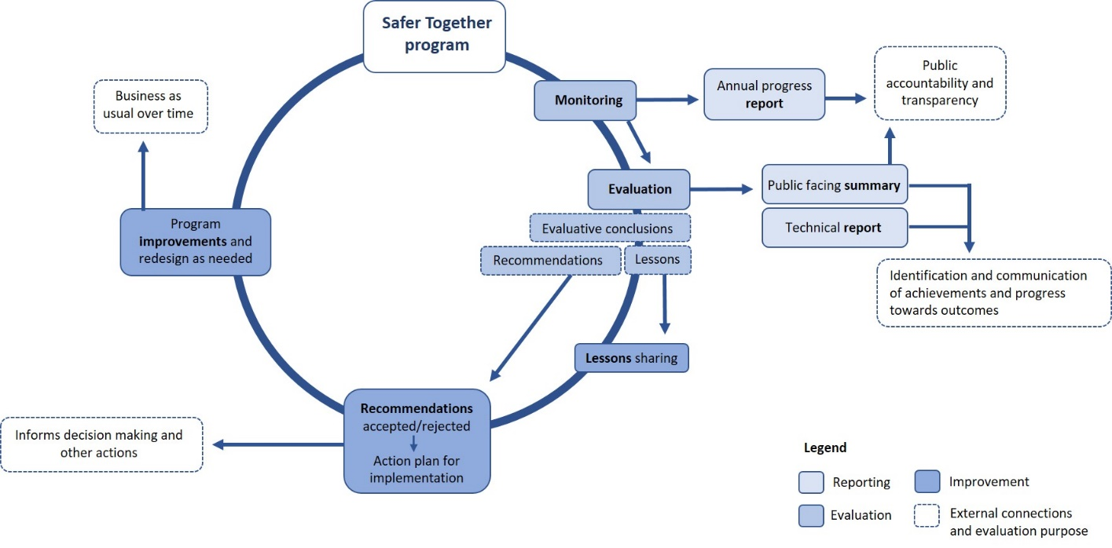

5 Glossary
Agencies: includes all government fire management organisations, both with employees and volunteers: specifically Forest Fire Management Victoria (Department of Environment, Land Water and Planning, Parks Victoria, VicForests and Melbourne Water), the Country Fire Authority and Emergency Management Victoria.
Continuous improvement: a process of consistently re-examining a system, process or program to make changes as needed to make it better and more likely to achieve its intended outcome.
Evaluation: a planned and periodic assessment of the quality and value of a program, where a judgement is made about the achievement of or progress toward the program’s objectives and outcomes. This definition is from Markiewicz and Patrick (2016). Developing Monitoring and Evaluation Frameworks. Thousand Oaks, California, USA. Sage.
Evaluative conclusion: the result of what an evaluation discovers for each evaluation question and for the whole program.
Lesson: a generalisation about an experience from the program that identifies a course of action and which is based on one or more lines of evidence from an evaluation.
Monitoring: the planned, systematic and continuous collection and analysis of data and other information, to track the progress of a program.
Partner: a key stakeholder that is working on or included in the Safer Together program or operations including local governments, land managers (other than those named in ‘Agencies’ above), Traditional Owners, business and industry; but not the general community.
Recommendation: a suggestion for a prescriptive, viable course of action that either reinforces a positive finding of an evaluation or addresses an identified need for improvement.

Appendix 1: Enabling projects (2017-2019)

Community first

1.1 Build capacity and capability
This project aims to build the skills and capabilities of staff and volunteers including firefighters and fire managers across the agencies using common training packages. Three levels of training are available: Level 1 (Community Engagement), Level 2 (Community Development) and Level 3 (Creative Facilitation).

1.2 Community-based bushfire management
This project will review community feedback and the guidelines for community-based bushfire management (CBBM) and will establish best practice engagement through CBBM approaches. Eight CBBM officers are working with 22 communities across the state, using this approach.

1.3 Community risk understanding
This project aims to help communities understand and manage their bushfire risk. It focuses on interpreting the science and on the tools that community members can use to see what actions they can take or activities they can get involved in.

Working together

2.1 Joint planning
This project is developing a model for cross-agency planning for fuel management, preparation for planned burning and engagement activities to improve interoperability between the CFA and Forest Fire Management Victoria (FFMVic). The project team is responsible for understanding the capacity and capability required to deliver joint planning, preparation and engagement; to develop the joint fuel management program; and to prepare burn plans.

2.2 Joint delivery
This project is establishing a joint FFMVic / CFA regional process for selecting burns and coordinating resources. It will also develop agreed principles and processes for the tenure-blind use of funds for operations, appliance coordination, use of resources including machinery, hazardous trees management and burn planning and preparation work.

2.3 Expanding strategic bushfire management planning
This project is supporting regional, multi-agency teams to deliver a strategic bushfire management planning process across public and private land. The project’s other intention is to incorporate additional strategic mitigations, particularly prevention and suppression.

2.4 Joint training system in relation to planned burning
This project focuses on the development of a joint training system, which will include content, accreditation pathways and burn complexity levels.

2.5 Shared doctrine framework
This project is producing a shared doctrine framework to guide the development and maintenance of shared fuel management standards and procedures between the CFA and FFMVic.

2.6 Common burn risk assessment tool
This project is delivering a burn risk assessment approach, which will determine complexity levels and community risks to improve interoperability between agencies’ planned burning risk assessments.

2.8 Common quality assurance system for fuel management
This project is establishing a common quality assurance system and consistent statewide processes and mechanisms for continuous improvement and lesson management and sharing. This will improve interoperability between agencies for planned burning quality assurance.

2.9 Cultural burning practices
This project is supporting Traditional Owners and Registered Aboriginal Parties to undertake fuel management on all land tenures, and it is providing opportunities for Traditional Owners to develop their traditional burning capacity and capability. The project is supporting the work of the Federation of Victorian Traditional Owner Corporations to implement the Victorian Traditional Owner Cultural Fire Strategy.

2.10 Safer Together policy and legislative enablers
This project is delivering solutions to align policy and legislative settings with the government’s overarching vision for whole-of-landscape bushfire fuel management. The project will identify legislative changes required to support the greater participation of local governments and public authorities in fuel management and management objectives for whole-of-landscape bushfire fuel management. It will also propose options to modernise relevant legislation.

2.11 Fuel management system
This project is optimising interoperability between agencies by developing a single, intuitive, flexible platform for delivering the multi-agency fuel management program in Victoria.

Measuring success

3.1 Monitoring, evaluation and reporting framework
This project is delivering this document: the MER framework to measure the effectiveness of the Safer Together program. This includes how we work with communities and across agencies and how we use science and information to inform our actions. It will help us to measure success and to continually improve our approach to bushfire risk reduction.

Better knowledge = better decisions

4.1 Joint research strategy
To enable a coordinated, targeted approach to bushfire science and research investment, this project will deliver a bushfire science strategy including joint priorities for investment and governance and processes for engaging research providers.

4.3 Improve modelling tools
This project is delivering analysis guidelines for better complimentary application of Phoenix and the Victorian Fire Risk Register and a long-term plan to better integrate modelling tools.

Appendix 2: Program logics for priority areas
Figure A1: Community first program logic
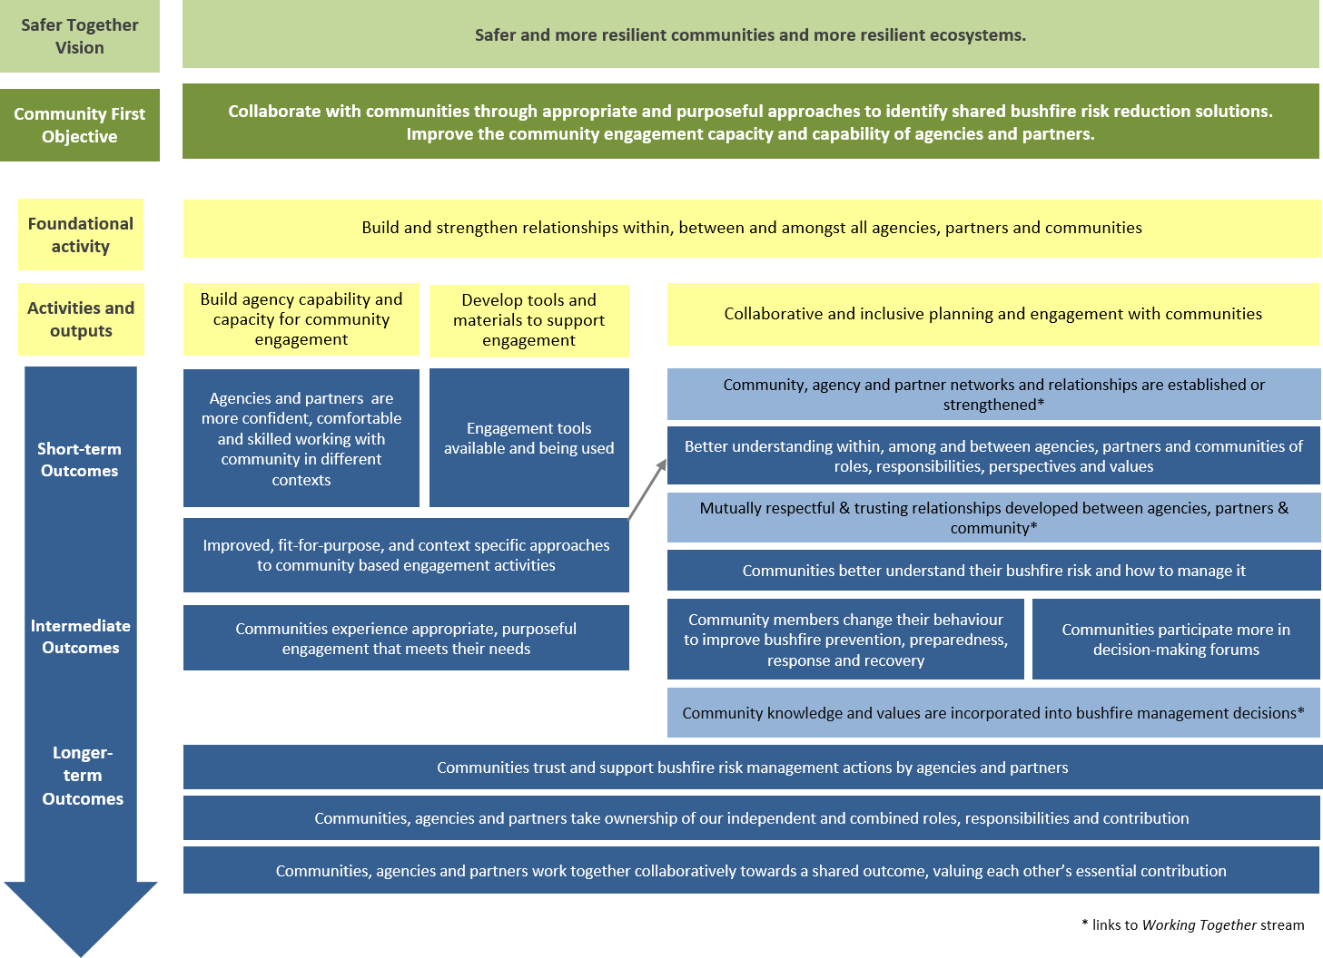

Figure A2: Working together program logic
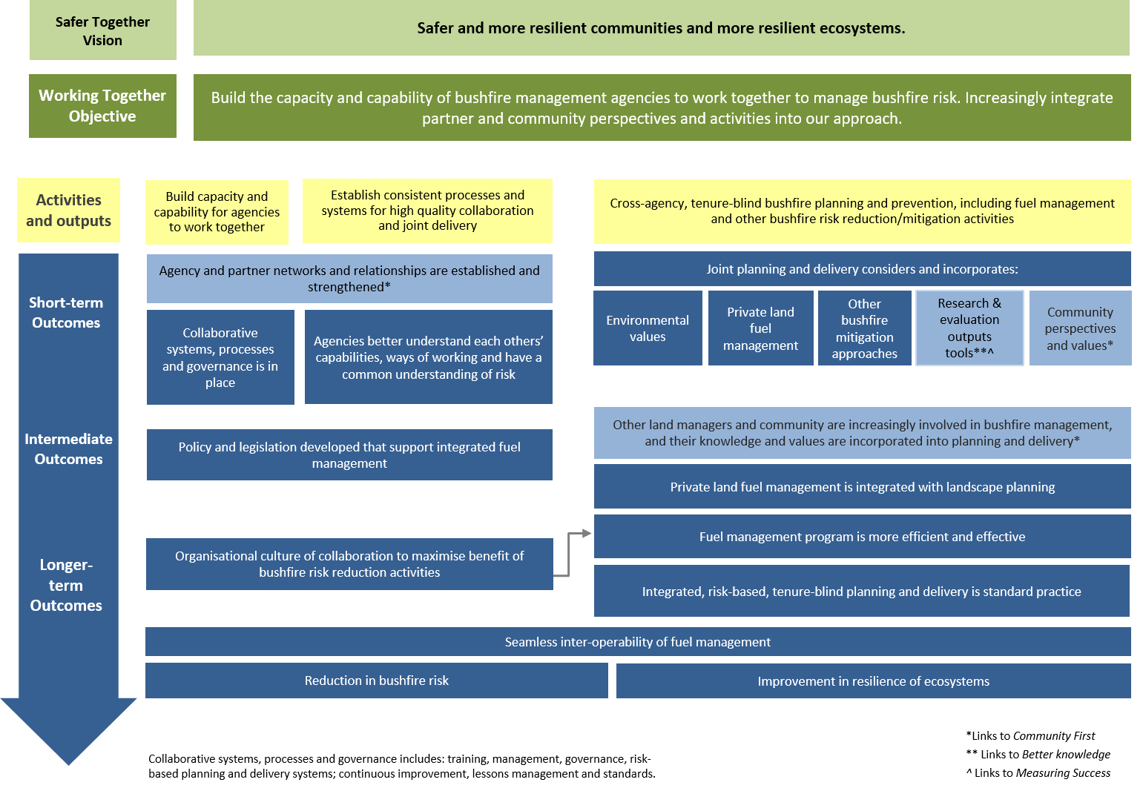
Figure A3: Measuring success program logic
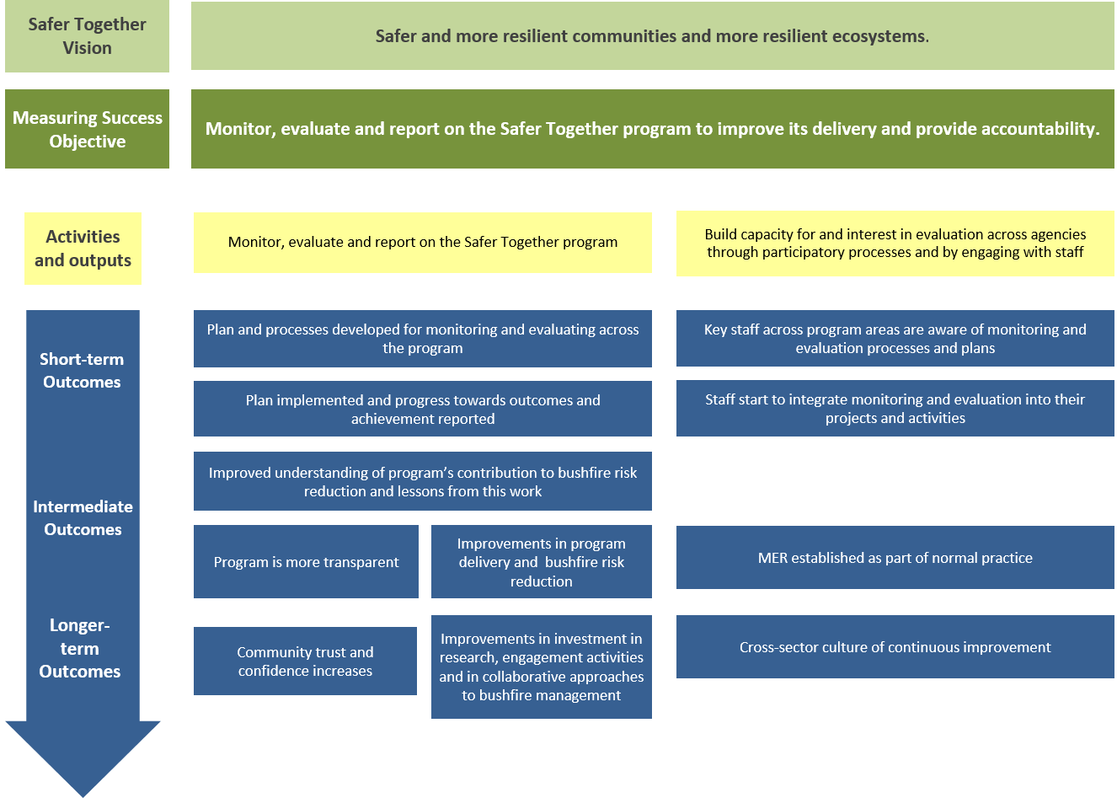

Figure A4: Better knowledge = better decisions program logic
