Hume Bushfire Management Strategy 2020
  - Fuel management
  - Bushfire Risk Engagement Areas

Acknowledgements
We acknowledge and respect Victoria’s Traditional Owners as the original custodians of the state’s land and waters, their unique ability to care for Country and deep spiritual connection to it. We honour Elders past and present, whose knowledge and wisdom has ensured the continuation of culture and traditional practices.
We are committed to genuinely partner and meaningfully engage with Victoria’s Traditional Owners and Aboriginal communities to support the protection of Country, the maintenance of spiritual and cultural practices and their broader aspirations in the 21st century and beyond.
The authors would like to thank members of the Hume Safer Together Coordinating Committee and the Safer Together Working Group for their advice on the technical approach and contribution to this publication.
We also thank the community members who have participated in focus groups and completed surveys as part of developing this plan.
We thank our colleagues and partners in the following organisations who have provided valuable input supporting this project: Country Fire Authority, Department of Environment, Land, Water and Planning, Emergency Management Victoria, Landcare, Parks Victoria, Regional Development Victoria, Department of Defence, Regional Roads Victoria, Local Governments of Hume, Victoria State Emergency Service, HVP Plantations, North-East Water, North-East Catchment Management Authority, North East Apiary Association, Vignerons Association, VicForests.
Aboriginal people should be aware that this publication may contain images or names of deceased persons in photographs or printed material.

Cover photograph:
Aerial view of the Woods Point Brewery creek planned burn conducted in 2018
Photo credit: Shaun Lawlor, FFMVic, Hume
© The State of Victoria Department of Environment, Land, Water and Planning 2020
This work is licensed under a Creative Commons Attribution 4.0 International licence. You are free to re-use the work under that licence, on the condition that you credit the State of Victoria as author. The licence does not apply to any images, photographs or branding, including the Victorian Coat of Arms, the Victorian Government logo and the Department of Environment, Land, Water and Planning (DELWP) logo. To view a copy of this licence, visit http://creativecommons.org/licenses/by/4.0/
Printed by
ISBN 978-1-76105-004-6 (Print)
ISBN 978-1-76105-005-3 (pdf/online/MS word)

Disclaimer
This publication may be of assistance to you but the State of Victoria and its employees do not guarantee that the publication is without flaw of any kind or is wholly appropriate for your particular purposes and therefore disclaims all liability for any error, loss or other consequence which may arise from you relying on any information in this publication.

Accessibility
If you would like to receive this publication in an alternative format, please telephone the DELWP Customer Service Centre on 136186, email customer.service@delwp.vic.gov.au or via the National Relay Service on 133 677 or at www.relayservice.com.au. This document is also available on the internet at www.delwp.vic.gov.au.

Contents
Abbreviations and Definitions 3
Introduction 4
Recognising the role of Victoria’s Traditional Owners 6
Bushfire management planning 8
Strategic planning 8
Operational and tactical planning 8
Other bushfire management actions 8
About this bushfire management strategy 10
Method overview 11
Identifying and assessing risk to values and assets 11
Our landscape context 12
Bushfire history and patterns 14
Values and assets 15
Human landscape 15
Aboriginal cultural heritage 17
Natural landscape 18
Our objectives 20
Our risk management approach 21
Bushfire Risk in Hume Region 21
Higher risk areas in Hume 21
Lower risk areas in Hume 22
Why model house loss? 23
How do we model house loss? 23
Our fuel management strategy 23
Fire Management Zones 23
Ecosystem resilience 25
About our fuel management strategy 26
Victoria’s residual risk 27
Bushfire Risk Engagement Areas 29
Implementation 30
Monitoring, evaluation and reporting 31
Appendix 1: Program logic 31
References 32

Abbreviations and Definitions
Abbreviation | Term
APZ | Asset Protection Zone  an area around properties and infrastructure where we intensively manage fuel to provide localised protection to reduce radiant heat and ember attack on life and property in the event of a bushfire
BMZ | Bushfire Moderation Zone  an area around properties and infrastructure where we manage fuel to reduce the speed and intensity of bushfires and to protect nearby assets, particularly from ember attack in the event of a bushfire
BREA | Bushfire Risk Engagement Area  parts of the landscape, on public and private land, where managing bushfire fuels is most effective in reducing risk. It guides agencies and communities working together to determine the best actions in their local area
CAR | Comprehensive, Adequate and Representative reserve system
CFA | Country Fire Authority
DELWP | Department of Environment, Land, Water and Planning
EFG | Ecological Fire Group  a broad native vegetation classification unit based on grouping multiple Ecological Vegetation Classes that share similar ecological responses and relationships, in particular fire responses
EMV | Emergency Management Victoria
FAME | Fire Analysis Module for Ecological values
FFMVic | Forest Fire Management Victoria  comprised of staff from DELWP, PV, Melbourne Water and VicForests when working in bushfire management on public land
FMZ | Fire Management Zone  for fuel management purposes, public land in Victoria is classified into four fire management zones: asset protection zone, bushfire moderation zone, landscape management zone, and planned burning exclusion zone
Ha | Hectares
HVEA | High Value Ecological Area
IMT | Incident Management Team
JFMP | Joint Fuel Management Program
LMZ | Landscape Management Zone  an area where we manage fuel to minimise the impact of major bushfires, to improve ecosystem resilience and for other purposes (such as to regenerate forests and protect water catchments)
MER | Monitoring, Evaluation and Reporting
PBEZ | Planned Burning Exclusion Zone  an area where we try to avoid planned burning, mainly because ecological assets in this zone are primarily intolerant to fire
PV | Parks Victoria
RAP | Registered Aboriginal Party
Residual risk | the amount of risk that remains after bushfires and fuel management activities reduce fuel. Residual risk is used by DELWP as a performance measure
RSFMPC | Regional Strategic Fire Management Planning Committee
SDM | Structured Decision Making
TFI | Tolerable Fire Interval  a term which expresses the minimum or maximum recommended time intervals between successive fire disturbance events at a site or defined area for a particular vegetation community. The time interval is derived from the vital attributes of plant species that occupy the vegetation community. The TFIs guide how frequent fires should be in the future to allow the persistence of all species at the site or defined area.
VFRR-B | Victorian Fire Risk Register – Bushfire

Introduction
Victoria is one of the most bushfire-prone areas in the world. Victorians are accustomed to living with bushfire risk, which is the likelihood and consequence of bushfires. It includes the likelihood of a fire starting and spreading across the landscape, and the consequences of it impacting the things we value: people, communities, houses and farms, infrastructure, our economy and the natural environment.
Bushfires are driven by three key factors – fuel, weather and topography – which together make up the ‘fire behaviour triangle’. These three factors combine to affect how a bushfire behaves: how fast it travels, where it spreads, and how intensely it burns. Fuel management is important, because it is the only element of the fire behaviour triangle that we can influence.
Bushfire fuels are the leaves, bark, twigs and shrubs that are burnt by fire. The fuel type, dryness, size, moisture content and arrangement can all affect the speed, size and intensity of a bushfire. Fuel management includes planned burning — lighting and managing planned fires in the landscape — and mechanical treatment — mowing, slashing, mulching and using herbicides. Fuel management activities reduce the amount of fuel across our landscape, decreasing the fire behaviour of bushfires, helping limit their spread and intensity when they occur, and making it easier for our firefighters to control them and lessen their impacts.
Bushfire risk is influenced not only by how a bushfire behaves, but also by how fire impacts the different things that we value. For example, population growth in and near forested areas increases the bushfire risk, as more people enter areas where major bushfires are more likely to impact. The Victorian community is changing in other ways, with an aging population and decreases in volunteering in some areas, leading to an increase in vulnerability to bushfire. For plants and animals, drought, invasive species incursion, as well as habitat loss and fragmentation increase the susceptibility to negative bushfire impacts.
Our changing climate – bringing rising average temperatures, more hot days and less rainfall – means bushfire risk is constantly increasing as fuels dry out and extreme fire weather events increase. Bushfires with the worst consequences typically occur during extreme weather conditions (such as during very hot, dry and windy periods). The disastrous 2019–20 bushfire season, followed periods where parts of Eastern Australia – extending from Tasmania through Victoria, New South Wales and into Queensland – had experienced their driest conditions on record. Over 1.5 million hectares (ha) in Victoria were burnt and large areas of eastern Australia impacted.

Case study: 2019/20 Black Summer bushfires in Hume
In Hume, below average rainfall and underlying dryness resulted in an early start to the bushfire season across the region with a dry lightning event causing multiple ignitions on 21 November, 2019. Additional dry lightning events in late December resulted in new ignitions across the east of State leading to large campaign fires in the Hume and Gippsland regions.
Since 2000, Hume region has been subject to a series of particularly severe bushfire events in relatively quick succession, some involving significant loss of life and property. Major fire events in the region include: a total of 1,200,000 hectares burnt in the 1939 Black Friday fires; more than 503,000 hectares in the 2003 Alpine fires; 444,000 hectares in the 2006/07 Great Divide fires; and 247,000 hectares in the 2009 Black Saturday fires, and 36,000 ha in the 2013 Harrietville fires.
During the 2019/20 Black Summer fires FFMVic and the CFA responded to 1596 ignitions in Hume , which burnt over 319,401 ha and caused widespread impacts to our communities, the environment and led to the fatality of one FFMVic firefighter. The most significant fires: Upper Murray-Walwa fire burnt 200,442 ha and Ovens Abbeyard fire burnt 105,910 ha.
These fires caused significant impacts: damage and disruption across tourism, farming, forestry, winemaking and beekeeping. In summary: 189 properties, over 20,000 ha crops and pasture, 921 ha plantation, 246 sheds, over 4000 stock losses, 85 beehives, as well as extensive fencing losses. On public land damage included roads and bridges, recreation sites, heritage sites including three huts. Extensive areas of immature Alpine ash and Mountain ash forest regrowth from previous recent fires were also impacted, leading to the largest reseeding program in Victoria, with 5551 ha resown in Hume in areas where the risk of forest loss was highest.
The Upper Murray - Walwa fire also caused widespread disruptions to power, water, telecommunications and road networks which had immediate and lasting consequences for local industries and communities. As part of the recovery process and lessons from these fires, local communities and industries are working with local government and recovery agencies to focus on future energy security and connectivity across Hume region. This will improve community resilience to future emergencies, particularly for remote communities that may be cut off during emergencies.
In Victoria, climate change is forecast to:
- extend the bushfire season
- make bushfires larger, more severe, and more frequent
- make days with an elevated fire danger rating more frequent
- extend the area that experiences extreme weather conditions, increasing the frequency of these for communities that may have never or have only infrequently experienced such conditions
- start the bushfire season earlier, with more bushfires starting in spring (which may also change fire weather conditions that are experienced, such as wind speed and direction)
- further strain available resources and capacity as the bushfire season increasingly overlaps with suitable weather periods for planned burning.
The impacts of climate change on fire-sensitive habitats and refugia for plants and animals will become increasingly important to manage.
With climate change making many extreme weather events more frequent and more extreme, the impacts on communities are also likely to increase. Of 15,700 disasters between 1980 to 2015, 91% were weather related, and 51% of fatalities and 79% of economic losses were caused by weather related extremes.

Our shared responsibility to mitigate bushfire risk
While bushfires will always be a threat, Victorians have demonstrated their ability to work together to plan and deliver activities on public and private land to mitigate bushfire risk. As with all areas of emergency management, supporting communities to be safer and more resilient is the shared responsibility of all Victorians, not just of government agencies. To best manage bushfires, it is important that communities and government organisations come together to understand bushfire risk, agree on strategies, and then work both individually and collaboratively to fulfil their individual and shared responsibilities.
Actions that agencies are responsible for include issuing fire danger warnings and advice, reducing fuel through planned burning and mechanical treatments, commissioning bushfire science research, and recruiting and training firefighters. Actions that community members are responsible for include developing and practising a bushfire plan, fully extinguishing campfires, preparing their property, and participating in community bushfire preparedness activities and events. Actions we do together include building an understanding of risk in our area, sharing information through community and social channels, developing, practicing and implementing plans to protect what is valued most by the local community.
Resilient communities prepare better for bushfires. They provide the volunteer workforce essential in the response phase, and they are better able to face the acute shocks and stresses of a bushfire and to recover after it.
Victoria’s ‘shared responsibility’ approach recognises that communities:
- are best-placed to understand and mitigate their risks and drive preparedness and recovery, including through their fundamentally important volunteer contribution
- have knowledge, expertise, capability and diverse perspectives to work with agencies to mitigate bushfire risk
- have networks and relationships that help agencies identify and protect the things communities value, improve their capacity and create meaningful, sustainable solutions.
The shared responsibility approach seeks to ensure:
- the interests, values and expectations of stakeholders in, or members of, communities are understood and considered in the planning process
- ownership of the planning process and responsibility for implementing strategies are broadly shared.
Shared responsibility does not mean equal responsibility: there are some areas where land and fire management agencies are better-placed and have more resources and information to make decisions and act on them. Equally, while agencies develop plans and implement programs for mitigation, planning, preparedness, response and recovery, governments or agencies cannot guarantee that bushfires will be consequence-free for the community. Communities and individuals have the responsibility to prepare their own plans, properties and assets to reduce the impact of bushfires. During major bushfires with far-reaching consequences, land and fire agencies may not always be able to coordinate and deliver the support the community may expect.

Recognising the role of Victoria’s Traditional Owners
The Hume region recognises the Victorian Traditional Owner Cultural Fire Strategy, which aims to re-establish cultural fire with Traditional Owner led practices across Victoria, so Traditional Owners can heal Country and fulfil their rights and obligations to care for Country. The Victorian Traditional Owner Cultural Fire Strategy provides a set of principles and strategic priorities to facilitate greater self-determination for Traditional Owners and a framework for effective Traditional Owner-led cultural fire management in Victoria. The strategy has an important role in informing the Joint Fuel Management Program (JFMP) in consultation with individual Traditional Owner groups. Traditional Owners emphasise that cultural fire is applied to achieve culturally meaningful objectives, but that risk reduction is often a complementary outcome.
Figure 1: Bushfire management strategic, operational and tactical planning for fuel management
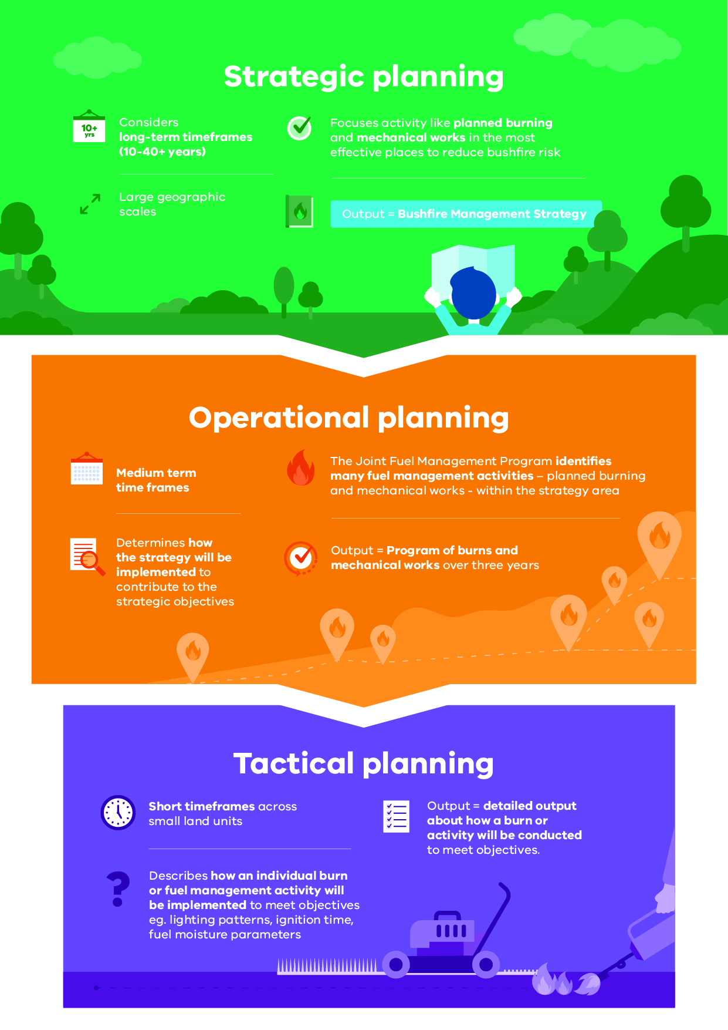

Bushfire management planning
Bushfire management planning occurs at different levels, with varying time frames, focuses and outputs. Figure 1 shows fuel management planning at strategic, operational and tactical levels.

Strategic planning
The strategic planning process identifies where important values and assets are located across the landscape. It considers the current extent and quality of these values and where possible considers future trends including population, industry and environmental change. Strategic planning identifies objectives for the important values and assets, and develops an approach to manage the risks posed to them. The resulting bushfire management strategies describe landscape zones that focus fuel management activities to deliver bushfire risk reduction and ecological outcomes.
Strategic bushfire management planning takes place within a legislative and policy context which includes:
- the Emergency Management Act 2013, which requires from 1 December 2020 the Emergency Management Commissioner to prepare a state emergency management plan and to approve eight regional emergency management plans. In combination with the municipal emergency management plans, these provide for an integrated, coordinated and comprehensive approach to emergency management. The Act also requires emergency management plans to contain provisions providing for the mitigation of, response to and recovery from emergencies and to specify the emergency management roles and responsibilities of agencies
- the Conservation Forests and Lands Act 1987, which requires the Department of Environment, Land, Water and Planning (DELWP), through the Code of Practice for Bushfire Management on Public Land (2012), to develop a risk-based approach to bushfire management on public land. This document meets the requirements set out in the Code of Practice to prepare a strategic bushfire management plan.
- Safer Together: A new approach to reducing the risk of bushfire in Victoria (2015), a Victorian Government policy, focuses on how effective our actions are in reducing risk and not just the amount of activity we undertake.

Operational and tactical planning
This bushfire management strategy informs the development of operational plans, primarily the Joint Fuel Management Program (JFMP). The JFMP is the three-year rolling statewide program of fuel management works on public and private lands carried out by Forest Fire Management Victoria (FFMVic) and Country Fire Authority (CFA) to reduce bushfire risk and to maintain the health of native plants and animals that rely on fire to survive. Works include planned burning, slashing, mowing and clearing works, creating and maintaining fuel breaks, and carrying out maintenance on fire infrastructure (like fire dams and lookout towers).
This strategy does not directly address tactical (burn) planning, which is done for individual burns. Tactical planning can include individual burn objectives, community engagement plans and how the burn will be delivered safely.

Other bushfire management actions
This Bushfire Management Strategy outlines our risk-based approach to fuel and ecological fire management. However, fuel management is not the only bushfire management action that reduces bushfire risk and is not always the most effective action to reduce that risk. Fuel management needs to be supported with other actions for a number of reasons:
- Some parts of the landscape have inherently high levels of bushfire risk which requires more actions to reduce that risk
- The ability to reduce risk through fuel management may be limited in some landscapes and there will always be fuel re-accumulation
- The effectiveness of fuel management may be reduced under extreme weather conditions
- Fuel management reduces fire behaviour, it does not eliminate bushfire. Suppression activities are always required to control bushfires.
Table 1 lists some key actions that agencies and communities undertake together to manage bushfire risk and complement our fuel management approach.
As with fuel management, these actions are guided by bushfire risk analysis combined with other information to ensure they are most effective. Strategies and plans for these actions are developed through emergency management planning processes by agencies at the state, regional and municipal levels.
Table 1: Bushfire management approaches beyond fuel management
Approach | Key actions
Reduce bushfire ignitions through prevention activities | - Education and advertising campaigns (e.g. campfire safety, reporting ignitions)  - Coordinated, risk-based patrolling  - Deterrence for deliberate or negligent ignition – laws/prosecution  - Monitoring arsonists  - Restrictions – fire danger period and total fire ban triggers, duration and restrictions (including legislative change)  - Reducing ignitions from powerlines
Increase the effectiveness of fire suppression | - Fire detection (towers, aerial surveillance)  - Resourcing, capacity and capability of fire-fighting resources (fire crews, contractors, incident management teams)  - Aircraft fleet management: type, distribution, availability and pre-determined dispatch  - Road infrastructure including maintenance of the strategic fire access road network and network of fuel reduced areas.  - Other fire response infrastructure maintenance including remote water access and helipads  - Fire readiness including rostered and pre-formed IMTs and fire crews
Reduce bushfire spread and severity | - Planned burning based on tenure-blind risk  - Strategic breaks and burn unit boundary standards  - Flexible delivery of burning (e.g. managed bushfire, unbounded burns)  - Other forms of fuel management (e.g. slashing, spraying, mulching) particularly in high-risk areas where planned burning is not suitable  - Identify and effectively manage fuel hazard reduction on private bush
Reduce the physical effects of bushfires in inhabited areas | - Domestic property preparedness in towns, including fire prevention notices, penalties and cost recovery  - Vegetation management on public and private land within or immediately bordering towns including implementation of fire prevention notices  - Identification, prioritisation and treatment of risk to critical infrastructure  - Access and egress (roadside vegetation/tree maintenance) pre- and post-fire  - Asset protection (on-ground)
Reduce the social effects of bushfires on communities | - Bushfire education programs targeting vulnerable communities including those with identified at-risk or changing demographics, and/or where bushfire risk cannot be effectively reduced through planned burning.  - Recovery planning and relationship building pre-bushfire (e.g. via community groups, scenario events and activities)  - Municipal emergency and/or bushfire plans  - Warnings and advice messaging  - Personal and neighbourhood bushfire plans
Reduce impacts from fire management actions | - Community engagement about fire management and smoke impacts  - Planning to minimise impacts on biodiversity, cultural heritage and other values  - Connections between planning and delivery (e.g. on-ground staff aware of biodiversity/cultural sites and mitigation actions)  - Cross-tenure planning and consultation  - Monitoring effectiveness of mitigations (and subsequent improvement)

Case study: Integrated actions support fire suppression
We undertake fire management actions using an integrated approach across detection, fire response, access roads and fuel breaks, and fuel management. Together, these actions provide fire management agencies the best opportunity to safely, rapidly and effectively control and supress bushfires when they occur.
Detection and response to new fire ignitions is critical to keeping fires small. A network of 16 Fire Lookout Towers are staffed throughout the bushfire period in the Hume region enabling rapid and accurate detection of fires across vast areas of the Region that may otherwise go undetected until they reach a size where first attack may be compromised. The fire lookout network is supplemented by scheduled aerial detection flights on days of high fire danger or heightened ignition risk. In recent years other detection mechanisms have been successfully utilised within Hume including remote sensing via satellites and this is being rapidly enhanced as technology progresses.
If a fire is detected, then response is enacted in line with existing response plans and a unique Hume Region Model of Response which outlines the minimum number of resources required to be despatched to the ignition on public land. This model is comprehensive and covers all types of resources for frontline firefighters, appliances, heavy plant and machinery, support resources and aircraft. The scale of the response is variable dependant on a number of factors including fire danger rating, forecast lightning activity level and other fires in the landscape. Specialist Rappel crews are also available to be deployed to remote or difficult fires via helicopter to either undertake direct first attack or gather intelligence to help develop appropriate suppression strategies.
For many years the Hume Region has worked hard to identify and manage a number of strategic breaks across the landscape that can be quickly utilised in the event of a bushfire. These breaks are complemented by the delivery of broadscale fuel reduction burns with a particular emphasis on public/private land interface and the creation of access tracks along these boundaries that are managed in an on-going capacity by the relevant landholder.

About this bushfire management strategy
Victorian landscapes, environments and communities are diverse and multifaceted, and Victorian communities have diverse values, preferences and priorities. This regional bushfire management strategy reflects our region’s unique environments and communities. To develop this strategy, we undertook a regional planning process that was guided by the knowledge and priorities of experts, stakeholders and community members from Hume region.
Between November 2017 and September 2019, representatives of CFA, DELWP, Parks Victoria (PV), Emergency Management Victoria and local governments engaged in a strategic bushfire risk management planning process. The process was guided by the Hume Regional Strategic Fire Management Planning Committee, through the regional Safer Together Coordinating Committee and Working Group. They offered opportunities to stakeholders and the broader regional community to be involved in the planning process through both in-person and online mechanisms.
The strategic planning process resulted in two strategies to reduce bushfire risk and maintain ecosystem health: together, they comprise this strategy — the Hume Bushfire Management Strategy 2020.
The individual strategies are:
- our fuel management strategy, which focuses on reducing bushfire fuels through planned burning and mechanical works (mowing and slashing) on public land
- our Bushfire Risk Engagement Areas (BREAs), which focus on targeted community engagement to complement, inform and drive fuel management and other risk mitigation activities on public and private land.
Our bushfire management strategy focuses on:
- reducing the risk of bushfires threatening lives, homes, the environment and other important values and assets across the landscape
- maintaining or improving the resilience of ecosystems
- establishing a shared understanding of bushfire risk across the sector, based on the latest science and the extensive knowledge of agency personnel
- using a 40-year horizon, so long-term ecological changes and fuel accumulation rates can be considered in annual operational planning processes.
Our common understanding of our values and of bushfire risk will underpin ongoing development of future strategies and enable agencies to work together to reduce risk (such as by informing Joint Fuel Management Planning and Municipal planning, Hume CFA’s engagement treatment plan for high-risk communities and Hume’s readiness and response arrangements).
The strategy is a supplement to the Hume Regional Strategic Fire Management Plan 2011 - 2021, developed by the Hume RSFMPC, and applies to the same Hume emergency management region footprint. The plan’s agreed vision, strong leadership and greater cooperation between agencies promotes greater community resilience through effective engagement and best-practice integrated fire management planning.
Regional emergency management plans and municipal emergency management plans are being prepared in line with the new amendments to the Emergency Management Act 2013. This strategy will help inform the bushfire components of these plans, now and into the future.
For the purpose of the Code of Practice for Bushfire Management on Public Land (2012), the FFMVic Chief Fire Officer has approved the public land components of this strategy: specifically, where the strategy relates to state forests, parks administered under the National Parks Act 1975 and protected public land. These components of the strategy will directly guide FFMVic’s fuel management operations. This strategy replaces the former Strategic Bushfire Management Plans for public land, published by DELWP and PV in 2014 and 2015, which used bushfire risk landscape footprints.

Method overview
This document presents the outcomes of the strategic bushfire management planning process.
The planning process involved considerable community engagement — with individuals, private land managers, businesses, community organisations and other stakeholders — to tap into their knowledge, understand their priorities, discuss and evaluate options with them and prepare to involve them in implementing the strategy.
In the planning process, we:
- identified the values and assets that are most important to the residents of and visitors to the region: we grouped these into human life, health and relationships, critical infrastructure and environmental values.
- developed regional objectives: the things we want to achieve by implementing the strategy
- combined local knowledge, bushfire behaviour modelling, historical data and the best-available science to understand how bushfires behave in our region and to forecast bushfire and fuel management strategy impacts on our most important and at-risk values and assets
- developed and evaluated many potential strategies to select two — our fuel management strategy and the Bushfire Risk Engagement Areas (BREAs) — that will enable agencies and communities to best mitigate bushfire risk to the region’s most important and at-risk values and assets.
The planning process was underpinned by the International Standard for Risk Management ISO 31000. The standard acknowledges that risk can never be completely eliminated. Bushfires will still occur, and we must all be prepared and ready to respond. However, bushfire risk can be reduced with a high-quality risk management approach.
The planning process followed the principles of structured decision making (SDM). SDM is a framework that helps people unpack complex decisions, navigate trade-offs and make logical and transparent choices. It provides a means of bringing together both scientific information and human values to make decisions, through analysis and inclusive deliberation. The principles of SDM are particularly useful in decision-making contexts characterised by uncertainty, multiple stakeholders and competing objectives. Broadly, the SDM steps included understanding the landscape context, setting objectives, identifying possible management strategies, and estimating and analysing the consequences and inherent trade-offs of these strategy options. We then selected the strategy that gives the greatest benefit to the things we care about, while balancing the impacts of fuel management actions on those same values.
In Hume, we developed our strategy through an inclusive, comprehensive approach with shared decision-making and advice sought across our region. This included the formation of a core interagency working group and coordinating committee, which we used to build a holistic engagement approach including workshops with a wide range of experienced agency representatives and committees, targeted stakeholder meetings, an active and interested external community reference group and a range of community conversations including events, meetings and engagement surveys.

Identifying and assessing risk to values and assets
To identify the region’s most important values and assets, we consulted with our partners, stakeholders and communities, and we drew on specialised data sets including the Victorian Fire Risk Register – Bushfire (VFRR-B) and Victorian Biodiversity Atlas.
We used Phoenix RapidFire, which is world-leading bushfire simulation software developed in Victoria, to model the spread of a bushfire from an ignition point under the specified weather conditions. This enables us to understand the impact bushfires could have on people, homes and other important values and assets in our landscape. We modelled ignitions and bushfire spread patterns at thousands of places throughout the region:
- using the bushfire characteristics information in the ‘Bushfire history and patterns’ section
- under a range of bushfire weather conditions, including Code Red conditions: a Forest Fire Danger Index (FFDI) rating of 130 or above. These were the conditions in many parts of the state on Black Saturday 2009, and conditions were similar at times during the 2019–20 fire season. Code Red conditions are also forecast to become more frequent and more extreme with climate change.
We also used a new 20-year historical weather dataset for Victoria to identify recent changes to the state’s climate and so we could better model the average frequency with which various weather scenarios occur. This provided some indication of the likelihood of these scenarios occurring in future. We also partnered with climate scientists to forecast various climate conditions relevant to bushfires which will inform future strategic bushfire risk management planning and preparedness decisions.
Our planning process considered outcomes for flora, fauna and ecological communities. We modelled these ecological outcomes for a range of possible fuel management scenarios. To predict fauna and TFI outcomes, we drew on modelling that sits within the Fire Analysis Module for Ecological values (FAME) including Habitat distribution models. This module was designed for this purpose by the Arthur Rylah Institute and the University of Melbourne. We also drew on decades worth of flora, fauna and ecological data collected in Hume as well as newer modelling tools.

Our landscape context
The Hume region (Figure 2) makes up 20% (4.5 million ha) of Victoria’s land area, with over 1.65 million ha (21.4%) of this area located on public land. It stretches northward from the fringe of Melbourne to the Murray River and westward from the alpine areas of the Great Dividing Range to the floodplains and grasslands of the Goulburn and Murray rivers. The Hume region is home to more than 320,000 people and four formally-recognised Aboriginal Traditional Owner groups.
Figure 2: The Hume region with local government boundaries and public land tenure
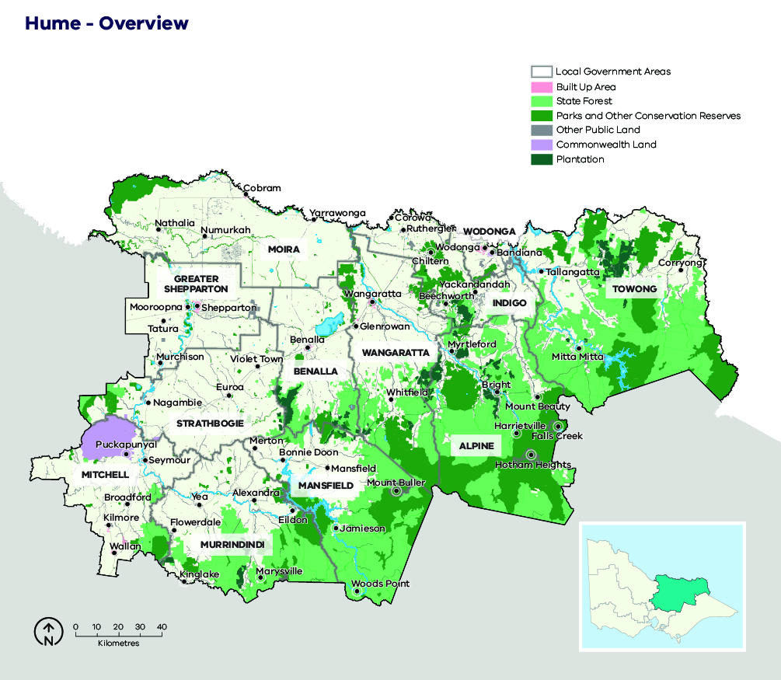

Case study: Local government profiles
The communities of the Hume region are represented by 12 councils, with three large population centres: Shepparton, Wodonga and Wangaratta.

Mitchell Shire Council (population 40,918)
Mitchell Shire Council is a growth area for Melbourne experiencing substantial development and an expanding population, which is anticipated to grow from 40,000 to 270,000 people in the next 25 years. The area consists of farmland and rolling foothills, and it includes Beveridge, Wallan and Kilmore.

Greater Shepparton City Council (population 63,387)
Located on the Goulburn River, the area is a vibrant, diverse municipality about two hours north of Melbourne. There is a substantial manufacturing base along with farming and a thriving food production industry. Notable enterprises include Furphy and Sons, Visy, SPC Ardmona and Tatura Milk Industries.

Murrindindi Shire Council (population 13,732)
Including the towns of Alexandra, Yea, Marysville and Eildon, Murrindindi Shire is an area the industries of which include agriculture and viticulture, forestry and tourism. Much of the shire is subject to substantial bushfire risk, due to towns abutting extensive forest and bushland. The area was severely damaged by bushfire in the 2009 Black Saturday fires.

Mansfield Council (population 8,584)
Tourism and agriculture are the key industries for this area, which also is home to two of Victoria’s key skiing areas: Mt Buller and Mt Stirling. The area includes the headwaters of several important water systems including the Delatite, Howqua, Jamieson and Goulburn rivers.

Rural City of Wangaratta (population 28,310)
The Rural City of Wangaratta is centred on the city of Wangaratta, which is Victoria’s tenth largest. Industries in the area include agriculture, transport and health. The northern part of the local government area consists of plains and hills bisected by the Ovens River. The southern area is foothills and ranges.

Moira Shire Council (population 29,112)
Located on the Murray River, the shire has several settlements including Cobram, Nathalia and Yarrawonga as well as major food and tourism industries. The area was subjected to a major flood impact in 2010–11, with recovery continuing in many areas.

Benalla Rural City Council (population 13,681)
Benalla is 193 km north of Melbourne, and it is home to industries including value-adding for timber production, a major defence components manufacturer and agriculture. Other features include its location on the Hume Highway and the Melbourne-to-Sydney rail line, and it is also the home of the State Gliding Centre.

Towong Shire Council (population 5,985)
The municipality of Towong is one of Victoria’s remotest local government areas, being located in the far north-east of the state. Settlements include Corryong and Tallangatta, and the area is home to agriculture, tourism and forestry (including extensive softwood plantations) industries. Much of the municipality, particularly Cudgewa and Corryong were severely impacted by the 2019–20 fires.

Alpine Shire Council (population 12,337)
The main towns are Bright, Myrtleford and Mt Beauty, and the area has mountain ranges and foothills along two main river valleys. Key industries are agriculture and tourism, and the area features the ski resorts of Mt Hotham and Falls Creek. A substantial area of public land including Mt Buffalo was impacted or under threat by the 2019-20 fires.
The area has a long history of large fires with the shire affected in 1985, 2003, 2006/07 and 2013. The 2019-20 fires also impacted a substantial area of public land including Mt Buffalo, and threatened local communities.

Indigo Shire Council (population 15,952)
Home to the historically significant towns of Beechworth, Rutherglen and Chiltern, the area also has important viticulture, agriculture and tourism industries.
The area has important tourism and agriculture industries including viticulture and apiary. The towns are also known for their evidence of the gold rush era, with landmarks and relics throughout the areas. The shire has experienced fires with significant fires in 2003 and 2009. the 2003 Alpine fires.

Wodonga City Council (population 39,351)
The local government area is one of the smallest in the Hume region, but it is a major population centre with a range of industries including Mars Petcare food manufacturing, Woolworths distribution centre – Greenfreight at Barnawartha; and it hosts the Bandiana Military Area and Wodonga TAFE La Trobe University. Wodonga City Council is anticipating significant future growth, and it is the fastest-growing municipality in north-east Victoria.

Shire of Strathbogie (population 10,781)
Strathbogie Shire enjoys excellent transport linkages via the Hume Freeway, Goulburn Freeway and Melbourne – Sydney railway line. In part as a result of these strategic transport links populations in the areas of Nagambie, Avenel and Strathbogie Ranges have been steadily increasing. A feature of the area is vegetated rising hills in the south which have areas of forest and bushland that are long unburnt and of environmental significance. Important industries include wineries, tourism and farming.

Bushfire history and patterns
Hume region has a long history of large and intense fires, some involving significant loss of life and property. Major fire events in the region include a total of 1.27 million ha burnt in the 1939 Black Friday fires, more than 503,000 ha in the 2003 Alpine fires, 444,000 ha in the 2006–07 Great Divide fires, 247,000 ha in the 2009 Black Saturday fires, 36,000 ha in the 2013 Harrietville fire and 320,120 ha in the 2019–20 Black Summer fires (Figure 3).
Since 2000, the region has been subject to a series of particularly severe bushfire events in relatively quick succession. These fires have affected many thousands of hectares of public and private land and had significant social, economic and environmental impacts.
The risk of bushfire is widespread across our landscape. In the northern and western parts of the region, fires are often fast-moving, wind-driven grassfires that are generally contained within 24 hours, despite sometimes covering large areas. In the southern and eastern areas, the steep, long and heavily forested slopes of our landscape mean fires are generally slower, intense and difficult to suppress. These fires in the difficult terrain of the Great Dividing Range, High Country and Central Highlands have impacts not only for Hume region but for landscapes, communities and regions to the south and east of Hume. Significant fires have also entered the Hume region from fires in NSW.
Responding to more than 1,000 ignitions a year, fire management agencies in Hume see extreme contrasts in ignition patterns and fire behaviours that require a variety of suppression strategies. More than 80% of ignitions in the Hume region occur on private land, and 20% of these are caused by lightning.
Figure 3: Bushfire history for the Hume region, 1980–2020
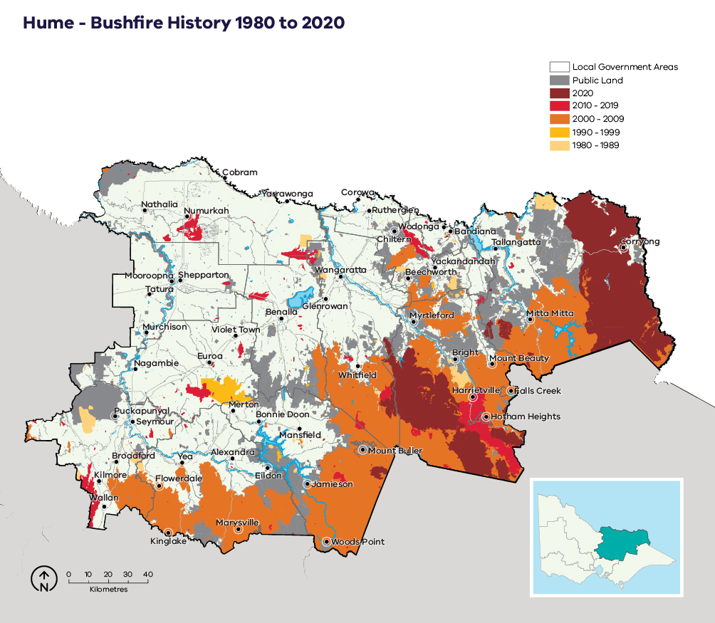

Values and assets
Here we describe the most important features of our landscape that informed our strategy.

Human landscape
The region comprises 12 local government areas — Mitchell Shire, Murrindindi Shire, Mansfield Shire, Greater Shepparton City, Moira Shire, Strathbogie Shire, Benalla Rural City, Wangaratta Rural City, Alpine Shire, Indigo Shire, City of Wodonga and Towong Shire — and four Alpine Resort Management Boards — Mount Hotham, Mount Buller-Mount Stirling, Falls Creek and Southern (Lake Mountain and Mt Baw Baw). Unlike other regions, there is no single, dominant regional city. Hume’s main economic sectors include tourism, plantation timber and native hardwood resources, and agriculture.

Human life, health and relationships
The Hume region is home to more than 320,000 people, with the population distributed across the landscape in small settlements and agricultural areas and in the main settlements of Alexandra, Benalla, Beechworth, Bright, Corryong, Eildon, Euroa, Seymour, Shepparton, Mansfield, Wangaratta, Wodonga and Yarrawonga. People are more dispersed in the west of the region, where the topography is much flatter. In the east of the region, settlements are mostly located along the river valleys. Visitation and seasonal populations swell in the summer periods, particularly in the riverine areas of the west including around the Goulburn and Murray rivers and in the Alpine valleys: particularly in Bright, Mt Beauty/Tawonga, Harrietville, Eildon and Mansfield, which are popular tourist destinations.

Critical infrastructure
National, state and regionally significant infrastructure include nationally important high-voltage powerlines and power stations, major transport corridors (such as the Hume Highway and the Melbourne-to-Sydney rail line), major road links with limited alternative routes (such as the Great Alpine Road), and mobile, internet and television communications networks including aircraft communications towers (Figure 4).
The critical infrastructure identified was considered to be particularly important for bushfire management, as it underpins the region’s social and economic functions. Disruption to our infrastructure and communications networks impacts essential services, industries, the economy and our community connections. This was recently evident during the 2019–20 season, when significant disruptions to power, water, telecommunications and road networks had immediate and lasting consequences for local industries and communities, including impacts on wellbeing from the emotional toll of significant isolation caused by these disruptions.
The Hume region has nationally significant water catchments and storages, which provide almost 40% of the inflows into the Murray-Darling river system and supply water for irrigation districts and hydro-electric power generation. These large water storages are also important tourism destinations and include Lake Eildon, Lake Mulwala and Lake Hume. Catchments in the Central Highlands also provide drinking water for Melbourne.
Figure 4: Critical infrastructure, assets, systems and networks in the Hume region
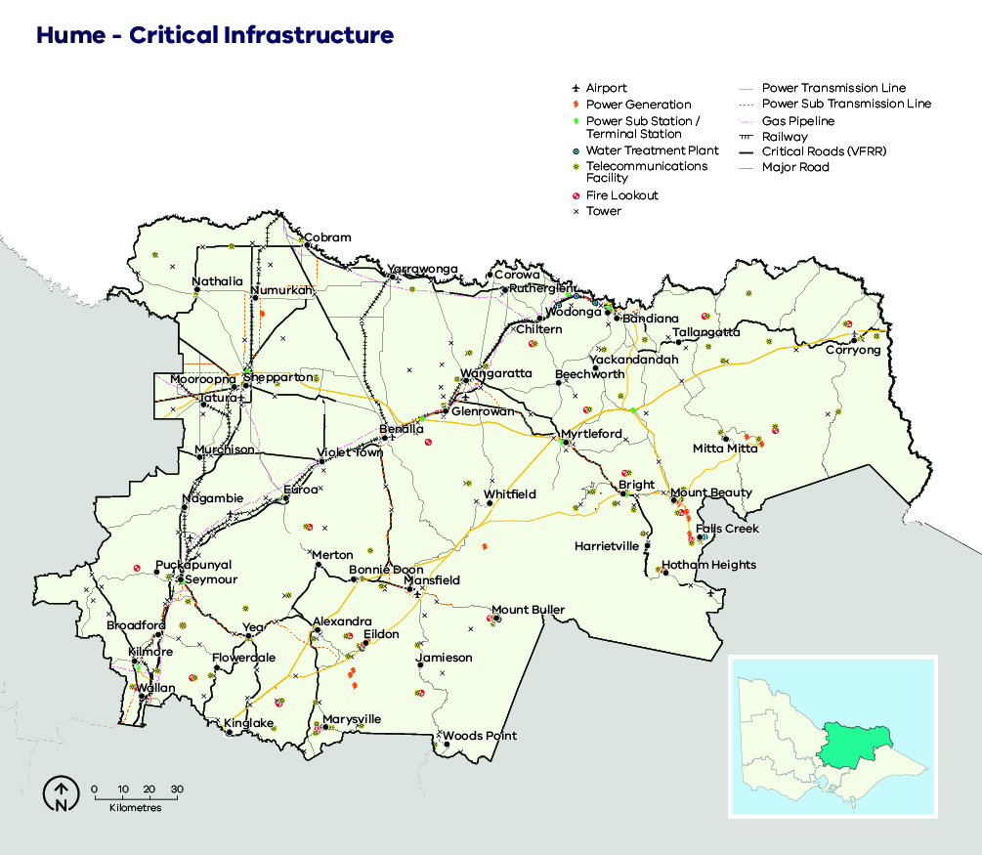

Regional economy
The Hume region is extremely varied in its industry and employment make-up, with a strong concentration of agricultural industries in the west, and the Alpine wine and gourmet food areas in the east making a strong contribution to regional employment. Tourism is an important industry for the region, particularly in and around the Alpine resorts and along the Murray River. The region is also home to large forestry operations, with Alpine and Mountain Ash timber currently harvested from state forests, and soft and hardwood sourced from managed plantations. The region’s forested areas also support a significant apiary industry. The region is the main gateway to Sydney from Melbourne, with Wodonga a major ‘twin-city’ border community (Figure 5).
Figure 5: Generalised land use in the Hume region
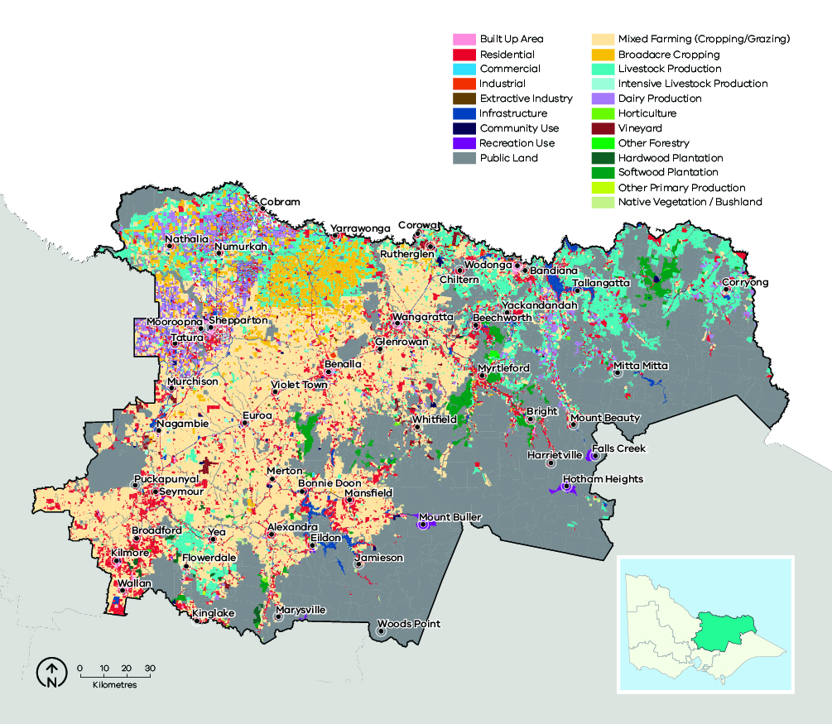

Historic heritage
Our region’s non-Indigenous history dates back to the 1820s when cattlemen across the Central highland and High country built their rough huts, some of which still stand. In the early 1850s, people (many from China) flocked to the region — particularly to the Alpine valleys, the High Country and the Chiltern and Rutherglen areas — to look for gold. Many heritage sites remain from this period including gravesites, mining relics and diggings. European settlers first inhabited the forested hills on the northern fringes of Melbourne in the 1860s, followed closely by paling splitters and then timber cutters who camped deep in the bush. Our region also includes many relics from these periods including bush huts, sawmills, sawdust heaps, tramways and timber trestle bridges.

Aboriginal cultural heritage
Our region’s history stretches back thousands of generations and includes the use of fire by Aboriginal people for environmental, economic and social purposes. Our region has thousands of Aboriginal cultural heritage sites including ceremonial gathering places, shell middens, burial sites, scar trees, artefact scatters, stone quarries, rock shelters and art sites. We work with cultural heritage specialists, Aboriginal Victoria and Traditional Owners to manage and protect these important sites.
The Hume region is home to three formally recognised Aboriginal Traditional Owner groups; the boundaries of a fourth Traditional Owner group — the Gunaikurnai Land and Waters Aboriginal Corporation — abut a small area of the region in the Alpine area. The Registered Aboriginal parties (Traditional Owners) across our area are Taungurung Land and Waters Council, the Yorta Yorta Nation Aboriginal Corporation and Wurundjeri Woi Wurrung Cultural Heritage Aboriginal Corporation (Figure 6).
Figure 6: Traditional Owner groups in the Hume region
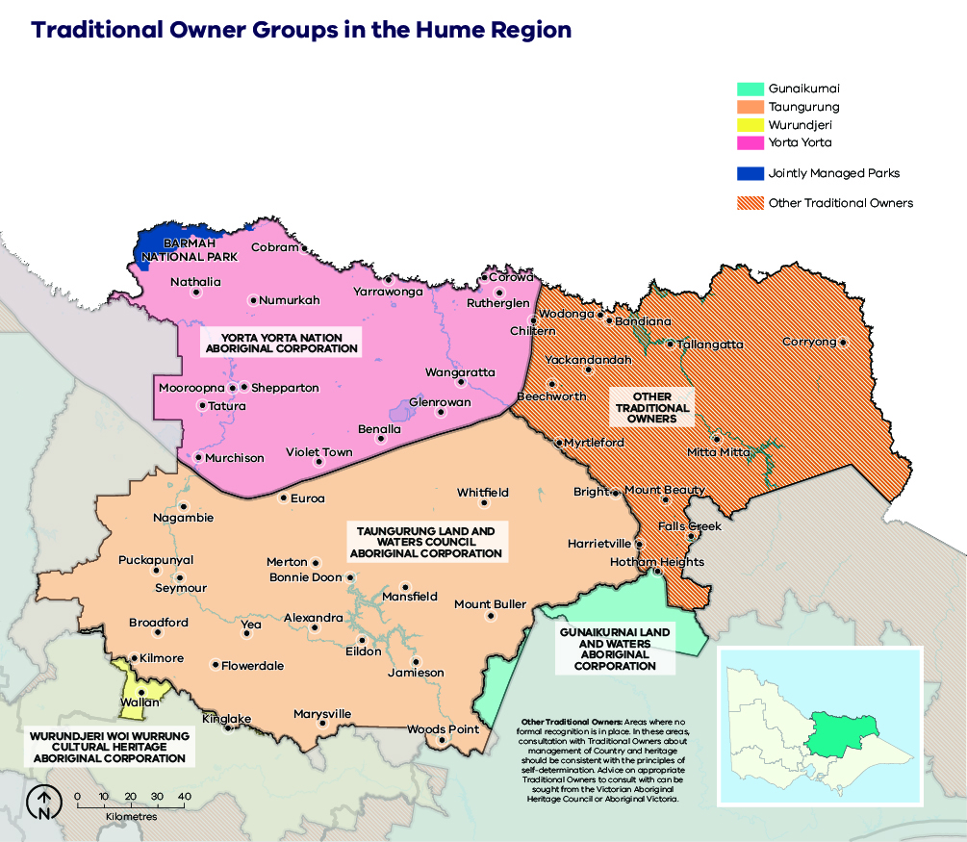
Note: the remainder of Eastern Maar’s RAP application is still being considered and may in future include additional area in the landscape.

Natural landscape
Hume region’s 1.65 million ha public land estate is comprised of a network of parks and reserves and state forest, which is built upon the national criteria for a comprehensive, adequate and representative (CAR) reserve system of Australia’s forests (Figure 7). Parks and reserves are primarily managed for nature conservation, ecosystem services and recreation. State forest is managed for a greater diversity of purposes including biodiversity conservation, water catchment services, timber harvesting, firewood production, cattle grazing, minor produce and apiary use. Recreation and tourism are also important and increasingly popular uses of state forest, with many active and passive pursuits commonplace across the region. Alpine resorts are also key areas of public land in the region and are important areas for tourism, recreation and biodiversity conservation.
Vegetation communities change dramatically from west to east across the region, following a distinct rainfall and elevation gradient. In the west, there are floodplains of grasslands and woodlands; the landscape then becomes undulating and foothill forest; in the east are tall, wet montane forests, with snow gum woodlands and grassy alpine meadows on the higher mountain ranges. Several of these vegetation communities are sensitive to fire regimes, and along with several flora and fauna species are listed under the Flora and Fauna Guarantee Act 1988 and the Environment Protection and Biodiversity Conservation Act 1999. The flatter part of the region in the west has been more extensively cleared for agriculture and settlements, compared to the east, which remains largely forested. Several river valleys run in a north-west-to-south-east direction, the most significant of which are the Mitta Mitta, Kiewa, Ovens, King, Broken and Goulburn valleys.
Figure 7: Native vegetation by land tenure in the Hume region
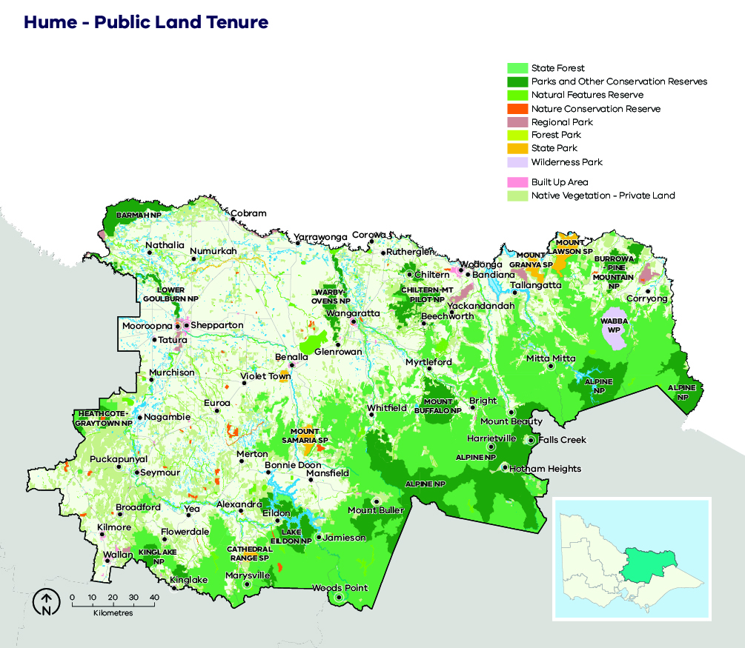

Case study: Managing natural values in Hume; Bogong High Plains
The Bogong High Plains is the most extensive tract of alpine and sub-alpine vegetation in Victoria. It is habitat for threatened reptiles, amphibians, fish, mammals (including the Mountain Pygmy-possum) and home to many threatened species that are only found in restricted areas.
The endangered Mountain Pygmy-possum is protected at a National and State level. They are restricted to alpine and subalpine areas in south-eastern Australia, including fragmented populations in the Bogong High Plains, where habitat includes high elevation boulder fields with associated shrubby heathlands, typically above 1200m. These heathlands are vulnerable to bushfire and planned burning, with other major threats to the species including the isolation and fragmentation of these populations, introduced predators and climate change (which is predicted to increase bushfires). Careful planning is required during suppression activities and planned burning in these area to avoid any negative impacts of fire to Mountain Pygmy-possums and their habitat.
Alpine Sphagnum Bogs and Associated Fens (Alpine Peatlands) are listed as endangered and are protected at a National and State level. Alpine Peatlands are highly sensitive to disturbances such as fire and are slow to recover. They contribute to plant and animal diversity and provide significant benefits to the environment: storing carbon and filtering out sediments, nutrients and pathogens from water. In addition, bogs add organic carbon to water which underpins the food chain in mountain streams.
In Hume and Gippsland regions, DELWP and PV partnered with other States and agencies to improve management of 4086 ha of Alpine Peatlands in Eastern Victoria, aiming to reduce the impacts of fire and fire control activities by informing fuel management planning (such as fire management zones and planned burn frequency) and using better fire response techniques near Alpine Peatlands during bushfire response. This includes detailed mapping of Alpine Peatlands that can be used to inform management decisions, for example keeping use of bulldozers and fire retardants away from peatlands, or directing water drops to protect them from fire.

Our objectives
What matters most in the Hume region is discussed in the landscape context section and is summarised into the following fundamental values:
- human life, health and relationships
- critical infrastructure
- environmental values
These values are the ultimate, durable reasons why we care about managing bushfires, and they are what we want to protect and manage through bushfire management in the Hume region.
From our combined fire experience, our research, our conversations with experienced agency representatives, our interagency working groups, our stakeholder meetings, our community groups meetings and our community surveys, we focused on the following regional objectives:
- Minimise loss of human life from bushfires
- Minimise smoke impacts from bushfires
- Minimise disruption by bushfires on critical infrastructure
- Minimise impacts of bushfires on water catchments
- Minimise impacts of bushfires on threatened species and fire-sensitive flora, fauna and vegetation communities
- Minimise declines in the persistence of ecosystems.
The following examples describe the importance of these objectives. Fire causes damage and disruption to the systems that underpin our social functioning and our businesses. Planning to protect these elements from disruption, and restore them after disruption, is essential to minimising the impacts of bushfire events. For example, our region includes nationally and regionally important infrastructure which can be directly damaged by fire, as can the networks (including power, water, transport and communications networks), causing short- and medium-term disruption to community functioning to essential services, to emergency response capability and to business and industry continuity and recovery.
From our experience of past and recent seasons, we know that long periods of bushfire smoke affect community health and well-being, disrupt tourism, disrupt regional aircraft travel and affect aerial fire response capability. They can also cause grape crops to become smoke-tainted, harming our local wine industry.
There is a wide range of ecosystems found throughout the Hume region, with a variety of fire responses, and includes vegetation communities which are threatened at State and National levels. Hume is also home to a high diversity of flora and fauna species, many of which are also considered to be threatened. Many of these threatened vegetation communities and species are also fire-sensitive, thus making it essential to be considered in fuel management planning and bushfire response, to minimise further decline. For example, the threatened Spotted Tree Frog is found in discrete populations in mountain streams in Hume. It is sensitive to fire because fire can increase sediment inflows causing water turbidity and can damage or destroy its streamside habitat.
Our water catchments are nationally important, supplying 40% of the inflows into the Murray-Darling system. Impacts to water catchments cause impacts to the water assets, to our environment through habitat loss and degradation, to our water quality from increased sediment and runoff, and also to our important forested catchments. In particular, the impacts to our fire-sensitive ash forests causes impacts to our water quality, and also the water quantity over time with large areas of thirsty young ash forest stands regrowing.
The following regional objectives are derived from our values and articulate what we are aiming to achieve in the Hume region (Table 2). These objectives contribute to the overall objectives for fire management articulated in the Hume Regional Strategic Fire Management Plan.
Table 2: Hume region’s values and objectives and how they align with the statewide vision, policy context and strategic objectives
Vision
Safer and more resilient communities
Policy context
The Victorian Preparedness Goal is A safer and more resilient community that has the capabilities to withstand, plan for, respond to and recover from emergencies that pose the greatest risk.
The Safer Together policy’s four priorities for reducing the risk of bushfires in Victoria are Community first, Land and fire agencies working together, Measuring success and Better knowledge = better decisions.
Strategic objectives (Code of Practice for Bushfire Management on Public Land)
To minimise the impact of major bushfires on human life, communities, essential and community infrastructure, industries, the economy and the environment. Human life will be afforded priority over all other considerations.
To maintain or improve the resilience of natural ecosystems and their ability to deliver services such as biodiversity, water, carbon storage and forest products.
Hume region values
Human life, health and relationships |  | Critical  infrastructure |  | Environmental  values
Hume region objectives
Minimise loss of human life from bushfires | Minimise smoke impacts from bushfires | Minimise disruption by bushfires on critical infrastructure | Minimise impacts of bushfires on water catchments | Minimise impacts of bushfires on threatened species and fire-sensitive flora, fauna and vegetation communities | Minimise declines in the persistence of ecosystems

Our risk management approach
In hot, dry and windy conditions, a bushfire can travel quickly across a large area of our landscape. To effectively understand bushfire risk, we simulate many bushfires across the entire landscape to determine where bushfires are likely to start, spread and cause damage to values and assets, with a particular focus on people and communities. We can then reduce fuel hazard across the spread paths of these simulated bushfires with the intention of reducing the spread and intensity of these fires and ultimately limiting their impacts.

Bushfire Risk in Hume Region
Figure 8 shows the risk of house loss in the Hume region. It compares where houses could be destroyed by bushfire across the region.
Different shades represent different levels of risk. As the shades progress from yellow through red to purple, more and more houses are potentially destroyed. The purple areas represent the top 5% of risk in the Hume region. More houses could potentially be destroyed in these areas than any other.
While bushfire risk exists across the entire landscape and house loss can and will occur in other areas, this map shows where the greatest 70% of house loss risk sits within our region.
Bushfire simulations generated by Phoenix RapidFire illustrate risk by showing where significant impacts on houses may occur. Simulations are undertaken using a range of different weather conditions, likelihood of FDI at ignition, maximum fuel loads and limited bushfire suppression.
This helps us plan where, how often and how much fuel management we do to reduce risks to communities over years, or even decades.
This map does not reflect any recent bushfires or activities that could change the risk in the region. Importantly, this map shows where there is potential to destroy more houses compared to other parts of the region. It does not show risk to individual houses.

Higher risk areas in Hume
In Hume, communities with relatively high numbers of properties, which are also in the path of many simulated bushfires and/or identified in the VFRR-b are considered as highest risk. Property risk is highest around the communities in the valleys and surrounding hilly terrain in the Murrindindi, Alpine, Indigo and Mansfield shires. Some examples of particular higher risk localities include Marysville, Kinglake, Flowerdale, Yackandandah, Bright, Mount Beauty/Tawonga, Jamieson, Sawmill Settlement / Merrijig, and Tolmie. The communities in these localities are in the paths of multiple simulated bushfires with the greatest level of potential impact. They are vulnerable to bushfires starting at a variety of locations, and bushfires under worst-case weather conditions could result in the most properties lost.
An example of a community with higher bushfire risk is Tolmie, which is surrounded by hilly forest. Although the area was impacted by the 2006/07 fires, the undergrowth has recovered strongly and fire history and prediction modelling tells us that fires reaching Tolmie, particularly those travelling from the north and west toward the township, may cause many house losses.

Lower risk areas in Hume
On the grassland plains, wind driven fires can be fast moving and impact large areas, threatening people and property. While they are serious fires, they are usually controlled within 24 hours of ignition. Benalla is a community surrounded mostly by farms on grassy plains and open woodland, not forest. While grass fuels burn quickly, house loss from grass fires is less likely than from forest fires. Grass fires are not as hot and cause less embers. Fire history and prediction modelling tells us that communities in these areas would experience less house losses, although their impacts can be still be significant. In 1952 a bushfire ignited near Benalla close to the Hume Highway burnt more than 100,000ha and several lives were lost.
Figure 8: Bushfire risk within the Hume region. This map only considers modelled house loss within the Hume region and so risk shown on this map can only be compared within this region.
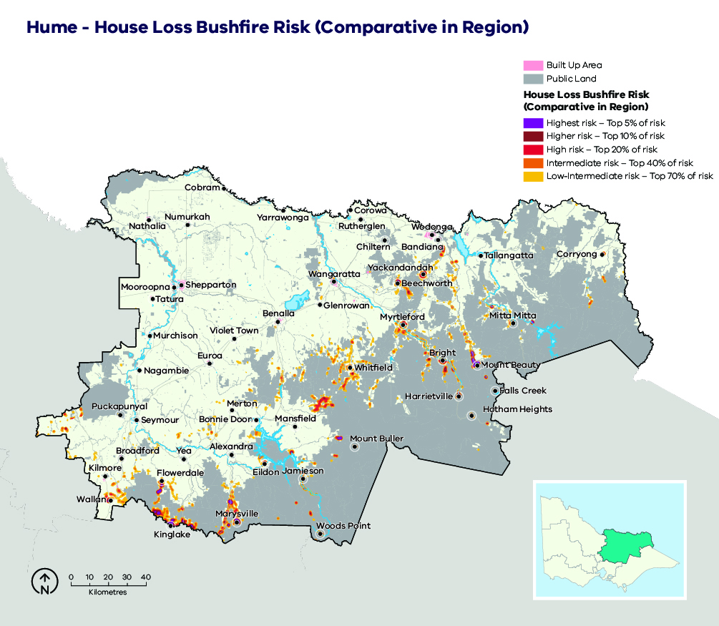

Why model house loss?
Human lives are given priority over all other considerations, however we cannot know where exactly people will be in the event of a bushfire. Simulations of house loss help to identify areas across our landscape where bushfires could have the greatest potential impacts on lives, as well as on other things we value such as our homes themselves, livelihoods and communities. This also reflects the importance of homes as a primary place of shelter and residence. The simulated house loss shown in Figure 8 indicates where these areas are and the possible scale of bushfire impacts relative to other parts of our region. We consider these impacts when developing fuel management strategies for the values and objectives in our region. We can model how our strategies improve the outcomes by reducing bushfire risk to people’s homes, and the social values connected with them. House loss informs one of our key metrics — ‘residual risk’— by which we assess the effectiveness of our fuel management strategies. The residual risk metric is explained in more detail below.

How do we model house loss?
We compare the characteristics of bushfires that are simulated in Phoenix RapidFire with those that led to actual house loss in historic bushfires. Our model assumes houses (based on address points) are destroyed by a simulated bushfire if the modelled fire intensity exceeds 10,000 kilowatts per metre (generally a crown fire) or if ember density exceeds 2.5 embers per square metre. Research indicates that bushfire embers account for the majority of houses lost, with most occurring within 1 km of the edge of forested areas and native vegetation (although house loss still occurs beyond this distance). This is consistent with our modelling which shows similar patterns of house loss. Other fire behaviour factors can have a strong influence on house loss (such as convective strength of the fire), and they are being further researched to understand this risk.
We estimate the magnitude of property impacts by analysing how many houses are modelled as destroyed under all of our simulated bushfires. We can compare between communities to understand which are more likely to suffer large numbers of houses lost.
It is important to note that the modelled property impact is only a coarse estimate and should not be applied at the individual house level. The vulnerability of a house also depends on other factors: its building materials, design and maintenance, how close it is to combustible elements, the presence of human intervention (before, during and after a fire) and the environment in which a bushfire occurs. These factors cannot all be modelled in landscape scale simulations. However, over time they can be included in statistical models, to improve estimates of potential house loss.

Our fuel management strategy
Our fuel management strategy describes our approach to balance the threats posed by bushfire to our most important values and assets, with managing fire to enhance the health and resilience of ecosystems. It responds to Hume region’s unique bushfire risk profile, determined through our risk assessment process.

Fire Management Zones
The fuel management strategy is presented as an arrangement of different Fire Management Zones (FMZ) on public land, as described in the Code of Practice for Bushfire Management on Public Land (2012). There are four zones – Asset Protection Zone (APZ), Bushfire Moderation Zone (BMZ), Landscape Management Zone (LMZ) and Planned Burning Exclusion Zone (PBEZ). Although the name of the zone indicates the primary purpose of that zone, it is recognised that multiple goals can be achieved when undertaking activities in each zone. For example, a burn undertaken primarily for land management purposes may also have asset protection outcomes. The configuration of fire management zone placement, and the frequency of fuel management within them is optimised across space and time, to deliver bushfire risk reduction to the identified values across the landscape for the life of the strategy (30–40 years).
Bushfire risk mitigation outcomes are the primary purpose of Asset Protection Zones. Ecological outcomes are still considered, but the protection of life and property is the priority for the management of these zones. This emphasis gradually shifts through the Bushfire Moderation Zone and the Landscape Management Zone, such that the Planned Burning Exclusion Zone’s primary focus is ecological outcomes. It is important to note that although the Bushfire Moderation Zone has a stronger bushfire risk mitigation focus than the Landscape Management Zone, there is still a focus on risk mitigation in the Landscape Management Zone. Fuel management is often scheduled in the Landscape Management Zone to complement that which has been undertaken in the Bushfire Moderation Zone and the Asset Protection Zone and enhance the risk reduction that can be achieved across the whole landscape. Fuel management in the Landscape Management Zone may be rotated through adjacent areas over the lifetime of the strategy, or burns may be undertaken over a broader area with lower coverage, to reduce the ecological impacts. Fuel management in LMZ is sometime undertaken to reduce risk of fire to more sensitive areas such as those in PBEZ.
In some areas, communities may see fuel management works occurring in nearby forest most years. This may be because we are delivering a multi-year planned burn, where some fuel types or areas of the burn are targeted in one year, and a different fuel type or area targeted the next year. It may be because we are burning in adjacent blocks to those previously treated, to ensure the highest level of protection to the town. If we undertake mechanical treatments such as slashing in an area, fuels often re-accumulate quickly and treatments need to be repeated.
The aims of each zone, how they have been placed and how they will be implemented in Hume region is described further in Table 2.
The FMZ configuration for public land in the Hume region is shown in Figure 9.
Figure 9: Fire Management Zones for public land in the Hume region. This zoning configuration was developed through risk assessment processes and in consultation with key delivery partners.
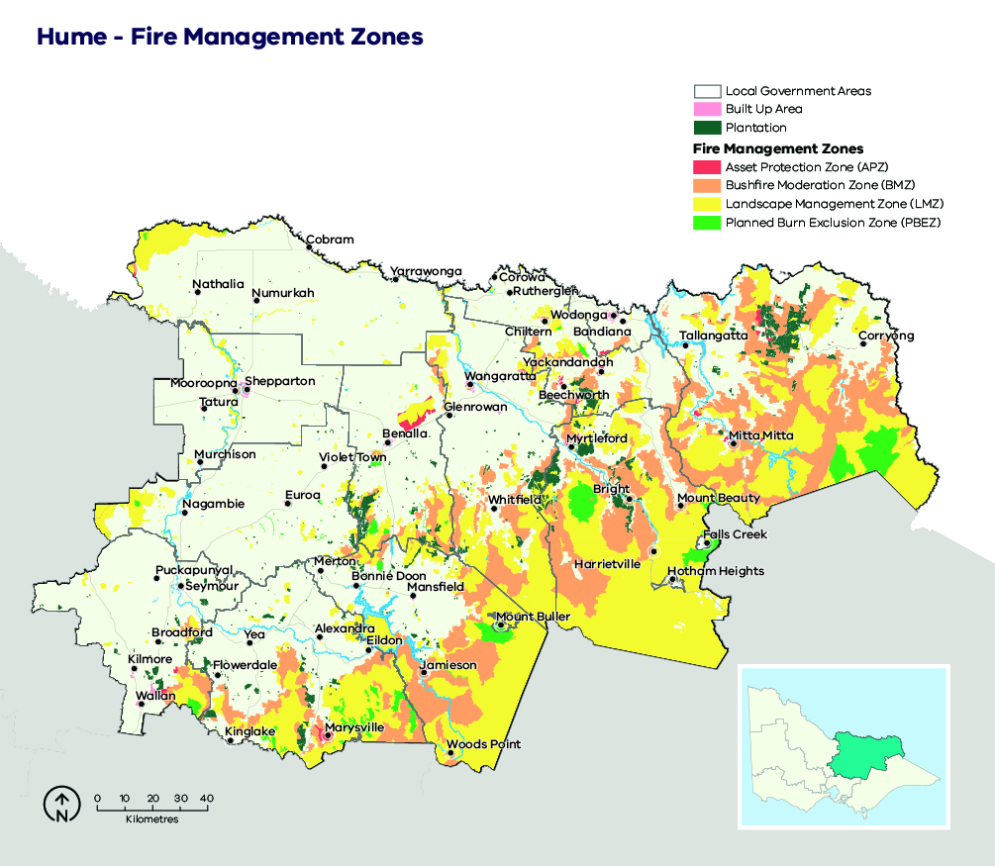
Table 3: Description of the aims, placement, planned fire intervals and typical outcomes of fire management zones for public land in the Hume region. This is a description of typical features of these four zones, consistent with the aims of the zones in the Code of Practice for Bushfire Management on Public Land (2012).
 | Asset Protection Zone (APZ) | Bushfire Moderation Zone (BMZ) | Landscape Management Zone (LMZ) | Planned Burning Exclusion Zone (PBEZ)
Aim | Provide the highest level of localised protection to human life and property and key community assets.  Provide localised protection to human life, property and key assets. | Maintain fuel-reduced corridors, reducing the speed and intensity of bushfires. Achieve ecologically-desirable outcomes where possible. | Reduce overall bushfire hazard at the landscape scale; support ecological resilience and land-management objectives.  Manage land for particular values (forest regeneration and protection of water catchments). | Exclusion of planned burning from areas primarily intolerant to fire.
Typical placement | Where most effective to reduce overall bushfire risk: typically, smaller burn units on the public/private interface. | Near public/private interface or key assets (a range of values) or strategic placement in fire spread paths to reduce the spread of large fires and increase our ability to suppress fires. | Rest of landscape not covered by APZ, BMZ or PBEZ.  Typically, areas of lower community fire risk. Does include areas of high ecological value. | Burn units wholly or largely covered by vegetation communities less tolerant of fire.
Typical planned fire interval | 5 to 10 years. | 8 to 15 years. | Varies depending on land-management and fire-management objectives. | Not applicable.
 | These intervals are indicative only to help provide an understanding of time between planned fire in each zone. Planned fire intervals for each zone are determined by fuel hazard (type, size, arrangement and quantity) triggers to achieve fuel treatment outcomes in each zone. Actual planned fire intervals may be more or less frequent depending on previous fire severity and coverage, vegetation type, climatic and seasonal conditions and actual rate of fuel re-accumulation. It is also important to note that some burns are conducted in multiple stages and sequenced with other burns in the landscape to form a landscape mosaic, meaning that planned burning operations can occur in the same area over successive years. Some areas, especially in APZ, are treated with mechanical treatments which may occur more frequently.
Fuel treatment goal | Reduce radiant heat and ember attack. | Complement APZ goals and reduce bushfire spotting.  Increase ability to suppress fires. | Reduce treatable fuels to reduce fire spread and impacts on landscape values and achieve ecologically beneficial fire intervals. | Not applicable.
Typical fuel treatment outcomes | Intensive treatment; 80-100% burn cover, with reduction of bark fuel hazard a priority.  In some cases, mechanical treatment as alternative or complementary. | Moderately intense treatment, seeking significant reductions in fuel hazard over a majority of treatable fuels within the burn unit. Coverage targets typically 50–70%. | Varies depending on land-management and fire-management objectives.  Generally, involves burning at low intensity, e.g. less than 50% burn cover. | No planned fire.

Ecosystem resilience
An ecosystem’s resilience is its capacity to withstand and recover from a range of disturbances, including fire. We cannot measure ecosystem resilience by looking at a single species or fire event: we must look at the whole landscape, and at multiple fires with various frequencies, intensities, scales and seasons of burning. Tolerable fire intervals (TFIs) are the minimum and maximum recommended times between fire events for a particular ecological fire group. Burning regularly outside these intervals increases the risk that there will be fundamental changes in the abundance and composition of species, and the type of vegetation. Growth stage structures (GSS) describe the mix of habitats available across a particular landscape or vegetation type.
In our fuel management strategy, TFI has been used as a tool to guide where burning can occur that has the least amount of impact on a vegetation community. The strategy aims to minimise the total area burnt below minimum TFI because fire can affect overall ecosystem resilience if it occurs too frequently. However, planned burning may be conducted in some areas below minimum TFI to reduce bushfire risk to life, property and important ecosystems.
Larger and more intensive bushfires have a significant impact on ecosystem resilience. Planned burning may also be conducted below minimum TFI to reduce the size, severity and frequency of large bushfires. There will be instances in the footprints of past large bushfires where fuels re-accumulate and become flammable before ecological maturity is reached. Fire is also reintroduced in these areas below minimum TFI to prevent large bushfires reoccurring, which can be more likely due to fuels loads being the same across a broad scale area. Burning below minimum TFI will have shorter term or localised impacts on vegetation communities, however we also need to compare this with how they would be impacted should a major bushfire occur.
We recognise that TFI is a broad measure of ecosystem resilience and there are finer-scale vegetation responses to differing severity of planned burning and bushfires, however it can help us with regional-scale planning.
We are continuing to improve our understanding of TFIs by monitoring the responses of different species of vegetation to differing fire severity, and by investing in research that improves our ability to predict these responses. We are also improving the TFI mapping by using species distribution models for key flora species on which minimum TFIs are based. This enables TFIs to be mapped more accurately.

About our fuel management strategy
Hume’s fuel management strategy utilises FMZs, which manage our values with respect to how much and how often fuel management occurs in the landscape, to determine our region’s residual risk.
Key principles are to:
- focus fuel management activities within Asset Protection Zone (APZ) and Bushfire Moderation Zone (BMZ), where fuel hazards are reduced to an acceptable level whilst protecting ecological assets where possible, and to select fuel management regimes that meet the target reduction in risk to life and property, reduce risk of large fires to other important values (such as water catchments) and minimise the negative impact on ecosystem resilience
- undertake fuel management activities within Landscape Management Zone (LMZ) where there is a clear bushfire risk reduction objective or ecological outcome, otherwise minimise fuel management activities within LMZ to reduce negative impacts on ecosystem resilience
- avoid fuel management within high value ecological areas (HVEAs), particularly within LMZ
- plan fuel management with consideration to the tolerable fire intervals of the region’s key vegetation types
- improve towards the goal distribution of vegetation growth stages including the maintenance of older growth stages
- reduce the size of bushfires as much as possible through rapid suppression and maintenance of a network of fuel-reduced areas (such as strategically placed BMZ and LMZ areas, which are managed together to reduce risk across the landscape, for example, interconnecting ridgelines in remote areas) and an annual schedule of maintenance of strategic fire access roads, water points, helipads and other fire response infrastructure in the landscape.

Case study: How we use fire management zones; an example around Jamieson
We place APZ in key areas around Jamieson to provide areas of reduced fuel to assist in township protection from radiant heat and ember attack in the event of a bushfire.
Along the western side of the Goulburn River valley, we place a corridor of BMZ to reduce the spread and intensity of fires to assets and properties along the valley between Jamieson and Woods Point.
We place BMZ corridors extending further southward, which also link into other regions. These corridors aim to break up the spread of larger fires across the mountainous, forested landscape with areas of reduced fuel loads, which support bushfire suppression efforts by allowing safer access for fire crews and increase opportunities to safely conduct back burns.
We place LMZ in areas further from communities, where fuel management can reduce overall fuel and bushfire hazard in the landscape. Maintaining ecosystem resilience is equally important, and we apply fire regimes that protect ecosystem values (for example, old-growth vegetation that provides critical habitat for Greater Glider and Powerful Owl).
In PBEZ, we aim to avoid planned burning, mainly because the vegetation cannot tolerate fire or because of other fire-sensitive values (such as riparian habitat for Spotted Tree Frog).
Figure 10: Fire management zone placement around Jamieson
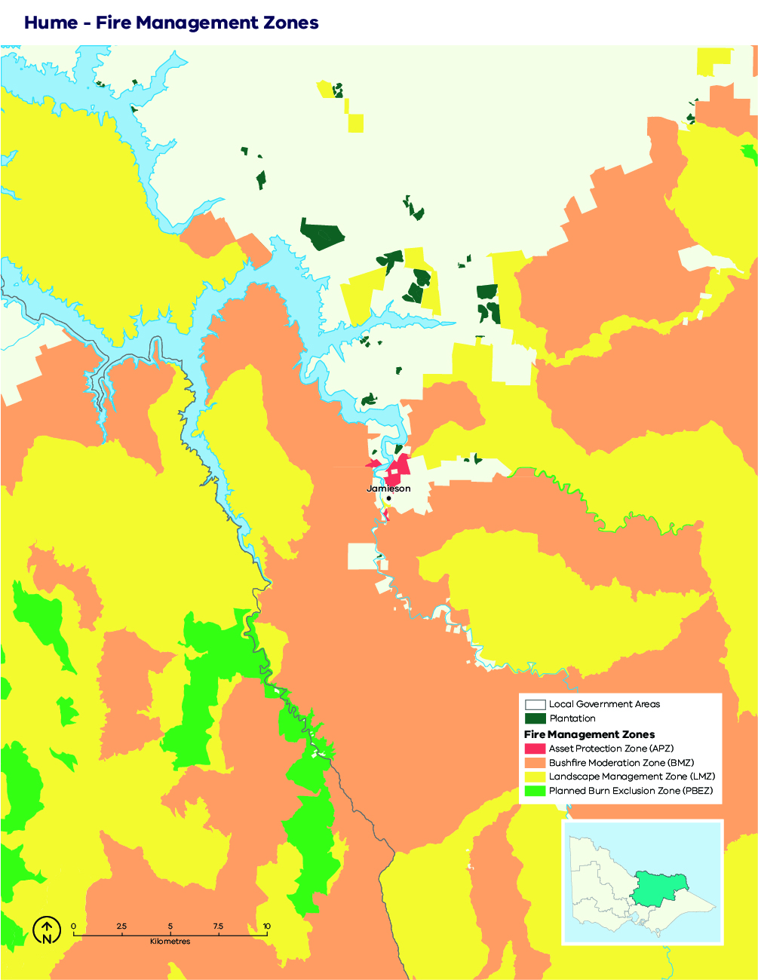

Victoria’s residual risk
We measure the impact of the fuel management on reducing bushfire risk. This measure is called ‘residual risk’. Residual risk is calculated as the percentage of bushfire risk ‘left over’ after fuel in forests has been reduced, either through fuel management activities or bushfires.
Our statewide fuel management target is to keep residual risk at or below 70% of Victoria’s potential maximum bushfire risk. Maximum bushfire risk refers to maximum fuel conditions and extreme bushfire conditions (Forest Fire Danger Index of 130). In practice however, the residual risk is different in different parts of the landscape, due to differences in vegetation, topography and where houses are located. Our fuel management strategy, together with the strategies of all regions of Victoria, contributes to achieving the statewide target.
To measure residual risk, we first use the Phoenix RapidFire bushfire simulation software to simulate thousands of bushfires across Victoria under conditions of highest fuel in the landscape and worst-case bushfire weather conditions. We calculate the impacts on houses, based on these simulations, and this is the maximum residual risk. We then simulate a second set of bushfires where we have changed the fuels in the landscape, to allow us to compare the two scenarios and estimate the reduced impact. When measuring current or past residual risk, we include bushfires and planned burns that have occurred to reduce the fuels in the landscape. When we are testing strategies, we model different arrangements of planned burning that might occur by implementing our strategy, for 40 years into the future.
Using Phoenix, we have forecast the performance of our preferred fuel management strategy together with other regions in Victoria. Figure 11 shows changes in residual risk from 1980 to 2060, with the residual risk values beyond 2020 representing the forecasted measurement.
Our fuel management program takes us some of the way to managing bushfire risk, however we also manage bushfire risk through other prevention, preparedness and response activities. As yet, we are unable to model the impacts of our other bushfire management actions beyond planned burning in our residual risk metric, including mechanical treatments. We are working to be able to include these and other improvements to the metric in the future.
Figure 11: Statewide residual risk
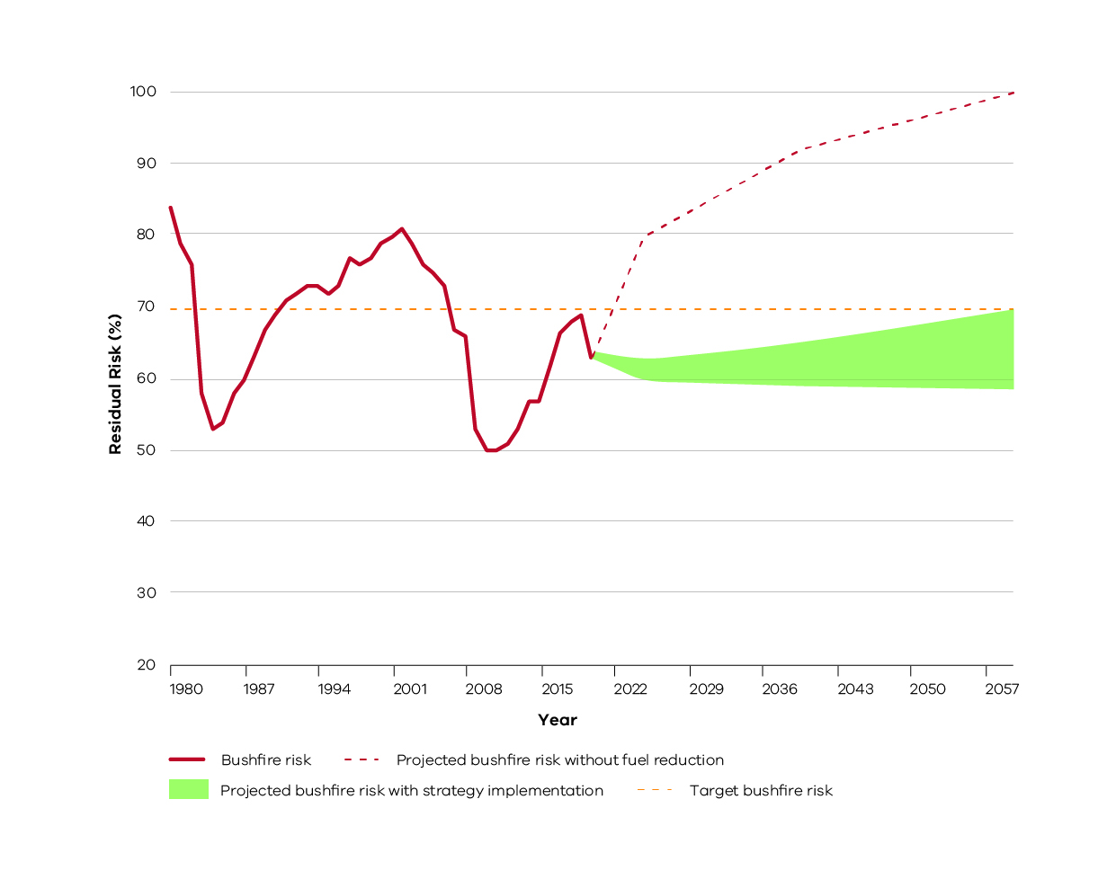
Historic and projected future bushfire risk for Victoria. The orange dotted line is the statewide bushfire risk target (70%). The red line represents historical bushfire risk due to past bushfires and planned burning. The green shaded area is the projected bushfire risk for the fuel management strategies of all Victorian regions collectively, measured from 2021 to 2060. This represents that there is a range of possible future residual risk values which is dependent on the amount of fuel reduction achieved each year in our region and across Victoria. The red dotted line represents projected increase in bushfire risk without fuel reduction.

Bushfire Risk Engagement Areas
As part of the 2017-2019 strategic bushfire management planning process, land and fire management agencies have undertaken an analysis to define Bushfire Risk Engagement Areas (BREAs). BREAs identify parts of the landscape where managing bushfire fuels is most effective in reducing risk. This helps to indicate the priority areas in our region where we can work with communities to reduce bushfire fuels.
BREAs also help land and fire management agencies, local government and stakeholders to focus conversations about the range of treatment options available to reduce bushfire risk. This may include other actions where reducing fuels may not be possible. Over time, on-ground discussions and assessments between agencies and the community will determine the treatments that best suit a particular place.
Managing fuels on private and public land begins with a conversation about the benefits, limitations and viability of fuel reduction in a BREA. Complementary or alternative treatments will arise from these discussions. We will work with the community to explore risk treatment options for private land and, where suitable, apply them to complement public land fuel management described in our fuel management strategy. By working together in this way, we will maximise the impact of our collective risk-reduction effort.
It is important to note that BREAs are not legislated planning zones and do not obligate landowners or land and fire agencies to take any action. They cover large areas of public and private land, their boundaries do not align to administrative or cadastral boundaries, and are not linked to individual parcels of freehold land.
The Hume region’s BREAs are shown in Figure 12.
Figure 12: Bushfire Risk Engagement Areas in the Hume region
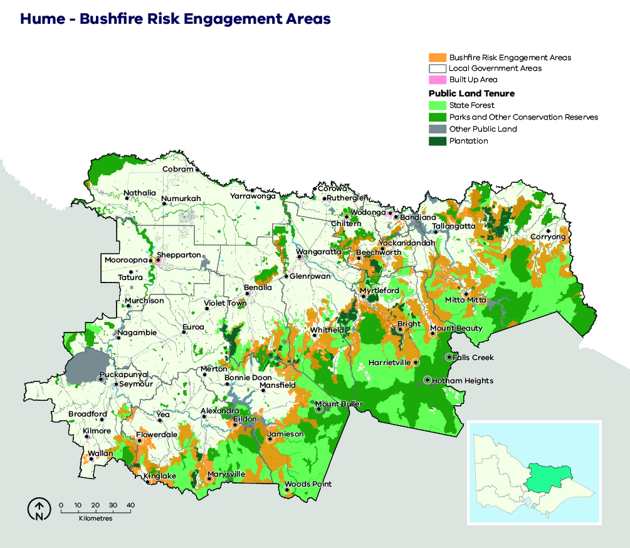

Implementation
Implementation of this bushfire management strategy will occur through the Joint Fuel Management Program (JFMP) prepared by FFMVic and CFA, as well as a range of agency-specific operational plans.
The fuel management strategy described here directly informs the development of the JFMP, and it is through the implementation of this program that bushfire risk in Hume region will be maintained in line with the state residual risk target, in a manner which balances outcomes for multiple values.
The risk mapping and analysis methodology will inform other fire management strategies including readiness and response operations planning, particularly where fuel management is not achieveable.
Fuel management on private land, where appropriate and with landholder permission, will form part of the overall JFMP and will reduce bushfire risk in Hume region even further.
The JFMP prepared by FFMVic and CFA is also informed by the Victorian Traditional Owner Cultural Fire Strategy.
Our bushfire management strategy can also help inform actions in municipal fire management plans.
The implementation of Bushfire Risk Engagement Areas will be undertaken by all agencies working together with the community. BREAs assist agencies to plan where to engage with communities about fuel management where it is most effective to reduce bushfire risk or explore alternative options to reduce that risk.
Figure 13: Schematic representation of the strategy’s influence on implementation programs and plans
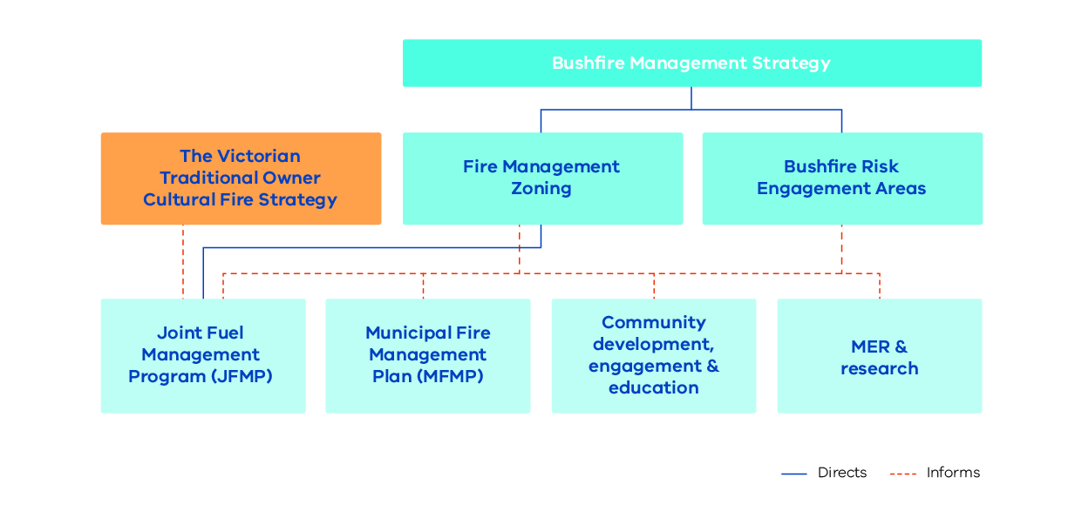

Monitoring, evaluation and reporting
Regional monitoring, evaluation and reporting (MER) enables us to measure how our strategies and actions are performing against the regional objectives set out in this bushfire management strategy. This is achieved by developing key evaluation questions that we will use to measure success against our objectives and enable reporting and improvements. The MER process ensures transparency and supports adaptation of management practices to achieve improved outcome from bushfire management to our important values. Key evaluation questions and the process for addressing them will be developed in MER plans by individual agencies.
A MER plan can also identify key knowledge gaps and prioritise research and monitoring activities to address them. MER plans ultimately improve risk-based planning and decision-making, helping to guide future resource and funding allocation.
Individual agencies will be responsible for the MER of their own work programs and the activities that they deliver. The spirit of collaboration will continue between agencies, such as identifying and addressing knowledge gaps that cross tenure boundaries.
FFMVic’s MER program is guided by the Monitoring, Evaluation and Reporting Framework for Bushfire Management on Public Land (MER Framework), which aims to assess how well management activities across Victoria are achieving the two objectives of the Code of Practice. Information on FFMVic’s annual fuel management monitoring and reporting can be found in Managing Victoria’s Bushfire Risk: Fuel Management Report.

Appendix 1: Program logic
Table 4: Hume Bushfire Management Strategy 2020 program logic
Vision | Safer and more resilient communities
Policy context | The Victorian Preparedness Goal is A safer and more resilient community that has the capabilities to withstand, plan for, respond to and recover from emergencies that pose the greatest risk.  The Safer Together policy’s four priorities for reducing the risk of bushfires in Victoria are Community first, Land and fire agencies working together, Measuring success and Better knowledge = better decisions.
Strategic objectives | Working together to effectively anticipate, respond and recover from major bushfire, to secure a safer region, a more resilient community, a healthier environment and a prosperous community (as per Hume Regional strategic fire management plan).  To minimise the impact of major bushfires on human life, communities, essential and community infrastructure, industries, the economy and the environment. Human life will be afforded priority over all other considerations  To maintain or improve the resilience of natural ecosystems and their ability to deliver services such as biodiversity, water, carbon storage and forest products
Hume region values | Human life, health and relationships | Critical infrastructure | Environmental values
Hume region objectives | - Minimise loss of human life from bushfires  - Minimise smoke impacts from bushfires | - Minimise disruption by bushfires on critical infrastructure  - Minimise impacts of bushfire on water catchments | - Minimise impacts of bushfire on threatened species and fire-sensitive flora, fauna and vegetation communities  - Minimise declines in the persistence of ecosystems
Outcomes | - Minimise house loss from bushfires  - Minimise areas burnt in large-scale bushfires producing intense and prolonged smoke | - Minimise impacts of bushfire on critical infrastructure: major roads, powerlines and communications networks  - Minimise areas of Ash forest burnt by intense bushfire and minimise impacts of bushfire on mass debris flow risk areas | - Minimise negative impacts from bushfire on high value ecological areas  - Minimise fuel management activities within high value ecological areas and areas below minimum tolerable fire interval
Assumptions | - Houses are a primary residence for people and are important to their livelihoods and recovery  - Large-scale bushfires cause intense, prolonged smoke that can impact tourism, vigneron industries and health | - Impacts to identified priority infrastructure disrupt supply or travel for more than 24 hours  - Ash and debris cause inflow contamination, asset and infrastructure damage, and reduce catchment inflows as burnt forests regrow | - High value ecological areas are an accurate representation of threatened species and fire-sensitive ecological assets in our landscape  - The current tolerable fire intervals are appropriate for maintaining ecosystem resilience

References
Aboriginal Victoria. (2019). Aboriginal Cultural Heritage Information System. Retrieved from Aboriginal Victoria: https://achris.vic.gov.au/#/onlinemap
Australian Institute for Disaster Resillience. (2015). National Emergency Risk Assessment Guidelines. Retrieved from Australian Institute for Disaster Resillience: https://knowledge.aidr.org.au/media/2030/handbook-10-national-emergency-risk-assessment-guidelines.pdf
Bushfire Cooperative Research Centre. (2010). Phoenix Rapid Fire. Retrieved from Bushfire Cooperative Research Centre: http://www.bushfirecrc.com/resources/poster/phoenix-rapidfire-%25E2%2580%2593-bushfire-simulator-and-risk-assessment-decision-support-tool
Country Fire Authority Victoria. (2019). Major Fires. Retrieved from Country Fire Authority: https://www.cfa.vic.gov.au/about/major-fires
Department of Environment Land Water and Planning. (2019). Barwon South West Technical Methods Reference Document. Geelong: Department of Environment Land Water and Planning.
Department of Environment Land Water and Planning. (2019). Black Friday. Retrieved from Forest Fire Management Victoria: https://www.ffm.vic.gov.au/history-and-incidents/black-friday-1939
Department of Environment Land Water and Planning. (2019). History and Incidents. Retrieved from Forest Fire Management Victoria: https://www.ffm.vic.gov.au/history-and-incidents/
Department of Environment, Land, Water and Planning. (2019). Hume Technical Methods Reference Document. Benalla: Department of Environment, Land, Water and Planning.
Department of Environment, Land, Water and Planning. (2019). Joint Fuel Management Program. Retrieved from Forest Fire Management Victoria: https://www.ffm.vic.gov.au/bushfire-fuel-and-risk-management/joint-fuel-management-program
Department of Environment, Land, Water & Planning (2015), Monitoring, Evaluation and Reporting Framework for Bushfire Management on Public Land. Retrieved from: https://www.ffm.vic.gov.au/__data/assets/pdf_file/0021/25734/BushfireMER_Framework_WEB.pdf
Department of Home Affairs. (2018). Deconstructing Disaster: The strategic case for developing an Australian Vulnerability Profile to enhance national preparedness - March 2017. National Resilience Taskforce. Australian Government.
Department of Sustainability and Environment. (2012). Code of Practice for Bushfire Management on Public Land. Retrieved from Forest Fire Management Victoria: https://www.ffm.vic.gov.au/__data/assets/pdf_file/0025/25747/Code-of-Practice-for-Bushfire-Management-on-Public-Land-1.pdf
Emergency Management Victoria. (2020). Victorian Fire Risk Register - Bushfire (VFRR - B). Retrieved from https://www.vfrr.vic.gov.au/
Forest Fire Management Victoria. (2020). Managing Victoria’s Bushfire Risk - Fuel Management Report 2018-19. Retrieved from https://www.ffm.vic.gov.au/fuel-management-report-2018-19.
Forest Fire Management Victoria. (2020). Managing Victoria’s Bushfire Risk - Fuel Management Report 2018-19. Retrieved from https://www.ffm.vic.gov.au/fuel-management-report-2018-19
Geelong Advertiser. (2019, July 29). Past major bush fires in Geelong. Retrieved from Geelong Advertiser: https://www.geelongaustralia.com.au/em/fires/article/item/8cb80c2c066782b.aspx
Hume Regional Strategic Fire Management Planning Committee. (2011). Hume Regional Strategic Fire Mangement Plan. Retrieved from Emergency Management Victoria: https://files-em.em.vic.gov.au/public/EMV-web/Hume-South-West-Regional-Strategic-Fire-Management-Plan.pdf
Hume Regional Strategic Fire Management Planning Committee, Terms of Reference. (2017). Hume Regional Strategic Fire Management Plan. Retrieved from Emergency Management Victoria: https://files-em.em.vic.gov.au/public/EMV-web/Hume-South-West-Regional-Strategic-Fire-Management-Plan.pdf
Inspector-General for Emergency Management (2020). Inquiry into the 2019–20 Victorian Fire Season - Phase 1 Summary Report: https://www.igem.vic.gov.au/fire-season-inquiry/inquiry-reports/inquiry-into-the-2019-20-victorian-fire-season-phase-1-summary
International Organisation for Standardisation. (2019). ISO 31000 RISK MANAGEMENT. Retrieved from ISO: https://www.iso.org/iso-31000-risk-management.html
Local Government Authority source information (2020), Regional Development Victoria. Retrieved from: https://www.rdv.vic.gov.au/victorias-regions/hume
Victorian Government. (2019). Legislation Victoria. Retrieved from Legislation Victoria: http://www.legislation.vic.gov.au
Victorian Government. (2020). Safer Together: Our approach to reducing the risk of bushfire in Victoria. Retrieved from https://www.safertogether.vic.gov.au/
Victorian Traditional Owner Cultural Fire Knowledge Group. (2018). Victorian Cultural Burning Strategy. Retrieved from Australian Institute for Disaster Resillience: https://knowledge.aidr.org.au/media/6817/fireplusstrategyplusfinal.pdf

Department of Home Affairs, 2018
During the consultation phases of this strategic planning process, these areas were called ‘Priority Fuel Management Areas’ (PFMAs). They have since been renamed to provide greater clarity as to their intended use. Feedback and comments received during the planning process from stakeholders and community members relating to PFMAs have been incorporated into designing the BREA strategy.

