Gippsland Bushfire Management Strategy 2020
  - Fuel management
  - Bushfire Risk Engagement Areas
  - Prevention of human-caused ignition strategy (pilot)
  - First-attack suppression strategy (pilot)

Acknowledgements
We acknowledge and respect Victoria’s Traditional Owners as the original custodians of the state’s land and waters, their unique ability to care for Country and deep spiritual connection to it. We honour Elders past and present, whose knowledge and wisdom has ensured the continuation of culture and traditional practices.
We are committed to genuinely partner and meaningfully engage with Victoria’s Traditional Owners and Aboriginal communities to support the protection of Country, the maintenance of spiritual and cultural practices and their broader aspirations in the 21st century and beyond.
We thank our colleagues and partners in the Gippsland Safer Together Executive Team, Gippsland Regional Strategic Fire Management Planning Committee and Gippsland Strategic Bushfire Management Planning Working Group for their support developing the strategy. We would like to acknowledge all the workshop participants and the agencies who provided staff to attend each session for their contributions to the working group. We would also like to acknowledge those who participated in the Engage Victoria surveys for their comments.

Authors
Prepared by members of the Gippsland Strategic Bushfire Management Planning Working Group. Analysis was undertaken by the Risk and Evaluation Team, Gippsland.
Aboriginal people should be aware that this publication may contain images or names of deceased persons in photographs or printed material.

Photo credits
Risk and Evaluation Team, Gippsland
© The State of Victoria Department of Environment, Land, Water and Planning 2020
This work is licensed under a Creative Commons Attribution 4.0 International licence. You are free to re-use the work under that licence, on the condition that you credit the State of Victoria as author. The licence does not apply to any images, photographs or branding, including the Victorian Coat of Arms, the Victorian Government logo and the Department of Environment, Land, Water and Planning (DELWP) logo. To view a copy of this licence, visit http://creativecommons.org/licenses/by/4.0/

Printed by
ISBN 978-1-76105-008-4 (Print)
ISBN 978-1-76105-009-1 (pdf/online/MS word)

Disclaimer
This publication may be of assistance to you but the State of Victoria and its employees do not guarantee that the publication is without flaw of any kind or is wholly appropriate for your particular purposes and therefore disclaims all liability for any error, loss or other consequence which may arise from you relying on any information in this publication.

Accessibility
If you would like to receive this publication in an alternative format, please telephone the DELWP Customer Service Centre on 136186, email customer.service@delwp.vic.gov.au or via the National Relay Service on 133 677 or at www.relayservice.com.au. This document is also available on the internet at www.delwp.vic.gov.au.

Contents
Abbreviations and Definitions 2
Introduction 4
Case study: 2019/20 Black Summer bushfires in Gippsland 5
Recognising the role of Victoria’s Traditional Owners 6
Bushfire management planning 6
Strategic planning 7
Operational and tactical planning 8
Other bushfire management actions 8
About this bushfire management strategy 9
Method overview 10
Identifying and assessing risk to values and assets 11
Our landscape context 11
Bushfire history and patterns 13
Values and assets 15
Human landscape 15
Aboriginal cultural heritage 17
Natural landscape 18
Our objectives 19
Our risk management approach 20
Risk in Gippsland region 20
Higher risk areas in Gippsland 20
Lower risk areas in Gippsland 20
Why model house loss? 21
How do we model house loss? 21
Our fuel management strategy 22
Fire Management Zones 22
Ecosystem resilience 24
About our fuel management strategy 24
Basis for updated fire management zoning 25
Strategy implementation following major bushfire events 26
Victoria’s residual risk 28
Bushfire Risk Engagement Areas 29
Our pilot strategies 31
Bushfire prevention of human-caused ignition strategy (pilot) 31
Bushfire first attack suppression strategy (pilot) 33
Implementation 36
Monitoring, evaluation and reporting 37
Appendix 1: Program logic 38
References 40

Abbreviations and Definitions
Abbreviation | Term
APZ | Asset Protection Zone  an area around properties and infrastructure where we intensively manage fuel to provide localised protection to reduce radiant heat and ember attack on life and property in the event of a bushfire
BMZ | Bushfire Moderation Zone  an area around properties and infrastructure where we manage fuel to reduce the speed and intensity of bushfires and to protect nearby assets, particularly from ember attack in the event of a bushfire
BREA | Bushfire Risk Engagement Area  parts of the landscape, on public and private land, where managing bushfire fuels is most effective in reducing risk. It guides agencies and communities working together to determine the best actions in their local area
CAR | Comprehensive, Adequate and Representative reserve system
CFA | Country Fire Authority
DELWP | Department of Environment, Land, Water and Planning
EFG | Ecological Fire Group  a broad native vegetation classification unit based on grouping multiple Ecological Vegetation Classes that share similar ecological responses and relationships, in particular fire responses
EMV | Emergency Management Victoria
FAME | Fire Analysis Module for Ecological Values
FFMVic | Forest Fire Management Victoria  comprised of staff from DELWP, PV, Melbourne Water and VicForests when working in bushfire management on public land
FMZ | Fire Management Zone  for fuel management purposes, public land in Victoria is classified into four fire management zones: asset protection zone, bushfire moderation zone, landscape management zone, and planned burning exclusion zone
GLaWAC | Gunaikurnai Land and Waters Aboriginal Corporation
Ha | Hectares
JFMP | Joint Fuel Management Program
LGA | Local Government Area
LMZ | Landscape Management Zone  an area where we manage fuel to minimise the impact of major bushfires, to improve ecosystem resilience and for other purposes (such as to regenerate forests and protect water catchments)
MER | Monitoring, Evaluation and Reporting
PBEZ | Planned Burning Exclusion Zone  an area where we try to avoid planned burning, mainly because ecological assets in this zone cannot tolerate fire
PV | Parks Victoria
RAP | Registered Aboriginal Party
Residual risk | the amount of risk that remains after bushfires and fuel management activities reduce fuel. Residual risk is used by DELWP as a performance measure
RSFMPC | Regional Strategic Fire Management Planning Committee
SDM | Structured Decision Making
TFI | Tolerable Fire Interval  a term which expresses the minimum or maximum recommended time intervals between successive fire disturbance events at a site or defined area for a particular vegetation community. The time interval is derived from the vital attributes of plant species that occupy the vegetation community. The TFIs guide how frequent fires should be in the future to allow the persistence of all species at the site or defined area
VFRR-B | Victorian Fire Risk Register – Bushfire

Introduction
Victoria is one of the most bushfire-prone areas in the world. Victorians are accustomed to living with bushfire risk, which is the likelihood and consequence of bushfires. It includes the likelihood of a fire starting and spreading across the landscape, and the consequences of it impacting the things we value: people, communities, houses and farms, infrastructure, our economy and the natural environment.
Bushfires are driven by three key factors – fuel, weather and topography – which together make up the ‘fire behaviour triangle’. These three factors combine to affect how a bushfire behaves: how fast it travels, where it spreads, and how intensely it burns. Fuel management is important, because it is the only element of the fire behaviour triangle that we can influence.
Bushfire fuels are the leaves, bark, twigs and shrubs that are burnt by fire. The fuel type, dryness, size, moisture content and arrangement can all affect the speed, size and intensity of a bushfire. Fuel management includes planned burning — lighting and managing planned fires in the landscape — and mechanical treatment — mowing, slashing, mulching and using herbicides. Fuel management activities reduce the amount of fuel across our landscape, decreasing the fire behaviour of bushfires, helping limit their spread and intensity when they occur, and making it easier for our firefighters to control them and lessen their impacts.
Bushfire risk is influenced not only by how a bushfire behaves, but also by how fire impacts the different things that we value. For example, population growth in and near forested areas increases the bushfire risk, as more people enter areas where major bushfires are more likely to impact. The Victorian community is changing in other ways, with an ageing population and decreases in volunteering in some areas, leading to an increase in vulnerability to bushfire. For plants and animals, drought, invasive species incursion, as well as habitat loss and fragmentation increase the susceptibility to negative bushfire impacts.
Our changing climate – bringing rising average temperatures, more hot days and less rainfall – means bushfire risk is constantly increasing as fuels dry out and extreme fire weather events increase. Bushfires with the worst consequences typically occur during extreme weather conditions (such as during very hot, dry and windy periods). The disastrous 2019–20 bushfire season, followed periods where parts of Eastern Australia – extending from Tasmania through Victoria, New South Wales and into Queensland – had experienced their driest conditions on record. Over 1.5 million hectares (ha) in Victoria were burnt, including more than a quarter of Gippsland’s total area, and large areas of eastern Australia impacted.

Case study: 2019/20 Black Summer bushfires in Gippsland
In mid-December 2019, East Gippsland had experienced its driest three-year period on record, and multiple bushfires were burning across the landscape. By the end of December, the bushfires had burnt more than 30,000 hectares of forest in Gippsland, and lightning strikes had caused a number of new fires across the Victorian alps.
Hot, dry and windy conditions on 30 December 2019 caused some of the fire fronts to grow rapidly to the south-east. The wind change that followed on December 31 pushed multiple fire fronts to the north-east. Most of the fires joined to become a bushfire complex of more than a million hectares.
Many communities surrounding these fires were isolated, including smaller townships of Clifton Creek, Sarsfield and Wairewa, isolated communities like Buchan, Gelantipy, Wulgulmerang, Goongerah and Club Terrace as well as larger tourist destinations like Mallacoota. Within these communities, hundreds of homes were lost, and thousands of kilometres of roads in the surrounding forest and parks were blocked by fallen trees. Many towns lost power for several days as well as access to clean water and fresh food. Residents and tourists in Mallacoota evacuating homes and holiday accommodation were stranded on the beach and eventually had to be evacuated by air.
Thousands of emergency workers and volunteers worked for months to contain fires and reopen access roads, until the fires were brought under control in March. The clean-up process for residents continued for a further six months, starting with reparation to fall back lines on private property, hazard tree assessments on the private property interface and fencing assessments leading to repairs and/or funds to rebuild.
In Victoria, climate change is forecast to:
- extend the bushfire season
- make bushfires larger, more severe, and more frequent
- make days with an elevated fire danger rating more frequent
- extend the area that experiences extreme weather conditions, increasing the frequency of these for communities that may have never or have only infrequently experienced such conditions
- start the bushfire season earlier, with more bushfires starting in spring (which may also change fire weather conditions that are experienced, such as wind speed and direction)
- further strain available resources and capacity as the bushfire season increasingly overlaps with suitable weather periods for planned burning.
The impacts of climate change on fire-sensitive habitats and refugia for plants and animals will become increasingly important to manage.
With climate change making many extreme weather events more frequent and more extreme, the impacts on communities are also likely to increase. Of 15,700 disasters between 1980 to 2015, 91% were weather related, and 51% of fatalities and 79% of economic losses were caused by weather related extremes.

Our shared responsibility to mitigate bushfire risk
While bushfires will always be a threat, Victorians have demonstrated their ability to work together to plan and deliver activities on public and private land to mitigate bushfire risk. As with all areas of emergency management, supporting communities to be safer and more resilient is the shared responsibility of all Victorians, not just of government agencies. To best manage bushfires, it is important that communities and government organisations come together to understand bushfire risk, agree on strategies, and then work both individually and collaboratively to fulfil their individual and shared responsibilities.
Actions that agencies are responsible for include issuing fire danger warnings and advice, reducing fuel through planned burning and mechanical treatments, commissioning bushfire science research, and recruiting and training firefighters. Actions that community members are responsible for include developing and practising a bushfire plan, fully extinguishing campfires, preparing their property, and participating in community bushfire activities and events. Actions we do together include building an understanding of risk in our area, sharing information through community and social channels, developing, practicing and implementing plans to protect what is valued most by the local community.
Resilient communities prepare better for bushfires. They provide the volunteer workforce essential in the response phase, and they are better able to face the acute shocks and stresses of a bushfire and to recover after it.
Victoria’s ‘shared responsibility’ approach recognises that communities:
- are best-placed to understand and mitigate their risks and drive preparedness and recovery, including through their fundamentally important volunteer contribution
- have knowledge, expertise, capability and diverse perspectives to work with agencies to mitigate bushfire risk
- have networks and relationships that help agencies identify and protect the things communities value, improve their capacity and create meaningful, sustainable solutions.
The shared responsibility approach seeks to ensure:
- the interests, values and expectations of stakeholders in, or members of, communities are understood and considered in the planning process
- ownership of the planning process and responsibility for implementing strategies are broadly shared.
Shared responsibility does not mean equal responsibility: there are some areas where land and fire management agencies are better-placed and have more resources and information to make decisions and act on them. Equally, while agencies develop plans and implement programs for mitigation, planning, preparedness, response and recovery, governments or agencies cannot guarantee that bushfires will be consequence-free for the community. Communities and individuals have the responsibility to prepare their own plans, properties and assets to reduce the impact of bushfires. During major bushfires with far-reaching consequences, land and fire agencies may not always be able to coordinate and deliver the support the community may expect.

Recognising the role of Victoria’s Traditional Owners
The Gippsland region recognises the Victorian Traditional Owner Cultural Fire Strategy, which aims to re-establish cultural fire with Traditional Owner led practices across Victoria so Traditional Owners can heal Country and fulfil their rights and obligations to care for Country. The Victorian Traditional Owner Cultural Fire Strategy provides a set of principles and strategic priorities to facilitate greater self-determination for Traditional Owners and a framework for effective Traditional Owner-led cultural fire management in Victoria. The strategy has an important role in informing the Joint Fuel Management Program (JFMP) in consultation with individual Traditional Owner groups. Traditional Owners emphasise that cultural fire is applied to achieve culturally meaningful objectives, but that risk reduction is often a complementary outcome.

Bushfire management planning
Bushfire management planning occurs at different levels, with varying time frames, focuses and outputs. Figure 1 shows fuel management planning at strategic, operational and tactical levels.
Figure 1: Bushfire management strategic, operational and tactical planning for fuel management
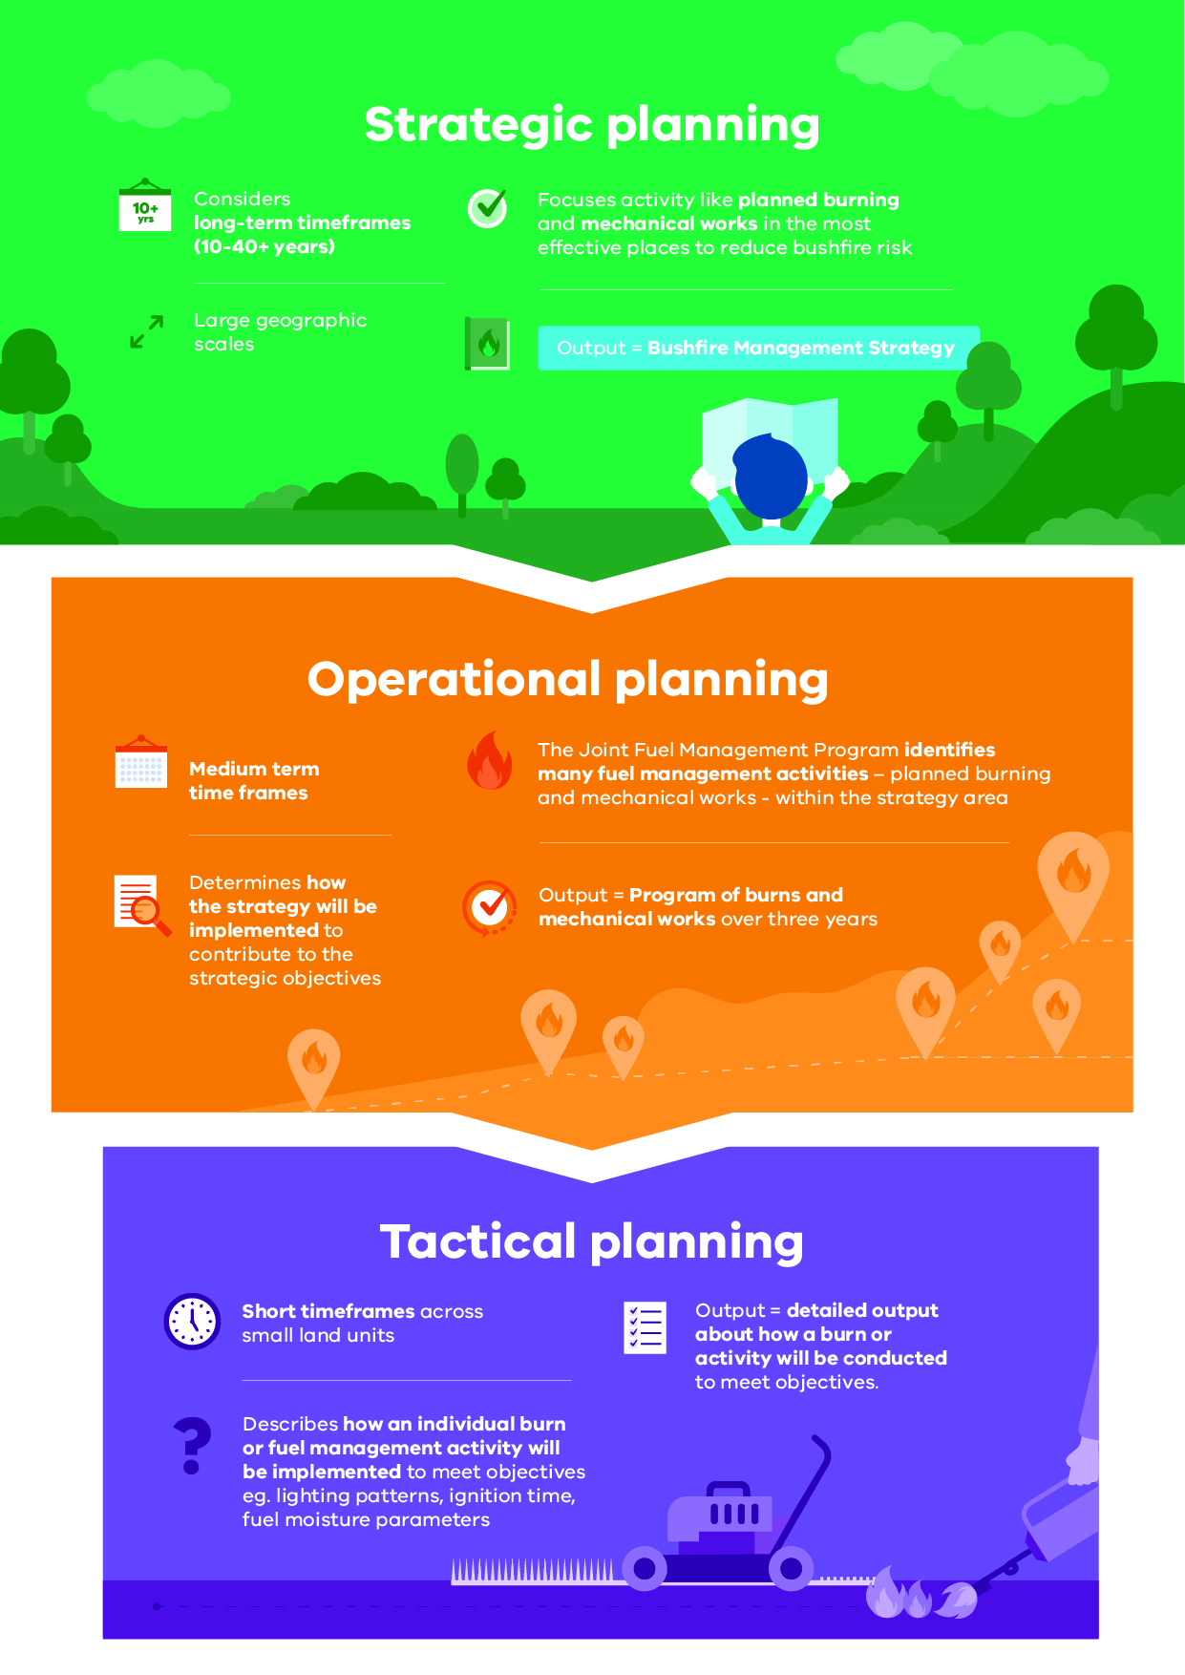

Strategic planning
The strategic planning process identifies where important values and assets are located across the landscape. It considers the current extent and quality of these values and where possible considers future trends including population, industry and environmental change. Strategic planning identifies objectives for the important values and assets, and develops an approach to manage the risks posed to them. The resulting bushfire management strategies describe landscape zones that focus fuel management activities to deliver bushfire risk reduction and ecological outcomes.
Strategic bushfire management planning takes place within a legislative and policy context which includes:
- the Emergency Management Act 2013, which requires from 1 December 2020 the Emergency Management Commissioner to prepare a state emergency management plan and to approve eight regional emergency management plans. In combination with the municipal emergency management plans, these provide for an integrated, coordinated and comprehensive approach to emergency management. The Act also requires emergency management plans to contain provisions providing for the mitigation of, response to and recovery from emergencies and to specify the emergency management roles and responsibilities of agencies
- the Conservation Forests and Lands Act 1987, which requires the Department of Environment, Land, Water and Planning (DELWP), through the Code of Practice for Bushfire Management on Public Land (2012), to develop a risk-based approach to bushfire management on public land. This document meets the requirements set out in the Code of Practice to prepare a strategic bushfire management plan
- Safer Together: A new approach to reducing the risk of bushfire in Victoria (2015), a Victorian Government policy, focuses on how effective our actions are in reducing risk and not just the amount of activity we undertake.

Operational and tactical planning
This bushfire management strategy informs the development of operational plans, primarily the Joint Fuel Management Program (JFMP). The JFMP is the three-year rolling statewide program of fuel management works on public and private lands carried out by Forest Fire Management Victoria (FFMVic) and Country Fire Authority (CFA) to reduce bushfire risk and to maintain the health of native plants and animals that rely on fire to survive. Works include planned burning, slashing, mowing and clearing works, creating and maintaining fuel breaks, and carrying out maintenance on fire infrastructure (like fire dams and lookout towers).
This strategy does not directly address tactical (burn) planning, which is done for individual burns. Tactical planning can include individual burn objectives, community engagement plans and how the burn will be delivered safely.

Other bushfire management actions
This Bushfire Management Strategy outlines our risk-based approach to fuel and ecological fire management. However, fuel management is not the only bushfire management action that reduces bushfire risk and is not always the most effective action to reduce that risk. Fuel management needs to be supported with other actions for number of reasons:
- Some parts of the landscape have inherently high levels of bushfire risk which requires more actions to reduce that risk
- The ability to reduce risk through fuel management may be limited in some landscapes and there will always be fuel re-accumulation
- The effectiveness of fuel management may be reduced under extreme weather conditions
- Fuel management reduces fire behaviour, it does not eliminate bushfire. Suppression activities are always required to control bushfires.
Table 1 lists some key actions that agencies and communities undertake together to manage bushfire risk and complement our fuel management approach.
As with fuel management, these actions are guided by bushfire risk analysis combined with other information to ensure they are most effective. Strategies and plans for these actions are developed through emergency management planning processes by agencies at the state, regional and municipal levels. We have also piloted a risk-based approach to support the development of strategies for bushfire prevention and suppression, described in the Strategies section of this document.
The holistic integration of our fire management approach across detection, response, access roads and breaks, and fuel management together provide fire management agencies the best opportunity to safely, rapidly and effectively control and suppress bushfires when they occur.
Table 1: Bushfire management approaches beyond fuel management
Approach | Key actions
Reduce bushfire ignitions through prevention activities | - Education and advertising campaigns (e.g. campfire safety, reporting ignitions)  - Coordinated, risk-based patrolling  - Deterrence for deliberate or negligent ignition – laws/prosecution  - Monitoring arsonists  - Restrictions – fire danger period and total fire ban triggers, duration and restrictions (including legislative change)  - Reducing ignitions from powerlines
Increase the effectiveness of fire suppression | - Fire detection (towers, aerial surveillance)  - Resourcing, capacity and capability of fire-fighting resources (fire crews, contractors, incident management teams)  - Aircraft fleet management: type, distribution, availability and pre-determined dispatch  - Road infrastructure including maintenance of the strategic fire access road network and network of fuel reduced areas.  - Other fire response infrastructure maintenance including remote water access and helipads  - Fire readiness including rostered and pre-formed Incident Management Teams and fire crews
Reduce bushfire spread and severity | - Planned burning based on tenure-blind risk  - Reintroduction of fire into fire scars across the landscape  - Strategic fuel breaks and burn unit boundary standards  - Flexible delivery of burning (e.g. managed bushfire, unbounded burns)  - Other forms of fuel management (e.g. slashing, spraying, mulching) particularly in high-risk areas where planned burning is not suitable  - Identify and effectively manage fuel hazard reduction on private bush
Reduce the physical effects of bushfires in inhabited areas | - Domestic property preparedness in towns, including fire prevention notices, penalties and cost recovery  - Vegetation management on public and private land within or immediately bordering towns including implementation of fire prevention notices  - Identification, prioritisation and treatment of risk to critical infrastructure  - Access and egress (roadside vegetation/tree maintenance) pre- and post-fire  - Asset protection (on-ground)
Reduce the social effects of bushfires on communities | - Bushfire education programs targeting vulnerable communities including those with identified at-risk or changing demographics, and/or where bushfire risk cannot be effectively reduced through planned burning.  - Recovery planning and relationship building pre-bushfire (e.g. via community groups, scenario events and activities)  - Municipal bushfire plans  - Warnings and advice messaging  - Personal and neighbourhood bushfire plans
Reduce impacts from fire management actions | - Community engagement about fire management and smoke impacts  - Planning to minimise impacts on biodiversity, cultural heritage and other values  - Connections between planning and delivery (e.g. on-ground staff aware of biodiversity/cultural sites and mitigation actions)  - Cross-tenure planning and consultation  - Monitoring effectiveness of mitigations (and subsequent improvement)

About this bushfire management strategy
Victorian landscapes, environments and communities are diverse and multifaceted, and Victorian communities have diverse values, preferences and priorities. This regional bushfire management strategy reflects our region’s unique environments and communities. To develop this strategy, we undertook a regional planning process that was guided by the knowledge and priorities of experts, stakeholders and community members from Gippsland.
Between November 2017 and September 2019, representatives of the CFA, DELWP, Parks Victoria, Emergency Management Victoria, water corporations, local governments, Gunaikurnai Land and Waters Aboriginal Corporation (GLaWAC), Aboriginal Victoria and VicForests undertook a strategic bushfire risk management planning process. The process was guided by the Gippsland Regional Strategic Fire Management Planning Committee (RSFMPC). They offered opportunities to stakeholders and the broader regional community to be involved in the planning process through both in-person and online mechanisms.
The strategic planning process resulted in four strategies to reduce bushfire risk and maintain ecosystem health: together, they comprise this strategy — the Gippsland Bushfire Management Strategy 2020.
The individual strategies are:
- our fuel management strategy, which focuses on reducing bushfire fuels through planned burning and mechanical works (mowing and slashing) on public land
- our Bushfire Risk Engagement Areas (BREAs), which focus on targeted community engagement to complement, inform and drive fuel management and other risk mitigation activities on public and private land
- our prevention of human-caused ignition strategy (pilot), comprising maps of areas where medium-term investment in reducing human-caused ignitions will provide the greatest reduction in bushfire risk
- our bushfire first-attack suppression strategy (pilot), comprising maps of areas where medium-term investment in improving first-attack suppression will provide the greatest reduction in bushfire risk.
Our bushfire management strategy focuses on:
- reducing the risk of bushfires threatening lives, homes, the environment and other important values and assets across the landscape
- maintaining or improving the resilience of ecosystems
- establishing a shared understanding of bushfire risk across the sector, based on the latest science and the extensive knowledge of agency personnel
- using a 40-year horizon, so long-term ecological changes and fuel accumulation rates can be considered in annual operational planning processes.
The strategy is a supplement to the Gippsland Regional Strategic Fire Management Plan, developed by the Gippsland RSFMPC, and applies to the same Gippsland emergency management region footprint. The plan’s agreed vision, strong leadership and greater cooperation between agencies promotes greater community resilience through effective engagement and best-practice integrated fire management planning.
Regional emergency management plans and municipal emergency management plans are being prepared in line with the new amendments to the Emergency Management Act 2013. This strategy will help inform the bushfire components of these plans, now and into the future.
For the purpose of the Code of Practice for Bushfire Management on Public Land (2012), the FFMVic Chief Fire Officer has approved the public land components of this strategy: specifically, where the strategy relates to state forests, parks administered under the National Parks Act 1975 and protected public land. These components of the strategy will directly guide FFMVic’s fuel management operations. This strategy replaces the former Strategic Bushfire Management Plan for public land, published by DELWP and PV in 2014 and 2015, which used bushfire risk landscape footprints.

Method overview
This document presents the outcomes of the strategic bushfire management planning process.
The planning process involved considerable community engagement — with individuals, private land managers, businesses, community organisations and other stakeholders — to tap into their knowledge, understand their priorities, discuss and evaluate options with them and prepare to involve them in implementing the strategy.
In the planning process, we:
- identified the values and assets that are most important to the residents of and visitors to the region: we grouped these into human life, wellbeing (individual, social and cultural) and nature (biodiversity and ecosystem function)
- developed regional objectives: the things we want to achieve by implementing the strategy
- combined local knowledge, bushfire behaviour modelling, historical data and the best-available science to understand how bushfires behave in our region and to forecast bushfire and fuel management strategy impacts on our most important and at-risk values and assets
- developed and evaluated many potential strategies to select four — our fuel management strategy, the Bushfire Risk Engagement Areas (BREAs) and our pilot strategies for prevention of human-caused ignitions and first-attack suppression — that will enable agencies and communities to best mitigate bushfire risk to the region’s most important and at-risk values and assets.
The planning process was underpinned by the International Standard for Risk Management ISO 31000. The standard acknowledges that risk can never be completely eliminated. Bushfires will still occur, and we must all be prepared and ready to respond. However, bushfire risk can be reduced with a high-quality risk management approach.
The planning process followed the principles of structured decision making (SDM). SDM is a framework that helps people unpack complex decisions, navigate trade-offs and make logical and transparent choices. It provides a means of bringing together both scientific information and human values to make decisions, through analysis and inclusive deliberation. The principles of SDM are particularly useful in decision-making contexts characterised by uncertainty, multiple stakeholders and competing objectives. Broadly, the SDM steps involved included understanding the landscape context, setting objectives, identifying possible management strategies, and estimating and analysing the consequences and inherent trade-offs of these strategy options. We then selected the strategy that gives the greatest benefit to the things we care about, while balancing the impacts of fuel management actions on those same values.

Identifying and assessing risk to values and assets
The planning process identified values and assets across the region and modelled the impact bushfires and fuel management would have on them. Values are the ultimate durable reasons we care about managing bushfires, and assets are the physical sites that represent these values. For example, we value native species, and the locations of their populations and habitat are the assets we protect to ensure their continued existence.
To identify the region’s most important values and assets, we consulted with our partners, stakeholders and communities, and we drew on specialised data sets including the Victorian Fire Risk Register – Bushfire (VFRR-B) and Victorian Biodiversity Atlas.
We used Phoenix RapidFire, which is world-leading bushfire simulation software developed in Victoria, to model the spread of a bushfire from an ignition point under the specified weather conditions. This enables us to understand the impact bushfires could have on people, homes and other important values and assets in our landscape. We modelled ignitions and bushfire spread patterns at thousands of places throughout the region:
- using ignition likelihood models based on historical ignition characteristics and patterns
- using the bushfire characteristics information in the ‘Bushfire history and patterns’ section
- under a range of bushfire weather conditions, including Code Red conditions: a Forest Fire Danger Index (FFDI) rating of 130 or above. These were the conditions in many parts of the state on Black Saturday 2009, and conditions were similar at times during the 2019–20 fire season. Code Red conditions are also forecast to become more frequent and more extreme with climate change.
We also used a new 20-year historical weather dataset for Victoria to identify recent changes to the state’s climate and so we could better model the average frequency with which various weather scenarios occur. This provided some indication of the likelihood of these scenarios occurring in future. We also partnered with climate scientists to forecast various climate conditions relevant to bushfires which will inform future strategic bushfire risk management planning and preparedness decisions.
Our planning process considered outcomes for flora and fauna. We modelled ecological outcomes for a range of possible fuel management scenarios by drawing on modelling that sits within the Fire Analysis Module for Ecological values (FAME). This module was designed for this purpose by the Arthur Rylah Institute for Environmental Research and the University of Melbourne. Data for prediction of fauna population responses was drawn from thousands of previous field surveys conducted in Gippsland.

Our landscape context
Gippsland is defined by the area south of the Great Dividing Range in Victoria to the coast, and from the Latrobe River catchment and the Strzelecki Ranges in the west to the New South Wales border in the east. Gippsland has a landmass of 4,130,000 ha, or 19% of Victoria. The region is home to less than 5% of Victoria’s population, and it encompasses the local government areas (LGAs) of Latrobe City, Baw Baw, Bass Coast, South Gippsland, Wellington and East Gippsland (Figure 2). The public land estate comprises over 2,700,000 ha, or 62% of the regional footprint. The regional economy relies heavily on its wealth of natural resources including more than 60% of Victoria’s forested public land.
Figure 2: The Gippsland region with local government boundaries and public land tenure
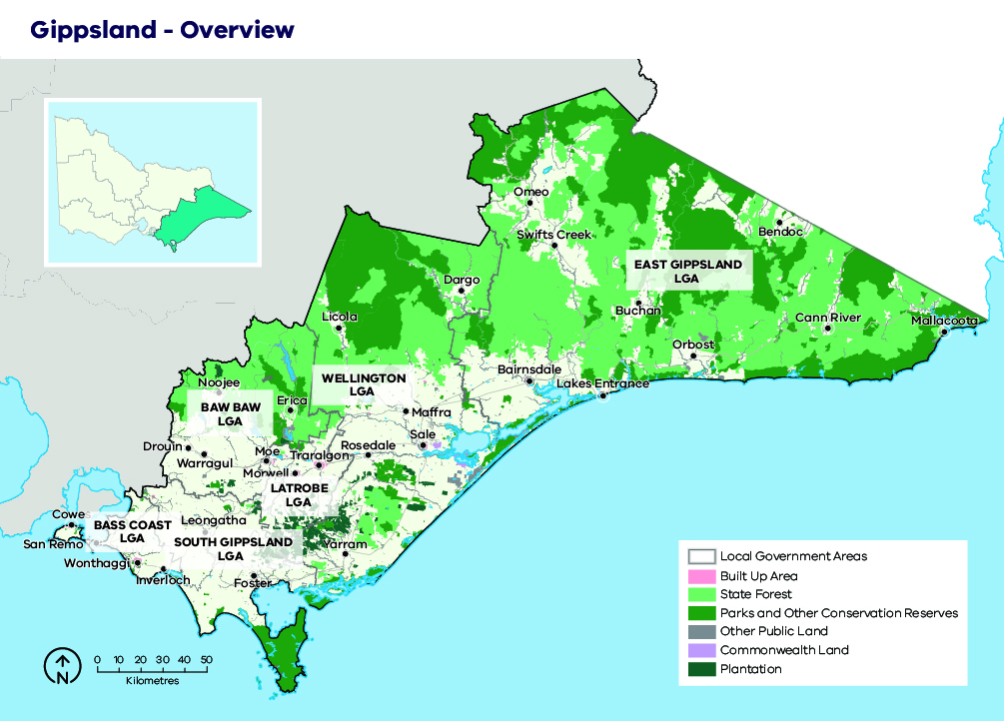

Case study: Local government profiles

Bass Coast Shire (population 35,000)
Bass Coast is the LGA closest to Melbourne and has the second-highest population density in Gippsland. With easy access to the coastlines of Western Port and Bass Strait, Bass Coast’s significant tourism industry is concentrated around Phillip Island and Inverloch. The economic and government hub of the LGA is Wonthaggi, which is also home to the Victorian Desalination Plant. The great majority of Bass Coast is private land (91%), with predicted population increases likely to drive land use change from agriculture to lifestyle properties and subdivisions.

South Gippsland Shire (population 29,000)
Leongatha is the largest town and the administrative centre of South Gippsland. The LGA is predominantly private land with agriculture, especially dairy production, making a strong contribution to the shire’s economy. Wilsons Promontory is one of Victoria’s most iconic national parks and supports a major tourist industry in surrounding towns (such as Fish Creek and Mirboo North). Venus Bay and Tarwin Lower are also increasingly popular coastal tourist destinations.

Baw Baw Shire (population 52,000)
The Baw Baw Shire extends from the high elevations of the Baw Baw Plateau, through large forested areas of public land in the north, down to cleared private land in the south. The larger towns in the LGA are located on the Princes Highway, with administrative centres in Drouin and Warragul. The rate of predicted population growth is the highest in Gippsland, with building construction forming one of the main industries. The Mount Baw Baw Alpine Resort is situated in an unincorporated area surrounded by the Baw Baw Shire, and it offers snow sports in winter and other recreational opportunities (especially cycling) through the rest of the year.

Latrobe City (population 75,000)
Latrobe has the highest population of any shire in Gippsland, and it also has a substantially higher population density than other shires. Most of the population live in the urban centres of Churchill, Moe, Morwell and Traralgon. With over 90% private land, the LGA is primarily centred on the Latrobe Valley, but it also includes substantial areas of forest and plantations in the Strzelecki Ranges in the south. The energy sector in the Latrobe Valley generates most of Victoria’s electricity from large brown coal deposits, and it is a major employer. The Australian Paper mill is the largest in Australia, supporting a network of forestry contractors and sawmills. The retail sector and Federation University are also major contributions to the Gippsland economy.

Wellington Shire (population 44,000)
Wellington is the second largest LGA in Gippsland and the third largest in Victoria. Most of Wellington (57%) is forested public land, concentrated in the north of the shire. The timber industry and agriculture are both major employers in the shire, and the Macalister Irrigation District is a significant hub of primary production. Sale is the largest town and the seat of local government. Other main towns include Heyfield, Maffra, Stratford and Yarram.

East Gippsland Shire (population 46,000)
Although this shire has the lowest average population density in Gippsland, it contains significant settlements (such as Bairnsdale, Lakes Entrance, Orbost, Omeo and Mallacoota). East Gippsland has the largest area of any shire in Gippsland and the second largest in Victoria. It also contains the most public land of any Victorian municipality: over 1,600,000 ha. Nature-based recreation is a major drawcard, particularly to the alpine areas in the north and to the coastal areas in the south. Agriculture, forestry and fishing are also notable industries, with Lakes Entrance hosting the largest fishing fleet in the state. About 2.9% of the total East Gippsland population is Aboriginal, which is over three times the Victorian average. Bairnsdale is the commercial and administrative centre of this LGA.

Bushfire history and patterns
Large bushfires have occurred throughout Gippsland’s recorded (post-European) history, and sedimentary charcoal records indicate the prevalence of fire for millennia.
In most cases, accurate spatial information is not available for bushfires before the 1980s. However, newspaper reports and post-fire enquiries show Gippsland has a documented history of large or damaging bushfires including those in 1851, 1898, 1926, 1932, 1939, 1942, 1965, 1978, 1983, 1985 and 1998. In the last two decades, this pattern of recurring major fires has intensified, consistent with an increased frequency of dry years during this period (Figure 3).
Figure 3: Rainfall anomaly for Bairnsdale 1920-2020, with Gippsland’s major recorded bushfires shown as asterisks. Rainfall anomaly was calculated as the rainfall in the 12 months to February (i.e. leading into peak bushfire season), minus the long-term (1880-2020) average annual rainfall (687 mm). Monthly rainfall data from the Bairnsdale Advertiser 27/1/2020.
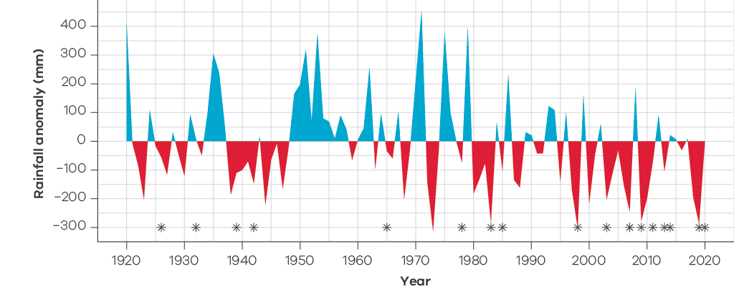
Since 2000, over 2,000,000 ha have been burnt by bushfire at least once in Gippsland (Figure 4). Some locations have been burnt by bushfire up to four times in this period. DELWP and the CFA respond to an average of 620 bushfires and grass fires per season and are successful in suppressing the great majority (about 95%). However, the extent of forested areas in Gippsland means that early fire suppression is not always possible, especially when lightning ignites multiple fires in remote areas simultaneously. This scenario, when preceded by low rainfall and followed by hot, windy conditions, has repeatedly led to landscape-scale bushfires in the last 20 years.
The progressive spread of multiple ignitions in remote areas resulted in extensive areas of Gippsland burnt by bushfire in 2003 (490,000 ha), 2006–7 (590,000 ha), 2014 (190,000 ha) and 2019 (183,000 ha). 2019-20 was the largest bushfire season in Gippsland’s recent history, with about 1,000,000 ha burnt across East Gippsland, during a time of underlying soil dryness from extended drought across the landscape. The 2019-20 fires started from lightning strikes in remote areas of forests and parks, similar to the 2003 and 2006-7 fires. The fire behaviour across the landscape was different for each new fire, with factors such as fuel loads, terrain and proximity determining priorities for suppression. The weather further influenced fire behaviour, with hot windy days causing the larger fires to gain momentum and jump containment lines. The four larger fires across the Tambo Complex at the start of December eventually joined together after the weather events of December 30 and 31, 2019 to form one large landscape-scale fire.
These cases are known by fire agencies as ‘campaign fires’, in which the scale of active fire means that direct suppression is insufficient, and fires continue to expand for weeks or months until a significant rainfall event occurs. Although large, remote fires may not always directly threaten major settlements, they still cause extensive impacts to primary producers, tourism operators and the natural environment, and risk the death or injury of firefighters. These large fires have a detrimental impact on environmental values across the landscape, resulting in the decline of flora and fauna species due to loss of habitat and/or food source, loss of regenerative ability or predation.
Large scale fires in the landscape presents a potential risk to communities when severe weather days occur, as was experienced on several occasions in 2019/20 when fires impacted small isolated communities such as Buchan, Goongerah and Mallacoota. There is also a growing understanding of the consequences of sustained smoke exposure, the psychological impacts of fire, and the cumulative health impacts of these.
The direct risk posed by bushfires to the Gippsland community is dominated by four factors that influence where and when fires are likely to cause the greatest loss of life and property: weather, fuel, topography and the geography of human settlement.
Communities and infrastructure are most threatened by a fire run that occurs during days of elevated fire danger, whether the fire run originates from an existing fire or from a new ignition. Typically, on such days, a strong north-westerly wind blows hot, dry air from central Australia across Victoria. If a bushfire ignites or is already burning, this wind can push it rapidly south-east, creating a relatively narrow fire front and long fire flanks on its western and eastern sides. Then, an approaching cold front with a strong south-westerly wind can expand the bushfire’s eastern flank into a wide front and intensify the fire. These weather conditions can create fast-moving bushfires with powerful convection columns, which in turn cause extreme fire behaviour and ember storms. The losses of life or assets that can occur in such conditions are exemplified by recent fires: Churchill–Jeeralang (February 2009), Tostaree–Princes Highway (February 2011), Morwell–Hearnes Oak (February 2014) and, in multiple locations (including Sarsfield and Mallacoota), the 2019–20 East Gippsland bushfire complex.
The distribution of human settlements in the landscape is the other dominant driver of bushfire risk to human life. In Gippsland, the localities at highest risk are typified by extensive areas of forest abutting settlements (such as Bruthen, Mallacoota and Noojee). Many other localities are interspersed with discontinuous or fragmented native vegetation, which is still a source of significant bushfire risk. The larger regional centres are surrounded by areas of cleared land, meaning that fire severity in these areas is reduced and successful suppression is more likely.
Figure 4: Bushfire history for the Gippsland region, 1980–2020
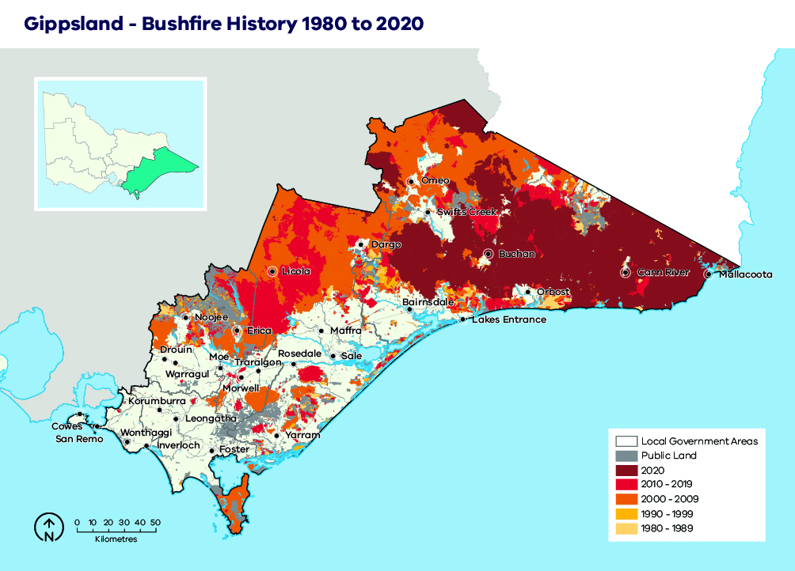

Values and assets
Here we describe the most important features of our landscape that informed our strategy.

Human landscape
Despite comprising about 19% (4.13 million ha) of Victoria’s landmass, Gippsland has less than 5% of the state’s total resident population. Many of these people live in clearly defined urban centres (such as Warragul, Traralgon, Wonthaggi, Sale and Bairnsdale). About 40% of the population live in towns and settlements of less than 500 people. Many coastal towns are popular holiday destinations subject to significant seasonal population fluctuations. Lakes Entrance and Mallacoota, for example, can experience a five-fold or greater population increase during holiday periods.
Transport links in Gippsland are largely oriented east-west, with the Princes Highway and Bairnsdale rail line defining the principal corridor connecting most of the major settlements. North-south movement in Gippsland is facilitated by the South Gippsland, Bass and Strzelecki highways (Figure 5).
The industries with the greatest employment in Gippsland are health care and social assistance, retail trade, agriculture, fishing and forestry, education and training, accommodation and food services. Power generation based on the area’s significant brown coal deposits makes the electricity, gas, water and waste services sectors very important, particularly in the Latrobe Valley (Figure 6).
Figure 5: Critical infrastructure, assets, systems and networks in the Gippsland region
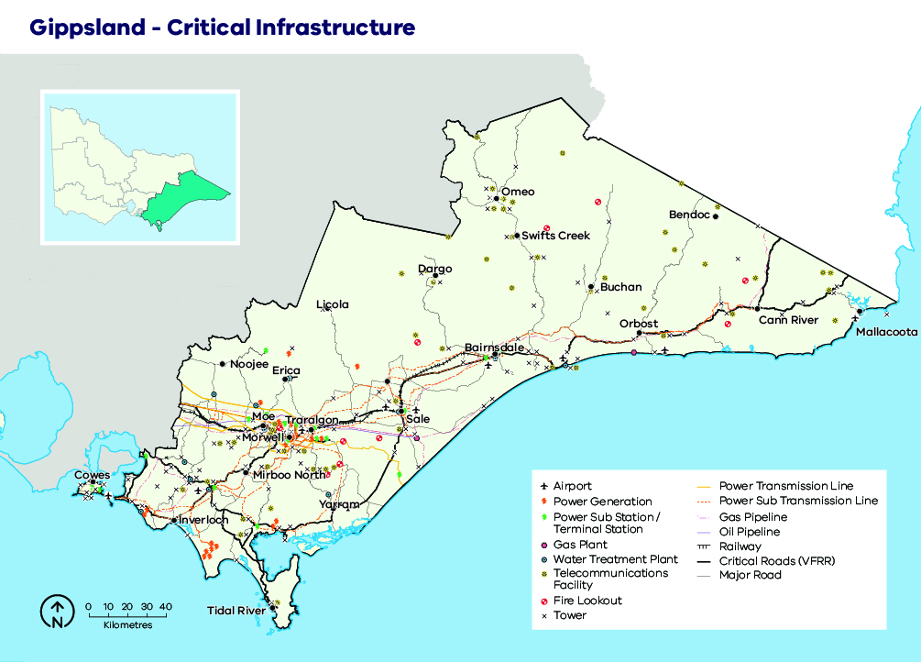

Non-indigenous cultural heritage
While the first settler contact with Gippsland is thought to have occurred early in the 19th century, it wasn’t until the 1830s that settlers steadily began to enter the region for a range of agricultural, timber harvesting and mining purposes. Consequently, the interactions between settlers and the landscape form an important component of the region’s recent history and culture. Today, this can be seen in the form of various mines, relics, timber tramways, huts, cemeteries and town sites.
Many hundreds of sites are currently listed on the Victorian Heritage Database, while a number are listed on the Victorian Heritage Register as sites of state significance and offered statutory protection under the Heritage Act 2017.
Figure 6: Generalised land use in the Gippsland region
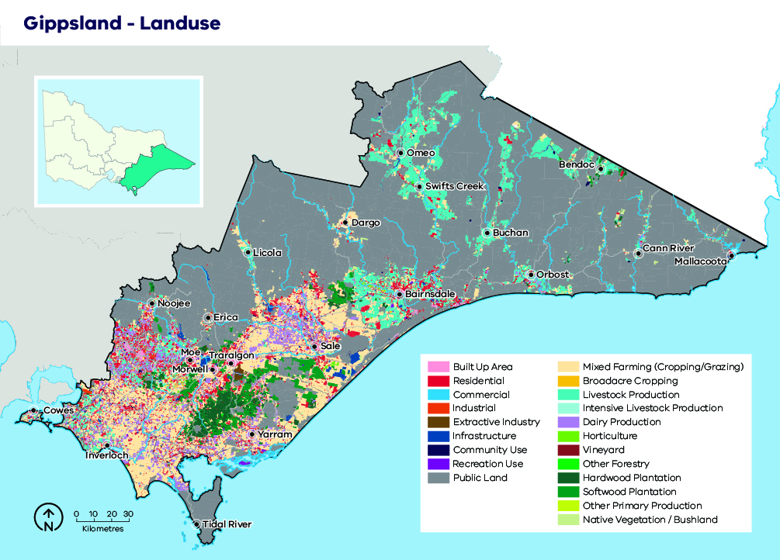

Aboriginal cultural heritage
Registered Aboriginal Parties (RAPs) are organisations formally recognised as responsible for protecting Aboriginal cultural heritage in specified geographical areas. Two RAPs are responsible for much of Gippsland (Figure 7).
The Gunaikurnai Land and Waters Aboriginal Corporation (GLaWAC) is the RAP formally representing the five Gunaikurnai family clans: the Brataualung, Brayakaulung, Brabralung, Krauatungalung and Tatungalung. GLaWAC’s area of responsibility extends from near Drouin in the west to the Snowy River in the east, and from south of the Great Dividing Range to the coast. The RAP also currently co-manages ten parks and reserves across Gippsland and is heavily involved in land management and stewardship activities across the region.
In the far south-west of Gippsland, the Bunurong Land Council Aboriginal Corporation is the RAP and formally represents the Bunurong people. The organisation’s area of responsibility covers the Mornington Peninsula, much of the Bass Coast Shire and parts of South Gippsland Shire including from Wonthaggi in the south, Leongatha in the east and north to Warragul.
The Taungurung Land and Waters Council Aboriginal Corporation and the Wurundjeri Woi Wurrung Cultural Heritage Aboriginal Corporation have formal RAP status over small areas on the boundaries of the Mansfield and Wellington shires and the Yarra Ranges and Baw Baw shires respectively.
No RAP has been appointed east of the Snowy River, but the area has significant cultural heritage and discussions are ongoing. Aboriginal organisations in this area include the Bidwell-Maap Nation Aboriginal Corporation, Nindi-Ngujarn Ngarigo Aboriginal Corporation and Snowy Cann South Monero Aboriginal Corporation. In the absence of a formally appointed RAP, Aboriginal Victoria has overarching responsibility for Aboriginal cultural heritage decisions.
Figure 7: Traditional Owner groups in the Gippsland region
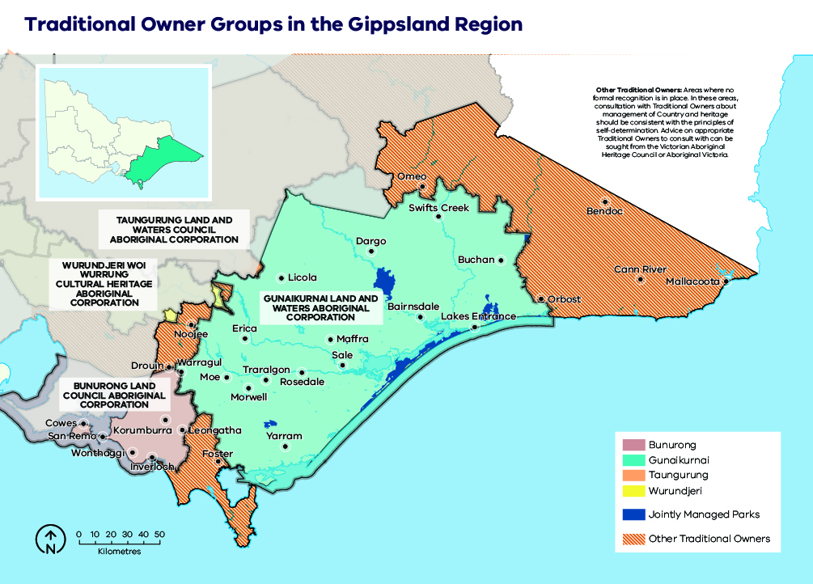

Natural landscape
Gippsland region’s 2,700,000 ha public land estate is comprised of a network of parks and reserves and state forest, which is built upon the national criteria for a comprehensive, adequate and representative reserve (CAR) system of Australia’s forests (Figure 8). Parks and reserves are primarily managed for nature conservation, ecosystem services and recreation. State forest is managed for a greater diversity of purposes including biodiversity conservation, water catchment services, timber harvesting, firewood production, minor produce and apiary use. Recreation and tourism are also an important and increasingly popular use of state forest, with many active and passive pursuits commonplace across the region.
Gippsland has a diverse natural landscape and is one of the few places in Australia where native vegetation extends continuously from alpine to coastal ecosystems. In the north and east of the region, the landscape is one of largely contiguous vegetation, interspersed with small settlements of cleared land in the river valleys or around townships adjacent to the coast. Further to the west and along the Gippsland Plain are the largest tracts of private land, much of which has been cleared for agriculture.
The Gippsland region is home to a range of terrestrial and aquatic environments that support a large diversity of flora, fauna and vegetation communities. The largely intact nature of the landscape provides habitat for common and widespread species, as well as species considered threatened or restricted in their range. Many of the species and floristic communities occurring in Gippsland are considered threatened under Victoria’s Flora and Fauna Guarantee Act 1988 or are listed under the federal Environment Protection and Biodiversity Conservation Act 1999. A number of these species occur nowhere else in Victoria or have a high proportion of their known Victorian distribution in the region. Some examples include Aniseed Boronia, Marble Daisy-bush, Eastern Bristlebird, Diamond Python and Warm temperate rainforest (far east Gippsland) community.
Major rivers are a distinct characteristic of the Gippsland landscape. Rivers such as the Snowy, Mitchell, Tambo, Nicholson, Latrobe and Thomson have substantial catchments and flow into some of Victoria’s nationally and internationally significant wetlands.
Several iconic Victorian landscape features exist in Gippsland including the Gippsland Lakes, Wilsons Promontory, the Anderson Inlet, Corner Inlet and the Ninety Mile Beach.
Figure 8: Public land in the Gippsland region
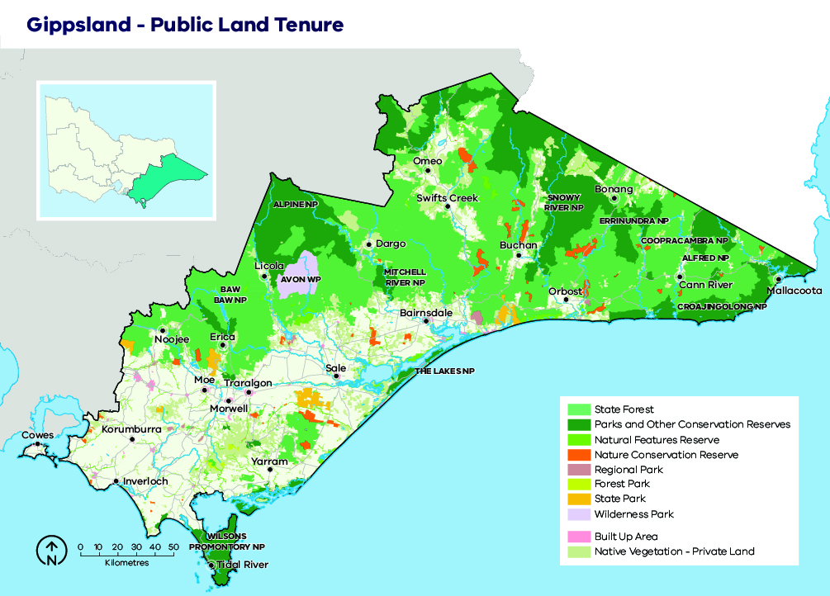

Our objectives
What matters most in the Gippsland region is discussed in the landscape context section and is summarised into the following fundamental values:
- human life
- wellbeing: individual, social and cultural
- nature: biodiversity and ecosystem function.
These values are the ultimate, durable reasons why we care about managing bushfires, and they are what we want to protect and manage through bushfire management in the Gippsland region.
The following regional objectives are derived from our values and articulate what we are aiming to achieve in the Gippsland region (Table 1). These objectives contribute to the overall objectives for fire management articulated in the Gippsland Regional Strategic Fire Management Plan.
Table 2: Gippsland region’s values and objectives and how they align with the statewide vision, policy context and strategic objectives
Vision
Safer and more resilient communities
Policy context
The Victorian Preparedness Goal is A safer and more resilient community that has the capabilities to withstand, plan for, respond to and recover from emergencies that pose the greatest risk.
The Safer Together policy’s four priorities for reducing the risk of bushfires in Victoria are Community first, Land and fire agencies working together, Measuring success and Better knowledge = better decisions.
Strategic objectives (Code of Practice for Bushfire Management on Public Land)
To minimise the impact of major bushfires on human life, communities, essential and community infrastructure, industries, the economy and the environment. Human life will be afforded priority over all other considerations.
To maintain or improve the resilience of natural ecosystems and their ability to deliver services such as biodiversity, water, carbon storage and forest products.
Gippsland region values
Human life |  | Wellbeing:  individual, social, cultural |  | Nature: biodiversity and ecosystem function
Minimise human life loss and serious injury | Minimise social, livelihood and economic disruption | Minimise disruption to essential services and critical infrastructure | Minimise loss of community and cultural assets | Minimise decline in native plant and animal populations

Our risk management approach
In hot, dry and windy conditions, a bushfire can travel quickly across a large area of our landscape. To effectively understand bushfire risk, we simulate many bushfires across the entire landscape to determine where bushfires are likely to start, spread and cause damage to values and assets, with a particular focus on people and communities. We can then reduce fuel hazard across the spread paths of these simulated bushfires with the intention of reducing the spread and intensity of these fires and ultimately limiting their impacts.

Risk in Gippsland region
Figure 9 shows the risk of house loss in the Gippsland region. It compares where houses could be destroyed by bushfire across the region.
Different shades represent different levels of risk. As the shades progress from yellow through red to purple, more and more houses are potentially destroyed. The purple areas represent the top 5% of risk in Gippsland. More houses could potentially be destroyed in these areas than any other.
While bushfire risk exists across the entire landscape and house loss can and will occur in other areas, this map shows where the greatest 70% of house loss risk sits within our region.
Bushfire simulations generated by Phoenix RapidFire illustrate risk by showing where significant impacts on houses may occur. Simulations are undertaken using a range of different weather conditions, likelihood of an ignition, maximum fuel loads and limited bushfire suppression.
This helps us plan where, how often and how much fuel management we do to reduce risks to communities over years, or even decades.
This map does not reflect any recent bushfires or activities that could change the risk in the region. Importantly, this map shows where there is potential to destroy more houses compared to other parts of the region. It does not show risk to individual houses.

Higher risk areas in Gippsland
The highest risk places in Gippsland are towns bordered by forest, such as Noojee, Erica, Mirboo North, Bruthen, Cann River and Mallacoota. Large areas of forest can allow fires to become large and intense before they impact on communities. Other, smaller settlements near forests may be equally likely to be impacted by bushfire but have fewer houses and people at risk.

Lower risk areas in Gippsland
The larger population centres in Gippsland are typically surrounded by cleared farmland, including Warragul, Leongatha, the Latrobe Valley, Bairnsdale and Sale. Dangerous grass fires can still occur in such areas but are less likely to destroy large numbers of houses.
Figure 9: Bushfire risk within the Gippsland region. This map only considers modelled house loss within the Gippsland region and so risk shown on this map can only be compared within this region.
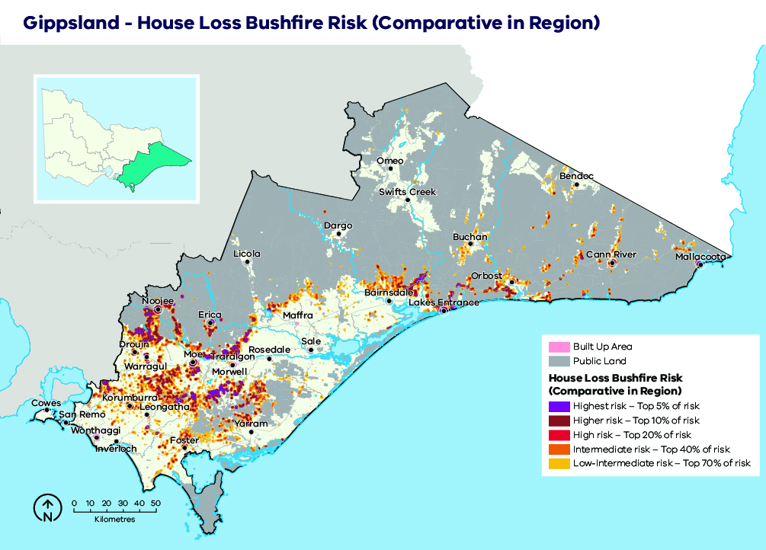

Why model house loss?
Human lives are given priority over all other considerations, however, we cannot know where exactly people will be in the event of a bushfire. Simulations of house loss help to identify areas across our landscape where bushfires could have the greatest potential impacts on lives, as well as on other things we value such as our homes themselves, livelihoods and communities. This also reflects the importance of homes as a primary place of shelter and residence. The simulated house loss shown in Figure 9 indicates where these areas are and the possible scale of bushfire impacts relative to other parts of our region. We consider these impacts when developing fuel management strategies for the values and objectives in our region. We can model how our strategies improve the outcomes by reducing bushfire risk to people’s homes, and the social values connected with them. House loss informs one of our key metrics — ‘residual risk’— by which we assess the effectiveness of our fuel management strategies. The residual risk metric is explained in more detail below.

How do we model house loss?
We compare the characteristics of bushfires that are simulated in Phoenix RapidFire with those that led to actual house loss in historic bushfires. Our model assumes houses (based on address points) are destroyed by a simulated bushfire if the modelled fire intensity exceeds 10,000 kilowatts per metre (generally a crown fire) or if ember density exceeds 2.5 embers per square metre. Research indicates that bushfire embers account for the majority of houses lost, with most occurring within 1 km of the edge of forested areas and native vegetation (although house loss still occurs beyond this distance). This is consistent with our modelling which shows similar patterns of house loss. Other fire behaviour factors can have a strong influence on house loss (such as convective strength of the fire), and they are being further researched to understand this risk.
We estimate the magnitude of property impacts by analysing how many houses are modelled as destroyed under all of our simulated bushfires. We can compare between communities to understand which are more likely to suffer large numbers of houses lost.
It is important to note that the modelled property impact is only a coarse estimate and should not be applied at the individual house level. The vulnerability of a house also depends on other factors: its building materials, design and maintenance, how close it is to combustible elements, the presence of human intervention (before, during and after a fire) and the environment in which a bushfire occurs. These factors cannot all be modelled in landscape scale simulations. However, over time they can be included in statistical models, to improve estimates of potential house loss.

Our fuel management strategy
Our fuel management strategy describes our approach to balance the threats posed by bushfire to our most important values and assets, with managing fire to enhance the health and resilience of ecosystems. It responds to Gippsland’s unique bushfire risk profile, determined through our risk assessment process.

Fire Management Zones
The fuel management strategy is presented as an arrangement of different Fire Management Zones (FMZs) on public land, as described in the Code of Practice for Bushfire Management on Public Land (2012). There are four zones – Asset Protection Zone (APZ), Bushfire Moderation Zone (BMZ), Landscape Management Zone (LMZ) and Planned Burning Exclusion Zone (PBEZ). Although the name of the zone indicates the primary purpose of that zone, it is recognised that multiple goals can be achieved when undertaking activities in a given zone. For example, a burn undertaken primarily for land management purposes may also have asset protection results.
Bushfire risk mitigation outcomes are the primary purpose of Asset Protection Zones. Ecological outcomes are still considered, but the protection of life and property is the priority for the management of these zones. This emphasis gradually shifts through Bushfire Moderation Zone and Landscape Management Zone, such that Planned Burning Exclusion Zone’s primary focus is ecological outcomes. It is important to note that although Bushfire Moderation Zone has a stronger bushfire risk mitigation focus than Landscape Management Zone, there is still a strong focus on risk mitigation in Landscape Management Zone.
Fuel management is often scheduled in Landscape Management Zone to complement that which has been undertaken in Bushfire Moderation Zone and Asset Protection Zone and enhance the risk reduction that can be achieved, across the whole landscape. Fuel management in Landscape Management Zone can be undertaken at a larger scale than in the BMZ and APZ, it can be rotated through adjacent areas over the lifetime of the strategy, and burns can be undertaken over a broader area with lower coverage, to reduce the ecological impacts. Fuel management in the LMZ can also be used to reintroduce fire into areas burnt by campaign fires, to start to break down the fuel accumulation across a large portion of the landscape.
In some areas, communities may see fuel management works occurring in nearby forest most years. This may be because we are delivering a multi-year planned burn, where some fuel types or area(s) of the burn are targeted in one year, and a different fuel type or area targeted the next year. It may be because we are burning in adjacent blocks to those previously treated, to ensure the highest level of protection to the town. If we undertake mechanical treatments such as slashing in an area, fuels often re-accumulate quickly and treatments need to be repeated.
The aims of each zone, how they have been placed and how they will be implemented in Gippsland is described further in Table 3.
The FMZ configuration for public land in the Gippsland region is shown in Figure 10.
Figure 10: Fire Management Zones for public land in the Gippsland region. This zoning configuration was developed through risk assessment processes and in consultation with key delivery partners
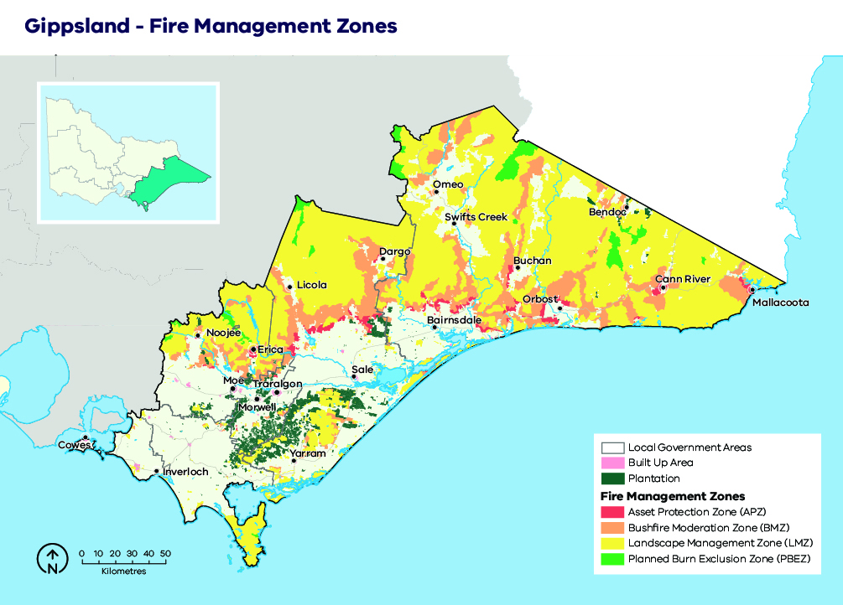
Table 3: Description of the aims, placement, planned fire intervals and typical outcomes of fire management zones for public land in the Gippsland region. This is a description of typical features of these four zones, consistent with the aims of the zones in the Code of Practice for Bushfire Management on Public Land (2012).
 | Asset Protection Zone (APZ) | Bushfire Moderation Zone (BMZ) | Landscape Management Zone (LMZ) | Planned Burn Exclusion Zone (PBEZ)
Aim | Provide localised protection to human life, property and key assets. | Reduce the speed and intensity of bushfires. Achieve ecologically-desirable outcomes where possible. | Reduce overall bushfire hazard at the landscape-scale; support ecological resilience and land-management objectives. | Exclusion of planned burning from areas intolerant to fire.
Typical placement | Where most effective to reduce overall bushfire risk; typically, smaller planning units on the public/private interface. | Near public/private interface or key assets, or strategic placement to inhibit the spread of large fires. | Rest of landscape not covered by APZ, BMZ or PBEZ. | Planning units wholly or largely covered by fire-intolerant vegetation communities.
Typical planned fire interval | 5 to 8 years. | 8 to 15 years. | Varies depending on land-management and fire-management objectives. | Not applicable.
 | These intervals are indicative only to help provide an understanding of time between planned fire in each zone. Planned fire intervals for each zone are determined by fuel hazard (type, size, arrangement and quantity) triggers to achieve fuel treatment outcomes in each zone. Actual planned fire intervals may be more or less frequent depending on previous fire severity and coverage, vegetation type, climatic and seasonal conditions and actual rate of fuel re-accumulation. It is also important to note that some burns are conducted in multiple stages and sequenced with other burns in the landscape to form a landscape mosaic, meaning that planned burning operations can occur in the same area over successive years. Some areas, especially in APZ, are treated with mechanical treatments which may occur more frequently.
Fuel treatment goal | Reduce radiant heat and ember attack. | Complement APZ goals and reduce bushfire spotting. | Reduce treatable fuels and achieve ecologically beneficial fire intervals. | Not applicable.
Typical fuel treatment outcomes | Intensive treatment; targeting 80-100% burn cover, with reduction of bark fuel hazard a priority.  In some cases, mechanical treatment as alternative or complementary. | Moderately intense treatment, seeking a significant reduction of fuel hazard over a majority of treatable fuels within the planning unit. Coverage targets typically 50–70%. | Varies depending on land-management and fire-management objectives.  Generally involves burning at low intensity, targeting less than 50% burn cover. | No planned fire.

Ecosystem resilience
An ecosystem’s resilience is its capacity to withstand and recover from a range of disturbances, including fire. We cannot measure ecosystem resilience by looking at a single species or fire event: we must look at the whole landscape, and at multiple fires with various frequencies, intensities, scales and seasons of burning. Tolerable fire intervals (TFIs) are the minimum and maximum recommended times between fire events for a particular ecological fire group. Burning regularly outside these intervals increases the risk that there will be fundamental changes in the abundance and composition of species, and the type of vegetation.
In our fuel management strategy, TFI has been used as a tool to guide where burning can occur that has the least amount of impact on a vegetation community. The strategy minimises the area where minimum TFI is breached for the first time (where feasible: that is, without failing to deliver other objectives). However, planned burning may be conducted in some areas below minimum TFI to reduce bushfire risk to life, property and important ecosystems.
Larger and more intensive bushfires have a significant impact on ecosystem resilience. Planned burning may also be conducted below minimum TFI to reduce the size, severity and frequency of large bushfires. There will be instances in the footprints of past large bushfires where fuels re-accumulate and become flammable before ecological maturity is reached. Fire is also reintroduced in these areas below minimum TFI to prevent large bushfires reoccurring, which can be more likely due to fuels loads being the same across a broad scale area. Burning below minimum TFI will have shorter term or localised impacts on vegetation communities, however we also need to compare this with how they would be impacted should a major bushfire occur.
We recognise that TFI is a broad measure of ecosystem resilience and there are finer-scale vegetation responses to differing severity of planned burning and bushfires, however it can help us with regional-scale planning.
We are continuing to improve our understanding of TFIs by monitoring the responses of different species of vegetation to differing fire severity, and by investing in research that improves our ability to predict these responses. We are also improving the TFI mapping by using species distribution models for key flora species on which minimum TFIs are based. This enables TFIs to be mapped more accurately.

About our fuel management strategy
Gippsland’s fuel management strategy has been extensively tested against our objectives to determine its suitability for our region.
The strategy focuses on fuel treatments where they will be most effective in reducing the impacts of bushfire on people and communities. This is done by configuring Asset Protection Zone (APZ) and Bushfire Moderation Zone (BMZ) close to communities to minimise radiant heat and ember attack, and in treating fuel in larger areas of Landscape Management Zone (LMZ) where it can most effectively reduce fire behaviour. Fuel treatments in APZ and BMZ generally aim to reduce existing fuels across the majority of the treatment area, whereas LMZ treatments may target lower burn coverage depending on environmental values within the treatment area. Larger planned burns within the LMZ focus on breaking up the fuel loads in a variety of different ways. Some LMZ fuel treatments use aerial incendiary and will drop incendiary devices at a regulated rate to achieve a mosaic pattern of burnt and unburnt areas across the landscape. Other treatments involve a more intense fire that is focussed on reducing all of the fuels on the northern and western aspects of the ridgelines, as these are generally drier and carry fire at a faster rate than southern or eastern aspects. The configuration of zones has been determined using a combination of computer risk modelling and local knowledge.
Each year, the strategy will require approximately 80, 000 to 90, 000 ha of public land within Gippsland to be treated. Approximately 50% of this area will be placed in APZ and BMZ, ensuring that these zones continue to give the highest level of protection. The other 50% will be allocated to LMZ, which distributes the fuel-reduction effort across the broader landscape, where it can assist APZ and BMZ in reducing risk to communities, and in reducing the spread, size and severity of large bushfires.
The allocation of which areas of the landscape are to be treated is reviewed annually based on the current levels of bushfire risk and articulated in the Joint Fuel Management Program (JFMP). In other words, there is a ‘broad plan’ for the landscape reflected in the FMZ system (Figure 10 and Table 3), but also regular updating (following bushfires and planned burns) to ensure we are targeting planned burning and mechanical works where they are most effective in reducing risk. When there have been large bushfires in the landscape, the number of hectares treated in subsequent years may be reduced.
The strategy minimises the area where minimum TFI is breached for the first time (where feasible: that is, without failing to deliver other objectives). However, in APZ and BMZ, our focus on reducing risk to people and assets may involve repeatedly burning below minimum TFI, acknowledging that this may result in changes to the vegetation community in such locations.
The strategy provides flexibility for applying or excluding planned burning to meet ecological objectives. When deciding where and how to burn in LMZ, we will seek to minimise the area burnt below minimum TFI for the first time, while also avoiding individual fauna species declining in abundance below an acceptable threshold, at the regional scale. It is not possible to achieve the needs of all species in all locations. This is an important consideration for future planning to reintroduce fire into the large-scale fire scars of 2018/19 and 2019/20, and any future large bushfires. In these areas, burning may be introduced below TFI, but in the best possible locations to minimise the impacts on known environmental values.
The strategy provides flexibility to use managed fire to achieve planned burn outcomes. An example of this is in areas where lightning strikes start fires in autumn within large planned burns in the LMZ. The strategy allows for that fire to naturally burn out to the edges of the planned burn, without ignition assistance from methods such as aerial drip torches or incendiaries. The result is a more natural burn across the LMZ, which can provide more refuge for smaller animals in unburnt pockets across the treated area.
The strategy aims to reduce the size of bushfires because they can cause significant ecological harm, smoke impact, economic cost and risk to firefighting personnel, even if they do not directly impact communities. It does this through maintenance of a network of fuel-reduced areas, such as strategically placed BMZ and LMZ areas which are managed together to reduce risk across the landscape. Rapid suppression and an annual schedule of maintenance of strategic fire access roads, water points, helipads and other fire response infrastructure in the landscape further contribute. We are committed to undertaking further planning on how to best integrate fuel reduction, strategic breaks and other approaches to reduce the size, severity and occurrence of large bushfires.
The strategy uses decision-support tools and enhanced readiness to identify the best places to improve capacity for preventing and suppressing bushfires.

Basis for updated fire management zoning
This fuel management strategy includes a similar amount of APZ and BMZ to the strategy it replaces. The overall pattern of where these zones are located is comparable, being generally located close to the assets they are designed to protect. In some areas, BMZ or APZ have replaced LMZ, especially in areas close to assets where increased frequency in burning will provide more protection for communities. In other areas, LMZs have replaced higher-intensity fuel management zones (BMZ or APZ) due to reasons such as operational difficulty in burning to the required frequency, or environments where higher frequency burning will have a long-term detrimental effect on a species. Where changes to the zoning have been made, they are the result of a thorough stakeholder review with considerations including:
- a better understanding of the effectiveness of burning these areas, due to improved burn coverage modelling and analysis from burning undertaken in the landscape in previous years
- improvements in bushfire risk modelling (such as variation in weather conditions in different parts of the landscape) that suggested that frequency of burning in areas could be either increased or decreased, depending on the environmental values present in that location
- the most suitable balance of what plant and animal species need to maintain a healthy environment in which they can increase their population, while still considering the requirement to protect human life and property
- input from fire and land managers about practical and operational constraints in these areas, as some terrain is inaccessible and difficult for firefighters to access and undertake burns safely, and other fuel types will not burn easily when it is safe to do so
- community feedback, with some landholders requesting changes to the frequency of fire adjacent to their properties and other community members requesting changes because of known environmental values in the areas that do not respond well to a higher frequency of fire in the environment.

Strategy implementation following major bushfire events
The 2019–20 bushfire season was one of the most extensive in Gippsland’s recorded fire history. With a changing climate, the frequency of large fire events like this is likely to increase. This bushfire management strategy and future strategic planning work address large bushfire events in the following ways:
- Continue efforts to avoid or minimise major bushfires
While bushfires will continue to occur, we can reduce the size, frequency and severity of impacts from major fires. Under this strategy, about 50% of the area of fuel reduction in Gippsland will continue to be conducted in LMZs. In these remote areas, planned burning can be implemented at a larger scale and with relatively fewer resources compared to those required for burning closer to houses and community infrastructure. The intent of these larger burns is to create a mosaic of burn coverages and intensities, often over multiple years, targeting fuel reduction on the drier ridges and slopes that often promote the rapid growth and severity of bushfires. This strategy provides for the continuation of this style of landscape burning, supported by current planning tools that allow us to better understand the fine-scale treatability of fuels within large remote areas. This will improve how we prioritise these areas according to their potential influence on bushfire behaviour and the ecological costs and benefits of burning.
The pilot strategies — the bushfire prevention of human-caused ignition strategy and the first attack suppression strategy — are the first examples of how non-fuel treatment measures can be spatially optimised using risk analysis methods. Extending this approach will also allow us to review the placement and standards of major access roads and fire breaks. While it is challenging to predict accurately how different management actions influence the spread or containment of campaign fires, we will also continue to refine our measures of bushfire risk.
- Review and adjust priorities where needed
This bushfire management strategy is underpinned by a set of performance measures and planning tools, designed to allow yearly updating of which areas are the highest priority for fuel management. Gippsland’s fire history changes every year, due to both bushfire and planned burns. Our strategic planning approach is to recheck our Joint Fuel Management Plan annually in light of the latest fire history, and if necessary, to adjust it to ensure we will continue to meet our objectives. This is particularly important after major bushfire seasons, which can rapidly change the distribution of bushfire risk and ecological risk across Gippsland.
Following major bushfire events, additional work may be needed to plan the reintroduction of planned burning into a widely burnt landscape. This may require starting the reintroduction of fire sooner than typical planned fire rotations in some places, to avoid a spike in risk as broad areas of fuel mature simultaneously. However, in these circumstances we will also consider the ecological costs and benefits of shorter fire intervals and the cumulative impacts of burning within an already impacted landscape. Work is currently underway to plan for reintroduction of fire into the 2018-19 and 2019-20 fire scars across Gippsland within the next ten years.
The performance measures and planning tools underpinning the bushfire management strategy can be used in an adaptive management approach to help guide this work. For example, identifying areas where multiple fauna species are modelled to be more abundant in younger vegetation types could provide initial guidance for reintroducing fire within the LMZ. Similarly, potential outcomes for individual fauna species can be modelled under different future planned burning scenarios, allowing adjustments to be made at the draft stage of the JFMP should issues with the long-term abundance of fauna species be identified.
- Adapt to new information
New bushfire events provide opportunities to test the effectiveness of our planning processes and management actions. For example, we will assess the performance of our fuel reduction program during the 2019–20 East Gippsland bushfire complex, both at the individual burn and landscape scales. We need to examine not only how often fuel reduction is effective in reducing the spread of fire, but also whether it provides ecological benefits by reducing bushfire severity and increasing wildlife refuge areas. We will continue to adapt our strategies, based on evidence of what is effective.
The significant biodiversity recovery program from the 2019–20 bushfires will include the identification of important refuge populations of plants and animals, both inside and outside the bushfire footprint. We will review the outcomes of this work and other stand-alone projects (such as the Ecological Fire Management Plan for the Eastern Bristlebird in Far East Gippsland) to ensure that critical ecological refuge areas are considered in fuel management, both to reduce impacts to refugia from planned burns and potentially to deliver burns that reduce bushfire risk to these areas in coming years.

Case study: Re-introducing fire after the 2019/20 bushfires
Gippsland has had many large-scale bushfires over recent years, most recently the 2019/20 fire season in which more than 1,000,000 ha were burnt. Re-introducing planned fire into this landscape over the coming years, to reduce the scale, severity and impact of future landscape fires, will be critically important to achieving the objectives of this strategy, and minimise the impact of future fire.
Active planning will be undertaken to re-introduce fire in this area to prevent fuel re-accumulating all at once over the entire area. This will require some areas being burnt below tolerable fire intervals so as to moderate the spread of future major fires and provide firefighters with areas of strategic advantage to support fire control. It will also be designed to protect communities and infrastructures, as well as local ecological values such fire refugia (eg. deep gullies), remnant old growth and critically threatened species’ habitats.
For example, Figure 11 shows one portion of our landscape, between Licola and Dargo. There are large bushfire scars from 2018, 2019 and 2020 present, however, there is also unburnt vegetation that could still carry large bushfires in the near future. The figure also shows our zoning, with the BMZ acting to break up the landscape in north to south ‘corridors’ and the APZ working to prevent impacts to communities on the private-public land interface. The new Cowwarr to Bruthen Strategic Fuel Break cuts across this landscape, helping us to suppress fires before they can exit the public land estate and impact on agricultural land and communities. Finally, the figure shows the planned burns on our 2021-2023 Joint Fuel Management Program (JFMP) in this area. Fire will continue to be applied in APZ, BMZ and LMZ over the coming years to reduce the risk from bushfires to communities and other values, and to try to minimise the size, spread and intensity of fires to prevent them becoming landscape-scale.
When designing the 2021-23 JFMP, we have carefully considered the past bushfire history and current levels of bushfire risk. We review the fuel hazard levels within our APZ and BMZ and how long since each block has been burnt, and then target fuel management within those that have reached their trigger levels. We consider how to best provide future protection for the area, such as by linking up bushfire scars with existing fuel reduced corridors. This helps to reduce fire behaviour of future bushfires moving through this area and increase our likelihood of being able to suppress them early.
Future JFMPs will include planned burning within the burnt area from past bushfires. Introducing fire within past bushfire scars helps to prevent fuel re-accumulating at once over the whole area. If the entire bushfire footprint is left to regrow at the same rate, it will be able to carry another large bushfire in the future.
We will continue working on how best to introduce fire into the landscape following the 2019/20 fire season to meet all of our objectives.
- Planned burning over successive years knits together fuel reduced corridors that moderate the east-west spread of large scale bushfires
- In future years, some burning will be conducted within fire scars to break up the area and prevent fuel re-accumulating all at once which could carry another fire
- The new Cowwarr to Bruthen Strategic Fuel Break helps us suppress fires before they impact on communities
- Planned burning in LMZ reinforces the strategically-placed BMZ and further reduces bushfire risk. Over the life of the strategy, complementary burning in LMZ may be rotated through adjacent areas or conducted with lower coverage than in BMZ, to reduce ecological impacts.
- This planned burn (7,800 ha) in LMZ links the bushfire area with other strategic fuel management areas to provide a fuel reduced corridor helping to disrupt and moderate the spread of bushfire
- The arrangement of APZ and BMZ on the interface helps to reduce impacts from bushfires on communities and agricultural land
Figure 11: An example of current planned burning (Macalister District JFMP 2021-2023) including the history of recent large fires in the landscape.
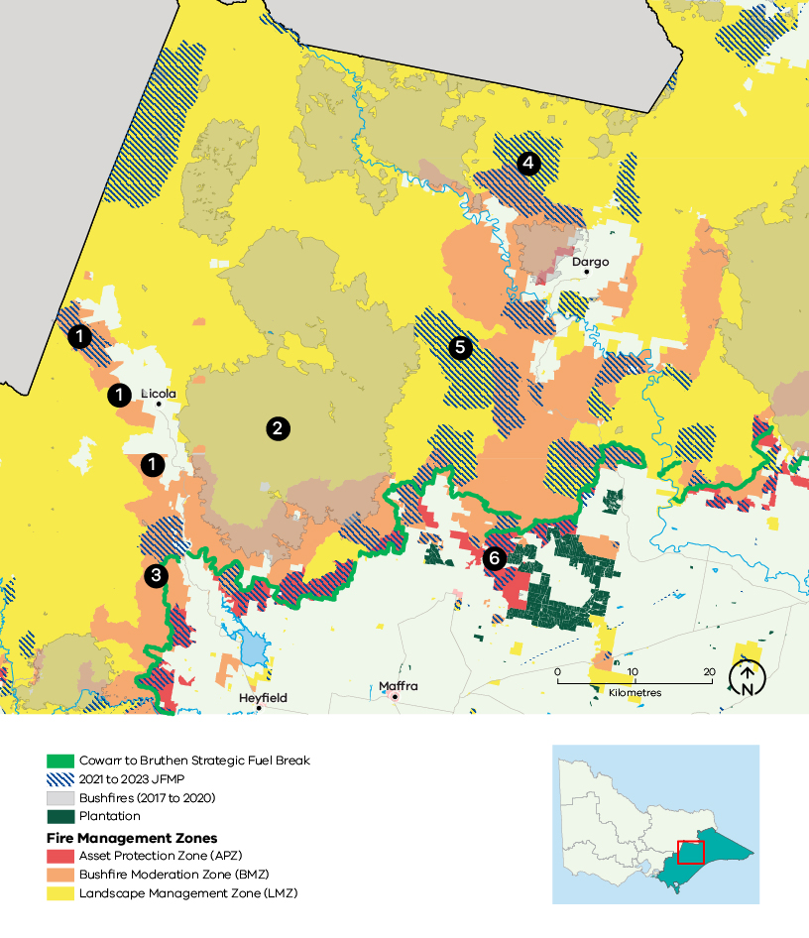

Victoria’s residual risk
We measure the impact of the fuel management on reducing bushfire risk. This measure is called ‘residual risk’. Residual risk is calculated as the percentage of bushfire risk ‘left over’ after fuel in forests has been reduced, either through fuel management activities or bushfires.
Our statewide fuel management target is to keep residual risk at or below 70% of Victoria’s potential maximum bushfire risk. Maximum bushfire risk refers to maximum fuel conditions and extreme bushfire conditions (Forest Fire Danger Index of 130).In practice however, the residual risk is different in different parts of the landscape, due to differences in vegetation, topography and where houses are located. Our fuel management strategy, together with the strategies of all the other regions in Victoria, contributes to achieving the statewide target.
To measure residual risk, we first use the Phoenix RapidFire bushfire simulation software to simulate thousands of bushfires across Victoria under conditions of highest fuel in the landscape and worst-case bushfire weather conditions. We calculate the impacts on houses, based on these simulations, and this is the maximum residual risk. We then simulate a second set of bushfires where we have changed the fuels in the landscape, to allow us to compare the two scenarios and estimate the reduced impact. When measuring current or past residual risk, we include bushfires and planned burns that have occurred to reduce the fuels in the landscape. When we are testing strategies, we model different arrangements of planned burning that might occur by implementing our strategy, for 40 years into the future.
Using Phoenix, we have forecast the performance of our preferred fuel management strategy together with other regions in Victoria. Figure 12 shows changes in residual risk from 1980 to 2060, with projected residual risk values beyond 2020.
Our fuel management program takes us some of the way to managing bushfire risk, however we also manage bushfire risk through other prevention, preparedness and response activities. As yet, we are unable to model the impacts of our other bushfire management actions beyond planned burning in our residual risk metric, including mechanical treatments. We are working to be able to include these and other improvements to the metric in the future.
Figure 12: Statewide residual risk
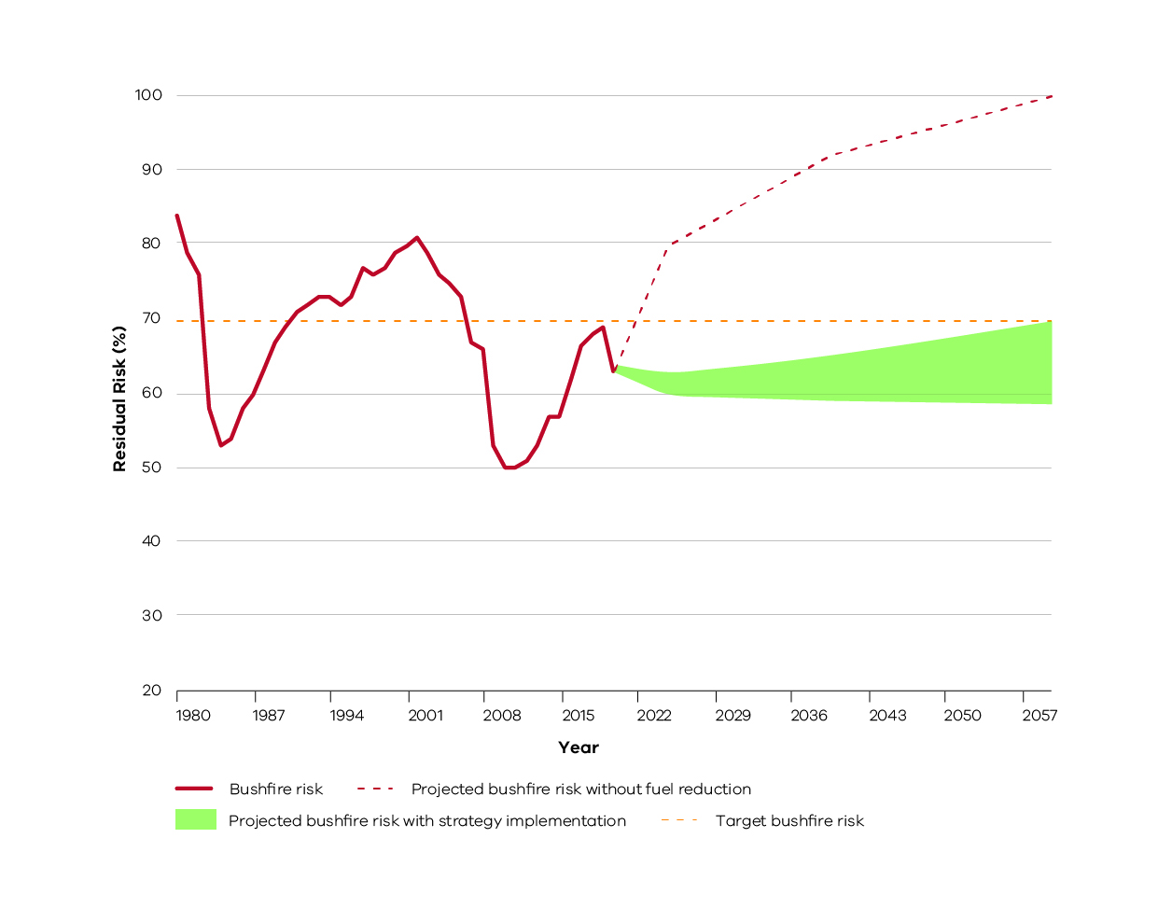
Historic and estimated future residual risk for Victoria. The orange dotted line is the statewide residual risk target (70%). The red line represents historical bushfire risk due to past bushfires and planned burning. The green shaded area is the predicted bushfire risk for the fuel management strategies of all Victorian regions collectively, measured from 2021 to 2060. This represents that there is a range of possible future residual risk values which is dependent on the amount of fuel reduction achieved each year in our region and across Victoria. The red dotted line represents projected increase in bushfire risk without fuel reduction.

Bushfire Risk Engagement Areas
As part of the 2017-2019 strategic bushfire management planning process, land and fire management agencies have undertaken an analysis to define Bushfire Risk Engagement Areas (BREAs). BREAs identify parts of the landscape where managing bushfire fuels is most effective in reducing risk. This helps to indicate the priority areas in our region where we can work with communities to reduce bushfire fuels.
BREAs also help land and fire management agencies, local government and stakeholders to focus conversations about the range of treatment options to reduce bushfire risk. This may include other actions where reducing fuels may not be possible. Over time, on-ground discussions and assessments between agencies and the community determine the treatments that best suit a particular place.
Managing fuels on private and public land begins with a conversation about the benefits, limitations and viability of fuel reduction in a BREA. Complementary or alternative treatments will arise from these discussions. We will work with the community to explore risk treatment options for private land and, where suitable, apply them to complement public land fuel management described in our fuel management strategy. By working together in this way, we will maximise the impact of our collective risk-reduction effort.
It is important to note that BREAs are not legislated planning zones and do not obligate landowners or land and fire agencies to take any action. They cover large areas of public and private land, their boundaries do not align to administrative or cadastral boundaries and are not linked to individual parcels of freehold land.
The Gippsland region’s BREAs are shown in Figure 13.
Figure 13: Bushfire Risk Engagement Areas in the Gippsland region
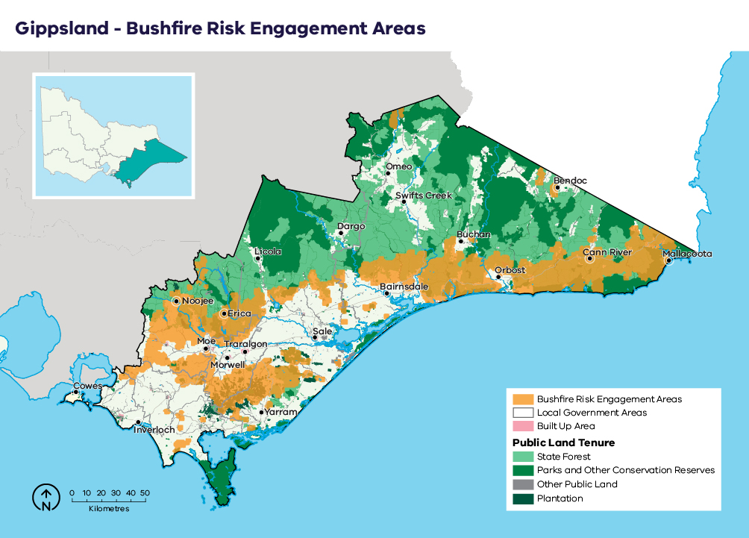

Our pilot strategies
Safer Together is about working as one fire-management sector to estimate the risk reduction from implementing all our strategies, so we can invest in the most effective ways to reduce risk. Planning and delivery of these actions have been continuous over many years, supported by science, fire-management experience and local knowledge.
As part of the Safer Together approach, the region conducted a pilot program using the Phoenix RapidFire modelling that was done for the fuel management strategy to inform and improve approaches of other bushfire risk management strategies. Using the information on how bushfires spread from specified ignition points and impact human life and property under a range of weather scenarios, we developed pilot strategies to:
- minimise bushfires from human-caused ignitions (Priority Prevention Areas [PPAs])
- improve the first-attack suppression of bushfires (Priority Suppression Areas [PSAs]).
The inputs used to create pilot strategies included:
- Phoenix RapidFire fire behaviour simulations and modelled-asset impacts: topography and location of assets (proximity and direction) to potential extreme bushfire behaviour areas; maximum overall fuel hazards and rates of fuel accumulation; and fire-spotting distance, flame height, convective potential and rates of spread under various vales of the Forest Fire Danger Index
- risk assessment including analysis of both ignition and weather likelihood, and historical ignition causes
- resource availability and travel time of resources to attend a going bushfire
- the likelihood of successful suppression (as defined by the Bushfire and Natural Hazards Cooperative Research Centre).
The decision-support tools developed through the pilots complement the fuel management strategy and the Bushfire Risk Engagement Areas. These tools help paint a common picture of risk across multiple administrative boundaries, from the landscape to locality scales. They can also be used in conjunction with risk mitigation planning for fuel management and other bushfire risk management actions to prioritise actions that most effectively reduce risk.

Bushfire prevention of human-caused ignition strategy (pilot)
Of the many ways agencies and communities mitigate bushfire risk, arguably the most effective is to prevent ignitions from occurring. Effective prevention not only reduces risks to human life and property; it also reduces the costs of suppression.
This pilot began work (which is ongoing) to identify priority prevention areas (PPAs). These are areas where the highest-consequence fires are most likely to occur due to human activities. In these areas, medium-term investment in reducing human-caused ignitions can provide the greatest reduction in bushfire risk. To determine these areas, we assessed historical patterns of human-caused bushfire ignitions from escaped burn-offs, deliberate ignitions and campfire escapes, under varying weather conditions.
The aim of identifying PPAs is to inform and improve activities (such as regulation, enforcement and awareness campaigns) that minimise the number of human-caused bushfire ignitions.
Activities in PPAs will be developed in line with relevant legislation and organisational policy and in close consultation with emergency services representatives, park and forest managers and communities.
Figure 14: Pilot Priority Prevention Areas for Gippsland.
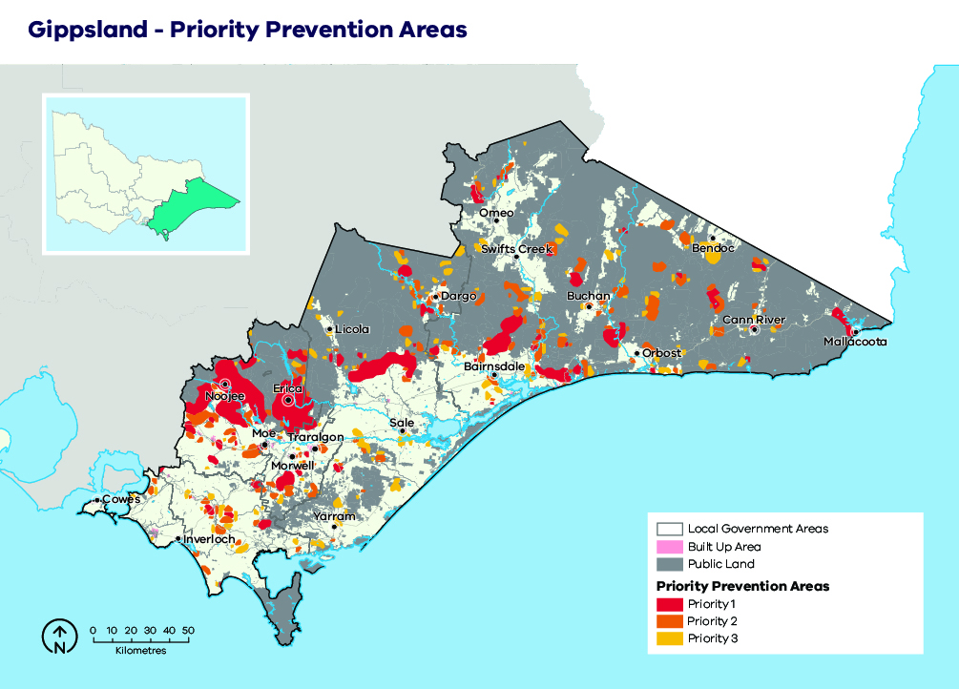
This map provides an example of a suite of maps produced by the pilot to provide decision support tools to guide effective strategic actions to prevent human-caused bushfires.
The Gippsland Region has a well-established program for agencies and industry to work together to reduce human-caused bushfire ignitions, called the Gippsland Arson Prevention Program (GAPP). The GAPP committee includes Victoria Police, CFA, DELWP, HVP Plantations, Latrobe City, Baw Baw Shire, Wellington Shire and the Latrobe Valley power generators. The intent of GAPP is to prevent arson occurring across Gippsland. GAPP has supported the development of PPAs to enhance efforts to effectively target these ignitions as a commitment to communities across Gippsland. GAPP provides education to the public as well as media strategies in a collaborative approach to inform communities about prevention of arson.
PPAs will inform several actions to reduce human-caused bushfire ignitions.

Documenting origin and cause
Understanding how, why, when and where fires are ignited allows for improved strategic decision-making, targeted actions and coordination between agencies and through the GAPP. To improve the accuracy and breadth of strategic prevention planning in future:
- fires will be investigated for their origins and causes by a trained fire investigator
- where there is any cause to expect arson or negligence, firefighters will aim to protect the point of origin for investigation
- statistics on bushfire causes will be analysed regularly and maintained between agencies
- protocols between bushfire management agencies and police will be maintained to ensure a coordinated response to all investigations.

Engagement, education, empowerment
Community education and engagement is a long-term process aimed at creating behavioural changes and empowering the community. Public education programs will be actively maintained by the CFA, local governments and FFMVic across the region. All agencies actively work to improve community knowledge of bushfire behaviour and potential risks, promote the responsible use of fire by the community and actively raise awareness of bushfire threats.
These engagement activities already occur in PPAs across the region and can be further targeted into the future. Actions include communications and publications (such as face-to-face meetings, internet, media releases and other media opportunities), interpretations (such as displays, shows and simulations), school activities, media and advertising, social media presence, and fire conferences and forums.
Additionally, a number of community-based bushfire management (CBBM) projects are running in the Gippsland region, with Mallacoota, Cann River and Bruthen in the eastern part of Gippsland and Briagolong, Moe South and Toongabbie in the western part. These projects are currently undertaken are areas connected with PPAs. CBBM aims to enhance community bushfire knowledge, strengthen relationships and empower the community to take control of their own bushfire risks.

Raising awareness
Scientific literature indicates that increased community awareness not only improves resilience and community responses to a bushfire event, but it also leads to a reduction in total bushfire ignitions. Emergency service agencies already use targeted messaging campaigns (such as the use of variable message boards) to raise awareness of bushfire risks and the fire danger period.
The use of variable message boards and other engagement opportunities to raise community awareness will be used in PPAs across the region. These strategies need to continue to be implemented as part of an integrated, multi-pronged awareness campaign.

Patrol
Emergency services and agencies already undertake regular patrols in strategic areas where barbeques and campfires are used, with efforts tied to known visitor seasonality and fire danger ratings. These patrols aim to provide assistance in the wise and proper use of fire and to ensure compliance with relevant legislation.
The active patrol of PPAs by emergency services personnel can significantly reduce the risks posed by escaped campfires and other non-compliance. PPAs will be used to target patrol routes for maximum risk reduction outcomes where appropriate.

Fuel modification
Agency personnel will, where appropriate and in accordance with legal requirements, direct the owner/occupier of land within a fire-protected area to remove or modify fuels for bushfire prevention purposes, thereby significantly reducing the likelihood of ignition in PPAs.

Burn offs and fire danger period
The CFA declares the fire danger period each year, based on weather and fuel conditions. Compliance with the fire danger period significantly reduces the risk of escaped burn-offs and minimises the threat of ignitions under severe bushfire conditions. Many councils also ban burning-off on certain days or within certain locations, with similar risk-reduction benefits.

Park closures
Prevention of bushfire in high-risk areas is actively managed through the closure of parks and state forests under certain weather conditions. Land management agencies will as necessary declare the closure of areas of public land under section 64 of the Forests Act 1958, during which time the use of fire in the open air is prohibited. This may include seasonal closures or the closure of parks on Code Red bushfire days.

Municipal bushfire prevention
Municipal committees may further identify localised actions that can be informed by these products or similar strategic outputs and work in conjunction with GAPP.

Bushfire first attack suppression strategy (pilot)
The culture and ethos of land and fire management agencies is to suppress and manage bushfires before they do harm, and agencies seek to continuously improve their bushfire suppression techniques and capability using expert knowledge and experience.
First attack suppression aims at reducing the risk of a bushfire spreading in its initial phases. Its success is affected by potential location of ignitions, fire detection capabilities, readiness of agencies to respond and ability of agencies to access the fire.
This pilot developed a method and began work (which is ongoing) to identify Priority Suppression Areas (PSAs): areas where medium-term investment in improved capabilities for first-attack suppression could result in the greatest reduction in bushfire risk. Figure 15 shows Priority Suppression Areas in the region. Identification of these areas also considered travel times from responding agencies’ depots and stations, fire detection times and times taken to begin bushfire suppression works. The strategy also considers actions that can be undertaken to be more effective before a bushfire starts (such as improving road and fire break maintenance, improving fire detection capabilities and enhancing readiness and response protocols).
Figure 15: Pilot Priority Suppression Areas for Gippsland.
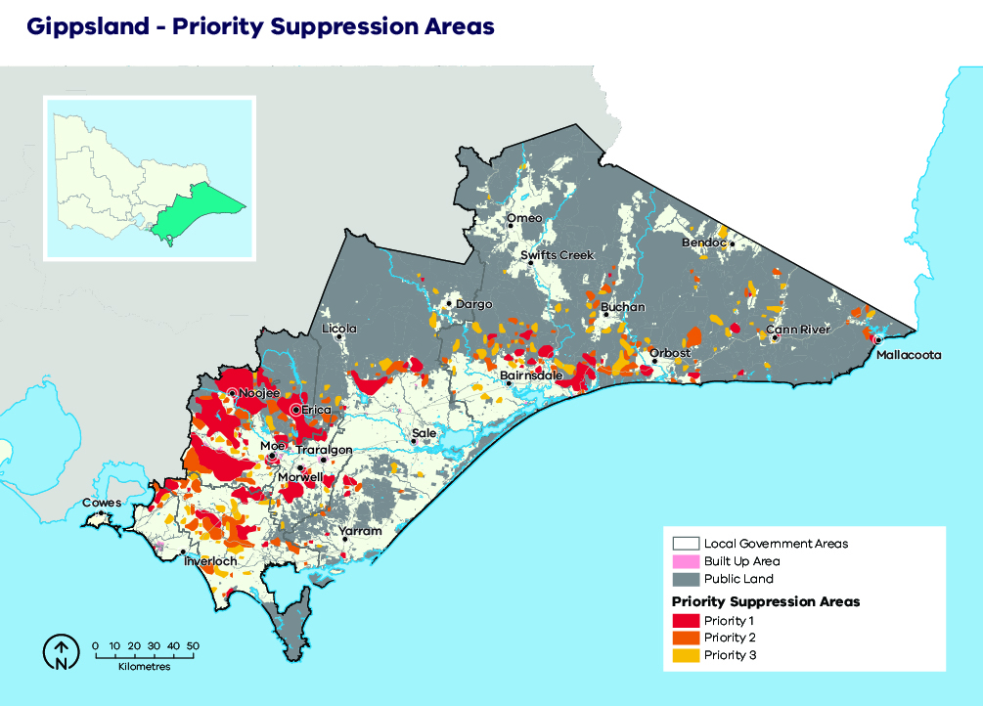
This map provides an example of a suite of maps produced by the pilot to provide decision support tools to guide effective strategic actions to enable suppression of bushfires in first attack.
Priority Suppression Area strategies include the following elements.

Detection time
Early detection is fundamental to reducing bushfire spread and ensuring a successful first attack.
In remote wilderness and alpine areas, a network of fire towers combined with aerial reconnaissance is used to detect fires. In rural and urban interface areas with higher population densities fires are more frequently reported by the community.
Strategies for bushfire detection include:
- maintaining the existing fire tower network to ensure the safety of use and early bushfire detection, and enhancing this network where appropriate in PSAs.
- aerial reconnaissance, particularly on severe fire danger rating days or following lightning events. Improved access to reconnaissance aircraft including numbers may greatly improve the detectability of fires in the remote areas, where lightning-caused fires are a common occurrence
- patrols undertaken by emergency management professionals during days of high fire danger. Increasing the number of patrols by emergency agencies, as well as strategically targeting patrols to PSAs, may considerably improve the time taken to detect bushfires.

Strategic access roads and fire breaks
Ground access to bushfires by firefighters, plant and other machinery is fundamental to efficient and effective suppression of a bushfire event. Ready access requires maintaining a strategic network of roads and tracks, and the construction of additional tracks to complement the existing network where required. PSAs across the region can be used to highlight areas where there is a need for continued maintenance of and a potential need for new access routes. On public land, strategic roads and fire breaks are maintained throughout forests and parks to support firefighter access, in addition to the thousands of kilometres maintained by local governments and VicRoads.
Gippsland has created the Cowwarr to Bruthen Strategic Break to complement the current network for strategic access roads across the landscape. The break has created a safe boundary for firefighters to use for indirect attack on large fires to the north of this line. The break has been aligned as close to the public-private interface as possible, running along the top of ridge lines where practicable.
Strategies to improve access opportunities in PSAs include:
- identification priority strategic roads for access and egress opportunities for firefighters to enhance access and first attack success rates in the region
- all roads and tracks will be where possible maintained and signposted
- new strategic roads and fire breaks will be considered for development where appropriate
- temporary tracks will be constructed to facilitate bushfire suppression and fuel reduction as needed
- aircraft will be used to undertake aerial attack and hold/halt the spread of bushfires until temporary control lines can be established where appropriate.

Enhance firefighter safety and access
Increasingly, hazardous trees are being identified as a risk to firefighter safety, and they continue to inhibit efficient and effective access to fires in tall forests. This issue exists in the PSA that covers large areas of fire killed ash across the region and other areas that have experienced high severity bushfires. Specific procedures have been developed for bushfire suppression in very high tree hazard environments, including mapping of hazardous areas, and safety will be enhanced by their continuous improvement. Training is already provided to accredit advanced fallers in bushfire agencies, and maintaining this program will continue to help address safety and access in these areas. Maintaining existing access to fire-bombing aircraft will similarly continue to assist in creating a safer environment for ground crews. Within the Gippsland region, allocation of additional plant resources (such as tree harvester excavators) may significantly enhance crew safety and access in these potentially hazardous areas.

Resourcing
The most effective strategy for maximising first attack suppression success is to effectively maintain and strategically locate priority firefighting resources across the region. PSAs may be also used to inform the prioritisation and use of rappel crews that are deployed to new fires via helicopter. PSAs may also be used to identify areas where additional machinery may significantly improve firefighting responses. An example of this is the Tambo and Latrobe Fire Districts, where there is a high proportion of fire killed ash requiring specialist equipment to enable more rapid containment. Bushfire management agencies may choose to use PSAs to help identify areas where volunteer recruitment campaigns can be targeted to improve resourcing to CFA stations or to identify priority areas for increasing the coverage and number of seasonal and ongoing/full-time fire-fighters.

Aircraft
Aircraft are used for a variety of purposes in bushfire management operations including detection, reconnaissance, firebombing, asset protection, transport and aerial ignition. The large landmass and dispersed nature of resources and population in the Gippsland Region highlight the fundamental need to maintain adequate access to aerial resources to support ground crews in bushfire management activities. Strategies include maintaining pre-determined dispatch within the region, as well as the maintenance of airstrips, water points and chemical retardant mixing facilities. Specific aircraft support details are in the FFMVic Readiness and Response Plan.
As fires in the Gippsland are often protracted, the use of specialist night bombing aircraft may significantly increase the ability to achieve suppression outcomes towards the end of a first shift. A trial of this method has been undertaken in Victoria. Specific details can be seen in the FFMVic Readiness and Response Plan and PSAs provide a potential focus for future specialist night bombing operations.

Water availability
Many roadside water points are distributed throughout the landscape. These provide an essential local water supply for bushfire suppression and planned burning operations. The location of water points aims to ensure adequate coverage over the public land estate.
Strategies for maintaining and improving water availability include:
- existing water points are to be maintained and improved by deepening and by improving access and signposting where necessary
- where appropriate, a range of strategic water points may be upgraded for use by helitankers
- new water points may be constructed in those parts of the region where access to water is inadequate, particularly in PSAs
- alternate equipment including larger or more water-efficient firefighting equipment/appliances should be investigated where necessary
- Ensure access to contracted water carriers and readiness arrangements, particularly for PSAs.

Implementation
Implementation of this bushfire management strategy will occur through the Joint Fuel Management Program (JFMP) prepared by FFMVic and CFA, as well as a range of agency-specific operational plans.
The fuel management strategy described here directly informs the development of the JFMP, and it is through the implementation of this program that bushfire risk in Gippsland will be maintained in line with the state residual risk target, in a manner which balances outcomes for multiple values.
Fuel management on private land, where appropriate and with landholder permission, will form part of the overall JFMP and will reduce bushfire risk in Gippsland even further.
The JFMP prepared by FFMVic and CFA is also informed by the Victorian Traditional Owner Cultural Fire Strategy.
Our bushfire management strategy can also help inform actions in municipal fire management plans.
The implementation of Bushfire Risk Engagement Areas will be undertaken by all agencies working together with the community. BREAs assist agencies to plan where to engage with communities about fuel management where it is most effective to reduce bushfire risk or explore alternative options to reduce that risk.
Figure 16: Schematic representation of the strategy’s influence on implementation programs and plans
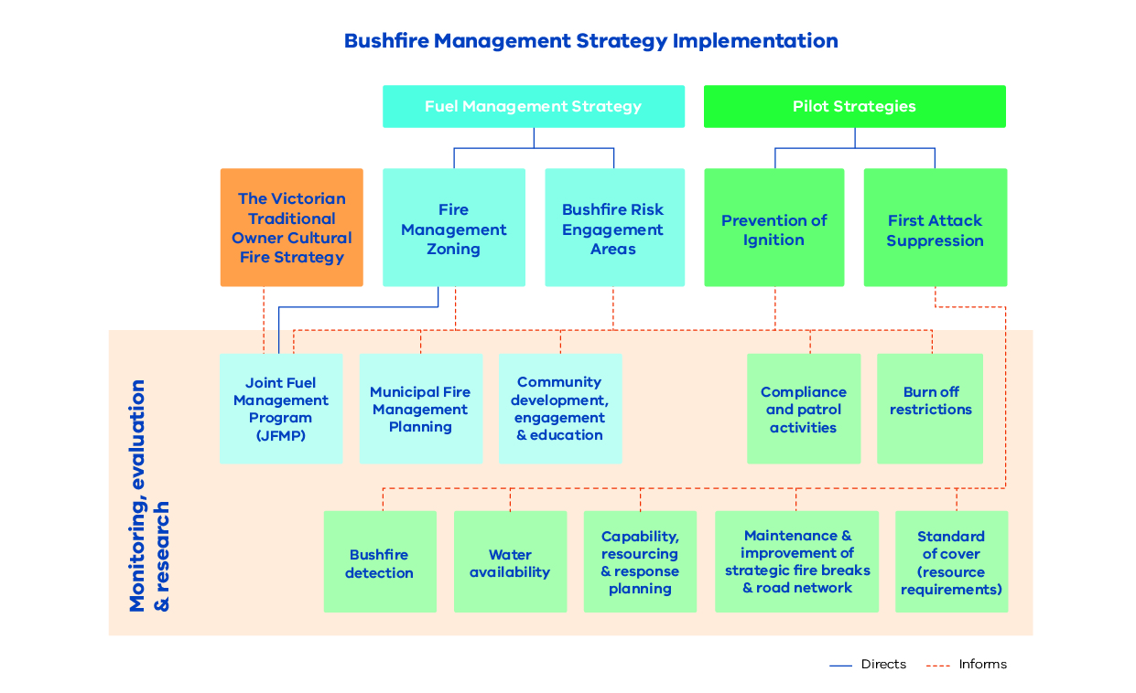

Monitoring, evaluation and reporting
Regional monitoring, evaluation and reporting (MER) enables us to measure how our strategies and actions are performing against the regional objectives set out in this bushfire management strategy. This is achieved by developing key evaluation questions that we will use to measure success against our objectives and enable reporting and improvements. The MER process ensures transparency and supports adaptation of management practices to achieve improved outcome from bushfire management to our important values. Key evaluation questions and the process for addressing them will be developed in MER plans by individual agencies.
An MER plan can also identify key knowledge gaps and prioritise research and monitoring activities to address them. MER plans ultimately improve risk-based planning and decision-making, helping to guide future resource and funding allocation.
Individual agencies will be responsible for the MER of their own work programs and the activities that they deliver. The spirit of collaboration will continue between agencies, such as identifying and addressing knowledge gaps that cross tenure boundaries.
FFMVic’s MER program is guided by the Monitoring, Evaluation and Reporting Framework for Bushfire Management on Public Land (MER Framework), which aims to assess how well management activities across Victoria are achieving the two objectives of the Code of Practice. Information on FFMVic’s annual fuel management monitoring and reporting can be found in Managing Victoria’s Bushfire Risk: Fuel Management Report.

Appendix 1: Program logic
Table 4: Gippsland Bushfire Management Strategy 2020 program logic
Vision | Safer and more resilient communities
Policy context | The Victorian Preparedness Goal is A safer and more resilient community that has the capabilities to withstand, plan for, respond to and recover from emergencies that pose the greatest risk.  The Safer Together policy’s four priorities for reducing the risk of bushfires in Victoria are Community first, Land and fire agencies working together, Measuring success and Better knowledge = better decisions.
Strategic objectives | To minimise the impact of major bushfires on human life, communities, essential and community infrastructure, industries, the economy and the environment. Human life will be afforded priority over all other considerations.  To maintain or improve the resilience of natural ecosystems and their ability to deliver services such as biodiversity, water, carbon storage and forest products.
Gippsland region values | Human life |  | Wellbeing:  individual, social, cultural |  | Nature:  biodiversity and ecosystem function
Gippsland region objectives | - Minimise human life loss and serious injury | - Minimise social, livelihood and economic disruption | - Minimise disruption to essential services and critical infrastructure | - Minimise loss of community and cultural assets | - Minimise decline in native plant and animal populations
Outcomes | - Residual risk in Gippsland is maintained below 71% through to 2050  - Reduce the occurrence, size and severity of future landscape bushfires | - Risk reduction is provided for communities throughout Gippsland  - Economic loss from bushfire is reduced through to 2050 | - Disruption or loss of infrastructure assets due to bushfire is reduced through to 2050 | - Loss of community and cultural assets due to bushfire is reduced through to 2050 | - The area of native vegetation planned to be burnt below minimum TFI for the first time does not exceed the thresholds set for the strategy by 2050  - The number of fauna species declining does not exceed the thresholds set for the strategy by 2050
Outputs | - Annual residual risk report  - Graphs, tables, reports showing modelled outcomes of future planned fuel treatment activities, and assessment against strategy thresholds |  | - Graphs, tables, reports showing modelled outcomes of future planned fuel treatment activities |  | - Graphs, tables, reports showing modelled outcomes of future planned fuel treatment activities, and assessment against strategy thresholds
Activities | - Annual identification of priority areas for fuel treatment to reduce residual risk across Gippsland | - Annual identification of priority areas for fuel treatment to reduce residual risk to communities |  |  | - Annual identification of priority areas for planned burning or planned burning exclusion to improve the relative abundance of fauna species  - Annual identification of priority areas to exclude planned burning to minimise area burnt below minimum TFI for the first time
- Plan and finalise Gippsland JFMP
- Implement Gippsland JFMP in accordance with annual requirements
Inputs/ resources | Address point spatial data  First attack suppression modelling | Locality spatial data  Spatial data for commodities of agricultural land, public land available for timber production, private plantation, private land with built assets | - VFRR-B | - Victorian Aboriginal Heritage Register  - Aboriginal Cultural Heritage Register and Information System site information | - Fauna species habitat models and fire response data  - Draft Environment Protection and Biodiversity Conservation Act significant impact thresholds (fauna)  - TFIs
- Data and information (modelled and actual) including fire history, fuel accumulation, weather, topography, vegetation treatability, future ‘fire histories’
- Appropriate software/ tools (Phoenix RapidFire, FAME, RStudio)
- Time and expertise
Assumptions | - Address points correlate to houses | - The threshold for residual risk of localities is appropriate  - Impact thresholds for commodities are suitable  - Exclusion of economic gain from bushfire is appropriate | - The premise for assigning unassigned asset types to asset categories is sound | - Impact thresholds assigned are suitable | - The thresholds used to determine declines in fauna species are appropriate  - Minimising the area burnt below minimum TFI for the first time has a direct relationship with minimising the decline in flora species  - The ability to minimise declines in native plant and animal species will not be impeded by factors currently out-of-scope (e.g. drought, climate change, introduced species, etc)
- All data, models and information are fit for purpose and accurate
- Fuel treatments and associated objectives are achievable and result in effective risk reduction
- The methods used to monitor the annual performance of the strategy are appropriate for predicting long-term success

References
Aboriginal Victoria. (2019). Aboriginal Cultural Heritage Information System. Retrieved from Aboriginal Victoria: https://achris.vic.gov.au/#/onlinemap
Arthur Rylah Institute. (2019). Fire Analysis Modules for Ecological Values (FAME). Retrieved from https://www.ari.vic.gov.au/research/fire/fire-analysis-module-for-ecological-values-fame
Australian Institute for Disaster Resilience. (2015). National Emergency Risk Assessment Guidelines. Retrieved from Australian Institute for Disaster Resilience: https://knowledge.aidr.org.au/media/2030/handbook-10-national-emergency-risk-assessment-guidelines.pdf
Bunurong Land Council Aboriginal Corporation. (2019). Bunurong Land Council . Retrieved from Bunurong Land Council : https://www.bunuronglc.org/
Bushfire Cooperative Research Centre. (2010). Phoenix Rapid Fire. Retrieved from Bushfire Cooperative Research Centre: http://www.bushfirecrc.com/resources/poster/phoenix-rapidfire-%25E2%2580%2593-bushfire-simulator-and-risk-assessment-decision-support-tool
Country Fire Authority Victoria. (2019). Major Fires. Retrieved from Country Fire Authority: https://www.cfa.vic.gov.au/about/major-fires
Department of Environment Land Water and Planning. (2019). Black Friday. Retrieved from Forest Fire Management VIctoria: https://www.ffm.vic.gov.au/history-and-incidents/black-friday-1939
Department of Environment Land Water and Planning. (2019). History and Incidents. Retrieved from Forest Fire Management Victoria: https://www.ffm.vic.gov.au/history-and-incidents/
Department of Environment Land Water and Planning. (2019). Joint Fuel Management Program. Retrieved from Fores Fire Management Victoria: https://www.ffm.vic.gov.au/bushfire-fuel-and-risk-management/joint-fuel-management-program
Department of Environment, Land, Water & Planning (2015), Monitoring, Evaluation and Reporting Framework for Bushfire Management on Public Land. Retrieved from: https://www.ffm.vic.gov.au/__data/assets/pdf_file/0021/25734/BushfireMER_Framework_WEB.pdf
Department of Environment, Land, Water and Planning. (2019). Strategic Bushfire Management Planning Process Technical Methods Reference Document - Gippsland Region. Traralgon: Department of Environment, Land, Water and Planning.
Department of Home Affairs. (2018). Deconstructing Disaster: The strategic case for developing an Australian Vulnerability Profile to enhance national preparedness - March 2017. National Resilience Taskforce. Australian Government.
Department of Sustainability and Environment. (2012). Code of Practice for Bushfire Management on Public Land. Retrieved from Forest Fire Management Victoria: https://www.ffm.vic.gov.au/__data/assets/pdf_file/0025/25747/Code-of-Practice-for-Bushfire-Management-on-Public-Land-1.pdf
Emergency Management Victoria. (2020). Victorian Fire Risk Register - Bushfire (VFRR - B). Retrieved from https://www.vfrr.vic.gov.au/
Forest Fire Managment Victoria. (2020). Managing Victoria’s Risk - Fuel Management Report 2018-19. Retrieved from https://www.ffm.vic.gov.au/fuel-management-report-2018-19
Gippsland Regional Strategic Fire Management Planning Committee. (2014, September 30). Gippsland Regional Strategic Fire Management Plan. Retrieved from Emergency Management Victoria: https://files-em.em.vic.gov.au/public/EMV-web/Gippsland-Regional-Strategic-Fire-Management-Plan.pdf
Gunaikurnai Land and Waters Aboriginal Corporation. (2019). Gunaikurnai Land and Waters Aboriginal Corporation Website. Retrieved from Gunaikurnai Land and Waters Aboriginal Corporation Website: https://gunaikurnai.org/
International Organization for Standardization. (2019). ISO 31000 RISK MANAGEMENT. Retrieved from ISO: https://www.iso.org/iso-31000-risk-management.html
Nindi-Ngujarn Ngarigo Monero Aboriginal Corporation. (2019). Nindi-Ngujarn Ngarigo Monero Aboriginal Corporation. Retrieved from Nindi-Ngujarn Ngarigo Monero Aboriginal Corporation: https://nnnmac.com.au/
Victorian Government. (2019). Gippsland Bushfire Management Planning. Retrieved from Engage Victoria: https://engage.vic.gov.au/bushfire-planning/gippsland
Victorian Government. (2020). Safer Together: Our approach to reducing the risk of bushfire in Victoria. Retrieved from https://www.safertogether.vic.gov.au/
Victorian Traditional Owner Cultural Fire Knowledge Group. (2018). Victorian Traditional Owner Cultural Fire Strategy. Retrieved from https://www.ffm.vic.gov.au/bushfire-fuel-and-risk-management/traditional-owner-burns

Department of Home Affairs, 2018
During the consultation phases of this strategic planning process, these areas were called ‘Priority Fuel Management Areas’ (PFMAs). They have since been renamed to provide greater clarity as to their intended use. Feedback and comments received during the planning process from stakeholders and community members relating to PFMAs have been incorporated into designing the BREA strategy.

