# **Community Based Bushfire Fuel Management Plan**

# **[Insert Name]**

**Background**

This Bushfire Fuel Management Plan was prepared by the [Insert Name] Fuel Management Working Group.

The Working Group consisted of representatives of: [Insert details]; (list all agencies and groups involved).

**Purpose**

The purpose of this Plan is to contribute to the safety of people seeking shelter in the 'safer centre' of [Insert Name] and ensure the viability and sustainability of the [Insert Name] Township from the impact of bushfires.

This Plan:

* Identifies Fuel Management Zones on private and public land (including fuel management exclusion zones);
* Details Fuel management actions appropriate to manage bushfire hazard;
* Assigns responsibility and timings for action;
* Records completed actions and reviews.

**Authorisation**

The [Insert Name] Bushfire Fuel Management Plan was presented to, and endorsed by interested community members on: ……………

The Plan was adopted by the [Insert Name] Municipal Fire Management Planning Committee (Insert Name MFMPC) on: ..........................

**Review**

**Annually**: The actions defined in this Plan will be reviewed annually by the [Insert Name] MFMPC.

**5 yearly:** The Plan will be reviewed every five years with regard to:

* Fire and risk modelling
* Completion of actions
* Appropriateness of Fuel Management Zones and risk treatment actions

**The next 5 year review is due on ……………….**

**References**

(List of relevant fire management plans this community plan links to)

*(Insert map of agreed fuel management zones developed by working group)***Action Plan**

|  |  |  |  |  |
| --- | --- | --- | --- | --- |
| Action | detail | Timing | Responsibility | Completed/reviewed |
| Fire hazard Inspections | targeting APZ & BMZ | Annually | [Insert Name] Council |  |
| Planned Burning | Burn Unit XX | 20XX | Parks Victoria |  |
| Burn Unit YY | 20XX | Melbourne water |  |
| Property Address | 20XX | [Insert Name] Fire Brigade |  |
|  |  |  |  |
|  |  |  |  |
| Mechanical Vegetation Modification |  |  |  |  |
|  |  |  |  |
|  |  |  |  |
|  |  |  |  |
|  |  |  |  |
| Grazing |  |  |  |  |
|  |  |  |  |
|  |  |  |  |
|  |  |  |  |
|  |  |  |  |
| Other? |  |  |  |  |
|  |  |  |  |
|  |  |  |  |

**(Insert Name of township/settlement)**

**Bushfire Fuel Management Plan**

Information for Residents

Developed and prepared by the

(Insert name of community working group)

*(Insert fuel management zones map from Bushfire Fuel Management Plan*

# Working together to reduce bushfire fuels

The [Insert Name] Bushfire Fuel Management Plan has been developed by a Working Group of community members, (list all agencies and groups involved).

# What does the [Insert Name] Bushfire Fuel Management Plan do?

The [Insert Name] Bushfire Fuel Management Plan identifies areas where fuel reduction is important to protect our town and community. It also identifies areas where fuel management may not be appropriate, or where natural values should be preserved.

Having a coordinated and agreed fuel management plan for [Insert Name] will help:

* protect the township of [Insert Name]
* reduce spot fires within the area
* reduce house-to-house ignitions
* protect the majority of critical community assets including schools, shops, and halls
* protect the majority of homes within the township
* provide greater safety to people (residents and visitors) seeking shelter in [Insert Name]
* ensure that critical community infrastructure remains viable to aid the recovery of our community after a fire has passed.

|  |
| --- |
| Important Note   * The Plan identifies areas where bushfire fuel management will be targeted to reduce bushfire risk to our community. * It is not designed to protect individual properties or houses (although many properties will benefit from this plan). **The responsibility for the protection of individual properties rests with individual property owners**. * Information on preparing and protecting your own property is readily available from the CFA and [Insert Name] Council |

# What is bushfire fuel?

Anything in the open that can burn, will add to the intensity of a bushfire. This includes all forms of vegetation, ground litter, and even houses. In managing the intensity of bushfires, most emphasis is placed on managing 'fine fuels' – plant material that is less than 6mm in diameter. Fine fuels dry out quickly, ignite easily, release all their energy in a short time and can be carried as embers.

While the amount of fine material is important, more important is its arrangement, both horizontally and vertically. For example, modifying middle storey vegetation will reduce the chances of flames getting into the tree canopy, while clumping vegetation and separating clumps by 10 metres with paths or managed grassed areas will change the way fire moves across the area. Clumps should not be bigger than 10 metres.

# About This Resident Information Pack

This information has been developed to inform residents about the [Insert Name] Bushfire Fuel Management Plan and how to contribute to bushfire fuel management in reducing bushfire risk to the [Insert Name] township and community.

A copy of the [Insert Name] Bushfire Fuel Management Plan is available on the [Insert Name] Council website: [Insert web address] or by contacting the Council’s emergency management team.

# Managing bushfire fuel

|  |
| --- |
| Important Note   * **Nothing in this fuel management plan removes the obligation for land owners to comply with all native vegetation protection regulations. Further information is available at [Insert Name] Council** * Exemptions may apply, particularly for the management of vegetation in close proximity to houses. Contact [Insert Name] Council for further information. |

Reducing the fine fuels that contribute to the bushfire risk can be undertaken in a number of ways. Many properties in [Insert Name] will already achieve a reduced bushfire risk through everyday gardening and property maintenance.

Where fuel management is required, it might be undertaken by:

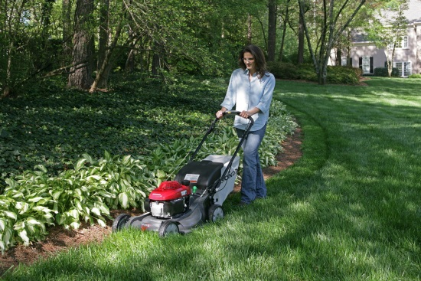Mowing & Slashing

Mowing and slashing, are effective in reducing the amount of fuel and changing the arrangement of grasses and undergrowth.

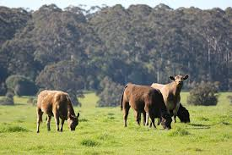Grazing

Grazing is a very efficient, low cost way of managing fine fuels (grass). Best applied in existing pasture areas, grazing is not appropriate in areas of native vegetation.

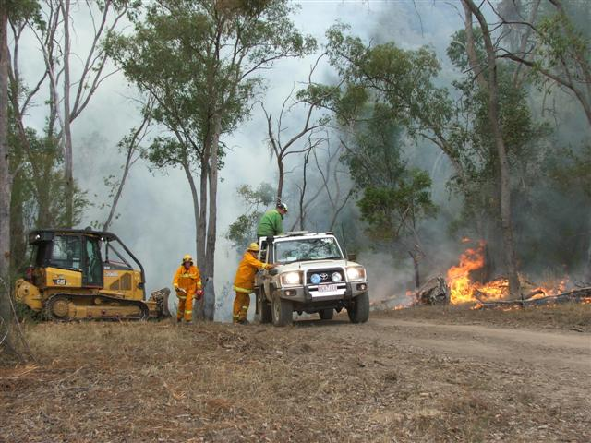Planned Burning

Using fire to reduce fuel is an option. Significant knowledge and skill is required to undertake planned burning and property owners should seek the advice of the CFA before undertaking any fuel reduction burning. (Contact CFA’s Vegetation Management Officer on [Insert Number])

# Enforcement and Exemptions

Where the bushfire fuel conditions on individual properties create a risk to the broader community, property owners may be served a Fire Prevention Notice under the CFA Act; which will detail specific fuel reduction actions the property owner must undertake. Failure to comply with Fire Prevention Notices may result in significant fines with the required work being undertaken by contractors.

Where properties are managed for ecological/biodiversity objectives, property owners are able to seek variations from the recommended fuel management strategy. If you would like to discuss variations for your property, call the Municipal Fire Prevention Officer at [Insert Name] Council.

# [Insert Name] Bushfire Fuel Management Plan

*(Insert fuel management zones map from Bushfire Fuel Management Plan)*

# What does it mean for you as a property owner?

|  |  |  |  |
| --- | --- | --- | --- |
|  | Asset Protection Zone |  | Landscape Management Zone |
|  | Bushfire Moderation Zone |  | Fuel Management Exclusion Zone |

**you as a property owner?**

If you live in the Asset Protection Zone (APZ)

The **Asset Protection Zone** is targeted to provide the greatest level of protection to the majority of community assets. Bushfire fuel management will be intense and the aim is to have very high fuel reduction across 90% of the area.

|  |  |
| --- | --- |
| **Example** | **Fuel Management** |
| DSC00234 | Gardens   * Garden maintenance * separated garden beds * grass mown to less than 10 cm * low flammability plants (see [**https://www.cfa.vic.gov.au/plan-prepare/landscaping**](https://www.cfa.vic.gov.au/plan-prepare/landscaping)for details) * minimal leaf litter |
| DSC00219 | Bushland areas   * middle storey (shrub layer) removed or heavily modified * grass slashed * minimal ground fuel |
|  | Roadsides   * Residents need to contact the appropriate road authority prior to conducting any work on roadsides. |

If you live in the Bushfire Moderation Zone (BMZ)

**Bushfire Moderation Zones** supports Asset Protection Zones by reducing bushfire intensity and the potential for embers. Fuel management is less intense than in the APZ, with more consideration for ecological outcomes. The aim is to have high bushfire fuel management across 80% of the area.

|  |  |
| --- | --- |
| **Example** | **Fuel Management** |
|  | Gardens   * clumped plantings with paths and grassed area separating plantings * reduced middle storey |
| G:\Photos\IMG_8133.JPG | Bushland areas   * middle storey (shrub layer) removed or heavily modified * bark fuels modified * ground fuels slashed or burnt every few years |
| C:\Users\Owner\AppData\Local\Microsoft\Windows\Temporary Internet Files\Content.Word\DSC00230.jpg | C:\Users\Owner\AppData\Local\Microsoft\Windows\Temporary Internet Files\Content.Word\DSC00222.jpg |

If you live in the Landscape Management Zone (LMZ)

All areas not identified as APZ, BMZ or Fuel Management Exclusion Zones are considered as **Landscape Management Zones.** Landscape Management Zones identify areas which are less critical for managing the bushfire threat to the town, and may have significant ecological or cultural values. Vegetation management by planned burning may be undertaken to improve ecosystem health, and will also have fuel reduction outcomes. Fuel management is to be undertaken less frequently, based on the needs of endemic species.

|  |  |
| --- | --- |
| **Example** | **Fuel management** |
| C:\Users\Owner\AppData\Local\Microsoft\Windows\Temporary Internet Files\Content.Word\DSC00231.jpg | Wet gullies   * may have significant ecological value and fire sensitive plants * difficult to undertake planned burning or mechanical fuel management   because of high moisture, generally pose lower bushfire risk.   * sometimes removal of woody weeds may contribute to fuel reduction |
| C:\Users\Owner\AppData\Local\Microsoft\Windows\Temporary Internet Files\Content.Word\DSC00226.jpg | Bushland areas   * may have significant ecological value * plant species may benefit from occasional planned burns * reduction in bark hazard may support bushfire protection. |
| C:\Users\Owner\AppData\Local\Microsoft\Windows\Temporary Internet Files\Content.Word\DSC00238.jpg |

Fuel Management Exclusion Zone (FMEZ)

FMEZs identify areas where the ecological values are so high that vegetation management should not be undertaken for the purposes of bushfire protection. They also identify areas where undertaking fuel management may lead to increases in risks such as landslip or erosion.

|  |  |
| --- | --- |
| **Example** | **Fuel management** |
| G:\Photos\IMG_8098.JPG | Bushland areas   * no planned bushfire fuel management * sometimes removal of woody weeds may reduce fire risk |

**Further assistance (who to call for help or more information)**

# More information?

[Insert Name] Council

* (insert internet, email and phone contact details)

Country Fire Authority

* (insert internet, email and phone contact details)

[Insert Name] Community Group/Others

* (insert internet, email and phone contact details)