Barwon South West Bushfire Management Strategy 2020
  - Fuel Management Bushfire Risk Engagement Areas

Acknowledgements
We acknowledge and respect Victoria’s Traditional Owners as the original custodians of the state’s land and waters, their unique ability to care for Country and deep spiritual connection to it. We honour Elders past and present, whose knowledge and wisdom has ensured the continuation of culture and traditional practices.
We are committed to genuinely partner and meaningfully engage with Victoria’s Traditional Owners and Aboriginal communities to support the protection of Country, the maintenance of spiritual and cultural practices and their broader aspirations in the 21st century and beyond.
We thank our colleagues and partners in the following organisations who provided valuable input at planning workshops and provided data or expert knowledge supporting this project: Aboriginal Victoria; Agriculture Victoria; Birdlife Australia; Borough of Queenscliffe; Barwon Water; City of Greater Geelong; City of Warrnambool; Country Fire Authority; Department of Environment, Land, Water and Planning; Emergency Management Victoria; Great Ocean Road Tourism; Gunditj Mirring Traditional Owners Aboriginal Corporation; Landcare; Parks Victoria; Regional Development Victoria; Regional Roads Victoria; Forest Owners Conference; shires of Colac Otway, Corangamite, Glenelg, Moyne, Southern Grampians and Surf Coast; United Dairy Farmers of Victoria; Vic State Emergency Service; Victorian Council of Churches Emergencies Ministry; Vision Australia; and Wannon Water.
We also thank the community members who participated in focus groups and completed surveys as part of developing this strategy.

Authors
Tim Gazzard, Catherine McLeod, Chris Medlin, Michael Baker, Hamish Martin, David Rourke
Aboriginal people should be aware that this publication may contain images or names of deceased persons in photographs or printed material.

Photo credit
Nathan Christian, FFMVic
© The State of Victoria Department of Environment, Land, Water and Planning 2020
This work is licensed under a Creative Commons Attribution 4.0 International licence. You are free to re-use the work under that licence, on the condition that you credit the State of Victoria as author. The licence does not apply to any images, photographs or branding, including the Victorian Coat of Arms, the Victorian Government logo and the Department of Environment, Land, Water and Planning (DELWP) logo. To view a copy of this licence, visit http://creativecommons.org/licenses/by/4.0/

Printed by
ISBN 978-1-76105-010-7 (print)
ISBN 978-1-76105-011-4 (pdf/online/MS word)

Disclaimer
This publication may be of assistance to you but the State of Victoria and its employees do not guarantee that the publication is without flaw of any kind or is wholly appropriate for your particular purposes and therefore disclaims all liability for any error, loss or other consequence which may arise from you relying on any information in this publication.

Accessibility
If you would like to receive this publication in an alternative format, please telephone the DELWP Customer Service Centre on 136186, email customer.service@delwp.vic.gov.au or via the National Relay Service on 133 677 or at www.relayservice.com.au. This document is also available on the internet at www.delwp.vic.gov.au.

Contents
Abbreviations and Definitions 5
Introduction 6
Our shared responsibility to mitigate bushfire risk 7
Recognising the role of Victoria’s Traditional Owners 8
Bushfire management planning 8
Strategic planning 9
Operational and tactical planning 9
Other bushfire management actions 9
About this bushfire management strategy 10
Method overview 11
Identifying and assessing risk to values and assets 12
Our landscape context 12
Bushfire history and patterns 14
How our worst bushfires behave 15
Values and assets 17
Human landscape 17
Aboriginal cultural heritage 18
Natural landscape 19
Our objectives 21
Our risk management approach 22
Risk in Barwon South West Region 22
Higher risk areas in Barwon South West 23
Lower risk areas in Barwon South West 23
Why model house loss? 24
How do we model house loss? 24
Our fuel management strategy 25
Fire Management Zones 25
Ecosystem resilience 27
About our fuel management strategy 28
Victoria’s residual risk 31
Bushfire Risk Engagement Areas 32
Implementation 34
Monitoring, evaluation and reporting 38
Appendix 1: Program logic 40
References 44

Abbreviations and Definitions
Abbreviation | Term
APZ | Asset Protection Zone  an area around properties and infrastructure where we intensively manage fuel to provide localised protection to reduce radiant heat and ember attack on life and property in the event of a bushfire
BMZ | Bushfire Moderation Zone  an area around properties and infrastructure where we manage fuel to reduce the speed and intensity of bushfires and to protect nearby assets, particularly from ember attack in the event of a bushfire
BREA | Bushfire Risk Engagement Area  part of the landscape, on public and private land, where managing bushfire fuels is most effective in reducing risk. It guides agencies and communities working together to determine the best actions in their local area
BSWFSC | Barwon South West Fire Sub-Committee
CAR | Comprehensive, Adequate and Representative reserve system
CFA | Country Fire Authority
DELWP | Department of Environment, Land, Water and Planning
EMV | Emergency Management Victoria
FFMVic | Forest Fire Management Victoria  comprised of staff from DELWP, PV, Melbourne Water and VicForests when working in bushfire management on public land
FMZ | Fire Management Zone  for fuel management purposes, public land in Victoria is classified into four fire management zones: asset protection zone, bushfire moderation zone, landscape management zone, and planned burning exclusion zone
FSW | Far South West
GMA | Geometric Mean Abundance  an index of the relative abundance of species within a community. As the relative abundance of species changes, so too does the GMA, and this can be used as a measure of resilience
GSS | Growth Stage Structures  the vegetation GSS of an area is its mix of vegetation of different ages, from juvenile to old. Vegetation’s GSS depends on when it was last burnt or otherwise disturbed. We assume that a diversity of GSSs and habitats across a landscape ensures a diversity of species, which helps maintain and improve ecosystem resilience
Ha | Hectares
JFMP | Joint Fuel Management Program
LMZ | Landscape Management Zone  an area where we manage fuel to minimise the impact of major bushfires, to improve ecosystem resilience and for other purposes (such as to regenerate forests and protect water catchments)
MER | Monitoring, Evaluation and Reporting
PBEZ | Planned Burning Exclusion Zone  an area where we try to avoid planned burning, mainly because ecological assets in this zone are primarily intolerant to fire
PV | Parks Victoria
RAP | Registered Aboriginal Party
Residual risk | the amount of risk that remains after bushfires and fuel management activities reduce fuel. Residual risk is used by DELWP as a performance measure
RSFMPC | Regional Strategic Fire Management Planning Committee
SDM | Structured Decision Making
SeRtBC | South-eastern Red-tailed Black Cockatoo
TFI | Tolerable Fire Interval  a term which expresses the minimum or maximum recommended time intervals between successive fire disturbance events at a site or defined area for a particular vegetation community. The time interval is derived from the vital attributes of plant species that occupy the vegetation community. The TFIs guide how frequent fires should be in the future to allow the persistence of all species at the site or defined area
VFRR-B | Victorian Fire Risk Register – Bushfire

Introduction
Victoria is one of the most bushfire-prone areas in the world. Victorians are accustomed to living with bushfire risk, which is the likelihood and consequence of bushfires. It includes the likelihood of a fire starting and spreading across the landscape, and the consequences of it impacting the things we value: people, communities, houses and farms, infrastructure, our economy and the natural environment.
Bushfires are driven by three key factors – fuel, weather and topography – which together make up the ‘fire behaviour triangle’. These three factors combine to affect how a bushfire behaves: how fast it travels, where it spreads, and how intensely it burns. Fuel management is important, because it is the only element of the fire behaviour triangle that we can influence.
Bushfire fuels are the leaves, bark, twigs and shrubs that are burnt by fire. The fuel type, dryness, size, moisture content and arrangement can all affect the speed, size and intensity of a bushfire. Fuel management includes planned burning — lighting and managing planned fires in the landscape — and mechanical treatment — mowing, slashing, mulching and using herbicides. Fuel management activities reduce the amount of fuel across our landscape, decreasing the fire behaviour of bushfires, helping limit their spread and intensity when they occur, and making it easier for our firefighters to control them and lessen their impacts.
Bushfire risk is influenced not only by how a bushfire behaves, but also by how fire impacts the different things that we value. For example, population growth in and near forested areas increases the bushfire risk, as more people enter areas where major bushfires are more likely to impact. The Victorian community is changing in other ways, with an aging population and decreases in volunteering in some areas, leading to an increase in vulnerability to bushfire. For plants and animals, drought, invasive species incursion, as well as habitat loss and fragmentation increase the susceptibility to negative bushfire impacts.
Our changing climate – bringing rising average temperatures, more hot days and less rainfall – means bushfire risk is constantly increasing as fuels dry out and extreme fire weather events increase. Bushfires with the worst consequences typically occur during extreme weather conditions (such as during very hot, dry and windy periods). The disastrous 2019–20 bushfire season, followed periods where parts of Eastern Australia – extending from Tasmania through Victoria, New South Wales and into Queensland – had experienced their driest conditions on record. Over 1.5 million hectares (ha) in Victoria were burnt and large areas of eastern Australia impacted.
In Victoria, climate change is forecast to:
- extend the bushfire season
- make bushfires larger, more severe, and more frequent
- make days with an elevated fire danger rating more frequent
- extend the area that experiences extreme weather conditions, increasing the frequency of these for communities that may have never or have only infrequently experienced such conditions
- start the bushfire season earlier, with more bushfires starting in spring (which may also change fire weather conditions that are experienced, such as wind speed and direction)
- further strain available resources and capacity as the bushfire season increasingly overlaps with suitable weather periods for planned burning.
The impacts of climate change on fire-sensitive habitats and refugia for plants and animals will become increasingly important to manage.
With climate change making many extreme weather events more frequent and more extreme, the impacts on communities are also likely to increase. Of 15,700 disasters between 1980 to 2015, 91% were weather related, and 51% of fatalities and 79% of economic losses were caused by weather related extremes.

Our shared responsibility to mitigate bushfire risk
While bushfires will always be a threat, Victorians have demonstrated their ability to work together to plan and deliver activities on public and private land to mitigate bushfire risk. As with all areas of emergency management, supporting communities to be safer and more resilient is the shared responsibility of all Victorians, not just of government agencies. To best manage bushfires, it is important that communities and government organisations come together to understand bushfire risk, agree on strategies, and then work both individually and collaboratively to fulfil their individual and shared responsibilities.
Actions that agencies are responsible for include issuing fire danger warnings and advice, reducing fuel through planned burning and mechanical treatments, commissioning bushfire science research, and recruiting and training firefighters. Actions that community members are responsible for include developing and practising a bushfire plan, fully extinguishing campfires, preparing their property, and participating in community bushfire preparedness activities and events. Actions we do together include building an understanding of risk in our area, sharing information through community and social channels, developing, practicing and implementing plans to protect what is valued most by the local community.
Resilient communities prepare better for bushfires. They provide the volunteer workforce essential in the response phase, and they are better able to face the acute shocks and stresses of a bushfire and to recover after it.
Victoria’s ‘shared responsibility’ approach recognises that communities:
- are best-placed to understand and mitigate their risks and drive preparedness and recovery, including through their fundamentally important volunteer contribution
- have knowledge, expertise, capability and diverse perspectives to work with agencies to mitigate bushfire risk
- have networks and relationships that help agencies identify and protect the things communities value, improve their capacity and create meaningful, sustainable solutions.
The shared responsibility approach seeks to ensure:
- the interests, values and expectations of stakeholders in, or members of, communities are understood and considered in the planning process
- ownership of the planning process and responsibility for implementing strategies are broadly shared.
Shared responsibility does not mean equal responsibility: there are some areas where land and fire management agencies are better-placed and have more resources and information to make decisions and act on them. Equally, while agencies develop plans and implement programs for mitigation, planning, preparedness, response and recovery, governments or agencies cannot guarantee that bushfires will be consequence-free for the community. Communities and individuals have the responsibility to prepare their own plans, properties and assets to reduce the impact of bushfires. During major bushfires with far-reaching consequences, land and fire agencies may not always be able to coordinate and deliver the support the community may expect.

Recognising the role of Victoria’s Traditional Owners
The Barwon South West region recognises the Victorian Traditional Owner Cultural Fire Strategy, which aims to re-establish cultural fire with Traditional Owner led practices across Victoria, so Traditional Owners can heal Country and fulfil their rights and obligations to care for Country. The Victorian Traditional Owner Cultural Fire Strategy provides a set of principles and strategic priorities to facilitate greater self-determination for Traditional Owners and a framework for effective Traditional Owner-led cultural fire management in Victoria. The strategy has an important role in informing the Joint Fuel Management Program (JFMP) in consultation with individual Traditional Owner groups Traditional Owners emphasise that cultural fire is applied to achieve culturally meaningful objectives, but that risk reduction is often a complementary outcome.

Bushfire management planning
Figure 1: Bushfire management strategic, operational and tactical planning for fuel management
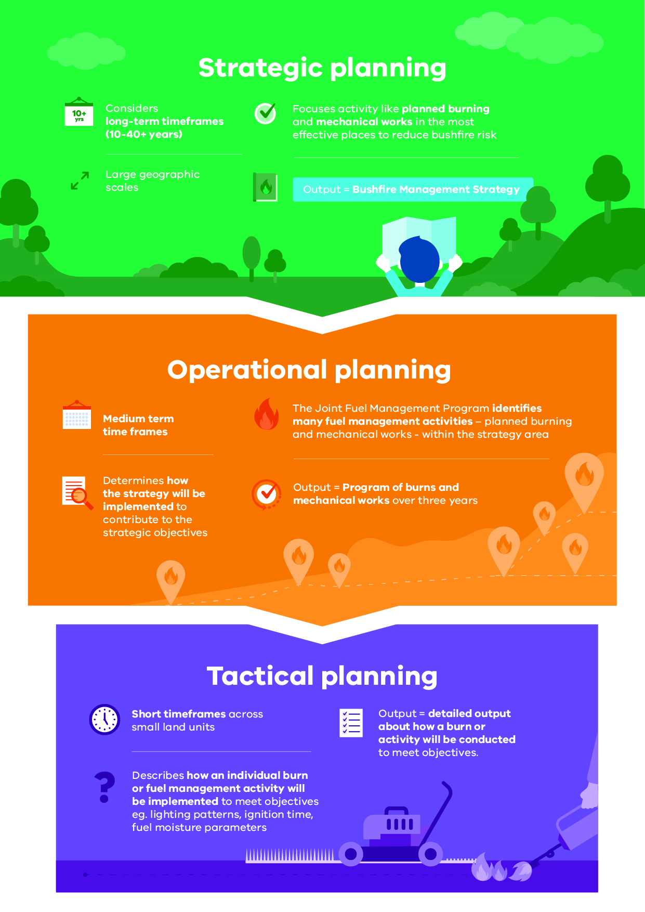
Bushfire management planning occurs at different levels, with varying time frames, focuses and outputs. Figure 1 shows fuel management planning at strategic, operational and tactical levels.

Strategic planning
The strategic planning process identifies where important values and assets are located across the landscape. It considers the current extent and quality of these values and where possible considers future trends including population, industry and environmental change. Strategic planning identifies objectives for the important values and assets, and develops an approach to manage the risks posed to them. The resulting bushfire management strategies describe landscape zones that focus fuel management activities to deliver bushfire risk reduction and ecological outcomes.
Strategic bushfire management planning takes place within a legislative and policy context which includes:
- the Emergency Management Act 2013, which requires from 1 December 2020 the Emergency Management Commissioner to prepare a state emergency management plan and to approve eight regional emergency management plans. In combination with the municipal emergency management plans, these provide for an integrated, coordinated and comprehensive approach to emergency management. The Act also requires emergency management plans to contain provisions providing for the mitigation of, response to and recovery from emergencies and to specify the emergency management roles and responsibilities of agencies
- the Conservation Forests and Lands Act 1987, which requires the Department of Environment, Land, Water and Planning (DELWP), through the Code of Practice for Bushfire Management on Public Land (2012), to develop a risk-based approach to bushfire management on public land. This document meets the requirements set out in the Code of Practice to prepare a strategic bushfire management plan.
- Safer Together: A new approach to reducing the risk of bushfire in Victoria (2015), a Victorian Government policy, focuses on how effective our actions are in reducing risk and not just the amount of activity we undertake.

Operational and tactical planning
This bushfire management strategy informs the development of operational plans, primarily the Joint Fuel Management Program (JFMP). The JFMP is the three-year rolling statewide program of fuel management works on public and private lands carried out by Forest Fire Management Victoria (FFMVic) and Country Fire Authority (CFA) to reduce bushfire risk and to maintain the health of native plants and animals that rely on fire to survive. Works include planned burning, slashing, mowing and clearing works, creating and maintaining fuel breaks, and carrying out maintenance on fire infrastructure (like fire dams and lookout towers).
This strategy does not directly address tactical (burn) planning, which is done for individual burns. Tactical planning can include individual burn objectives, community engagement plans and how the burn will be delivered safely.

Other bushfire management actions
This Bushfire Management Strategy outlines our risk-based approach to fuel and ecological fire management. However, fuel management is not the only bushfire management action that reduces bushfire risk and is not always the most effective action to reduce that risk. Fuel management needs to be supported with other actions for a number of reasons:
- Some parts of the landscape have inherently high levels of bushfire risk which requires more actions to reduce that risk
- The ability to reduce risk through fuel management may be limited in some landscapes and there will always be fuel re-accumulation
- The effectiveness of fuel management may be reduced under extreme weather conditions
- Fuel management reduces fire behaviour, it does not eliminate bushfire. Suppression activities are always required to control bushfires
Table 1 lists some key actions that agencies and communities undertake together to manage bushfire risk and complement our fuel management approach.
As with fuel management, these actions are guided by bushfire risk analysis combined with other information to ensure they are most effective. Strategies and plans for these actions are developed through emergency management planning processes by agencies at the state, regional and municipal levels.
Table 1: Bushfire management approaches beyond fuel management
Approach | Key actions
Reduce bushfire ignitions through prevention activities | - Education and advertising campaigns (e.g. campfire safety, reporting ignitions)  - Coordinated, risk-based patrolling  - Deterrence for deliberate or negligent ignition – laws/prosecution  - Monitoring arsonists  - Restrictions – fire danger period and total fire ban triggers, duration and restrictions (including legislative change)  - Reducing ignitions from powerlines
Increase the effectiveness of fire suppression | - Fire detection (towers, aerial surveillance)  - Resourcing, capacity and capability of fire-fighting resources (fire crews, contractors, incident management teams)  - Aircraft fleet management: type, distribution, availability and pre-determined dispatch  - Road infrastructure including maintenance of the strategic fire access road network and network of fuel reduced areas.  - Other fire response infrastructure maintenance including remote water access and helipads  - Fire readiness including rostered and pre-formed Incident Management Teams and fire crews
Reduce bushfire spread and severity | - Planned burning based on tenure-blind risk  - Strategic breaks and burn unit boundary standards  - Flexible delivery of burning (e.g. managed bushfire, unbounded burns)  - Other forms of fuel management (e.g. slashing, spraying, mulching) particularly in high-risk areas where planned burning is not suitable  - Identify and effectively manage fuel hazard reduction on private bush
Reduce the physical effects of bushfires in inhabited areas | - Domestic property preparedness in towns, including fire prevention notices, penalties and cost recovery  - Vegetation management on public and private land within or immediately bordering towns including implementation of fire prevention notices  - Identification, prioritisation and treatment of risk to critical infrastructure  - Access and egress (roadside vegetation/tree maintenance) pre- and post-fire  - Asset protection (on-ground)
Reduce the social effects of bushfires on communities | - Bushfire education programs targeting vulnerable communities including those with identified at-risk or changing demographics, and/or where bushfire risk cannot be effectively reduced through planned burning.  - Recovery planning and relationship building pre-bushfire (e.g. via community groups, scenario events and activities)  - Municipal bushfire plans  - Warnings and advice messaging  - Personal and neighbourhood bushfire plans
Reduce impacts from fire management actions | - Community engagement about fire management and smoke impacts  - Planning to minimise impacts on biodiversity, cultural heritage and other values  - Connections between planning and delivery (e.g. on-ground staff aware of biodiversity/cultural sites and mitigation actions)  - Cross-tenure planning and consultation  - Monitoring effectiveness of mitigations (and subsequent improvement)

About this bushfire management strategy
Victorian landscapes, environments and communities are diverse and multifaceted, and Victorian communities have diverse values, preferences and priorities. This regional bushfire management strategy reflects our region’s unique environments and communities. To develop this strategy, we undertook a regional planning process that was guided by the knowledge and priorities of experts, stakeholders and community members from Barwon South West.
Between November 2017 and September 2019, representatives of CFA, DELWP, Parks Victoria, Emergency Management Victoria, water corporations and local governments undertook a strategic bushfire risk management planning process. The process was guided by the Barwon South West Fire Sub-Committee (BSWFSC) and supported by the three Safer Together Working Groups. They offered opportunities to stakeholders and the broader regional community to be involved in the planning process through both in-person and online mechanisms.
The strategic planning process resulted in two strategies to reduce bushfire risk and maintain ecosystem health: together, they comprise this strategy — the Barwon South West Bushfire Management Strategy 2020.
The individual strategies are:
- our fuel management strategy, which focuses on reducing bushfire fuels through planned burning and mechanical works (mowing and slashing) on public land and selected private land.
- our Bushfire Risk Engagement Areas (BREAs), which focus on targeted community engagement to complement, inform and drive fuel management and other risk mitigation activities on public and private land.
Our bushfire management strategy focuses on:
- reducing the risk of bushfires threatening lives, homes, the environment and other important values and assets across the landscape
- maintaining or improving the resilience of ecosystems
- establishing a shared understanding of bushfire risk across the sector, based on the latest science and the extensive knowledge of agency personnel
- using a 40-year horizon, so long-term ecological changes and fuel accumulation rates can be considered in annual operational planning processes.
The strategy is a supplement to the Barwon South West Regional Strategic Fire Management Plan, developed by the (then) Barwon South West RFMPC, and applies to the same Barwon South West emergency management region footprint. The plan’s agreed vision, strong leadership and greater cooperation between agencies promotes greater community resilience through effective engagement and best-practice integrated fire management planning.
Regional emergency management plans and municipal emergency management plans are being prepared in line with the new amendments to the Emergency Management Act 2013. This strategy will help inform the bushfire components of these plans, now and into the future.
For the purpose of the Code of Practice for Bushfire Management on Public Land (2012), the FFMVic Chief Fire Officer has approved the public land components of this strategy: specifically, where the strategy relates to state forests, parks administered under the National Parks Act 1975 and protected public land. These components of the strategy will directly guide FFMVic’s fuel management operations. This strategy replaces the former Strategic Bushfire Management Plans for public land, published by DELWP and PV in 2014 and 2015, which used bushfire risk landscape footprints.

Method overview
This document presents the outcomes of the strategic bushfire management planning process.
The planning process involved considerable community engagement — with individuals, private land managers, businesses, community organisations and other stakeholders — to tap into their knowledge, understand their priorities, discuss and evaluate options with them and prepare to involve them in implementing the strategy.
In the planning process, we:
- identified the values and assets that are most important to the residents of and visitors to the region: we grouped these into human life and settlements; human health and well-being; critical infrastructure, assets, systems and networks; regional economy; natural environment; and Aboriginal cultural heritage
- developed regional objectives: the things we want to achieve by implementing the strategy
- combined local knowledge, bushfire behaviour modelling, historical data and the best-available science to understand how bushfires behave in our region and to forecast bushfire and fuel management strategy impacts on our most important and at-risk values and assets
- developed and evaluated many potential strategies to select two — our fuel management strategy and the Bushfire Risk Engagement Areas (BREAs) — that will enable agencies and communities to best mitigate bushfire risk to the region’s most important and at-risk values and assets.
The planning process was underpinned by the International Standard for Risk Management ISO 31000. The standard acknowledges that risk can never be completely eliminated. Bushfires will still occur, and we must all be prepared and ready to respond. However, bushfire risk can be reduced with a high-quality risk management approach.
The planning process followed the principles of structured decision making (SDM). SDM is a framework that helps people unpack complex decisions, navigate trade-offs and make logical and transparent choices. It provides a means of bringing together both scientific information and human values to make decisions, through analysis and inclusive deliberation. The principles of SDM are particularly useful in decision-making contexts characterised by uncertainty, multiple stakeholders and competing objectives. Broadly, the SDM steps involved included understanding the landscape context, setting objectives, identifying possible management strategies, and estimating and analysing the consequences and inherent trade-offs of these strategy options. We then selected the strategy that gives the greatest benefit to the things we care about, while balancing the impacts of fuel management actions on those same values.

Identifying and assessing risk to values and assets
The planning process identified values and assets across the region and modelled the impact bushfires and fuel management would have on them. Values are the ultimate durable reasons we care about managing bushfires, and assets are the physical sites that represent these values. For example, we value native species, and the locations of their populations and habitat are the assets we protect to ensure their continued existence.
To identify the region’s most important values and assets, we consulted with our partners, stakeholders and communities, and we drew on specialised data sets including the Victorian Fire Risk Register – Bushfire (VFRR-B) and Victorian Biodiversity Atlas.
We used Phoenix RapidFire, which is world-leading bushfire simulation software developed in Victoria, to model the spread of a bushfire from an ignition point under the specified weather conditions. This enables us to understand the impact bushfires could have on people, homes and other important values and assets in our landscape. We modelled ignitions and bushfire spread patterns at thousands of places throughout the region:
- using ignition likelihood models based on historical ignition characteristics and patterns
- using the bushfire characteristics information in the ‘Bushfire history and patterns’ section
  - under a range of bushfire weather conditions, including Code Red conditions: a Forest Fire Danger Index (FFDI) rating of 130 or above. These were the conditions in many parts of the state on Black Saturday 2009, and conditions were similar at times during the 2019–20 fire season. Code Red conditions are also forecast to become more frequent and more extreme with climate change.
We also used a new 40-year historical weather dataset for Victoria to identify recent changes to the state’s climate and so we could better model the average frequency with which various weather scenarios occur. This provided some indication of the likelihood of these scenarios occurring in future. We also partnered with climate scientists to forecast various climate conditions relevant to bushfires which will inform future strategic bushfire risk management planning and preparedness decisions.
Core measures used to predict ecological responses to fire used in our planning process included understanding potential changes to the tolerable fire interval (TFI) and geometric mean abundance (GMA) of species in a community. In the Barwon South West region, we also trialled a new approach to predict the number of plant species that might decline under each fuel management strategy option, engaging the University of Melbourne to develop fire-response curves for each species. To forecast the impact of the strategies on animal species, the characteristics of the habitat that terrestrial vertebrate animals — including birds, mammals and reptiles— need were linked to vegetation growth stage structures (GSS) after a fire.

Our landscape context
The Barwon South West region stretches west from the Bellarine Peninsula to the South Australian border and from the coast to north of Casterton, Balmoral, Dunkeld, Skipton and Winchelsea. The region covers an area of 2.9 million ha, or 13% of Victoria’s geographical footprint (Figure 2). The region is home to 7% of Victoria’s population and encompasses the local government areas of the City of Greater Geelong, Borough of Queenscliffe, Surf Coast Shire, Colac Otway Shire, Corangamite Shire, City of Warrnambool, Moyne Shire, Southern Grampians Shire and Glenelg Shire. The public land estate comprises 19% of the regional footprint. The major industries are agriculture, forestry and fishing, healthcare and social assistance, manufacturing and retail trade (including tourism), with the City of Greater Geelong also having a significant construction industry.
Figure 2: The Barwon South West region with local government boundaries and public land tenure
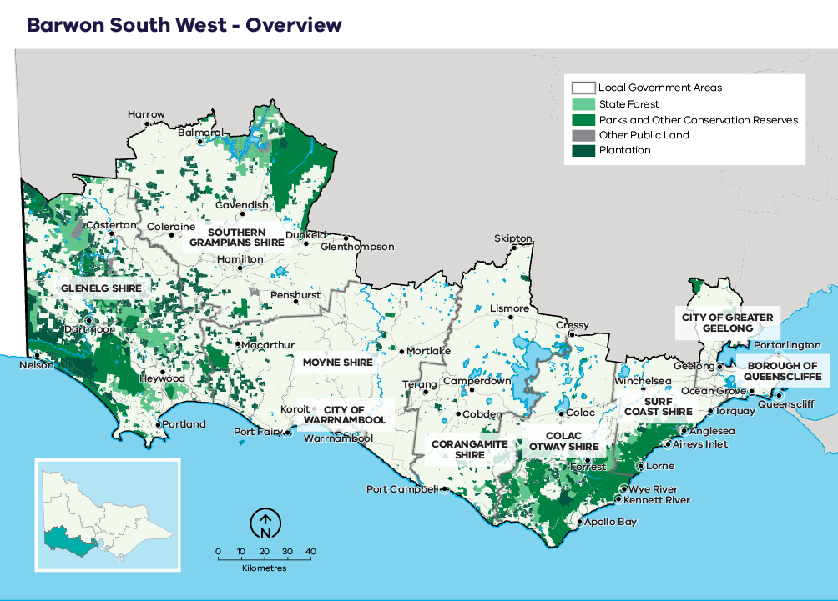

Case study: Local government profiles

Glenelg Shire (population 20,000 + summer tourists)
The shire is home to the busy farming centres of Casterton and Heywood, tourism destination Nelson and the busy harbourside urban centre of Portland. Portland is the oldest European settlement in Victoria, and it is home to a commercial fishing fleet and the Portland Aluminium Smelter.

Southern Grampians Shire (population 16,000)
The shire is serviced by the regional centre of Hamilton, and it is the gateway to the Grampians National Park, a major tourist destination for intrastate and interstate visitors. The Hamilton Regional Livestock Exchange sells approximately 1 million sheep and 50,000 cattle annually.

Moyne Shire (population 17,000 + summer tourists)
The shire includes small historic townships, extinct volcanoes and coastal villages (such as Port Fairy) popular with tourists. The municipality contributes significantly to dairy production.

City of Warrnambool (population 35,000 + summer tourists)
The city is the major urban centre in the south-west of the region and home to Warrnambool Cheese and Butter. It is also an education, retail and health services hub. Warrnambool is Victoria’s largest coastal city outside of Port Phillip Bay.

Corangamite Shire (population 16,000)
The shire includes volcanic lakes, craters and lush hinterland. Sections of the Great Ocean Road including the iconic Twelve Apostles are in the shire. The agriculture sector is the major employer in the shire, followed by health services and manufacturing and retail trade.

Colac Otway Shire (population 32,000 + summer tourists)
The shire includes volcanic lakes, craters and plains in the north, lush hinterland forests and waterfalls of the Otway Ranges and sections of the Great Ocean Road coastline. There are more than 800 farms in the shire and primary industry, tourism and food and fibre are important sectors. The inland city of Colac provides a service hub.

Surf Coast Shire (population 31,000 + summer tourists)
The shire includes the towns of Aireys Inlet, Anglesea, Lorne, Moriac, Torquay and Winchelsea. It is home to some spectacular sections of the Great Ocean Road and attracts large numbers of surfers to Bells Beach.

City of Greater Geelong (population 250,000)
The city is the industrial and service hub for Otway Ranges and Bellarine communities. Geelong is Victoria’s second-largest city, and it also has a major port and regional links to Avalon airport. The city is home to Victoria’s Worksafe Authority, the Transport Accident Commission, the National Disability Insurance Agency and one of only four remaining fuel refineries in Australia. Geelong also hosts major events significant to the region, and it has major healthcare facilities.

Borough of Queenscliffe (population 3,000 + summer tourists)
The borough comprises the towns of Queenscliff and Point Lonsdale. Queenscliff has a rich historical context and tourism is integral to the small borough’s economy. The borough scores highly in many of Victoria’s socioeconomic indicators compared to other areas in the region.

Bushfire history and patterns
The Barwon South West region has an extensive history of bushfire, with much of the forested landscape having been impacted by fire in the last 81 years (Figure 3). Significantly, the agricultural grasslands of the region have also been impacted by several very serious bushfires.

1939 Black Friday
The 1939 Black Friday fires affected Heywood, Portland and areas west of those townships to the South Australian border. A large section of the Otway Ranges from Port Campbell through to Lorne and Aireys Inlet was also burnt. The Grampians were also affected. Across Victoria, 71 people lost their lives. Many townships and sawmills were lost as well as thousands of sheep and cattle. Over 670,000 ha was burnt during this fire season in the region (Department of Environment Land Water and Planning, 2019).

1950s and 1960s: Lake Mundi–Casterton, Southern Grampians, Anakie–Lara–Little River
In 1952, a fire originating near Lake Mundi (near the SA border) burnt towards Casterton and is estimated to have burnt over 43,000 ha of native forest and farmland. In 1962, a fire in the southern Grampians burnt over 18,000 ha of what is now the Grampians National Park. In 1969, a fire that started near the You Yangs (extent not mapped) destroyed 43 homes in Lara and killed 17 motorists on the Princes Highway near Little River.

1970s: Lake Corangamite (Pomborneit East); Derrinallum, Cressy, Streatham and Penshurst; Caroline
In 1976, a fire of some 7,700 ha burnt in the Pomborneit East area on the southern shores of Lake Corangamite. In 1977, widespread fires occurred across the Western District of Victoria (Derrinallum, Cressy, Streatham and Penshurst), mostly in grasslands. The fires killed four people and burned about 103,000 ha. More than 198,500 stock, 2 million bales of hay, 3,800 km of fencing, 116 houses and 340 other buildings were also lost. In 1979, a fire originating near Caroline in South Australia burnt 3,300 ha of pine plantation and 4,100 ha of native forest.

1983 Ash Wednesday fires
In the Far South West, these fires affected Monivae (near Hamilton) and Cudgee–Ballangeich. At Monivae, almost 4,000 ha were burnt, and three houses lost. The Cudgee–Ballangeich fire claimed the lives of nine people and burnt 50,000 ha. This fire destroyed 157 houses and over 700 other buildings, and an estimated 20,000 livestock were lost.
In the Otway Ranges, three people lost their lives, over 700 structures were destroyed and over 42,000 ha were burnt. Communities with significant losses included Lorne, Moggs Creek, Fairhaven, Aireys Inlet and Anglesea (Department of Environment Land Water and Planning, 2019) (Country Fire Authority Victoria, 2019).

1985 Anakie and Little River
In 1985, 90% of the You Yangs was burnt out within several hours. Burning about 10,000 ha, this fire killed two people and destroyed 4,500 stock and over 50 buildings (Geelong Advertiser, 2019).

2006–13 Dergholm (Roseneath); Victoria Valley Complex, Grampians; Kentbruck
In November 2006, lightning started a fire north of Lake Mundi that burnt nearly 10,000 ha of state forest, with associated impacts on plantation forests. In February 2013, the Victoria Valley Complex of fires burnt nearly 36,000 ha. While much of this fire was contained within the Grampians National Park, 170 km of fencing, 60 sheep and 2,100 ha of pasture was impacted. The following year, a further 55,000 ha was burnt in the northern Grampians (in the DELWP Grampians region), destroying 135 structures including 32 dwellings, again as a result of a lightning strike. The Kentbruck fire in January 2013 burnt nearly 19,000 ha including 1,200 ha of pine plantation.

2015 Wye River, Christmas Day
The Christmas day fire at Wye River destroyed 116 houses in Wye River and Separation Creek and burnt 2,250 ha. In the nine months following the fire, rainfall triggered numerous landslips along the Great Ocean Road, which resulted in access to the road being restricted for extended periods, significantly disrupting local economies and the broader regional and state tourism economies. Landslips required substantial stabilisation works
by (then) Vic Roads.

2018 South West fires
Numerous bushfires ignited after 2100 hrs on St Patrick’s Day in March 2018, affecting the communities of Gazette, Hawkesdale, Terang, Garvoc, Camperdown and Cobden. Peat fires at Lake Elingamite and Cobrico Swamp burned for over eight weeks, and community health monitoring was established due to potentially high levels of carbon monoxide. The fires, known as the South West Complex Fire, resulted in confirmed losses of 24 houses and 66 sheds, as well as thousands of head of livestock, pasture and fodder. The South West Complex Fire burnt over 15,000 ha.

2019–20 Far South West fires including the Budj Bim complex
The 2019–20 bushfire season resulted in about 12,400 ha of area burnt by bushfire in the Barwon South West region. This included bushfires impacting on close to 900 ha of pine plantation. The season was marked by several periods during the summer when multiple ignitions occurred on the same day from lightning strikes. The Budj Bim complex (approximately 6,300 ha) and the Crawford River–Boulevard (approximately 3,000 ha) bushfires accounted for 75% of the total area burnt for the season. Fire agencies worked closely with Gunditj-Mirring Traditional Owners and specialist advisors to ensure that the response to the Budj Bim fire appropriately considered Aboriginal cultural heritage and minimised harm to important sites. The Budj Bim Cultural Landscape was recently declared a World Heritage Site by UNESCO and is recognised as one of the world’s most extensive and oldest aquaculture systems.

How our worst bushfires behave
In worst-case bushfire weather, north-westerly winds bring hot, dry air from central Australia to raise Victoria’s temperature above 40°. Then cold fronts, often with little rain, cause the wind direction to move more westerly or south-westerly, initially at strong-to-gale force. These conditions can create bushfires with powerful convection columns, and ember storms, wind-blown debris, downbursts, fire tornadoes and explosive flares of igniting eucalyptus vapour. These conditions were present on 16 February 1983 (Ash Wednesday) and 7 February 2009 (Black Saturday).

Landscape specific bushfire characteristics
The initial spread of a bushfire in our landscape is not usually as protracted as it can be in the forests of eastern Victoria, and the main damage generally occurs on the first day (South West Complex Fire, Wye River, Ash Wednesday). This is largely due to moderating weather conditions on the second day of the bushfire combined with the fire burning into grass fuels, which helps with fire containment.
Many of the most damaging bushfires in our landscape start in grasslands north of the Otway Ranges, then quickly move into the forest. In 1983, the Ash Wednesday Deans Marsh bushfire moved from the grasslands in the north to the coast in an afternoon.
The north-west-facing foothills and lower slopes of the Otway Ranges face the prevailing bushfire weather wind direction. Vegetation on these slopes and along the Gellibrand River valley provides fuel for bushfires to rapidly develop and spread. Initially, most bushfires travel rapidly in a south-east direction ahead of the strong north-westerly pre-frontal winds. Then, as strong south-westerly winds set in behind cold fronts, bushfires may quickly spread from their broad north-east flanks through the heathlands, grassy/heathy dry forest and coastal scrub along the coastline.
Outside of the Otway Ranges, the landscape is relatively flat, leading to bushfires being largely influenced by weather and fuel. The extensive areas of grassland through the region are often fully cured by mid-summer, and in some seasons they can carry upwards of five to seven tonnes per hectare of grass fuel loads.
These fuels conditions make very large, fast-moving grass fires possible. There are numerous examples in the fire history record of fires driven by north-northwest or north-west winds followed by a west, west-south-west or south-west change (e.g., Derrinallum 1977, Cressy 1977, Ash Wednesday 1983, Anakie 1985, South West Complex Fire 2018).
In the Far South West (FSW) of the region, there are many large patches of forested areas over a long north-south expanse that have non-forested areas in between. This typically will limit the fire size to less than 20,000 ha as fires move out into grass areas where more rapid containment is possible. While the classic north-west-to-south-west fire weather pattern does sometimes occur in the Far South West, it is common for bushfires in this area to be primarily driven by west or west-south-west winds.
Heathy fuels, sometimes combined with very low fuel moisture conditions in the far south-west of the region make suppression difficult, even under mild conditions. Some fires have reached over 10,000 ha in size burning under relatively mild fire-weather conditions (Tremaine swamp 1991, Kentbruck 2013).
In some areas of the region (such as the stony rises and Budj Bim National Park), rocky conditions make first attack difficult.
As a region, we are also increasingly dealing with peat fires that require sustained resourcing for prolonged periods. Peat fires produce a lot of smoke as they burn, with the smoke potentially containing fine particles, water vapor, and gases such as carbon monoxide and nitrogen oxides. Significant smoke exposure can led to health impacts for nearby communities.
Figure 3: Bushfire history for the Barwon South West region, 1936–2020
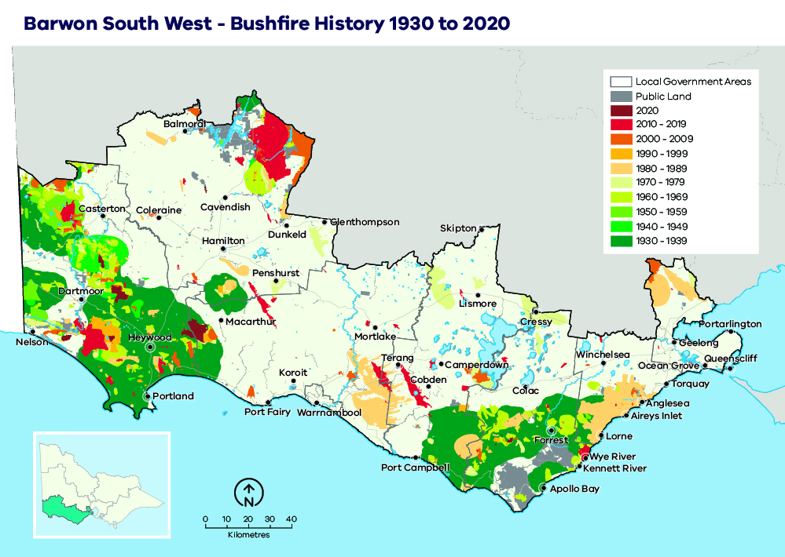

Values and assets
Here we describe the most important features of our landscape that informed our strategy.

Human landscape

Human life, human settlement and human health and wellbeing
Major townships include Geelong (Victoria’s second-largest city), Torquay, Colac, Warrnambool and Portland (Figure 2). The majority of the region’s population is located in the City of Greater Geelong (upwards of 250,000 people). Other local government areas have populations of less than 35,000, although this can significantly increase in the peak tourism period, particularly along the Great Ocean Road, which has up to 5.4 million visitors per year. Townships close to forested areas and particularly vulnerable to bushfire include Anglesea, Aireys Inlet, Fairhaven, Moggs Creek, Lorne, Wye River and Kennett River.

Critical infrastructure, assets, systems and networks
In the Barwon South West region, critical infrastructure includes water pipelines and pumping stations; public buildings (such as healthcare facilities, schools and community centres); rail and road infrastructure, telephone exchanges and power infrastructure (Figure 4). Specifically, the Great Ocean Road, Mt Cowley Communication Tower, Gellibrand Pumping Station and Heywood Terminal Station have been identified as high value assets. Where applicable, water catchment areas that support domestic and industrial water usage were also included in our landscape assessment.
Figure 4: Critical infrastructure, assets, systems and networks in the Barwon South West region
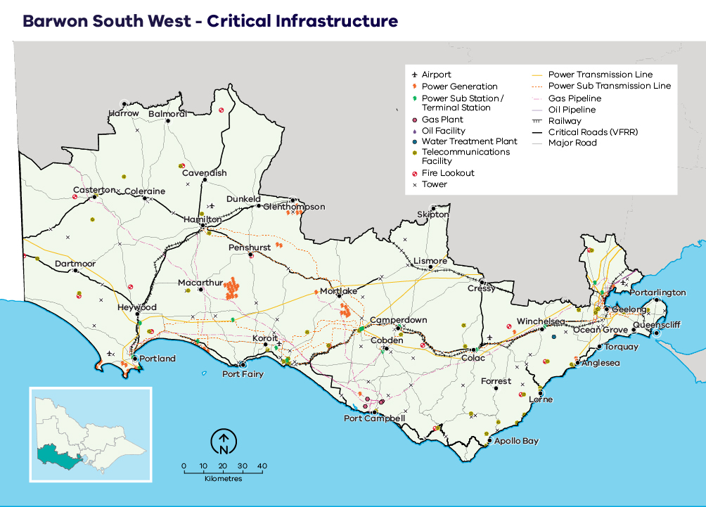

Regional economy
The major industries are agriculture (including grazing, cropping, dairy, agroforestry and viticulture), forestry, fishing, healthcare, social assistance, manufacturing and retail trade (including tourism). The City of Greater Geelong also has a significant construction industry (Figure 5). Tourism is a particularly important industry in the southern section along the Great Ocean Road and Bellarine Peninsula. The Great Ocean Road contributes significantly to the Region’s Gross Regional Product, and directly or indirectly employs approximately twenty thousand people.
Figure 5: Generalised land use in the Barwon South West region
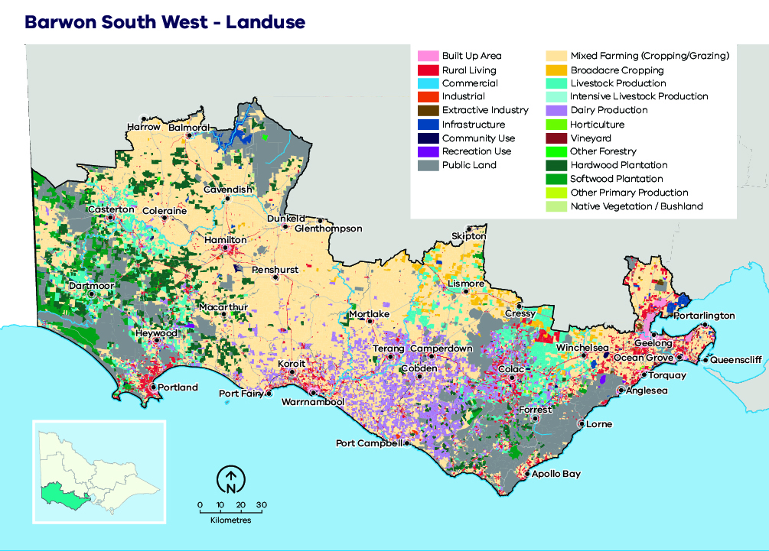

Aboriginal cultural heritage
The Registered Aboriginal Parties (RAPs) in our landscape are the Gunditj Mirring Traditional Owners Aboriginal Corporation, Eastern Maar Aboriginal Corporation, Barengi Gadjin Land Council Aboriginal Corporation and Wathaurung Aboriginal Corporation (Figure 6).
One of the most well-known Aboriginal sites in the region is the Budj Bim Cultural Landscape in the Lake Condah area. This site hosts the remains of one of the world’s oldest aquaculture systems, dating back 6,000 years, as well as the only remaining permanent houses built by a pre-contact Aboriginal community in Australia. The Budj Bim Cultural Landscape has recently been added to the World Heritage List. The Grampians National Park (Gariwerd) is one of the richest Indigenous rock-art sites in south-eastern Australia. The region has thousands of Aboriginal cultural heritage sites including ceremonial gathering places, shell middens, burial sites, scar trees and artefact scatters.
Figure 6: Traditional Owner groups in the Barwon South West region
Note: the remainder of Eastern Maar’s RAP application is still being considered and may in future include additional area in the landscape.
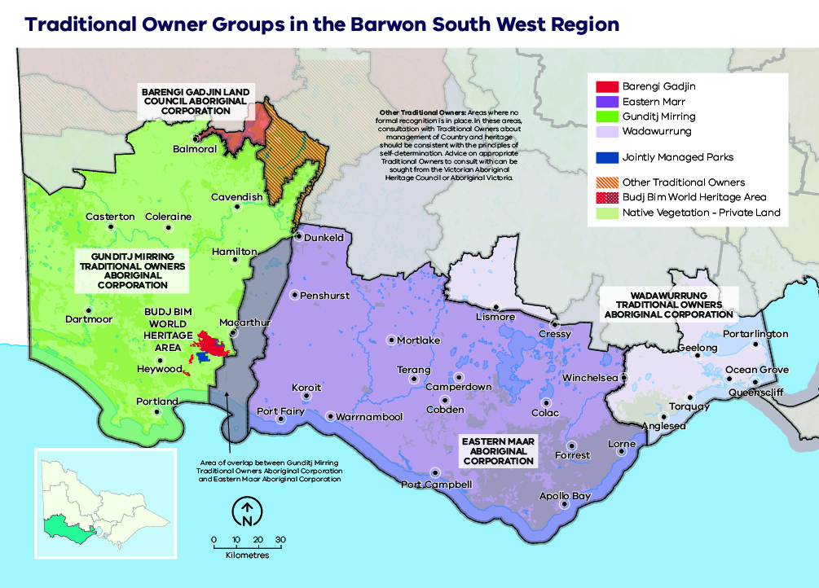

Natural landscape
The region’s 555,000-ha public land estate is comprised of a network of parks and reserves, forest parks and state forest, which is built upon the national criteria for a comprehensive, adequate and representative (CAR) reserve system of Australia’s forests (Figure 7). Parks and reserves are primarily managed for nature conservation, ecosystem services and recreation. Forest parks and state forest are managed for a greater diversity of purposes including biodiversity conservation, water catchment services, firewood production, minor produce and apiary use. Recreation and tourism are also important and increasingly popular uses of forest parks and state forest, with many active and passive pursuits commonplace across Barwon South West.
The high-altitude areas of the Otway Ranges comprise the westernmost extent of tall wet forests and cool temperate rainforest in Victoria. Drier forests, woodlands and heathlands are found on the lower slopes of the ranges.
Basalt grassland and woodlands are found in the Victorian Volcanic Plain to the north and west before returning to tall stringybark forest, heathland and extensive areas of pine and blue gum plantations in the Far South West District.
Figure 7: Native vegetation by land tenure in the Barwon South West region
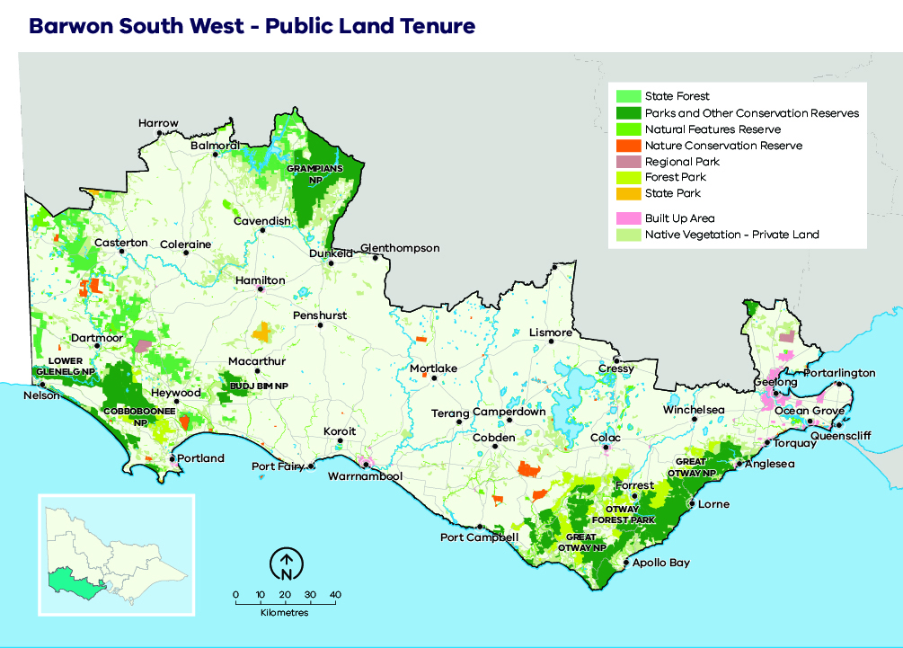
The region contains three distinct natural sub-landscapes: the Otway Ranges in the east, the
Far South West in the west, and the Grampians in the north-west. These sub-landscapes include areas of native vegetation found predominantly on public land.

Otway Ranges sub-landscape
The main vegetation communities include the westernmost extent of tall wet forests and cool temperate rainforests in Victoria across the high-altitude areas of the Otway Ranges, with drier forests, woodlands and heathland on the lower slopes of the ranges. Basalt grassland and woodlands are found in the Victorian Volcanic Plain to the north and west.
Of significance are the Anglesea Heathland, Carlisle Heathland and adjoining heathy woodlands, which include structurally and floristically diverse heathland vegetation that provides important habitat for threatened species such as the Swamp Antechinus (Antechinus minimus), Southern Brown Bandicoot (Isoodon obesulus), Long-nosed Potoroo (Potorous tridactylus), Rufous Bristlebird (Dasyornis broadbenti) and Anglesea Grevillea (Grevillea infecunda).

Grampians sub-landscape
The southern portion of the Grampians National Park (part of the Gariwerd Aboriginal cultural landscape) falls within the Barwon South West region. The Grampians is a national heritage landscape that is highly valued for its biodiversity and cultural values. The Grampians is characterised by intact forests, woodlands, heathlands and the sandstone mountain ranges that dominate the landscape. The Grampians area contains over 975 native plants, which represents approximately one-third of Victoria’s plant species. Of these species, 20 are endemic to the Grampians bioregion including the Grampians Gum and Grampians Parrot-pea. Much of the Grampians has been burnt in the last 20 years including by large fires in 2006, 2013 and 2014. Fuel Management over the next 10–20 years will need to balance fire ecology outcomes with the need to reduce the chances of further large bushfires.

Far South West sub-landscape
The Far South West sub-landscape is characterised by fragmented native vegetation extending from Warrnambool to the South Australian border and north past Casterton, between the border and the Grampians National Park. The sub-landscape also has extensive areas of pine and blue gum plantations.
The main vegetation communities include mixed-species forests, woodlands and heathland. Of significance are areas dominated by Brown Stringybark and heathland, which provide important habitat for a range of threatened species including the South-eastern Red-tailed Black Cockatoo (SeRtBC) (Calyptorhynchus banksii graptogyne) and Heath Mouse (Pseudomys shortridgei) , which only occur within the FSW sub-landscape and surrounding areas. The Long-nosed Potoroo (Potorous tridactylus), Southern Brown Bandicoot (Isoodon obesulus) and Chestnut-rumped Heathwren (Hylacola pyrrhopygia) are also priority species in the Far South West sub-landscape.

Case study: South-eastern Red-tailed Black Cockatoo in the Far South West sub-landscape
The South-eastern red-tailed black cockatoo (Calyptorhynchus banksii graptogyne) is an endangered and largely nomadic bird found only in south-west Victoria and south-east South Australia. The species is mainly restricted to stringybark woodlands where it relies on the seeds of Brown Stringybark and Desert Stringybark as an important food source. Fire is important for the health of the highly flammable stringybark woodlands: bushfires are common, and the vegetation’s reproductive cycle depends on fire. However, fire can also reduce the amount of seed stringybark trees produce for up to 10 years after fire, impacting the availability of this species’ primary food source. The species is also a significant totem or moiety ancestor for many Aboriginal language groups across the region.

Our objectives
What matters most in the Barwon South West region is discussed in the landscape context section and is summarised into the following fundamental values:
- human life and human settlement
- human health and well-being
- critical infrastructure, assets, systems and networks
- regional economy
- natural environment
- Aboriginal cultural heritage.
These values are the ultimate, durable reasons why we care about managing bushfires, and they are what we want to protect and manage through bushfire management in the Barwon South West region.
The following regional objectives are derived from our values and articulate what we are aiming to achieve in the Barwon South West region (Table 2). These objectives contribute to the overall objectives for fire management articulated in the Barwon South West Regional Strategic Fire Management Plan.
Table 2: Barwon South West region’s values and objectives and how they align with the statewide vision, policy context and strategic objectives
Vision
Safer and more resilient communities
Policy context
The Victorian Preparedness Goal is A safer and more resilient community that has the capabilities to withstand, plan for, respond to and recover from emergencies that pose the greatest risk.
The Safer Together policy’s four priorities for reducing the risk of bushfires in Victoria are Community first, Land and fire agencies working together, Measuring success and Better knowledge = better decisions.
Strategic objectives (Code of Practice for Bushfire Management on Public Land)
- To minimise the impact of major bushfires on human life, communities, essential and community infrastructure, industries, the economy and the environment. Human life will be afforded priority over all other considerations.
- To maintain or improve the resilience of natural ecosystems and their ability to deliver services such as biodiversity, water, carbon storage and forest products.
Values
Human life and human settlement | Human health and well-being | Critical infrastructure, assets, systems and networks | Regional economy | Natural environment | Aboriginal cultural heritage
Barwon South West region objectives
Minimise impact on human life | Minimise psychosocial impact | Minimise economic impact on public property | Minimise economic impact on plantations | Maximise flora and fauna species NOT listed as threatened | Minimise impact on Traditional Owner sites from bushfires
Minimise impact on private buildings |  | Minimise economic impact on water provision for human consumption | Minimise economic impact on agriculture | Maximise flora and fauna species listed as threatened
Maximise township risk reduction |  | Minimise disruption due to loss of telephone exchange | Minimise economic impact on tourism | Maximise Heath Mouse abundance
 |  | Minimise disruption due to power pole loss | Minimise economic impact on viticulture | Maximise South-eastern Red-tailed Black Cockatoo abundance
 |  |  | Minimise the cost of disaster relief | Maximise Swamp Antechinus abundance
 |  |  | Minimise the cost of strategy implementation

Our risk management approach
In hot, dry and windy conditions, a bushfire can travel quickly across a large area of our landscape. To effectively understand bushfire risk, we simulate many bushfires across the entire landscape to determine where bushfires are likely to start, spread and cause damage to values and assets, with a particular focus on people and communities. We can then reduce fuel hazard, through our fuel management program, across the spread paths of these simulated bushfires with the intention of reducing the spread and intensity of these fires and ultimately limiting their impacts.

Risk in Barwon South West Region
Figure 8 shows the risk of house loss in the Barwon South West region. It compares where houses could be destroyed by bushfire across the region.
Different shades represent different levels of risk. As the shades progress from yellow through red to purple, more and more houses are potentially destroyed. The purple areas represent the top 5% of risk in Barwon South West. More houses could potentially be destroyed in these areas than any other.
While bushfire risk exists across the entire landscape and house loss can and will occur in other areas, this map shows where the greatest 70% of house loss risk sits within our region.
Bushfire simulations generated by Phoenix RapidFire illustrate risk by showing where significant impacts on houses may occur. Simulations are undertaken using a range of different weather conditions, likelihood of an ignition, maximum fuel loads and limited bushfire suppression.
This helps us plan where, how often and how much fuel management we do to reduce risks to communities over years, or even decades.
This map does not reflect any recent bushfires or activities that could change the risk in the region. Importantly, this map shows where there is potential to destroy more houses compared to other parts of the region. It does not show risk to individual houses.

Higher risk areas in Barwon South West
In the Otways sub-landscape, an example of a high bushfire risk township is Lorne. There is a lot of forest to the north and west of the town. This can mean fires become very large and hot. Fire history and prediction modelling tells us many fires can reach Lorne and cause many house losses.
In the Far South West sub-landscape, an example of a higher risk township is Nelson, which is surrounded by forest to the north, and north-west. Burning stringybark trees produce embers that cause fires to spread quickly. On hot and very windy days, embers may cause fire to cross the Glenelg River. This could cut off the town bridge and make it hard for people to leave.

Lower risk areas in Barwon South West
Examples of lower risk areas are Birregurra and Casterton, which are surrounded mostly by grass, not forest. If a fire starts in a grassland, it can spread very quickly. However, grass fires produce less embers and burn for less days compared to forest fires. These factors mean that there is usually less house loss in grassland areas.
Figure 8: Bushfire risk within the Barwon South West region. This map only considers modelled house loss within the Barwon South West region, and so risk shown on this map can only be compared within this region.
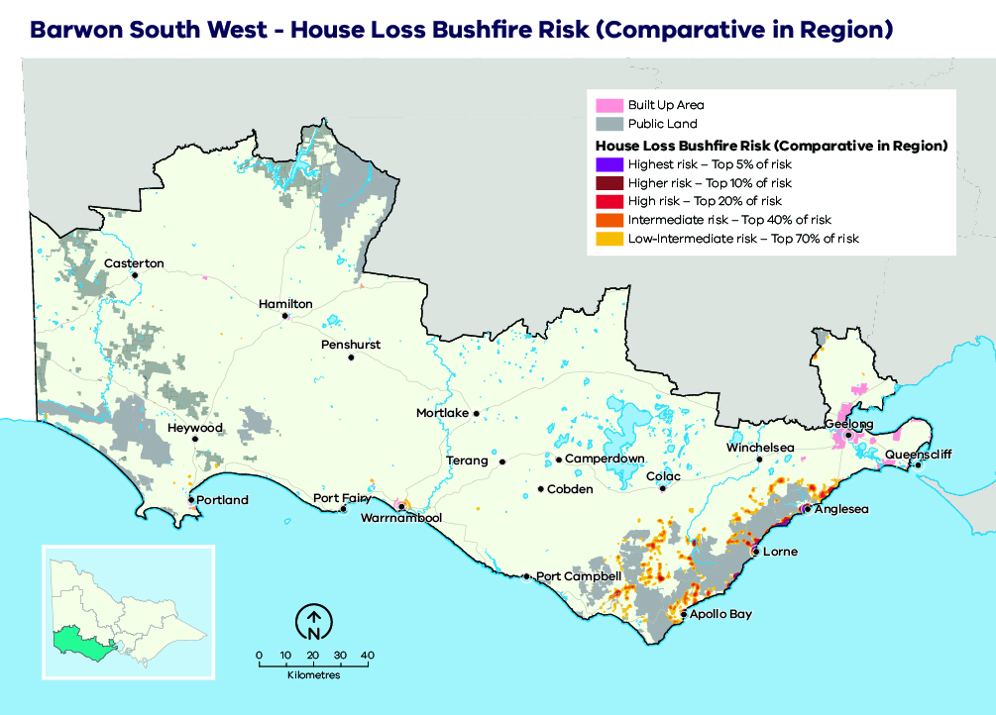

Why model house loss?
Human lives are given priority over all other considerations, however we cannot know where exactly people will be in the event of a bushfire. Simulations of house loss help to identify areas across our landscape where bushfires could have the greatest potential impacts on lives, as well as on other things we value such as our homes themselves, livelihoods and communities. This also reflects the importance of homes as a primary place of shelter and residence. The simulated house loss shown in Figure 8 indicates where these areas are and the possible scale of bushfire impacts relative to other parts of our region. We consider these impacts when developing fuel management strategies for the values and objectives in our region. We can model how our strategies improve the outcomes by reducing bushfire risk to people’s homes, and the social values connected with them. House loss informs one of our key metrics — ‘residual risk’— by which we assess the effectiveness of our fuel management strategies. The residual risk metric is explained in more detail below.

How do we model house loss?
We compare the characteristics of bushfires that are simulated in Phoenix RapidFire with those that led to actual house loss in historic bushfires. Our model assumes houses (based on address points) are destroyed by a simulated bushfire if the modelled fire intensity exceeds 10,000 kilowatts per metre (generally a crown fire) or if ember density exceeds 2.5 embers per square metre. Research indicates that bushfire embers account for the majority of houses lost, with most occurring within 1 km of the edge of forested areas and native vegetation (although house loss still occurs beyond this distance). This is consistent with our modelling which shows similar patterns of house loss. Other fire behaviour factors can have a strong influence on house loss (such as convective strength of the fire), and they are being further researched to understand this risk.
We estimate the magnitude of property impacts by analysing how many houses are modelled as destroyed under all of our simulated bushfires. We can compare between communities to understand which are more likely to suffer large numbers of houses lost.
It is important to note that the modelled property impact is only a coarse estimate and should not be applied at the individual house level. The vulnerability of a house also depends on other factors: its building materials, design and maintenance, how close it is to combustible elements, the presence of human intervention (before, during and after a fire) and the environment in which a bushfire occurs. These factors cannot all be modelled in landscape scale simulations. However, over time they can be included in statistical models, to improve estimates of potential house loss.

Our fuel management strategy
Our fuel management strategy describes our approach to balance the threats posed by bushfire to our most important values and assets, with managing fire to enhance the health and resilience of ecosystems. It responds to Barwon South West’s unique bushfire risk profile, determined through our risk assessment process.

Fire Management Zones
The fuel management strategy is presented as an arrangement of different Fire Management Zones (FMZ) on public land, as described in the Code of Practice for Bushfire Management on Public Land (2012). There are four zones – Asset Protection Zone (APZ), Bushfire Moderation Zone (BMZ), Landscape Management Zone (LMZ) and Planned Burning Exclusion Zone (PBEZ). Although the name of the zone indicates the primary purpose of that zone, it is recognised that multiple goals can be achieved when undertaking activities in each zone. For example, a burn undertaken primarily for land management purposes may also have asset protection outcomes.
Bushfire risk mitigation outcomes are the primary purpose of Asset Protection Zones. Ecological outcomes are still considered, but the protection of life and property is the priority for the management of these zones. This emphasis gradually shifts through the Bushfire Moderation Zone and the Landscape Management Zone, such that the Planned Burning Exclusion Zone’s primary focus is ecological outcomes. It is important to note that although the Bushfire Moderation Zone has a stronger bushfire risk mitigation focus than the Landscape Management Zone, there is still a focus on risk mitigation in the Landscape Management Zone. Fuel management is often scheduled in the Landscape Management Zone to complement that which has been undertaken in the Bushfire Moderation Zone and the Asset Protection Zone and enhance the risk reduction that can be achieved across the whole landscape. Fuel management in the Landscape Management Zone may be rotated through adjacent areas over the lifetime of the strategy, or burns may be undertaken over a broader area with lower coverage, to reduce the ecological impacts.
In some areas, communities may see fuel management works occurring in nearby forest most years. This may be because we are delivering a multi-year planned burn, where some fuel types or areas of the burn are targeted in one year, and a different fuel type or area targeted the next year. It may be because we are burning in adjacent blocks to those previously treated, to ensure the highest level of protection to the town. If we undertake mechanical treatments such as slashing in an area, fuels often re-accumulate quickly and treatments need to be repeated. The aims of each zone, how they have been placed and how they will be implemented in Barwon South West is described further in Table 3.
For internal planning purposes in the Barwon South West region, FMZs have incorporated private land, to inform planning and engagement activities. As a region, we have utilised this approach internally since 2012 to help guide the use of planned burning in areas to maximise community risk reduction outcomes and inform our community and landowner engagement in the delivery of the JFMP.
The FMZ configuration for public land in the Barwon South West region is shown in Figure 9.
Figure 9: Fire Management Zones for public land in the Barwon South West region. This zoning configuration was developed through risk assessment processes and in consultation with key delivery partners.
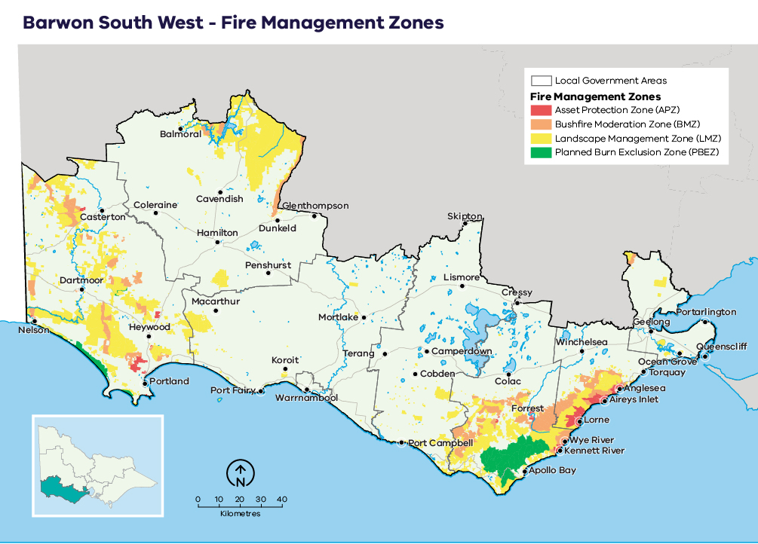
Table 3: Description of the aims, placement, planned fire intervals and typical outcomes of fire management zones for public land in the Barwon South West region. This is a description of typical features of these four zones, consistent with the aims of the zones in the Code of Practice for Bushfire Management on Public Land (2012).
 | Asset Protection Zone (APZ) | Bushfire Moderation Zone (BMZ) | Landscape Management Zone (LMZ) | Planned Burning Exclusion Zone (PBEZ)
Aim | Provide localised bushfire risk mitigation to human life, property and key assets. | Reduce the speed, size and intensity of bushfires. Achieve ecologically-desirable outcomes where possible, either directly within the burn unit or through reducing the likelihood of fire-sensitive vegetation being impacted by bushfires. | Reduce overall bushfire hazard at the landscape-scale; support ecological resilience and land-management objectives. | Exclusion of planned burning from areas primarily intolerant to fire.
Typical placement | Typically, in smaller burn units on the public/private interface adjacent to townships and assets. | Near public/private interface or key assets often critical to the support of the APZ, or strategic placement to inhibit the spread of large fires in the broader landscape. | Rest of landscape not covered by APZ, BMZ or PBEZ.  In FSW, burning adjacent to and nearby to the BMZ is critical to achieving strategy outcomes. | Burn units wholly or largely covered by vegetation communities less tolerant of fire.
Typical planned fire interval | 5–8 years.  In the highest-risk locations, may be as low as 3 years. | Otways: 8–13 years.  FSW: 8–20 years. | Varies depending on land-management and fire-management objectives. | Not applicable.
 | These intervals are indicative only to help provide an understanding of time between planned fire in each zone. Planned fire intervals for each zone are determined by fuel hazard (type, size, arrangement and quantity) triggers to achieve fuel treatment outcomes in each zone. Actual planned fire intervals may be more or less frequent depending on previous fire severity and coverage, vegetation type, climatic and seasonal conditions and actual rate of fuel re-accumulation. It is also important to note that some burns are conducted in multiple stages and sequenced with other burns in the landscape to form a landscape mosaic, meaning that planned burning operations can occur in the same area over successive years. Some areas, especially in APZ, are treated with mechanical treatments which may occur more frequently.
Fuel treatment goal | Reduce flame height, radiant heat and ember attack. | Complement APZ goals and reduce bushfire spotting and convective output. | Reduce treatable fuels and achieve ecologically beneficial fire intervals. | Not applicable.
Typical fuel treatment outcomes | Intensive treatment: ideally aiming for 70–100% burn cover with reduction of bark fuel hazard a priority.  In the Otways, the availability of treatable fuels may limit coverage outcomes to below 70% for some burn units.  Moderately intense treatment, seeking a significant reduction of fuel hazard over a majority of treatable fuels within the burn unit. | Moderately intense treatment, seeking a significant reduction of fuel hazard over a majority of treatable fuels within the burn unit.  Coverage targets reflect treatable fuels in the burn units ranging from 20–90%. Where treatable fuels allow, aiming for 60–90% coverage outcomes. | Varies depending on land-management and fire-management objectives.  In some areas of the landscape, it may involve the annual or near-annual burning of small areas within larger landscape scale burn units to create fine-scale mosaic patterns, including after recent bushfire. | No planned fire.

Ecosystem resilience
An ecosystem’s resilience is its capacity to withstand and recover from a range of disturbances, including fire. We cannot measure ecosystem resilience by looking at a single species or fire event: we must look at the whole landscape, and at multiple fires with various frequencies, intensities, scales and seasons of burning. Tolerable fire intervals (TFIs) are the minimum and maximum recommended times between fire events for a particular ecological fire group. Burning regularly outside these intervals increases the risk that there will be fundamental changes in the abundance and composition of species, and the type of vegetation. Growth stage structures (GSS) describe the mix of habitats available across a particular landscape or vegetation type.
In our fuel management strategy, TFI has been used as a tool to guide where burning can occur that has the least amount of impact on a vegetation community. The strategy aims to minimise the total area burnt below minimum TFI because fire can affect overall ecosystem resilience if it occurs too frequently. However, planned burning may be conducted in some areas below minimum TFI to reduce bushfire risk to life, property and important ecosystems.
Larger and more intensive bushfires have a significant impact on ecosystem resilience. Planned burning may also be conducted below minimum TFI to reduce the size, severity and frequency of large bushfires. There will be instances in the footprints of past large bushfires where fuels re-accumulate and become flammable before ecological maturity is reached. Fire is also reintroduced in these areas below minimum TFI to prevent large bushfires reoccurring, which can be more likely due to fuels loads being the same across a broad scale area. Burning below minimum TFI will have shorter term or localised impacts on vegetation communities, however we also need to compare this with how they would be impacted should a major bushfire occur.
We recognise that TFI is a broad measure of ecosystem resilience and there are finer-scale vegetation responses to differing severity of planned burning and bushfires, however it can help us with regional-scale planning.
We are continuing to improve our understanding of TFIs by monitoring the responses of different species of vegetation to differing fire severity, and by investing in research that improves our ability to predict these responses. We are also improving the TFI mapping by using species distribution models for key flora species on which minimum TFIs are based. This enables TFIs to be mapped more accurately.

About our fuel management strategy
The fuel and ecological fire management strategy for the Barwon South West region identifies the level of activity to reduce fuel hazard levels and/or optimise ecological outcomes. These objectives are achieved using planned burning or in some instances through the use of more intensive mechanical methods (such as mulching).
Landscape-scale bushfires (such as occurred in 1939 and 1983 in both the Otway Ranges and Far South West sub-landscapes) remain a possibility, particularly under a changing climate. To maximise the effectiveness of fuel management in reducing the risk of major bushfire events to multiple values, the sub-landscape strategies focus planned burning efforts in multiple locations to disrupt the spread pathways of major bushfires and the likelihood of them developing to large bushfires.
In the Otway and Far South West sub-landscapes, to maximise community bushfire risk reduction, fuel management activities are scheduled to occur every five to eight years on private and public land in the APZ. This is consistent with operational practice in the region since 2012. This is a priority focus of the strategy, with an emphasis on prioritising works around all higher-risk communities, not just focussing on the highest-risk communities.
It is not the intent of this landscape-scale strategy to provide details of internal township-specific fuel management treatments. Priority internal township fuel management actions will be captured in municipal-level plans and in the JFMP.

Otway Ranges sub-landscape and Brisbane Ranges
In the broader landscape of the Otway Ranges, there is a significant emphasis placed on regular burning in the BMZ — every 8–13 years — to reduce the impacts of fires that start in the grasslands to the north and north-west of the Otway Ranges. To take advantage of smaller suitable planned burning weather periods, we have begun trialling the application of more frequent fire usage on ridges surrounded by natural features such as deep gullies. In these selected areas, we expect the fire return period to potentially be below 8 years.
Burning in the BMZ aids the effectiveness of the strategy by reducing impacts on townships. BMZ placement also reduces bushfire impacts to areas of wet forest and rainforest — fire-sensitive vegetation communities in their westernmost extent. In addition, the BMZ pattern reduces impacts on the agricultural, tourism and plantation sectors. The strategy has several areas where ecological outcomes are the primary objective including in the Carlisle and Anglesea heathlands.
Annually, up to 800 ha of private land may be scheduled. This is often combined with large areas of public land to make burning in many areas in the Otway Ranges operationally possible.
Compared to poorer performing strategies that we tested, this strategy is predicted to reduce human life loss by 86% (82 compared with 44 modelled lives lost), private building economic losses by 66%, public property losses by 57%, Traditional Owner impacts by 59%, plantation losses by 27%, tourism losses by 20% and agricultural losses by 16%.
This difference in performance can be explained by three factors. Firstly, there is the alignment of typical bushfire weather patterns and the Otway Range topography, which contributes to potentially explosive, though relatively predictable, fire behaviour.
Secondly, the Otway Ranges abuts the coastline, and this limits the southerly movement of fire, particularly in the east of the landscape (e.g. Wye River 2015, Ash Wednesday 1983). In addition, the Otway Ranges are relatively narrow (only ~ 20km wide in places). This enables the concentrated placement of planned burns in multiple locations throughout likely bushfire pathways. This concentrated placement of planned burning is also enabled by the highest risk townships all being in the same bushfire pathway. Hence townships such as Aireys Inlet, Anglesea and Jan Juc are benefiting from the planned burns aimed at reducing risks to townships southwest of these locations (e.g. Lorne and Wye River).
Thirdly, the Otway Ranges has several significant areas of Heathland. These areas typically are available to undertake planned burning for longer periods then taller forested environments. Planned burns in Heathland also characteristically results in high coverage outcomes (70-100% of the target area being burnt), which facilitates more effective disruption of bushfires. This advantage is further enhanced by the Anglesea Heath also being in a rain shadow with lower productivity. This slows the fuel accumulation rates and makes planned burns in this environment effective for longer.
These factors also help to explain why even though the Otway sub-landscape has three of the highest bushfire risk townships in Victoria, planned burning can be particularly effective at reducing the bushfire risks to these townships, with risk reduction of greater than 70% possible in Anglesea and Aireys Inlet with the implementation of this strategy.
Modelled results also highlighted that some large bushfires starting under Code Red fire weather conditions have the potential to destroy most of the properties in the Lavers Hill, Kennett River, Separation Creek and Wye River townships. Fires impacting the coastal townships generally start north west of these communities, whereas, large damaging bushfires impacting Lavers Hill may come from the north west or after the wind change from the west or south west.
Environmentally, the strategy is designed to optimise outcomes for multiple species. Compared to the worst performing strategies, the selected strategy reduces the likelihood of major fires (more than 5000ha in size) occurring by 18% and results in up to a 15% reduction in the occurrence of major fires in fire sensitive wetter forests.
This selected strategy had widespread support from the 2017 Stakeholder Advisory Group who undertook the trade-off session, with stakeholders giving preference to strategies that maximised human life and fauna outcomes. This combination of features also had the highest level of community support based on over 1200 survey responses in 2016. In alignment with stakeholder preferences, the selected strategy is designed to reduce risk to below 60% for 17 townships – this being the highest number of townships achieving this risk reduction level out of the 50 strategies tested.
A small area of the Brisbane Ranges is in the Barwon South West region. The southern end of the Brisbane Ranges has an area of BMZ to the north-west of Anakie. This zone assists in the moderation of the spread of bushfires starting to the north and west of this area. There are significant portions of private, forested land in the southern parts of the Brisbane Ranges, and further exploration of opportunities for cross-tenure burning here will occur during the life of this strategy.

Far South West sub-landscape
In the Far South West sub-landscape, a landscape mosaic approach has been adopted, which includes burning many areas once over the next 40 years. This is complemented by burning targeted areas of BMZ two or three times over the same time period. APZs target regular fuel treatments close to the settlements of Nelson, Casterton, Milltown, Heathmere and Bolwarra. In particular, the largest modelled losses of properties occurs from large fires spreading out of forested areas to North west of Bolwarra and Gorae. To moderate this risk, frequent fuel management is identified in this area – both close to edge of the forest and in the broader landscape.
This design proved most effective in reducing bushfire impacts to human life, known traditional owner sites, settlements and industries, and it best balanced the needs of fauna and flora species with competing ecological needs including the SeRtBC and Heath Mouse, both species endemic to the broader area. This design also provides operational flexibility in the delivery of the strategy to accommodate periods where the SeRtBC canopy scorch threshold may be exceeded.
About 17,000 ha of private forested land has been identified in the strategy. While not critical to the delivery of the strategy, the inclusion of 30-40% of the private forested area would complement the landscape mosaic design on public land.
Changes to zoning along the heritage river section of the Glenelg River are designed to provide opportunities for fuel management along the riverbanks in this area. Fuel treatment works adjacent to the river will utilise measures to minimise impacts on the riverbanks, thus ensuring that disturbance and siltation are kept to a minimum in order to maintain the river’s heritage status.
Our modelling indicates that fuel management activities have a more moderate effect on reducing bushfire risk to many values in the FSW compared to what is possible in the Otway Ranges sub-landscape. For example, evaluation of many different strategy designs showed reduced bushfire impacts of up to 10% were possible for private buildings and the plantation and agricultural industries.
For private buildings, this moderate risk reduction outcome is largely due to the location of most settlements being several kilometres from forested areas. For the plantation and agriculture sectors, there are two factors that contribute to lower level of effectiveness. Firstly, there are many large patches of forested areas over a long north-south expanse that have non-forested areas in-between. The gaps between the forested areas mean that fires sometimes only partially intersect with forested areas and can continue to spread through non-forested areas, subsequently reducing our ability to place fuel reduced areas in the path of some fires. Secondly, there is a lack of strong geographical features in this landscape such as mountains that can drive significant medium-long distance spotting. When combined with the discontinuous forest areas, this decreases the chances of large (more than 10000ha) forest fires occurring. These factors also decrease the chances that a fire will intersect a recently burnt area.
The use of planned fire in the FSW is critical in balancing the ecological needs of species that have preferences for younger or older habitat, as well as to minimise impacts of large severe bushfires.
In particular, we modelled the abundance of two threatened, endemic species to the area – the Heath Mouse (Pseudomys shortridgei) and South-eastern Red-tailed Black Cockatoo (Calyptorhynchus banksii graptogyne). The Heath mouse responds favourably to the presence of recently burnt areas and regenerating heathland and showed a decline of 14% under a lower hectare strategy, whereas under this strategy, we expect a relatively neutral outcome with a 2% decline over 40 years.
Under the Far South West sub-landscape strategy, modelling showed that planned burning and bushfire contributed to a 1% decline in the SeRtBC over the 40 year period. This is in contrast to a much larger modelled decline due to overall low population total and lack of food rather than impacts from the implementation of the strategy. The minimal contribution of fire (planned and bushfire) to SeRtBC decline can be attributed to the relatively low proportion of feeding habitat likely to be scorched under this strategy. Specifically, modelling demonstrated that the strategy reduced the area scorched by bushfire by up to 20% (i.e. 10,000ha less area scorched by bushfire) compared to a strategy with no planned burning. Scorch associated with planned burning resulted in an average area of scorched canopy of 930 ha/year or 0.74% of the core feeding habitat.
Stakeholder feedback shows this strategy received good levels of support. Through a postal survey, community focus groups and stakeholder workshops, there was over eighty per cent support for a fuel management strategy that provided fair and balanced outcomes. The community supported ‘best available’ outcomes for the protection of human life and private property that could be delivered at a reasonable implementation cost.

Grampians sub-landscape
In the Grampians sub-landscape, the strategy remained unchanged from the update in 2015. Key features of this strategy are a focus on burning the Serra Range to moderate the spread of fires moving to the east. This also reduces impacts on Dunkeld and reduces the likelihood of high-altitude, fire-sensitive species being impacted on ridge tops. Other strategy features include small areas of planned burning close to Rocklands Reservoir (to mitigate possible bushfire impacts on campers) and the application of smaller, mosaic burns along the Victoria Range to break up the spread pathways of larger bushfires.

Case study
As part of the continuous improvement cycle and to respond to future needs, we are continuing to look for ways to apply fire to meet fuel reduction and ecological objectives. One of the approaches we are looking to extensively trial during this strategic planning cycle is the use of natural variations in fuel moisture, to broaden the number of days when planned burning can be undertaken. This will help us to:
- increase the likelihood of achieving patchy results in the heathland vegetation which contributes towards:
  - maximising outcomes for fire-sensitive, small-ground-dwelling mammals and the SeRtBC;
  - maintaining floristic diversity within
heathlands and;
  - supporting mitigate bushfire impacts to animal refugia areas (i.e. wetter drainage lines and gullies) which are particularly critical during drought periods.
- reduce operational costs associated with planned burning. Burning using fuel moisture differential boundaries is undertaken during periods when a fire is unable to continuously spread through the forest, and it will sometimes be undertaken away from the road and track network, hence moderating the extent of hazardous tree works required. Also, there is generally only a short burning window each day when fire can be applied, reducing the need for longer shifts
- continue to align our use of fire with traditional cultural fire practices through the application of ‘cool burning’, to meet a range of ecological and cultural outcomes.
A second continuous improvement focus will be on implementation of mulching to assist in the delivery of burning and in some locations, particularly within the APZ, as a complementary way to reduce the fuel hazard across larger areas adjacent to higher-risk communities and around critical infrastructure.

Victoria’s residual risk
We measure the impact of the fuel management on reducing bushfire risk. This measure is called ‘residual risk’. Residual risk is calculated as the percentage of bushfire risk ‘left over’ after fuel in forests has been reduced, either through fuel management activities or bushfires.
Our statewide fuel management target is to keep residual risk at or below 70% of Victoria’s potential maximum bushfire risk. Maximum bushfire risk refers to maximum fuel conditions and extreme bushfire conditions (Forest Fire Danger Index of 130). In practice however, the residual risk is different in different parts of the landscape, due to differences in vegetation, topography and where houses are located. Our fuel management strategy, together with the strategies of all regions of Victoria, contributes to achieving the statewide target.
To measure residual risk, we first use the Phoenix RapidFire bushfire simulation software to simulate thousands of bushfires across Victoria under conditions of highest fuel in the landscape and worst-case bushfire weather conditions. We calculate the impacts on houses, based on these simulations, and this is the maximum risk. We then simulate a second set of bushfires where we have changed the fuels in the landscape, to allow us to compare the two scenarios and estimate the reduced impact, called residual risk. When measuring current or past residual risk, we include bushfires and planned burns that have occurred to reduce the fuels in the landscape. When we are testing strategies, we model different arrangements of planned burning thatmight occur by implementing our strategy, for 40 years into the future.
Using Phoenix, we have forecast the performance of our preferred fuel management strategy together with other regions in Victoria. Figure 10 shows changes in residual risk from 1980 to 2060, with projected residual risk values beyond 2020. Our fuel management program takes us some of the way to managing bushfire risk, however we also manage bushfire risk through other prevention, preparedness and response activities.
As yet, we are unable to model the impacts of our other bushfire management actions beyond planned burning in our residual risk metric, including mechanical treatments. We are working to be able to include these and other improvements to the metric in the future.
Figure 10: Statewide residual risk
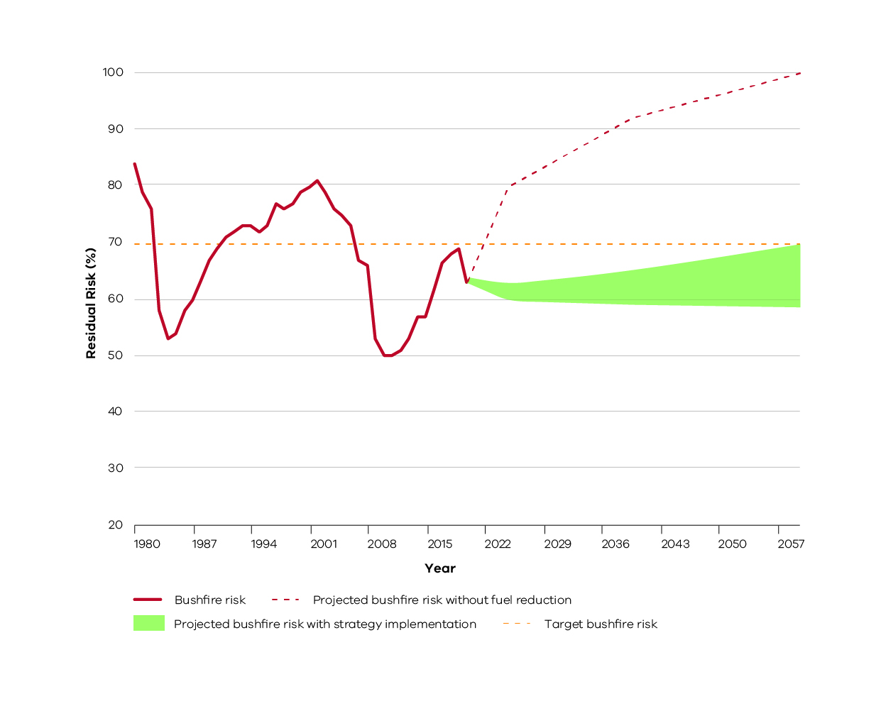
Historic and projected future bushfire risk for Victoria. The orange dotted line is the statewide bushfire risk target (70%). The red line represents historical bushfire risk due to past bushfires and planned burning. The green shaded area is the projected bushfire risk for the fuel management strategies of all Victorian regions collectively, measured from 2021 to 2060. This represents that there is a range of possible future residual risk values which is dependent on the amount of fuel reduction achieved each year in our region and across Victoria. The red dotted line represents projected increase in bushfire risk without fuel reduction.

Bushfire Risk Engagement Areas
As part of the 2017-2019 strategic bushfire management planning process, land and fire management agencies have undertaken an analysis to define Bushfire Risk Engagement Areas (BREAs). BREAs identify parts of the landscape where managing bushfire fuels is most effective in reducing risk. This helps to indicate the priority areas in our region where we can work with communities to reduce bushfire fuels.
BREAs also help land and fire management agencies, local government and stakeholders to focus conversations about the range of treatment options available to reduce bushfire risk. This may include other actions where reducing fuels may not be possible. Over time, on-ground discussions and assessments between agencies and the community will determine the treatments that best suit a particular place.
Managing fuels on private and public land begins with a conversation about the benefits, limitations and viability of fuel reduction in a BREA. Complementary or alternative treatments will arise from these discussions. We will work with the community to explore risk treatment options for private land and, where suitable, apply them to complement public land fuel management described in our fuel management strategy. By working together in this way, we will maximise the impact of our collective risk-reduction effort.
It is important to note that BREAs are not legislated planning zones and do not obligate landowners or land and fire agencies to take any action. They cover large areas of public and private land, their boundaries do not align to administrative or cadastral boundaries, and are not linked to individual parcels of freehold land.
Bushfire risk occurs across both forested public and private land, and often an effective strategy is to target risk across both land tenures. In the Otway Ranges sub-landscape and to a lesser degree in the Far South West sub-landscape, this has occurred annually since 2012, with planned burning prioritised based on community outcomes regardless of tenure. Priority burns are placed on the JFMP, and where possible messaging and engagement activities are aligned across agencies. We expect this to continue for the life of this strategy across these sub-landscapes.
For this planning update, we have focussed our modelling efforts on identifying forested areas of the landscape. It is recognised that there are other priority fuel management activities that are undertaken in the broader landscape (such as
along roadsides and around plantations). These areas will be a priority focus for the next iteration of the strategy.
The Barwon South West region’s BREAs are shown in Figure 11.
Figure 11: Bushfire Risk Engagement Areas in the Barwon South West region
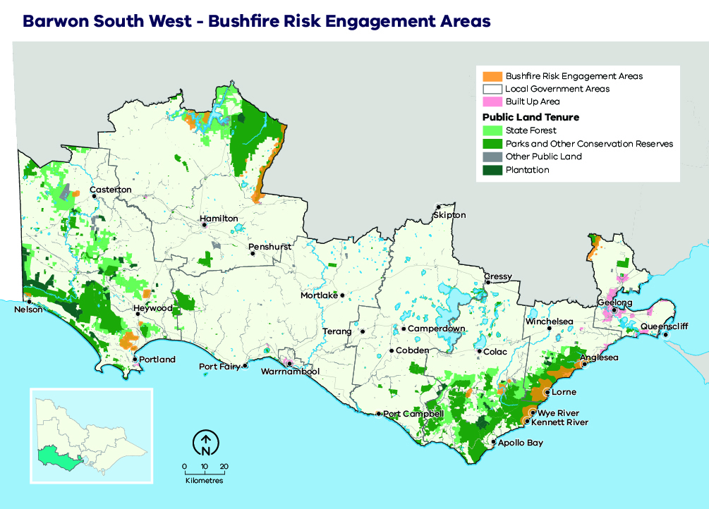

Implementation
Implementation of this bushfire management strategy will occur through the Joint Fuel Management Program (JFMP) prepared by FFMVic and CFA, as well as a range of agency-specific operational plans.
The fuel management strategy described here directly informs the development of the JFMP, and it is through the implementation of this program that bushfire risk in Barwon South West will be maintained in line with the state residual risk target, in a manner which balances outcomes for multiple values.
Fuel management on private land, where appropriate and with landholder permission, will form part of the overall JFMP and will reduce bushfire risk in Barwon South West even further.
The JFMP prepared by FFMVic and CFA is also informed by the Victorian Traditional Owner Cultural Fire Strategy.
Our bushfire management strategy can also help inform actions in municipal fire management plans.
The implementation of Bushfire Risk Engagement Areas will be undertaken by all agencies working together with the community. BREAs assist agencies to plan where to engage with communities about fuel management where it is most effective to reduce bushfire risk or explore alternative options to reduce that risk.
Figure 12: Schematic representation of the strategy’s influence on implementation programs and plans
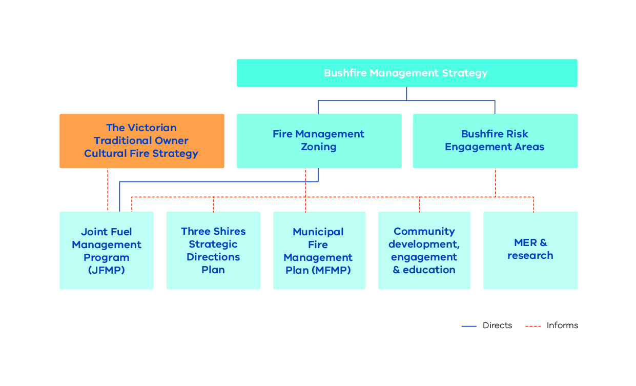

Case study: Management of values during implementation
The sub-landscape strategies provide a rationale for where we use fire and how much fire is appropriate in different parts of the landscape. Each sub-landscape map guides where we can prioritise our efforts, and conversely it identifies areas of the landscape where less fire is appropriate or required. (Figures 13–15).
The broad patterns displayed in sub-landscape maps provide an indication as to where and how much fire is required to meet the forecast outcomes of the strategy. In many instances, particularly in areas burnt only once or twice in the 40-year period, there is flexibility around which burn units are selected to be burnt. This is especially the case in the Far South West and Grampians sub-landscapes, which seek to achieve a whole-of-landscape mosaic outcome over the 40-year period. Operational planners work with the strategy team during the development of the JFMP to ensure alignment with the long-term sub-landscape strategies.

Reducing risk to human life and human settlements: the eastern Otway Ranges is a regional priority
The Barwon South West region’s residual risk target is 60%. To meet this target requires regular fuel reduction within 2 km of the highest-risk townships in the Barwon South West landscape: Lorne, Anglesea, Aireys Inlet, Fairhaven, Moggs Creek and Wye River. This needs to be supported by burning north and north-west of these locations along the northern fringe of the Otway Ranges between Forrest and Bellbrae — the highest-risk bushfire spread pathway in the region — to maintain residual risk below 60%.
The sub-landscape strategies, particularly for the Otway Ranges, represent an increase in the average annual area treated, compared to what has been achieved consistently over the last decade. Operational delivery approaches will need to continue to be innovative and nimble to provide consistent levels of bushfire risk reduction over time. Specifically, the Otway Ranges sub-landscape strategy has a long term goal of consistently achieving 7300ha/yr. In the near term, we expect that between 4000 and 10000 hectares will be treated in most years. This range reflects variability around the number of suitable planned burning days each year.

South-eastern Red-tailed Black Cockatoo and stringybark habitat in the Far South West
On average, planned burning is estimated to scorch 0.74% or 930 ha a year — or 7.4% or 9,300 ha over 10 years —of South-eastern Red-tailed Black Cockatoo (SeRtBC) feeding habitat, including areas in the Wimmera district. The strategy accommodates variation from year to year, with scorch estimated to vary from 0.2% to as high as 1.4% in years when multiple-larger planned burns are completed. The strategy aims to achieve a long term average of 4000 ha/yr in the FSW sub-landscape with significant variation around this amount expected from year to year based on the suitability of planned burning weather periods. Thus in seasons with more optimal burning weather, additional burning is expected to occur to offset seasons when less burning is possible. However, this will be assessed season-by-season and will depend on overall scorch levels over the preceding 10 years.
We have forecast that the 15% rolling scorch target is expected to be exceeded for at least six years and up to 12 years over the 40-year forecast period. During periods when SeRtBC food availability is further limited — that is, when scorch is above 15% — it may be necessary to limit burning to areas of APZ and BMZ and focus on parts of the landscape not covered by the SeRtBC core feeding habitat overlay. The broad-landscape, mosaic-design characteristic of the strategy facilitates this approach and provides considerable operational flexibility.
Pine (Pinus radiata) wildings, Pittosporum (Pittosporum undulatum) and Coast Wattle (Acacia longifolia var. sophorae) are significant weeds in the Far South West sub-landscape that impact on stringybark woodland and associated heathland habitat. It is intended that a holistic management plan be developed to minimise the impacts of these species on ecosystem health in the south-west corner of the Far South West sub-landscape. This plan will inform an updated planned burning and mulching schedule for this area, focusing on where and how planned burning will occur to help improve overall ecosystem health and mitigate woody weed infestations.

Small ground-dwelling mammals in the Otways
In the Anglesea heath, a tension exists between the need to reduce impacts on human settlements and critical infrastructure (such as the Great Ocean Road) and maintaining suitable, older habitat for small, ground-dwelling mammals. The strategy broadly prioritises minimising impacts to nearby human settlements over the needs of the small, ground-dwelling mammals in this area. To mitigate potential impacts on these species, particularly the Swamp Antechinus (Antechinus minimus), we will continue to refine what an appropriate local fire regime could look like in the area, to best meet the competing objectives. This could include the use of operational controls (such as reducing planned burn coverage) to maintain areas of refugia.
Figure 13: Far South West sub-landscape. The map outlines the spatial and temporal fuel management and ecological fire regime that will guide the development of the JFMP. The 40-year time horizon enables holistic planning for medium-term ecological changes and fuel accumulation rates to be incorporated into annual planning processes.
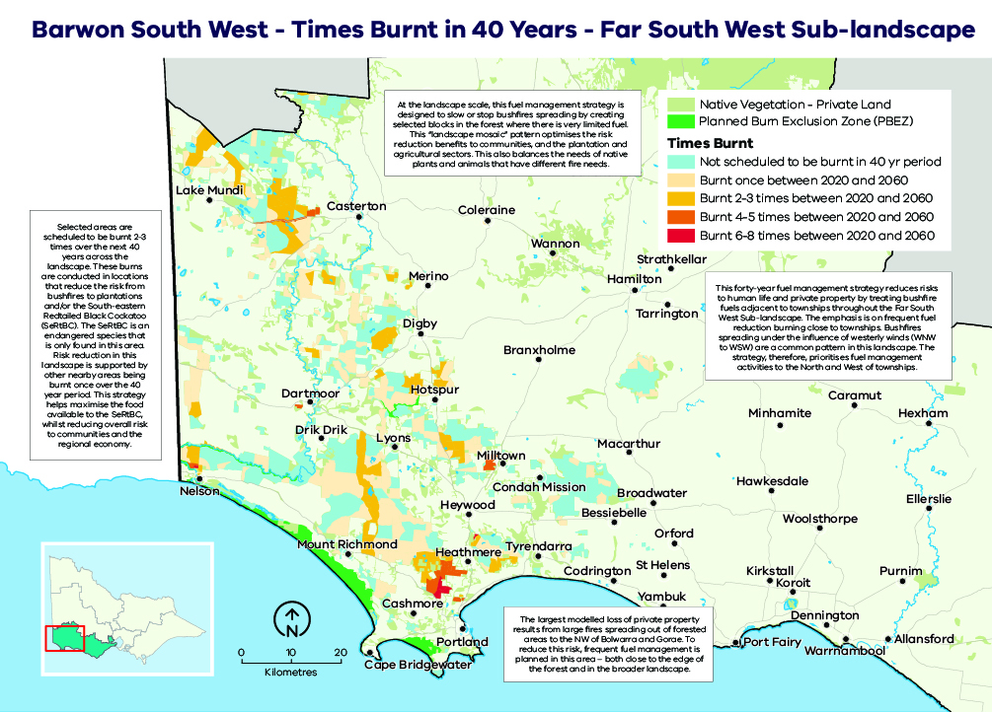
Figure 14: Otway Ranges sub-landscape. The map outlines the spatial and temporal fuel management and ecological fire regime that will guide the development of the JFMP. The 40-year time horizon enables holistic planning for medium-term ecological changes and fuel accumulation rates to be incorporated into annual planning processes.
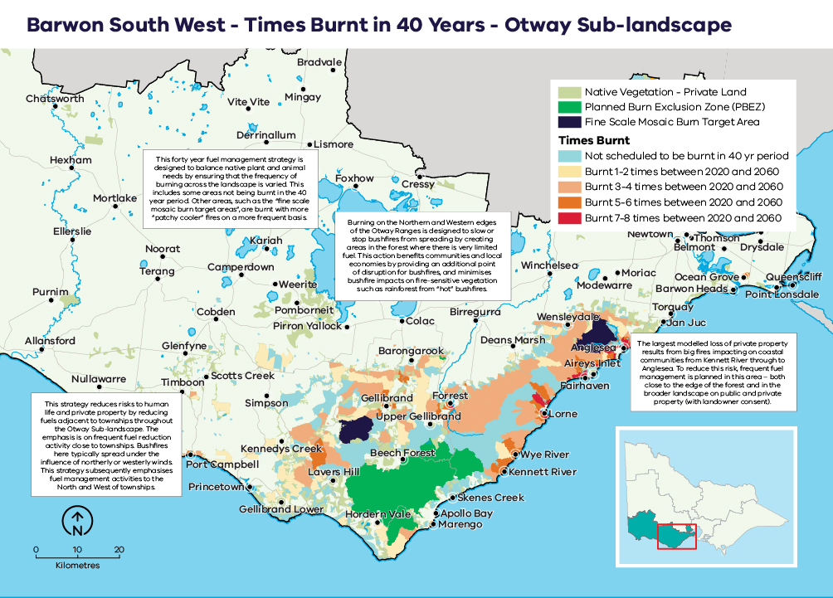
Figure 15: Grampians sub-landscape and Brisbane Ranges. The map outlines the spatial and temporal fuel management and ecological fire regime that will guide the development of the JFMP. The 40-year time horizon enables holistic planning for medium-term ecological changes and fuel accumulation rates to be incorporated into annual planning processes.
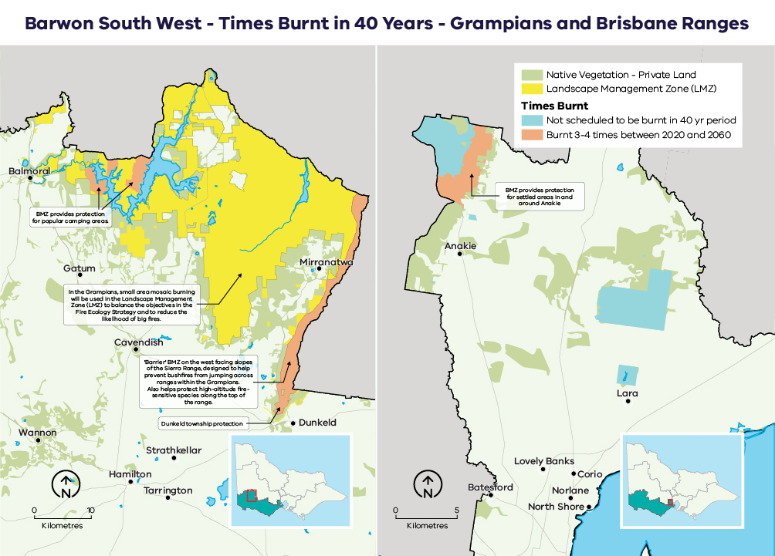

Monitoring, evaluation and reporting
Regional monitoring, evaluation and reporting (MER) enables us to measure how our strategies and actions are performing against the regional objectives set out in this bushfire management strategy. This is achieved by developing key evaluation questions that we will use to measure success against our objectives and enable reporting and improvements. The MER process ensures transparency and supports adaptation of management practices to achieve improved outcome from bushfire management to our important values. Key evaluation questions and the process for addressing them will be developed in MER plans by individual agencies.
Key evaluation questions might include:
- How has fuel management changed fuel levels within the landscape?
- How has the fuel management strategy reduced bushfire risk?
- How has the abundance of key habitat attributes changed as a result of fuel management?
- How has fuel management changed the occupancy of fire-sensitive species within their preferred habitat?
A MER plan can also identify key knowledge gaps and prioritise research and monitoring activities to address them. MER plans ultimately improve risk-based planning and decision-making, helping to guide future resource and funding allocation.
Individual agencies will be responsible for the MER of their own work programs and the activities that they deliver. The spirit of collaboration will continue between agencies, such as identifying and addressing knowledge gaps that cross tenure boundaries.
FFMVic’s MER program is guided by the Monitoring, Evaluation and Reporting Framework for Bushfire Management on Public Land (MER Framework), which aims to assess how well management activities across Victoria are achieving the two objectives of the Code of Practice. Information on FFMVic’s annual fuel management monitoring and reporting can be found in Managing Victoria’s Bushfire Risk: Fuel Management Report.

Case study: Research needs associated with fuel management
To ensure that bushfire management is informed by the most up-to-date scientific information, research projects often form part of a MER program. Below are two of the key research priorities for the Barwon South West region.

Otway Ranges sub-landscape
To ensure the persistence of Swamp Antechinus and other small, ground-dwelling mammals in the Otway Ranges, a collaborative project between DELWP, Parks Victoria and Deakin University researchers is underway to identify and map critical small-mammal-habitat refuges across the landscape. This will help land managers better understand the role and importance of fine-scale refuges and assist decision-making about the spatial and temporal arrangement of planned burns.

Far South West sub-landscape
In collaboration with the National Recovery Team for the SeRtBC and species experts, we are researching improvements to how we monitor and model impacts to the SeRtBC. This includes identifying areas of higher productivity across the species’ range that may support higher seed availability. This will help guide the spatial and temporal arrangement of planned burns to improve the species’ persistence.

Appendix 1: Program logic
Table 5: Barwon South West Bushfire Management Strategy 2020 program logic
Vision | Safer and more resilient communities
Policy context | The Victorian Preparedness Goal is A safer and more resilient community that has the capabilities to withstand, plan for, respond to and recover from emergencies that pose the greatest risk. |  |  | The Safer Together policy’s four priorities for reducing the risk of bushfires in Victoria are Community first, Land and fire agencies working together, Measuring success and Better knowledge = better decisions.
Strategic objectives | - To minimise the impact of major bushfires on human life, communities, essential and community infrastructure, industries, the economy and the environment. Human life will be afforded priority over all other considerations. |  |  | - To maintain or improve the resilience of natural ecosystems and their ability to deliver services such as biodiversity, water, carbon storage and forest products.
BSW region values | Human life and human settlement | Human health and well-being | Critical infrastructure, assets, systems and networks | Regional economy | Natural environment | Aboriginal cultural heritage
BSW region objectives | - Minimise impact on human life and private buildings  - Maximise township risk reduction | - Minimise psychosocial impact | - Minimise economic impact on public property, water provision, communication infrastructure and power loss | - Minimise economic impact on plantations, agriculture, tourism and viticulture  - Minimise the cost of disaster relief  - Minimise the cost of implementation | - Maximise flora and fauna species  - Maximise Heath Mouse, Swamp Antechinus and South-eastern Red-tailed Black Cockatoo abundance | - Minimise impact on Traditional Owner sites from bushfire
Outcomes | - Life loss and private building loss is reduced and is aligned to strategy outcomes  - Risk reduction is provided for communities throughout the Barwon South West is aligned to strategy outcomes  - Residual risk in Barwon South West is maintained below 60% through to 2050 for at least 25 out of 40 years | - Psychosocial impact is reduced and is aligned to strategy outcomes | - Disruption or loss of infrastructure assets due to bushfire is reduced and is aligned to strategy outcomes | - Economic loss from bushfire is reduced and is aligned to strategy outcomes | - Changes in fauna and flora abundances are in alignment with strategy outcomes | - Loss of cultural assets due to bushfire is reduced and is aligned to strategy outcomes
Outputs | - Annual residual risk report  - Graphs, tables, reports showing modelled outcomes of future planned fuel treatment activities and assessment against strategy thresholds | - Graphs, tables, reports showing modelled outcomes of future planned fuel treatment activities and historical outcomes compared to the thresholds set for the strategy |  | - Graphs, tables, reports showing modelled outcomes of future planned fuel treatment activities and historical outcomes compared to the thresholds set for the strategy
Activities | - Annual prioritisation of burn units for inclusion of the JFMP including the development of burn rankings and objectives for the following four years, to meet objectives for the Far South West and Otway Ranges sub-landscapes |  |  | - Implement the Barwon South West JFMP in accordance with annual requirements
Inputs/ resources | - Address point and/or actual house location data for the FSW  - Locality spatial data  - Data and information (modelled and actual) including fire history, fuel accumulation, weather, topography, vegetation treatability, future ‘fire histories’  - Appropriate software/ tools (Phoenix RapidFire, FAME, Postgres Db, Python & Custom scripts)  - Time and expertise | - Address point and/or actual house location data for the FSW  - Psychological first aid response rates | - VFRR-B  - Customised spatial datasets for the calculation of risks to water catchments  - Communication and power infrastructure datasets | - Spatial data for commodities of agricultural land, private plantation, vineyard locations, tourism-related datasets | - Fauna and flora species habitat models and fire-response data  - Draft Environment Protection and Biodiversity Conservation Act significant impact thresholds (fauna)  - Tolerable fire intervals | - Victorian Aboriginal Heritage Register  - Aboriginal Cultural Heritage Register and Information System site information
 | - Address points correlate to houses  - All data, models and information are fit for purpose and accurate  - Fuel treatments and associated objectives are achievable and result in effective risk reduction  - The methods used to monitor the annual performance of the strategy are appropriate for predicting long-term success  - The threshold for residual risk of localities is appropriate | - Impact thresholds assigned are suitable | - The use of proxies (such as power poles) are appropriate to capture the risks associated with power poles  - The water quantity and quality assumptions are appropriate to capture water impacts  - The premise for assigning unassigned asset types to asset categories is sound | - Impact thresholds for commodities are suitable  - Exclusion of economic gain from bushfire is appropriate | - The thresholds used to determine declines in fauna and flora species are appropriate  - The ability to minimise declines in native plant and animal species will not be impeded by factors currently out-of-scope (e.g. drought, climate change, introduced species) | - Impact thresholds assigned are suitable
Assumptions | - All data, models and information are fit for purpose and accurate  - Fuel treatments and associated objectives are achievable and result in effective risk reduction  - The methods used to monitor the annual performance of the strategy are appropriate for predicting long term success

References
Aboriginal Victoria. (2019). Aboriginal Cultural Heritage Information System. Retrieved from Aboriginal Victoria: https://achris.vic.gov.au/#/onlinemap
Australian Institute for Disaster Resilience. (2015). National Emergency Risk Assessment Guidelines. Retrieved from Australian Institute for Disaster Resilience: https://knowledge.aidr.org.au/media/2030/handbook-10-national-emergency-risk-assessment-guidelines.pdf
Barwon South West Regional Fire Management Planning Committee. (2011, October 26). Barwon South West Strategic Fire Management Plans. Retrieved from Emergency Management Victoria: https://files-em.em.vic.gov.au/public/EMV-web/Barwon-South-West-Regional-Strategic-Fire-Management-Plan.pdf
Bushfire Cooperative Research Centre. (2010). Phoenix Rapid Fire. Retrieved from Bushfire Cooperative Research Centre: http://www.bushfirecrc.com/resources/poster/phoenix-rapidfire-%25E2%2580%2593-bushfire-simulator-and-risk-assessment-decision-support-tool
Country Fire Authority Victoria. (2019). Major Fires. Retrieved from Country Fire Authority: https://www.cfa.vic.gov.au/about/major-fires
Department of Environment Land Water and Planning. (2019). Barwon South West Technical Methods Reference Document. Geelong: Department of Environment Land Water and Planning.
Department of Environment Land Water and Planning. (2019). Black Friday. Retrieved from Forest Fire Management Victoria: https://www.ffm.vic.gov.au/history-and-incidents/black-friday-1939
Department of Environment Land Water and Planning. (2019). History and Incidents. Retrieved from Forest Fire Management Victoria: https://www.ffm.vic.gov.au/history-and-incidents/
Department of Environment Land Water and Planning. (2019). Joint Fuel Management Program. Retrieved from Forest Fire Management Victoria: https://www.ffm.vic.gov.au/bushfire-fuel-and-risk-management/joint-fuel-management-program
Department of Environment, Land, Water & Planning (2015), Monitoring, Evaluation and Reporting Framework for Bushfire Management on Public Land. Retrieved from: https://www.ffm.vic.gov.au/__data/assets/pdf_file/0021/25734/BushfireMER_Framework_WEB.pdf
Department of Home Affairs. (2018). Deconstructing Disaster: The strategic case for developing an Australian Vulnerability Profile to enhance national preparedness - March 2017. National Resilience Taskforce. Australian Government.
Department of Sustainability and Environment. (2012). Code of Practice for Bushfire Management on Public Land. Retrieved from Forest Fire Management Victoria: https://www.ffm.vic.gov.au/__data/assets/pdf_file/0025/25747/Code-of-Practice-for-Bushfire-Management-on-Public-Land-1.pdf
Emergency Management Victoria. (2020). Victorian Fire Risk Register - Bushfire (VFRR-B). Retrieved from https://www.vfrr.vic.gov.au/
Forest Fire Management Victoria. (2020). Managing Victoria’s Bushfire Risk - Fuel Management Report 2018-19. Retrieved from https://www.ffm.vic.gov.au/fuel-management-report-2018-19.
Geelong Advertiser. (2019, July 29). Past major bush fires in Geelong. Retrieved from Geelong Advertiser: https://www.geelongaustralia.com.au/em/fires/article/item/8cb80c2c066782b.aspx
International Organization for Standardisation. (2019). ISO 31000 RISK MANAGEMENT. Retrieved from ISO: https://www.iso.org/iso-31000-risk-management.html
Victorian Government. (2020). Safer Together: Our approach to reducing the risk of bushfire in Victoria. Retrieved from https://www.safertogether.vic.gov.au/
Victorian Traditional Owner Cultural Fire Knowledge Group. (2018). Victorian Cultural Burning Strategy. Retrieved from https://www.ffm.vic.gov.au/bushfire-fuel-and-risk-management/traditional-owner-burns

Department of Home Affairs, 2018
During the consultation phases of this strategic planning process, these areas were called ‘Priority Fuel Management Areas’ (PFMAs). They have since been renamed to provide greater clarity as to their intended use. Feedback and comments received during the planning process from stakeholders and community members relating to PFMAs have been incorporated into designing the BREA strategy.

