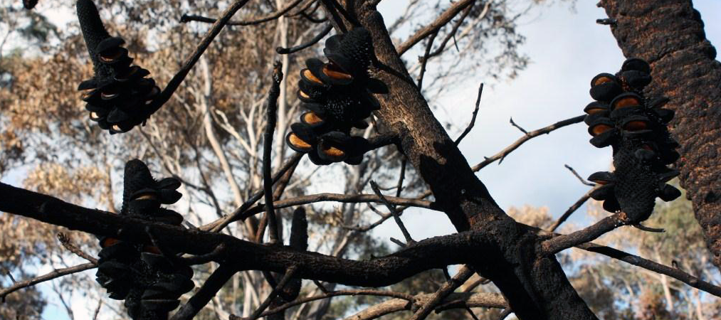­

This work is licensed under a [Creative Commons Attribution 4.0 International licence](http://creativecommons.org/licenses/by/4.0/).   
To view a copy of this licence, visit <http://creativecommons.org/licenses/by/4.0/> **­**

**Accessibility:** If you would like to receive this publication in an alternative format, please telephone DELWP Customer Service Centre 136 186, email [customer.service@delwp.vic.gov.au](mailto:customer.service@delwp.vic.gov.au), via the National Relay Service on 133 677 [www.relayservice.com.au](http://www.relayservice.com.au). This document is also available at [www.delwp.vic.gov.au](http://www.delwp.vic.gov.au)



What are the environmental features of our landscape?

The Alpine and Greater Gippsland landscape contains an extremely diverse ecology across mountains, tablelands, foothills, river valleys and coastal plains, including the unique Gippsland Lakes waterways.

This environment contains habitats for more than 250 species of threatened flora and 110 species of threatened fauna.

Fire plays an essential role in the ecology of many native plants. DELWP currently uses Tolerable Fire Intervals (TFIs) to determine the effect of the strategy on ecosystem resilience.

Strategic bushfire management acknowledges a balance between reducing bushfire risk to life and property and maintaining ecosystem resilience across the landscape.

For this reason, we modified our strategy in some areas to accommodate the needs of specific threatened plant and animal species.

For more information and factsheets phone (03) 5152 0600 or email [alpine.greatergippsland@delwp.vic.gov.au](mailto:alpine.greatergippsland@delwp.vic.gov.au).

What are the features of our landscape?

The Alpine and Greater Gippsland Bushfire Risk Landscape covers two shires, East Gippsland and Wellington, and parts of the shires in alpine areas. This landscape has many features that present a challenge for bushfire management, including:

3.3 million hectares, around 70% of which is public land, much of it continuous forest

more than 32,000 people living in towns of fewer than 500 in rural, coastal and remote areas, often adjacent to forest

an economy dependent on pristine natural resources with agriculture, horticulture, forestry, fishing and tourism being major contributors to employment

high-value state and national infrastructure and important water catchments

the Gippsland Lakes, and National and State parks and forests attracting significant numbers of tourists, campers and recreational users throughout the year, with visitor populations peaking in the summer holidays.

What is strategic bushfire risk management?

Alpine and Greater Gippsland is one of Victoria’s seven risk landscapes. These allow bushfire management planning to follow the natural bushfire ‘catchments’, where major bushfire could be expected to start, spread and impac­t on people and assets.

This strategic planning approach:

* adapts as conditions and risk factors change. It has evolved from the fire prevention planning DELWP does annually with communities and stakeholders

enables DELWP, PV and other agencies to focus on the most effective strategies to minimise bushfire risk to people, property, the economy and the environment

combines local knowledge with the latest technology, historical data and the best-available science to enable more precise planning.

What is bushfire simulation?

DELWP has invested in bushfire simulation software, called PHOENIX Rapidfire, in a joint initiative over several years with the University of Melbourne and the Bushfire and Natural Hazards Cooperative Research Centre.

The modelling software predicts the spread and intensity of a bushfire based on a number of variables, including ignition points, weather, terrain, vegetation and fire history.

It helps us understand fire behaviour by showing characteristics such as flame height, ember density, spotting density and convection column intensity.

It helps guide where planned burning and other fuel treatment methods will be most effective in reducing the risk of bushfire, and in protecting people, property and the environment.

In addition to its strategic and operational benefits, bushfire simulation is also a highly visual way of helping communities understand the risks they face, and which activities reduce those risks.

**Disclaimer:** This publication may be of assistance to you but the State of Victoria and its employees do not guarantee that the publication is without flaw of any kind or is wholly appropriate for your particular purposes and therefore disclaims all liability for any error, loss or other consequence which may arise from you relying on any information in this publication.

© The State of Victoria Department of Environment, Land, Water and Planning 2015

ISBN 978-1-74146-919-6 (print)

ISBN 978-1-74146-920-2 (pdf)

Effective fire management involves recognising the roles we all play in reducing risk to life, property and the environment

Strategic bushfire management – an overview

Alpine and Greater Gippsland

What is bushfire simulation?



What are the environmental features of our landscape?



What is strategic bushfire management?



What are   
the features of our landscape?

