Strategic bushfire risk management aims to achieve a balance between the two core objectives of reducing bushfire risk to life, communities, the economy and the environment, while maintaining resilient ecosystems.

Victoria is one of the most fire-prone areas in the world. In past decades, we have seen the disastrous effects that bushfires can have on communities — on people, properties, infrastructure, the economy and the environment.

Climate change projections indicate that Victoria is likely to have up to 70% more Extreme and Code Red days by 2050. Climate change is also likely to alter habitats for plants and animals.

**Alpine and Greater Gippsland** is one of Victoria’s seven risk landscapes, which are operational areas largely defined by the way bushfires start and spread within a region.

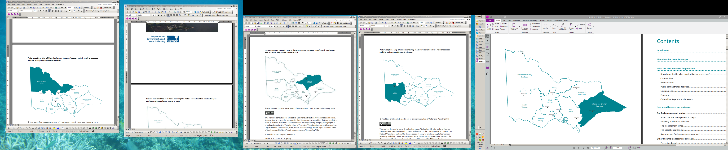

* The landscape covers two shires, East Gippsland and Wellington, and parts of the shires in alpine areas. It comprises 3.3million hectares, around 70% of which is public land, mostly continuous forest.
* Although covering 14.5% of the state, the landscape contains only 1.7% of the population.
* More than 32,000 people live in communities of fewer than 500 in rural, coastal and remote areas, often adjacent to forested public land.

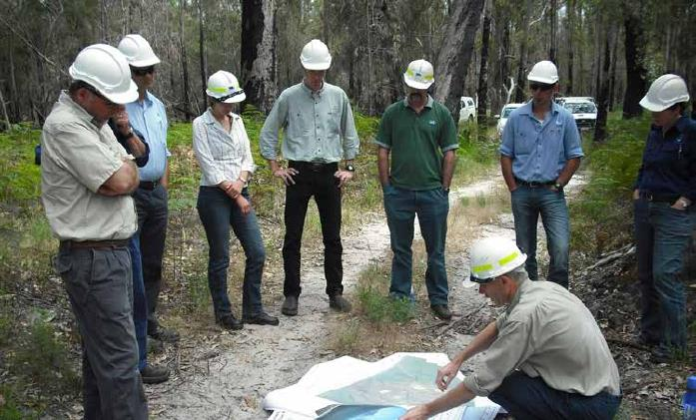

Teams from the Department of Environment, Land, Water and Planning (DELWP) and Parks Victoria (PV) have been working with stakeholders to develop a risk-based approach to bushfire management in the landscape. This allows DELWP, PV and other agencies responsible for bushfire management to focus on the most effective ways of reducing bushfire risk.

The framework

The risk planning process provides an adaptive and sustainable framework for DELWP, PV, key stakeholders and communities to work together to minimise bushfire risk. It comprises four key stages:

**Modelling Bushfire Risk: The first stage** gathersinputs such as historical fire data, fuel hazards, terrain and weather to model bushfire behaviour across a wide range of conditions, using world-leading bushfire simulation technology, PHOENIX RapidFire. (For more information, see factsheet ***Bushfire simulation***.)

**Community Values: The second stage** in the process involves DELWP and PV working with stakeholders and communities to understand what they value and want to protect from bushfires. Detailed information is gathered on assets of all kinds across the landscape, including dwellings, infrastructure, the economies and industries, the environment and its ecosystems. (For more information, see factsheet ***Community Values***.)

**Risk Assessment: The third stage** again produces bushfire modelling and detailed analysis with internationally recognised risk methodology, to assess bushfire risk profiles based on the likelihood and consequence of bushfire affecting each of the priorities. (For more information, see factsheet ***Assessing risk***.)

**Developing the plan: The fourth stage** combines the bushfire modelling, the risk profiles, in conjunction with local knowledge, experience and expertise in fire, to determine the fuel management strategy. Such detailed analysis allows planning for fuel treatments in each area of the landscape, based on its risk profile. (For more information, see factsheet ***Developing the plan***.)

This initial plan becomes the base for future iterations, which will be improved by continuous data improvements, input and feedback from stakeholders and the community

Fuel management reduces risk



Strategically treating the fuel hazard in our parks and forests makes a significant contribution to reducing the spread and intensity of bushfires. This helps protect people, towns, homes, emergency facilities and other priority assets.

The main fuel management option is planned burning, which is deliberate burning to reduce the quantity of leaf litter, twigs, bark and undergrowth. It is the most effective method of managing fuel in large areas of public land.

Where appropriate, we may also manage fuel by slashing, mowing, mulching and applying herbicide. We will continue to work with industry groups and communities to investigate other fuel management techniques.

Resilient Ecosystems

Resilient ecosystems support biodiversity of flora, fauna and micro-organisms, which are vital for clean air, fresh water and fertile soils. Maintaining or improving ecosystem resilience is a goal of strategic bushfire risk management, and we are currently using **Tolerable Fire Interval (TFI)** to help measure this. TFI will be used as an initial measure while we are refining more detailed ways of measuring ecosystem resilience. (For more information, see factsheet ***Ecosystem resilience***.)

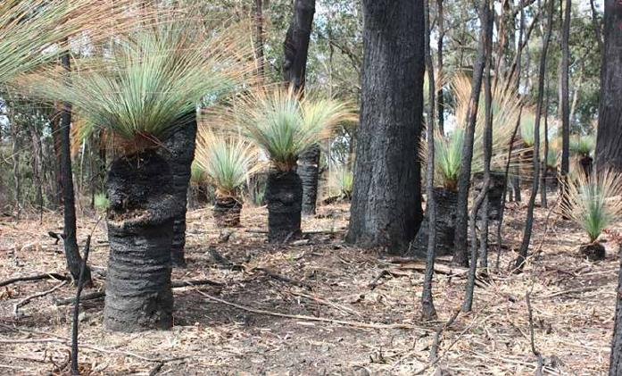

What has changed?

Each year, the fire districts in each region prepare, review and update a rolling three-year Fire Operations Plan, which includes the timing and location of proposed planned burns. This process takes into account factors such as fire history, community expectations, cultural heritage values, native title and biodiversity.

Planned burns usually take place in autumn and spring when the weather is milder and fire behaviour is easier to predict and manage.

In recent years, guided by the recommendations from the 2009 Bushfire Royal Commission, DELWP has used a hectare-based target for planned burning across the state.

Changing to a risk-based strategy allows for a more flexible, adaptive approach that can more easily accommodate changes such as seasonal conditions, or even changes to community values and priorities for risk reduction.

How is this approach different?

This strategic planning approach:

* combines local knowledge with the latest technology, historical data and the best-available science to enable more precise planning
* adapts as conditions and factors change
* allows DELWP and PV and other agencies to focus on the most effective strategies to minimise bushfire risk to people, property, the economy and the environment.

Who is involved?

DELWP and PV have been working with two main groups in reviewing the potential strategies, prioritising asset types and assessing risk to build the initial plan.

**The Landscape Reference Group (LRG)** comprises 14 community members with expertise and good local knowledge of bushfires in the landscape, including apiarists, timber workers, farmers, environmental contractors and CFA brigade members.

**The Internal Working Group (IWG)** includes specialists from DELWP and PV and cross-agency representatives with extensive knowledge and experience: this group focused on making sure the strategy was effective and practical.

Both groups met fortnightly to help guide the strategy development process, including; identifying priority assets, analysing alternative strategies, determining possible fuel management regimes, selection of the final strategy and incorporation of local knowledge to ensure operational implementability.

How we will monitor success

Strategic bushfire management planning is an ongoing process, where local knowledge, fire histories and burn outcomes will continue to help determine annual planned burning programs and develop future versions of the plan.

We will monitor, evaluate and review the effectiveness of our strategies and update the plan on an ongoing basis. We also report annually on fuel management and risk reduction in the DELWP Fuel Management Report, which was a recommendation of the 2009 Victorian Bushfires Royal Commission.

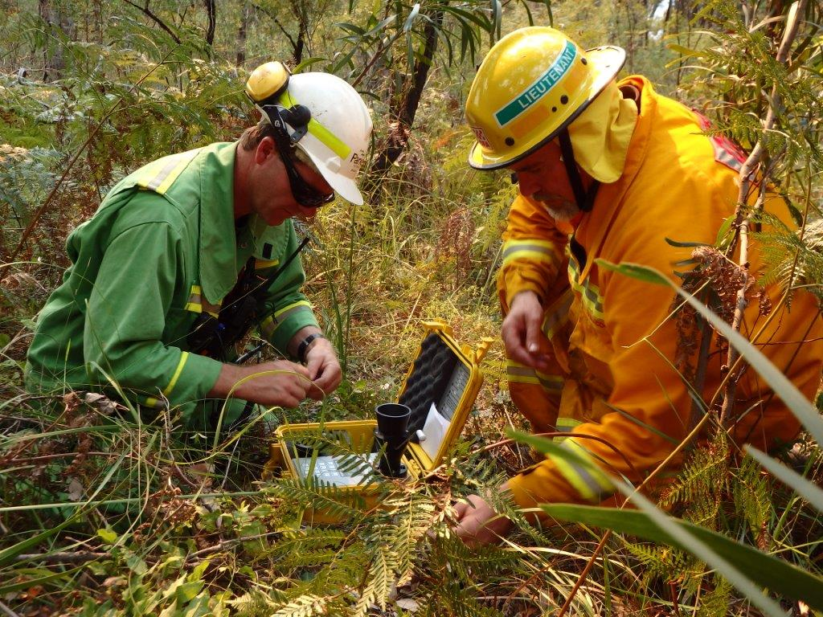

What happens next?

Consultation will now widen to include more stakeholders, interest groups, industries and the community.

DELWP and PV staff will be taking the initial plan to a series of stakeholder, community and interest groups for discussion and feedback.

Strategic bushfire management planning is an ongoing process, where local knowledge, fire histories and burn outcomes will continue to help determine annual planned burning programs and develop future versions of the plan.

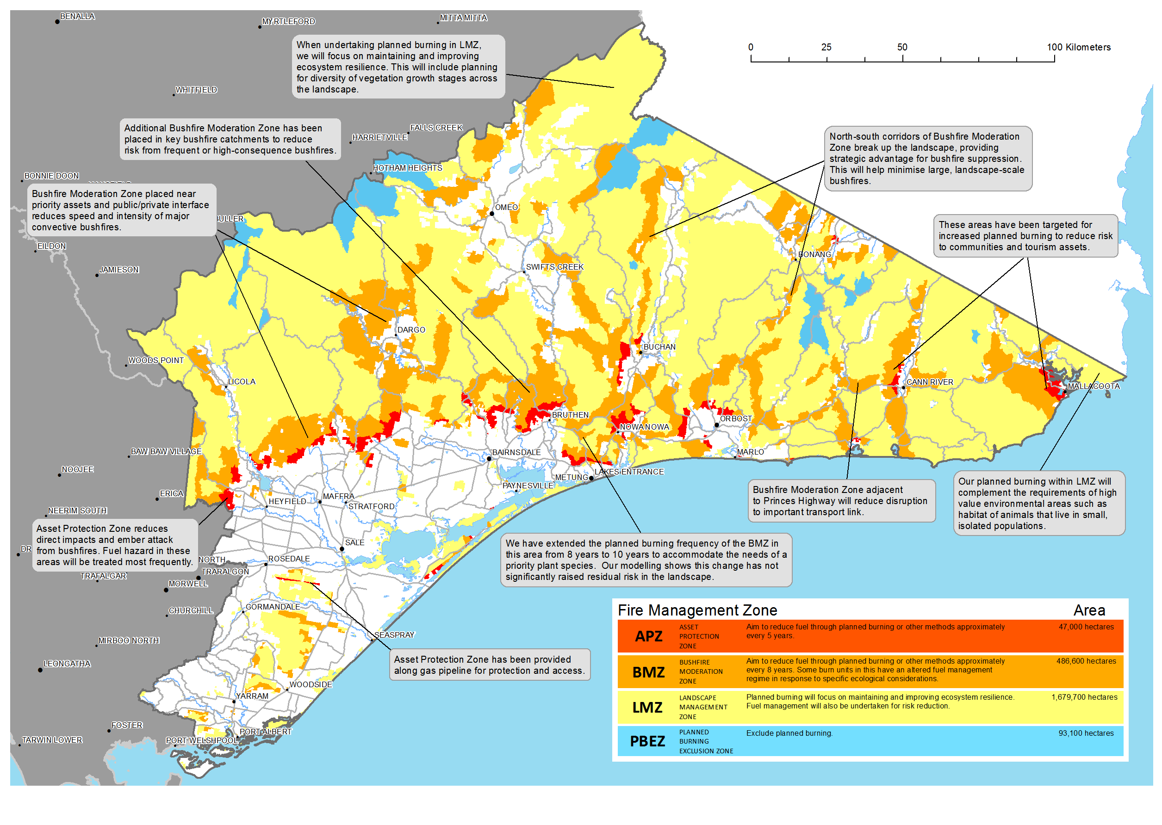

Alpine and Greater Gippsland Fuel Management Strategy

|  |  |
| --- | --- |
| © The State of Victoria Department of Environment, Land, Water and  Planning 2015  This work is licensed under a [Creative Commons Attribution 4.0 International licence](http://creativecommons.org/licenses/by/4.0/). You are free to re-use the work under that licence, on the condition that you credit the State of Victoria as author. The licence does not apply to any images, photographs or branding, including the Victorian Coat of Arms, the Victorian Government logo and the Department of Environment, Land, Water and Planning (DELWP) logo. To view a copy of this licence, visit <http://creativecommons.org/licenses/by/4.0/>  ISBN 978-1-74146-905-9 (print)  978-1-74146-906-6 (pdf) | **Disclaimer** This publication may be of assistance to you but the State of Victoria and its employees do not guarantee that the publication is without flaw of any kind or is wholly appropriate for your particular purposes and therefore disclaims all liability for any error, loss or other consequence which may arise from you relying on any information in this publication.  **Accessibility**  If you would like to receive this publication in an alternative format, please telephone DELWP Customer Service Centre 136 186, email [customer.service@delwp.vic.gov.au](mailto:customer.service@delwp.vic.gov.au), via the National Relay Service on 133 677 [www.relayservice.com.au](http://www.relayservice.com.au). This document is also available by emailing alpine.greatergippsland@delwp.vic.gov.au. |

For further information about managing bushfire risk in the Alpine and Greater Gippsland bushfire risk landscape email [*alpine.greatergippsland@delwp.vic.gov.au*](mailto:alpine.greatergippsland@delwp.vic.gov.au), or contact the Strategic Bushfire Management Program Manager on (03) 51520600.