|  |
| --- |
| 2. Landscape values  Alpine and Greater Gippsland landscape  Information for communities |

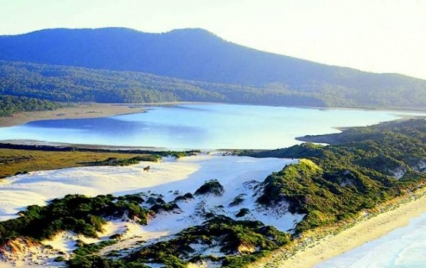Our region boasts natural beauty from coast to mountains. The countryside is not only a tourism drawcard and a haven for wildlife and flora, it also supports a diverse economy that relies on fertile soil and clean water.

The vast and unspoilt nature of our region is part of the main appeal for community and visitors, but also presents the biggest challenge for bushfire risk managers.

The Alpine and Greater Gippsland Bushfire Risk Landscape covers 14.5% of Victoria's landmass, but contains only 1.7% of the population. It extends eastwards from Rosedale to the New South Wales border, and northwards from the coast between Port Albert and the NSW border, to the southern fall of the Great Dividing Range.

With almost 30,000 jobs in the landscape, the region contributes around $5billion gross produce, with the tourism industry generating around $450million.

People

Approximately 86,000 people live in Alpine and Greater Gippsland with more than 38% living in settlements of fewer than 500, many of which are close to heavily forested public land.

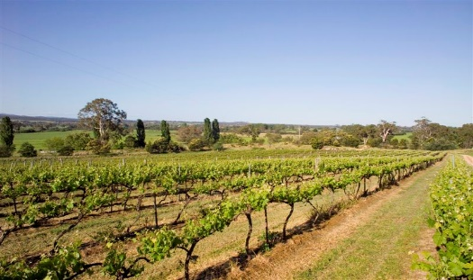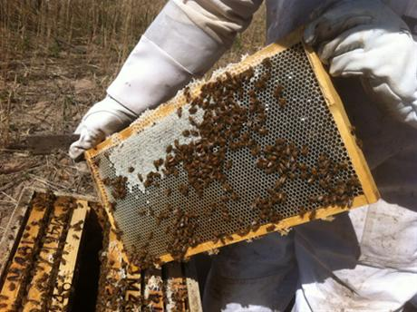

The region’s population swells during holidays as many visitors take advantage of the extensive coastline and Parks and Reserves. The tourism industry is vulnerable to bushfire: it damages or destroy natural environments and infrastructure or can cut road access. Media coverage of bushfire in a region has an adverse effect on bookings even when there is no immediate threat to their destination.

Population growth in key towns and coastal villages in the landscape outstrips that of smaller inland villages and settlements.

There is additional risk from an increasingly ageing population as many retirees move from small settlements across the landscape or from other parts of the state to access facilities available in the bigger centres.

Economy

Oil and gas contribute significantly to the landscape's gross output, but the most important industry sectors for employment are: health and social assistance, retail, education, agriculture, horticulture, forestry, fishing, accommodation, food services and manufacturing.

Bushfires can harm the agriculture, apiary, horticulture and viticulture industries: they destroy and damage crops, buildings, fencing, machinery and equipment, and kill or injure livestock. They impact apiary and threaten food security by damaging native flora and pollen-producing plants such as fruit trees and grape vines. The viticulture industry is particularly vulnerable to smoke taint during the summer bushfire season. We consult with stakeholders about planned burn operations.

Infrastructure

Priority assets in the landscape include utility infrastructure (gas plants, power generation and water treatment plants) and networks, communications, infrastructure (broadcast radio and television facilities, telephone towers and exchanges), emergency facilities and infrastructure (communication and aircraft navigation towers and radar stations), national transport routes (the Princes Highway) and high-value water catchments.

We have placed an Asset Protection Zone along the Esso gas pipeline, which supplies Melbourne with gas. The Princes Highway is the main freight route for produce into and out of Gippsland. There are few alternative routes suitable for heavy vehicles, which comprise 20% of the traffic on the highway.

In addition to its importance for transporting produce into and from Gippsland, the Princes Highway is essential in the peak summer holidays when there is a 50% increase in traffic to tourism destinations along the coast and mountains.

The water supply catchments are vulnerable to fire, not only by damage to infrastructure, but also contamination with ash and debris, and soil erosion after the loss of vegetation.

Environment

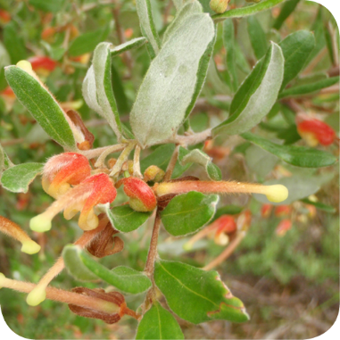The landscape features substantial areas of National and State Parks, forests and reserves, lakes, rivers and coastal areas. We prioritised the habitats of threatened or vulnerable animals and fire-sensitive listed vegetation communities because an intense bushfire can have severe and long-term ecological effects on them.

The landscape includes 29,100 hectares of these vegetation communities, 17 priority flora species and 26 priority fauna species, which are listed as important under state or federal legislation. (For more information, see factsheet ***Ecosystem Resilience****.)*

Heritage, culture and recreation

The AGGBRL supports more than 11,000 Aboriginal Cultural Heritage sites, 6,126 of which are fire-sensitive. The GunaiKurnai Land and Water Corporation (GLaWAC) is the Registered Aboriginal Party and is formally recognised as the traditional owners of a large proportion of the landscape. The landscape also contains more than 470 European cultural sites including a number of historical wooden bridges, deserted towns, mountain cattlemen's huts and disused timber mills that are fire-sensitive.

Bushfire history

The landscape is one of the most fire-prone in the world, with dozens of fires every year ranging from simple fires managed at a local level to 'campaign fires' lasting for weeks

and requiring extensive resources and a multi-agency response. Bushfires in the landscape often occur on high fire danger days with strong north-westerly winds and a south-westerly wind change.

Major bushfires over the past 30 years, have had significant impacts on many towns and communities and have caused loss of life, extensive loss of property, timber resources and other assets.

Bushfires can occur at any time of the year, but are most common between November and March with January being the peak month. Lightning is the major cause of bushfires (47%), human actions are responsible for another 34% of bushfire ignitions, with 60% of those being the result of arson.

What data was assessed?

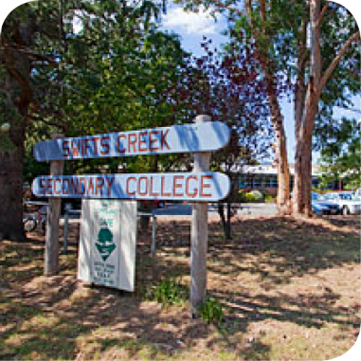Our planning method draws on the best available information and data, including from the *Victorian Fire Risk Register*, Office of the Emergency Management Commissioner, DELWP, VicForests, Environmental Scan, Aboriginal Affairs Victoria, Department of Health and Department of Education data and the BRRAT-Debris Flow Model.

From these data sets, we identified **11,200 individual assets across the Alpine and Greater Gippsland landscape**.

We identified priorities for protection and developed our fuel management strategy in partnership with emergency service agencies and stakeholders from across our community, including the Internal Working Group and Landscape Reference Group.

Our strategy is based on how we can reduce bushfire risk to the priority assets. Consultation will now widen to include more stakeholders and community. (For more information, see factsheet ***Monitoring and future strategy.***)

|  |  |
| --- | --- |
| © The State of Victoria Department of Environment, Land, Water and  Planning 2015  This work is licensed under a [Creative Commons Attribution 4.0 International licence](http://creativecommons.org/licenses/by/4.0/). You are free to re-use the work under that licence, on the condition that you credit the State of Victoria as author. The licence does not apply to any images, photographs or branding, including the Victorian Coat of Arms, the Victorian Government logo and the Department of Environment, Land, Water and Planning (DELWP) logo. To view a copy of this licence, visit <http://creativecommons.org/licenses/by/4.0/>  ISBN 978-1-74146-907-3 (print)  ISBN 978-1-74146-908-0(pdf) | **Disclaimer** This publication may be of assistance to you but the State of Victoria and its employees do not guarantee that the publication is without flaw of any kind or is wholly appropriate for your particular purposes and therefore disclaims all liability for any error, loss or other consequence which may arise from you relying on any information in this publication.  **Accessibility**  If you would like to receive this publication in an alternative format, please telephone DELWP Customer Service Centre 136 186, email [customer.service@delwp.vic.gov.au](mailto:customer.service@delwp.vic.gov.au), via the National Relay Service on 133 677 [www.relayservice.com.au](http://www.relayservice.com.au). This document is also available by emailing alpine.greatergippsland@delwp.vic.gov.au. |