To manage bushfire risk, we need to firstly have a clear understanding of the predicted risk and the influencing factors.

Over several years, the Department of Environment, Land, Water and Planning (DELWP) and Parks Victoria (PV) have worked in conjunction with the University of Melbourne and Bushfire and Natural Hazards Cooperative Research Centre to develop PHOENIX RapidFire, bushfire simulation software.

PHOENIX predicts how bushfires spread from a grid of ignition points, given variables including:

* terrain and fuel (as a result of fire history, type of vegetation and modelled fuel accumulation) at the starting point and along spread paths
* weather conditions

These scenarios can predict fire behaviour, showing characteristics such as flame height, ember density, spotting density and convection column intensity.

How was it used in the development of the plan?

The models guide where planned burning and other fuel treatment methods will be most effective in reducing the risk of bushfire, and in protecting people, property and the environment. In addition to the planning and operational benefits, bushfire simulation is also a highly visual way of engaging communities with the risks they face.

The DELWP landscape planning team and the Internal Working Group then combine Phoenix model outputs with detailed risk analysis to assess bushfire risk profiles based on likelihood and consequence of bushfire affecting each of the priorities. (For more information, see factsheet ***Assessing risk***.)

What is residual risk?

One way DELWP measures the effectiveness of the strategy is by how well it reduces the residual risk of bushfire. Residual risk is the percentage of bushfire risk that remains after fuel management activities and fire history. (See Figure 1 below.)

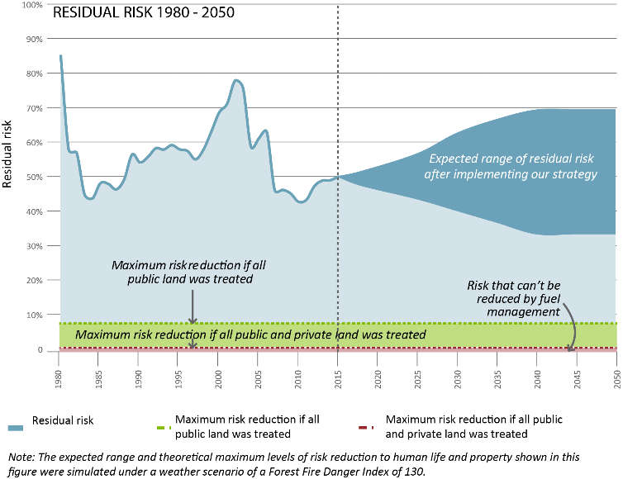**Figure 1: Residual Risk**

Residual risk is determined by the complex mosaic of fuel-reduced and bushfire-burnt patches across the landscape. PHOENIX RapidFire can simulate the reduction in residual risk at any particular location or point in time. Note that whilst risk can never be eliminated, risk reduction outcome

is better when fuels are managed on both public and private land.

Inputs will be refined over time

As information is updated, it will strengthen the models Phoenix produces. Currently, Phoenix uses ‘Address Points’ from the 2011 Victorian Fire Risk Register as a proxy for loss of property and life.

This data is being updated over time but leads to anomalies that require the input of local knowledge. New housing developments (post-2011) are not shown, which leads to risk being underestimated in growing towns.

In other areas, risk has been overestimated due to out-of-date records on the register. For example, the historic gold mining township of Grant, north of Dargo has no dwellings, but still shows up as many houses, which leads to higher modelled risk in that area

.

|  |  |
| --- | --- |
| Map2 | **(Left) Map of the simulated and actual extent of 2011 Tostaree bushfire**  This map shows the actual and simulated fire extent and intensity, as well as the effectiveness of planned burning in slowing or stopping the spread. |
| Map3 | **(Left) Map of the Phoenix RapidFire simulated potential spread of the 2011 Tostaree bushfire without planned burning**  This map shows that the Tostaree bushfire could have been three times larger, posing a much greater risk to life and property. |

Case study: Tostaree bushfire 2011, actual and simulated

For further information about managing bushfire risk in the Alpine and Greater Gippsland bushfire risk landscape email [*alpine.greatergippsland@delwp.vic.gov.au*](mailto:alpine.greatergippsland@delwp.vic.gov.au), or contact the Strategic Bushfire Management Program Manager on (03) 51520600.

|  |  |
| --- | --- |
| © The State of Victoria Department of Environment, Land, Water and  Planning 2015  This work is licensed under a [Creative Commons Attribution 4.0 International licence](http://creativecommons.org/licenses/by/4.0/). You are free to re-use the work under that licence, on the condition that you credit the State of Victoria as author. The licence does not apply to any images, photographs or branding, including the Victorian Coat of Arms, the Victorian Government logo and the Department of Environment, Land, Water and Planning (DELWP) logo. To view a copy of this licence, visit <http://creativecommons.org/licenses/by/4.0/>  ISBN | **Disclaimer** This publication may be of assistance to you but the State of Victoria and its employees do not guarantee that the publication is without flaw of any kind or is wholly appropriate for your particular purposes and therefore disclaims all liability for any error, loss or other consequence which may arise from you relying on any information in this publication.  **Accessibility**  If you would like to receive this publication in an alternative format, please telephone DELWP Customer Service Centre 136 186, email [customer.service@delwp.vic.gov.au](mailto:customer.service@delwp.vic.gov.au), via the National Relay Service on 133 677 [www.relayservice.com.au](http://www.relayservice.com.au). This document is also available by emailing alpine.greatergippsland@delwp.vic.gov.au. |

|  |  |
| --- | --- |
| © The State of Victoria Department of Environment, Land, Water and  Planning 2015  This work is licensed under a [Creative Commons Attribution 4.0 International licence](http://creativecommons.org/licenses/by/4.0/). You are free to re-use the work under that licence, on the condition that you credit the State of Victoria as author. The licence does not apply to any images, photographs or branding, including the Victorian Coat of Arms, the Victorian Government logo and the Department of Environment, Land, Water and Planning (DELWP) logo. To view a copy of this licence, visit <http://creativecommons.org/licenses/by/4.0/>  ISBN 978-1-74146-909-7 (Print)  ISBN 978-1-74146-910-3 (Pdf) | **Disclaimer** This publication may be of assistance to you but the State of Victoria and its employees do not guarantee that the publication is without flaw of any kind or is wholly appropriate for your particular purposes and therefore disclaims all liability for any error, loss or other consequence which may arise from you relying on any information in this publication.  **Accessibility**  If you would like to receive this publication in an alternative format, please telephone DELWP Customer Service Centre 136 186, email [customer.service@delwp.vic.gov.au](mailto:customer.service@delwp.vic.gov.au), via the National Relay Service on 133 677 [www.relayservice.com.au](http://www.relayservice.com.au). This document is also available by emailing alpine.greatergippsland@delwp.vic.gov.au. |