Loddon Mallee Bushfire Management Strategy 2020
  - Fuel Management
  - Bushfire Risk Engagement Areas
  - Prevention of Human-caused Ignitions Strategy (pilot)
  - First-attack Suppression Strategy (pilot)

Acknowledgements
We acknowledge and respect Victoria’s Traditional Owners as the original custodians of the state’s land and waters, their unique ability to care for Country and deep spiritual connection to it. We honour Elders past and present, whose knowledge and wisdom has ensured the continuation of culture and traditional practices.
We are committed to genuinely partner and meaningfully engage with Victoria’s Traditional Owners and Aboriginal communities to support the protection of Country, the maintenance of spiritual and cultural practices and their broader aspirations in the 21st century and beyond.
We also thank the community members who completed surveys as part of developing this plan and discussed the merits of the plan throughout this process.
We thank our colleagues and partners in the following organisations who provided valuable input at planning workshops and provided data or expert knowledge supporting this project: Birdlife Australia, Buloke Shire, Campaspe Shire, Central Goldfields Shire, City of Greater Bendigo, Coliban Water, Country Fire Authority, Department of Environment, Land, Water and Planning, Dja Dja Wurrung Corporation, Emergency Management Victoria, Gannawarra Shire, La Trobe University, Loddon Shire, Macedon Ranges Shire, Mallee Fire Advisory Committee, Mildura Rural City, Mount Alexander Shire, Parks Victoria, Pyrenees Shire, Swan Hill Rural City, Vic Roads and Victoria Police.
Aboriginal people should be aware that this publication may contain images or names of deceased persons in photographs or printed material.

Photo credit
Photos: DELWP Loddon Mallee photo library
© The State of Victoria Department of Environment, Land, Water and Planning 2020
This work is licensed under a Creative Commons Attribution 4.0 International licence. You are free to re-use the work under that licence, on the condition that you credit the State of Victoria as author. The licence does not apply to any images, photographs or branding, including the Victorian Coat of Arms, the Victorian Government logo and the Department of Environment, Land, Water and Planning (DELWP) logo. To view a copy of this licence, visit http://creativecommons.org/licenses/by/4.0/

Printed by
ISBN 978-1-76105-002-2 (Print)
ISBN 978-1-76105-003-9 (pdf/online/MS word)

Disclaimer
This publication may be of assistance to you but the State of Victoria and its employees do not guarantee that the publication is without flaw of any kind or is wholly appropriate for your particular purposes and therefore disclaims all liability for any error, loss or other consequence which may arise from you relying on any information in this publication.

Accessibility
If you would like to receive this publication in an alternative format, please telephone the DELWP Customer Service Centre on 136186, email customer.service@delwp.vic.gov.au or via the National Relay Service on 133 677 or at www.relayservice.com.au. This document is also available on the internet at www.delwp.vic.gov.au.

Contents
Abbreviations and Definitions 3
Introduction 5
Our shared responsibility to mitigate bushfire risk 5
Recognising the role of Victoria’s Traditional Owners 6
Bushfire management planning 6
Strategic planning 7
Operational and tactical planning 8
Other bushfire management actions 8
About this bushfire management strategy 9
Method overview 10
Identifying and assessing risk to values and assets 11
Our landscape context 11
Bushfire history and patterns 14
Values and assets 16
Human landscape 16
Aboriginal cultural heritage 18
Natural landscape 19
Our objectives 22
Our risk management approach 23
Risk in Loddon Mallee region 23
Why model house loss? 26
How do we model house loss? 26
Our fuel management strategy 26
Fire Management Zones 26
Ecosystem resilience 29
About our fuel management strategy 29
Victoria’s residual risk 31
Bushfire Risk Engagement Areas 33
Our pilot strategies 34
Bushfire prevention of human-caused ignition strategy (pilot) 35
Bushfire first attack suppression strategy (pilot) 36
Implementation 39
Implementation of pilot strategies 39
Monitoring, evaluation and reporting 40
Appendix 1: Program logic 41
Appendix 2: Other bushfire management actions 48
References 49

Abbreviations and Definitions
Abbreviation | Term
APZ | Asset Protection Zone  an area around properties and infrastructure where we intensively manage fuel to provide localised protection to reduce radiant heat and ember attack on life and property in the event of a bushfire
BMZ | Bushfire Moderation Zone  an area around properties and infrastructure where we manage fuel to reduce the speed and intensity of bushfires and to protect nearby assets, particularly from ember attack in the event of a bushfire
BREA | Bushfire Risk Engagement Area  parts of the landscape, on public and private land, where managing bushfire fuels is most effective in reducing risk. It guides agencies and communities working together to determine the best actions in their local area
CBBM | Community Based Bushfire Management
CAR | Comprehensive, Adequate and Representative reserve system
CFA | Country Fire Authority
DELWP | Department of Environment, Land, Water and Planning
EFG | Ecological Fire Group  a broad native vegetation classification unit based on grouping multiple Ecological Vegetation Classes that share similar ecological responses and relationships, in particular fire responses
EMV | Emergency Management Victoria
EPBC | Environment Protection and Biodiversity Conservation Act 1999 (C’th)
EVC | Ecological Vegetation Class  the standard unit for classifying vegetation types in Victoria, described through a combination of floristics, lifeforms and ecological characteristics
FFG | Flora and Fauna Guarantee Act 1988 (Vic)
FFMVic | Forest Fire Management Victoria  comprised of staff from DELWP, PV, Melbourne Water and VicForests when working in bushfire management on public land
FMZ | Fire Management Zone  for fuel management purposes, public land in Victoria is classified into four fire management zones: asset protection zone, bushfire moderation zone, landscape management zone, and planned burning exclusion zone
GMA | Geometric Mean Abundance  an index of the relative abundance of species within a community. As the relative abundance of species changes, so too does the GMA, and this can be used as a measure of resilience
GSS | Growth Stage Structures  the vegetation GSS of an area is its mix of vegetation of different ages, from juvenile to old. Vegetation’s GSS depends on when it was last burnt or otherwise disturbed. We assume that a diversity of GSSs and habitats across a landscape ensures a diversity of species, which helps maintain and improve ecosystem resilience
Ha | Hectares
HVEA | High Value Ecological Area
JFMP | Joint Fuel Management Program
LMZ | Landscape Management Zone  an area where we manage fuel to minimise the impact of major bushfires, to improve ecosystem resilience and for other purposes (such as to regenerate forests and protect water catchments)
MER | Monitoring, Evaluation and Reporting
MISS | Minimum Impact Suppression Strategy
PBEZ | Planned Burning Exclusion Zone  an area where we try to avoid planned burning, mainly because ecological assets in this zone cannot tolerate fire
PPA | Priority Prevention Area
PSA | Priority Suppression Area
PV | Parks Victoria
RAP | Registered Aboriginal Party
Residual risk | the amount of risk that remains after bushfires and fuel management activities reduce fuel. Residual risk is used by DELWP as a performance measure.
RSFMPC | Regional Strategic Fire Management Planning Committee
SDM | Structured Decision Making
TFI | Tolerable Fire Interval  a term which expresses the minimum or maximum recommended time intervals between successive fire disturbance events at a site or defined area for a particular vegetation community. The time interval is derived from the vital attributes of plant species that occupy the vegetation community. The TFIs guide how frequent fires should be in the future to allow the persistence of all species at the site or defined area
VFRR-B | Victorian Fire Risk Register – Bushfire

Introduction
Victoria is one of the most bushfire-prone areas in the world. Victorians are accustomed to living with bushfire risk, which is the likelihood and consequence of bushfires. It includes the likelihood of a fire starting and spreading across the landscape, and the consequences of it impacting things we value: people, communities, houses and farms, infrastructure, our economy, and the natural environment.
Bushfires are driven by three key factors – fuel, weather and topography – which together make up the ‘fire behaviour triangle’. These three factors combine to affect how a bushfire behaves: how fast it travels, where it spreads, and how intensely it burns. Fuel management is important, because it is the only element of the fire behaviour triangle that we can influence.
Bushfire fuels are the leaves, bark, twigs and shrubs that are burnt by fire. The fuel type, dryness, size, moisture content and arrangement can all affect the speed, size and intensity of a bushfire. Fuel management includes planned burning — lighting and managing planned fires in the landscape — and mechanical treatment — mowing, slashing, mulching and using herbicides. Fuel management activities reduce the amount of fuel across our landscape, decreasing the fire behaviour of bushfires, helping limit their spread and intensity when they occur, and making it easier for our firefighters to control them and lessen their impacts.
Bushfire risk is influenced not only by how a bushfire behaves, but also by how fire impacts the different things that we value. For example, population growth in and near forested areas increases the bushfire risk, as more people enter areas where major bushfires are more likely to impact. The Victorian community is changing in other ways, with an aging population and decreases in volunteering in some areas, leading to an increase in vulnerability to bushfire. For plants and animals, drought, invasive species incursion, as well as habitat loss and fragmentation increase the susceptibility to negative bushfire impacts.
Our changing climate – bringing rising average temperatures, more hot days and less rainfall – means bushfire risk is constantly increasing as fuels dry out and extreme fire weather events increase. Bushfires with the worst consequences typically occur during extreme weather conditions (such as during very hot, dry and windy periods). The disastrous 2019–20 bushfire season, followed periods where parts of Eastern Australia – extending from Tasmania through Victoria, New South Wales and into Queensland – had experienced their driest conditions on record. Over 1.5 million hectares (ha) in Victoria were burnt and large areas of eastern Australia impacted.
In Victoria, climate change is forecast to:
- extend the bushfire season
- make bushfires larger, more severe, and more frequent
- make days with an elevated fire danger rating more frequent
- extend the area that experiences extreme weather conditions, increasing the frequency of these for communities that may have never or have only infrequently experienced such conditions
- start the bushfire season earlier, with more bushfires starting in spring (which may also change fire weather conditions that are experienced, such as wind speed and direction)
- further strain available resources and capacity as the bushfire season increasingly overlaps with suitable weather periods for planned burning.
The impacts of climate change on fire-sensitive habitats and refugia for plants and animals will become increasingly important to manage.
With climate change making many extreme weather events more frequent and more extreme, the impacts on communities are also likely to increase. Of 15,700 disasters between 1980 to 2015, 91% were weather related, and 51% of fatalities and 79% of economic losses were caused by weather related extremes.

Our shared responsibility to mitigate bushfire risk
While bushfires will always be a threat, Victorians have demonstrated their ability to work together to plan and deliver activities on public and private land to mitigate bushfire risk. As with all areas of emergency management, supporting communities to be safer and more resilient is the shared responsibility of all Victorians, not just of government agencies. To best manage bushfires, it is important that communities and government organisations come together to understand bushfire risk, agree on strategies, and then work both individually and collaboratively to fulfil their individual and shared responsibilities.
Actions that agencies are responsible for include issuing fire danger warnings and advice, reducing fuel through planned burning and mechanical treatments, commissioning bushfire science research, and recruiting and training firefighters. Actions that community members are responsible for include developing and practising a bushfire plan, fully extinguishing campfires, preparing their property, and participating in community bushfire activities and events. Actions we do together include building an understanding of risk in our area, sharing information through community and social channels, developing, practicing and implementing plans to protect what is valued most by the local community.
Resilient communities prepare better for bushfires. They provide the volunteer workforce essential in the response phase, and they are better able to face the acute shocks and stresses of a bushfire and to recover after it.
Victoria’s ‘shared responsibility’ approach recognises that communities:
- are best-placed to understand and mitigate their risks and drive preparedness and recovery, including through their fundamentally important volunteer contribution
- have knowledge, expertise, capability and diverse perspectives to work with agencies to mitigate bushfire risk
- have networks and relationships that help agencies identify and protect the things communities value, improve their capacity and create meaningful, sustainable solutions.
The shared responsibility approach seeks to ensure:
- the interests, values and expectations of stakeholders in, or members of, communities are understood and considered in the planning process
- ownership of the planning process and responsibility for implementing strategies are broadly shared.
Shared responsibility does not mean equal responsibility: there are some areas where land and fire management agencies are better-placed and have more resources and information to make decisions and act on them. Equally, while agencies develop plans and implement programs for mitigation, planning, preparedness, response and recovery, governments or agencies cannot guarantee that bushfires will be consequence-free for the community. Communities and individuals have the responsibility to prepare their own plans, properties and assets to reduce the impact of bushfires. During major bushfires with far-reaching consequences, land and fire agencies may not always be able to coordinate and deliver the support the community may expect.

Recognising the role of Victoria’s Traditional Owners
The Loddon Mallee region recognises the Victorian Traditional Owner Cultural Fire Strategy, which aims to re-establish cultural fire with Traditional Owner led practices across Victoria, so Traditional Owners can heal Country and fulfil their rights and obligations to care for Country. The Victorian Traditional Owner Cultural Fire Strategy provides a set of principles and strategic priorities to facilitate greater self-determination for Traditional Owners and a framework for effective Traditional Owner-led cultural fire management in Victoria. The strategy has an important role in informing the Joint Fuel Management Program (JFMP) in consultation with individual Traditional Owner groups Traditional Owners emphasise that cultural fire is applied to achieve culturally meaningful objectives, but that risk reduction is often a complementary outcome.

Bushfire management planning
Figure 1: Bushfire management strategic, operational and tactical planning for fuel management
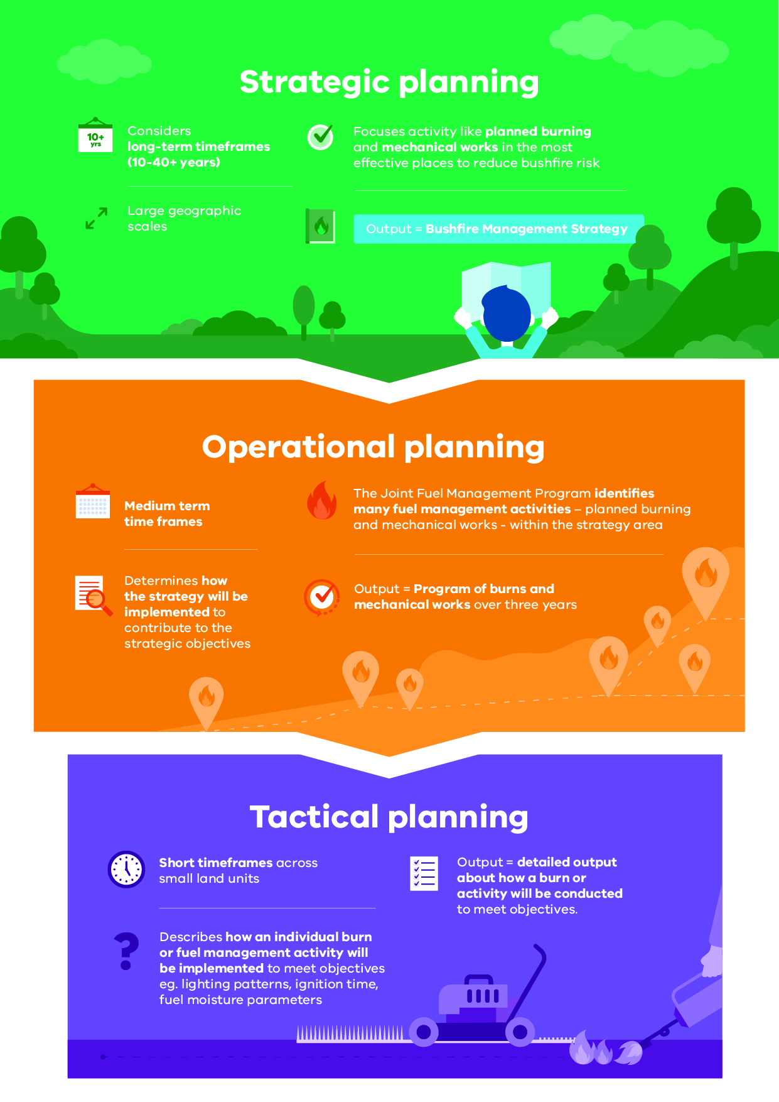
Bushfire management planning occurs at different levels, with varying time frames, focuses and outputs. Figure 1 shows fuel management planning at strategic, operational and tactical levels.

Strategic planning
The strategic planning process identifies where important values and assets are located across the landscape. It considers the current extent and quality of these values and where possible considers future trends including population, industry and environmental change. Strategic planning identifies objectives for the important values and assets, and develops an approach to manage the risks posed to them. The resulting bushfire management strategies describe landscape zones that focus fuel management activities to deliver bushfire risk reduction and ecological outcomes.
Strategic bushfire management planning takes place within a legislative and policy context which includes:
- the Emergency Management Act 2013, which requires from 1 December 2020 the Emergency Management Commissioner to prepare a state emergency management plan and to approve eight regional emergency management plans. In combination with the municipal emergency management plans, these provide for an integrated, coordinated and comprehensive approach to emergency management. The Act also requires emergency management plans to contain provisions providing for the mitigation of, response to and recovery from emergencies and to specify the emergency management roles and responsibilities of agencies
- the Conservation Forests and Lands Act 1987, which requires the Department of Environment, Land, Water and Planning (DELWP), through the Code of Practice for Bushfire Management on Public Land (2012), to develop a risk-based approach to bushfire management on public land. This document meets the requirements set out in the Code of Practice to prepare a strategic bushfire management plan.
- Safer Together: A new approach to reducing the risk of bushfire in Victoria (2015), a Victorian Government policy, focuses on how effective our actions are in reducing risk and not just the amount of activity we undertake.

Operational and tactical planning
This bushfire management strategy informs the development of operational plans, primarily the Joint Fuel Management Program (JFMP). The JFMP is the three-year rolling statewide​ program of fuel management works on public and private lands carried out by Forest Fire Management Victoria (FFMVic) and Country Fire Authority (CFA) to reduce bushfire risk and to maintain the health of native plants and animals that rely on fire to survive. Works include planned burning, slashing, mowing and clearing works, creating and maintaining fuel breaks, and carrying out maintenance on fire infrastructure (like fire dams and lookout towers).
This strategy does not directly address tactical (burn) planning, which is done for individual burns. Tactical planning can include individual burn objectives, community engagement plans and how the burn will be delivered safely.

Other bushfire management actions
This Bushfire Management Strategy outlines our risk-based approach to fuel and ecological fire management. However, fuel management is not the only bushfire management action that reduces bushfire risk and is not always the most effective action to reduce that risk. Fuel management needs to be supported with other actions for number of reasons:
- Some parts of the landscape have inherently high levels of bushfire risk which requires more actions to reduce that risk
- The ability to reduce risk through fuel management may be limited in some landscapes and there will always be fuel re-accumulation
- The effectiveness of fuel management may be reduced under extreme weather conditions
- Fuel management reduces fire behaviour, it does not eliminate it. Suppression activities are always required to control bushfires
Table 1 lists some key actions that agencies and communities undertake together to manage bushfire risk and complement our fuel management approach. Appendix 2 lists some of the key locations where selected actions are being undertaken in Loddon Mallee.
As with fuel management, these actions are guided by bushfire risk analysis combined with other information to ensure they are most effective. Strategies and plans for these actions are developed through emergency management planning processes by agencies at the state, regional and municipal levels. We have also piloted a risk-based approach to support the development of strategies for bushfire prevention and suppression, described in the Strategies section of this document.
Table 1: Bushfire management approaches beyond fuel management
Approach | Key actions
Reduce bushfire ignitions through prevention activities | - Education and advertising campaigns (e.g. campfire safety, reporting ignitions)  - Coordinated, risk-based patrolling  - Deterrence for deliberate or negligent ignition – laws/prosecution  - Monitoring arsonists  - Restrictions – fire danger period and total fire ban triggers, duration and restrictions (including legislative change)  - Reducing ignitions from powerlines
Increase the effectiveness of fire suppression | - Fire detection (towers, aerial surveillance)  - Resourcing, capacity and capability of fire-fighting resources (fire crews, contractors, incident management teams)  - Aircraft fleet management: type, distribution, availability and pre-determined dispatch  - Road infrastructure including maintenance of the strategic fire access road network and network of fuel reduced areas.  - Other fire response infrastructure maintenance including remote water access and helipads  - Fire readiness including rostered and pre-formed Incident Management Teams and fire crews
Reduce bushfire spread and severity | - Planned burning based on tenure-blind risk  - Strategic breaks and burn unit boundary standards  - Flexible delivery of burning (e.g. managed bushfire, unbounded burns)  - Other forms of fuel management (e.g. slashing, spraying, mulching) particularly in high-risk areas where planned burning is not suitable  - Identify and effectively manage fuel hazard reduction on private bush
Reduce the physical effects of bushfires in inhabited areas | - Domestic property preparedness in towns, including fire prevention notices, penalties and cost recovery  - Vegetation management on public and private land within or immediately bordering towns including implementation of fire prevention notices  - Identification, prioritisation and treatment of risk to critical infrastructure  - Access and egress (roadside vegetation/tree maintenance) pre- and post-fire  - Asset protection (on-ground)
Reduce the social effects of bushfires on communities | - Bushfire education programs targeting vulnerable communities including those with identified at-risk or changing demographics, and/or where bushfire risk cannot be effectively reduced through planned burning.  - Recovery planning and relationship building pre-bushfire (e.g. via community groups, scenario events and activities)  - Municipal bushfire plans  - Warnings and advice messaging  - Personal and neighbourhood bushfire plans
Reduce impacts from fire management actions | - Community engagement about fire management and smoke impacts  - Planning to minimise impacts on biodiversity, cultural heritage and other values  - Connections between planning and delivery (e.g. on-ground staff aware of biodiversity/cultural sites and mitigation actions)  - Cross-tenure planning and consultation  - Monitoring effectiveness of mitigations (and subsequent improvement)

About this bushfire management strategy
Victorian landscapes, environments and communities are diverse and multifaceted, and Victorian communities have diverse values, preferences and priorities. This regional bushfire management strategy reflects our region’s unique environments and communities. To develop this strategy, we undertook a regional planning process that was guided by the knowledge and priorities of experts, stakeholders and community members from Loddon Mallee.
Between November 2017 and September 2019, representatives of CFA, DELWP, Parks Victoria, Emergency Management Victoria and local governments undertook a strategic bushfire risk management planning process. The process was guided by the Loddon Mallee Regional Strategic Fire Management Planning Committee, through the regional Safer Together Coordinating Committee and Working Group. They offered opportunities to stakeholders and the broader regional community to be involved in the planning process through both in-person and online mechanisms.
The strategic planning process resulted in four strategies (including two pilot strategies) to reduce bushfire risk and maintain ecosystem health: together, they comprise this strategy — the Loddon Mallee Bushfire Management Strategy 2020.
The individual strategies are:
- our fuel management strategy, which focuses on reducing bushfire fuels through planned burning and mechanical works (mowing and slashing) on public land
- our Bushfire Risk Engagement Areas (BREAs), which focus on targeted community engagement to complement, inform and drive fuel management and other risk mitigation activities on public and private land
- our Prevention of Human-caused Ignition Strategy (pilot), involving identifying areas where medium-term investment in reducing human-caused ignitions will provide the greatest reduction in bushfire risk
- our First-attack Suppression Strategy (pilot), involving identifying areas where medium-term investment in improving first-attack suppression will provide the greatest reduction in bushfire risk.
Our bushfire management strategy focuses on:
- reducing the risk of bushfires threatening lives, homes and other important values and assets across the landscape
- maintaining or improving the resilience of ecosystems
- establishing a shared understanding of bushfire risk across the sector, based on the latest science and the extensive knowledge of agency personnel
- using a 40-year horizon, so long-term ecological changes and fuel accumulation rates can be considered in annual operational planning processes.
The strategy is a supplement to the Loddon Mallee Regional Strategic Fire Management Plan, developed by the Loddon Mallee RSFMPC, and applies to the same Loddon Mallee emergency management region footprint. The plan’s agreed vision, strong leadership and greater cooperation between agencies promotes greater community resilience through effective engagement and best-practice integrated fire management planning.
Regional emergency management plans and municipal emergency management plans are being prepared in line with the new amendments to the Emergency Management Act 2013. This strategy will help inform the bushfire components of these plans, now and into the future.
For the purpose of the Code of Practice for Bushfire Management on Public Land (2012), the FFMVic Chief Fire Officer has approved the public land components of this strategy: specifically, where the strategy relates to state forests, parks administered under the National Parks Act 1975 and protected public land. These components of the strategy will directly guide FFMVic’s fuel management operations. This strategy replaces the former Strategic Bushfire Management Plans for public land, published by DELWP and PV in 2014 and 2015, which used bushfire risk landscape footprints.

Method overview
This document presents the outcomes of the strategic bushfire management planning process.
The planning process involved considerable community engagement — with individuals, private land managers, businesses, community organisations and other stakeholders — to tap into their knowledge, understand their priorities, discuss and evaluate options with them and prepare to involve them in implementing the strategy.
In the planning process, we:
- identified the values and assets that are most important to the residents of and visitors to the region: we grouped these into human life, residency and livelihood, social connectedness and wellbeing, critical infrastructure, areas of cultural significance, fundamental drivers of the economy, and the natural landscape
- developed regional objectives: the things we want to achieve by implementing the strategy
- combined local knowledge, bushfire behaviour modelling, historical data and the best-available science to understand how bushfires behave in our region and to forecast bushfire and fuel management strategy impacts on our most important and at-risk values and assets
- developed and evaluated many potential strategies to select two — our fuel management strategy and the Bushfire Risk Engagement Areas (BREAs) — that will enable agencies and communities to best mitigate bushfire risk to the region’s most important and at-risk values and assets.
The planning process was underpinned by the International Standard for Risk Management ISO 31000. The standard acknowledges that risk can never be completely eliminated. Bushfires will still occur, and we must all be prepared and ready to respond. However, bushfire risk can be reduced with a high-quality risk management approach.
The planning process followed the principles of structured decision making (SDM). SDM is a framework that helps people unpack complex decisions, navigate trade-offs and make logical and transparent choices. It provides a means of bringing together both scientific information and human values to make decisions, through analysis and inclusive deliberation. The principles of SDM are particularly useful in decision-making contexts characterised by uncertainty, multiple stakeholders and competing objectives. Broadly, the SDM steps involved included understanding the landscape context, setting objectives, identifying possible management strategies, and estimating and analysing the consequences and inherent trade-offs of these strategy options. We then selected the strategy that gives the greatest benefit to the things we care about, while balancing the impacts of fuel management actions on those same values.

Identifying and assessing risk to values and assets
The planning process identified values and assets across the region and modelled the impact bushfires and fuel management would have on them. Values are the ultimate durable reasons we care about managing bushfires, and assets are the physical sites that represent these values. For example, we value native species, and the locations of their populations and habitat are the assets we protect to ensure their continued existence.
To identify the region’s most important values and assets, we consulted with our partners, stakeholders and communities, and we drew on specialised data sets including the Victorian Fire Risk Register – Bushfire (VFRR-B) and Victorian Biodiversity Atlas.
We used Phoenix RapidFire, which is world-leading bushfire simulation software developed in Victoria, to model the spread of a bushfire from an ignition point under the specified weather conditions. This enables us to understand the impact bushfires could have on people, homes and other important values and assets in our landscape. We modelled ignitions and bushfire spread patterns at thousands of places throughout the region:
- using ignition likelihood models based on historical ignition characteristics and patterns
- using the bushfire characteristics information in the ‘Bushfire history and patterns’ section
- under a range of bushfire weather conditions, including Code Red conditions: a Forest Fire Danger Index (FFDI) rating of 130 or above. These were the conditions in many parts of the state on Black Saturday 2009, and conditions were similar at times during the 2019–20 fire season. Code Red conditions are also forecast to become more frequent and more extreme with climate change.
We also used a new 20-year historical weather dataset for Victoria to identify recent changes to the state’s climate and so we could better model the average frequency with which various weather scenarios occur. This provided some indication of the likelihood of these scenarios occurring in future. We also partnered with climate scientists to forecast various climate conditions relevant to bushfires which will inform future strategic bushfire risk management planning and preparedness decisions.
To inform our ecological risk assessment, we identified ecological asset areas for seven sub-landscapes in the Loddon Mallee region. These areas were defined by grouping vegetation types that have similar post-bushfire regeneration responses.
Core measures we used in our planning process to predict ecological responses to fire included potential changes to area below the minimum tolerable fire interval (TFI) and to geometric mean abundance (GMA) of species in a community. We also considered high value ecological areas (HVEAs) as part of developing, evaluating and selecting bushfire management strategies. Inputs we used in each sub-landscape to inform this HVEA layer included drought refuge areas, hollow-bearing tree density, known populations of fire-sensitive plant species, vegetation communities listed under the Flora and Fauna Guarantee Act 1988 (FFG), fire-sensitive ecological vegetation classes (EVCs), areas of high government ecological investment (such as long-term total grazing control programs), and fire-sensitive threatened animal species.

Our landscape context
The Loddon Mallee region spans just under 5.9 million ha and occupies more than a quarter of Victoria (Figure 2). The region encompasses the local government areas of Buloke Shire, Campaspe Shire, Central Goldfields Shire, Gannawarra Shire, City of Greater Bendigo, Loddon Shire, Macedon Ranges Shire, Rural City of Mildura, Mount Alexander Shire and the Rural City of Swan Hill. The public land estate comprises 28% of the regional footprint. The region has a growing industry in tourism, viticulture, equine, horticulture, crops, cattle, manufacturing and wool production. Agriculture is the mainstay of the region, with 71% of land in the region used for this purpose. The region is also home to a vibrant manufacturing and service sector.
Figure 2: The Loddon Mallee region with local government boundaries and public land tenure
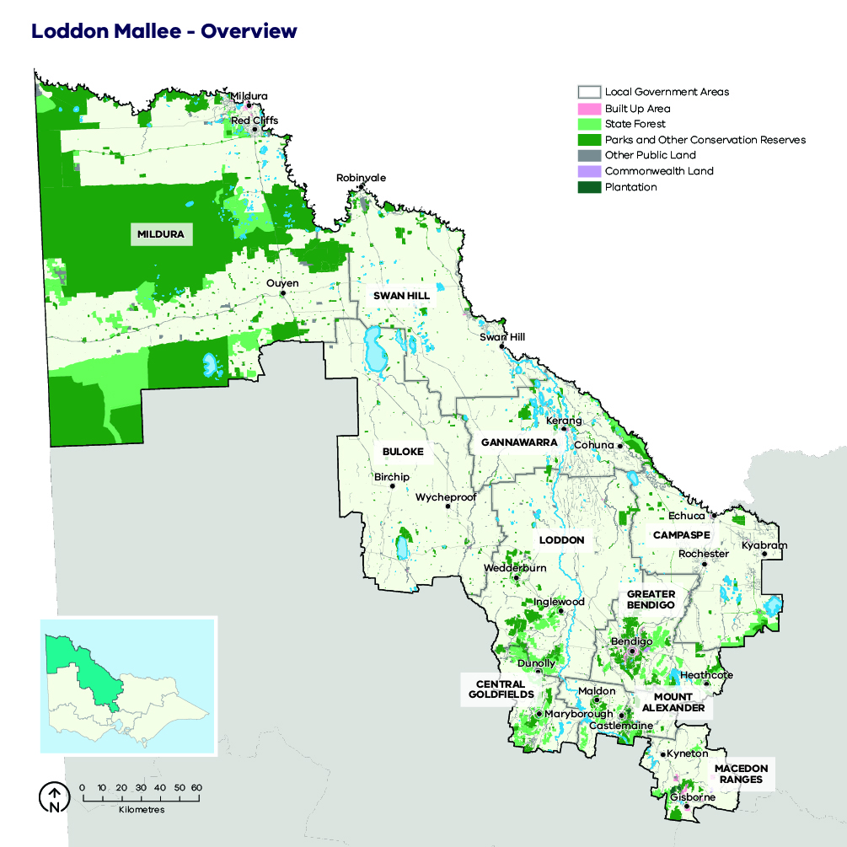

Case study: Local government profiles

Buloke Shire (population 5,952)
Characterised by broad-scale agriculture, Buloke Shire covers an area of about 8,000 km^{2.} The population of 5,952 is centred around the settlements of Sea Lake, Birchip, Donald, Wycheproof and Charlton. Agricultural enterprises including grain, sheep, chicken farms as well as supporting services are the key economic drivers of the municipality, but Buloke Shire Council is the single-largest employer. The Calder Highway and the Mildura–Geelong rail corridor are key state and regionally significant transport routes, which link Mildura, Bendigo and Melbourne.

Campaspe Shire (population 37,622)
Echuca is the largest centre in the Shire of Campaspe with Kyabram, Rochester, Tongala and Rushworth supporting smaller farming communities. Health care, social assistance, agriculture, forestry, fishing, manufacturing and retail provide the largest number of jobs. The natural and historic features of the Shire of Campaspe provide tourist attractions with the Murray River, Port of Echuca, Southern 80 Water Ski Race and several annual events attracting some 1.2 million visitors per year. The peak tourist season extends from November to March, with school and public holidays being the busiest times of the year.

Central Goldfields Shire (population 12,995)
Centred about the main settlement of Maryborough, the shire has 54% of its area as fragmented forest which interfaces with farming and urban land. Agriculture including wineries and their supporting businesses are the primary employers. Summer visitors come to the shire for the Highland Gathering, Talbot Market and RACV Energy Breakthrough Challenge: each bring several thousand people to the area.

Gannawarra Shire (population 10,500)
Kerang and Cohuna are the primary population and business hubs of this shire, accounting for over 5,000 of the 10,500 residents of the shire. Consistent with other northern shires in the Loddon Mallee, Gannawarra is experiencing a gradual decline in population. During the summer months, up to 15,000 people at any one time camp along the riverine forest systems. Cod opening, Southern 80 and duck opening bring thousands of forest users into the area. The forest systems are important to the local businesses in Gannawarra, as forest users use the services and facilities of Kerang, Koondrook and Cohuna.

City of Greater Bendigo (population 110,479)
Known as a city within a forest, the significant interface between forest and urban environments presents ongoing challenges in balancing a range of values and bushfire risk mitigation. The city is the most populated local government area in the Loddon Mallee, with 110,479 residents. The area covered by the City of Greater Bendigo contributes $5,431 million to the regional economy, and regionally important industries and corresponding infrastructure include health care, retail, education, construction, manufacturing, agriculture and mining. Tourism brings $828 million into the municipality a year and some 2.9 million visitors. There is no defined tourist season, with regular events held in and around Bendigo throughout the year including during summer.

Loddon Shire (population 7,555)
A large municipality of 6,694 km², the population of 7,555 represents only 2.3% of the population of the Loddon Mallee region. The most populated settlements in the municipality are Wedderburn, Boort, Tarnagulla, Inglewood, Pyramid Hill, Serpentine and Bridgewater, although none has more than 1,000 residents. As a central municipality, Loddon Shire contains regionally and state-significant transport routes including the Calder Highway, Loddon Valley Highway, Wimmera Highway and the Melbourne–Swan Hill rail corridor.

Macedon Ranges Shire (population 49,388)
Rapid changes in land use and population growth can be attributed to the proximity of Macedon Ranges Shire to Melbourne. Frequent public transport to Melbourne has redefined towns along the rail corridor as commuter suburbs, supporting a growing trend of people moving from Melbourne to regional areas for lifestyle and financial reasons. Changes in land use are also occurring from agriculture as a primary source of income, to hobby farming. Infrastructure of state, regional and local significance is located through the shire, with the Calder Highway and the railway providing a link between Melbourne and regional centres such as Bendigo, Mildura, Swan Hill, Kerang and Echuca.

Mount Alexander Shire (population 19,514)
Mount Alexander Shire has a significant proportion of its population of 19,514 people who moved from metropolitan areas and now commute to Melbourne for work. The large commuting population means that many landowners are absent during the week. The rail line provides commuters with 23 daily rail services to Melbourne. Major industries in the shire are smallgoods, agriculture, manufacturing and correctional services for three prisons.

Rural City of Mildura (population 53,878)
Home to Victoria’s largest expanse of Mallee vegetation and a fruit-dominated agricultural industry that contributes 17% to the area’s economy, the Rural City of Mildura has a unique level of isolation, ecological assets and weather compared to all other municipalities in Victoria. Critical infrastructure includes power transmission lines, the Calder Highway, the Sturt Highway and the Mildura–Ouyen Railway.

Rural City of Swan Hill (population 20,587)
The Rural City of Swan Hill covers an area of 6,116 km² and has a population of 20,587 people. Although the population is scattered among several localities, recent trends suggest smaller rural towns are declining in population whilst Swan Hill is growing. Primary production drives the economy, with agricultural pursuits including wool, cropping, viticulture, fruit and vegetable production. Services supporting agriculture and tourism associated with the Murray River are other significant contributors to the economy. The vegetation consists primarily of cleared farming land, with fuel hazard levels estimated at low to moderate over 88.7% of the shire area.

Bushfire history and patterns
Destructive bushfire weather in Victoria is generally defined by a high-pressure system over the Tasman Sea and a cold pressure system in the Great Australian Bight. This leads to hot and dry conditions, with strong north-westerly winds followed by a mid-afternoon south-westerly change. The change brings gusting winds, instability, lightning events and often no rainfall or increase in humidity to provide relief. Under these conditions, in the forests of the southern parts of the Loddon Mallee region, fires may be dominated by powerful convection columns, intense flames and ember storms. In the Mallee and heath vegetation in the northern part of the region, the spread of fires tends to be wind-driven and less frequently influenced by the effects of convection.
Fires in the region can occur at any time of the year but are most common between October and April, and the most damaging fires have occurred from December through to February. Despite the worst bushfires occurring on days with similar weather patterns, the hot, dry climate of our region means destructive bushfire events can occur under lower fire danger conditions. Days with a fire danger rating of low to moderate — with temperatures of 20° C, surface winds at 20 km/hr and relative humidity of 20% — often support fast-running grass and scrub fires that can significantly impact life, property and other values.
Large fires in the south of the region have often been associated with extended drought periods. The Macedon Ranges was severely burnt on Ash Wednesday 1983, and there were also major fires at Ravenswood in 1969 and Maryborough-Avoca in 1985 (Figure 3). On Black Saturday 2009, Bendigo and the Redesdale communities lost 72 homes experienced 41 casualties and one fatality. Nearly 14% of recorded bushfires in Victoria have occurred in the southern part of the Loddon Mallee region, and more than half of these can be attributed to human activities (Causes of bushfire ignitions across the Loddon Mallee region, 2008–18 inclusive). Fires can start at any time during the day, but most occur in the early afternoon between 14:00 and 15:30 hrs. This is when fire danger approaches its peak, with peak fuel dryness being a significant contributor to bushfire spread at this time of day.
In the region’s north, large bushfires of between 10,000 and 200,000 ha have regularly occurred in the Murray Sunset National Park and the Big Desert–Wyperfeld Park complex, with some fires coming into Victoria across state borders (Figure 3). In 2002, the Big Desert fire burnt over 105,000 ha. Bushfire ignitions are usually attributed to afternoon lightning correlated with the passage of cold fronts following hot days. The cause of fires in the Mallee District is strongly related to land use and topography. While most fires in the big Mallee parks are started by lightning, fires commonly start along the river, often as the result of campfire escapes and in agricultural areas due to human ignition (such as by sparks from harvesting machinery). The number of fires recorded a year is rapidly increasing, partially due to better detection technologies.
Figure 3: Map of bushfire history for the Loddon Mallee region, 1930–2019
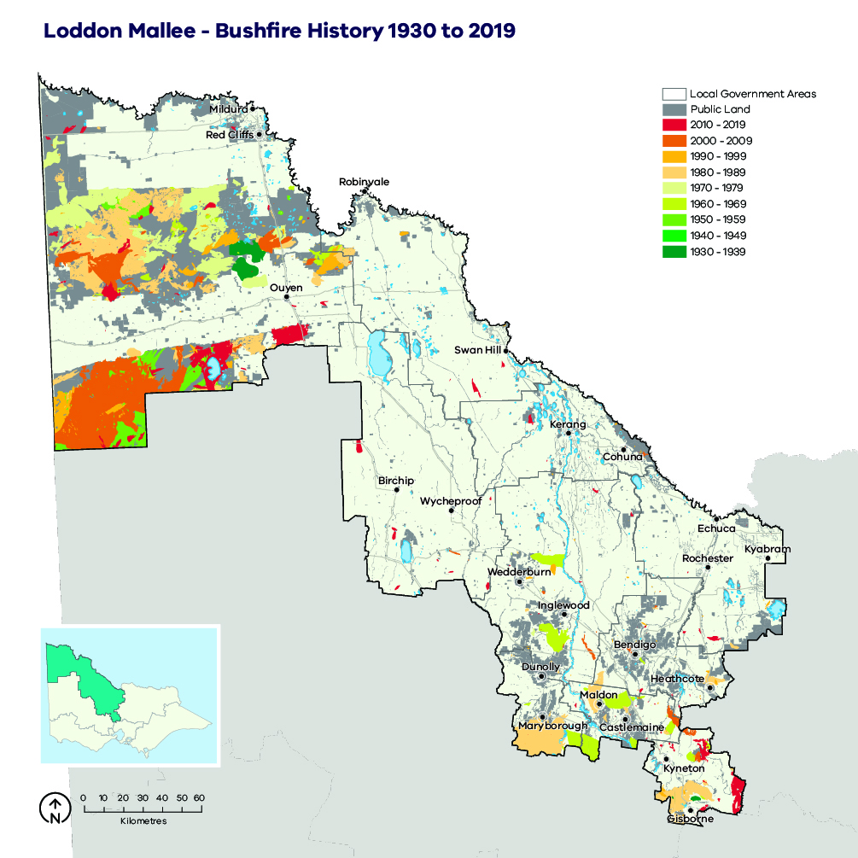
Figure 4: Causes of bushfire ignitions across the Loddon Mallee region, 2008–18 inclusive
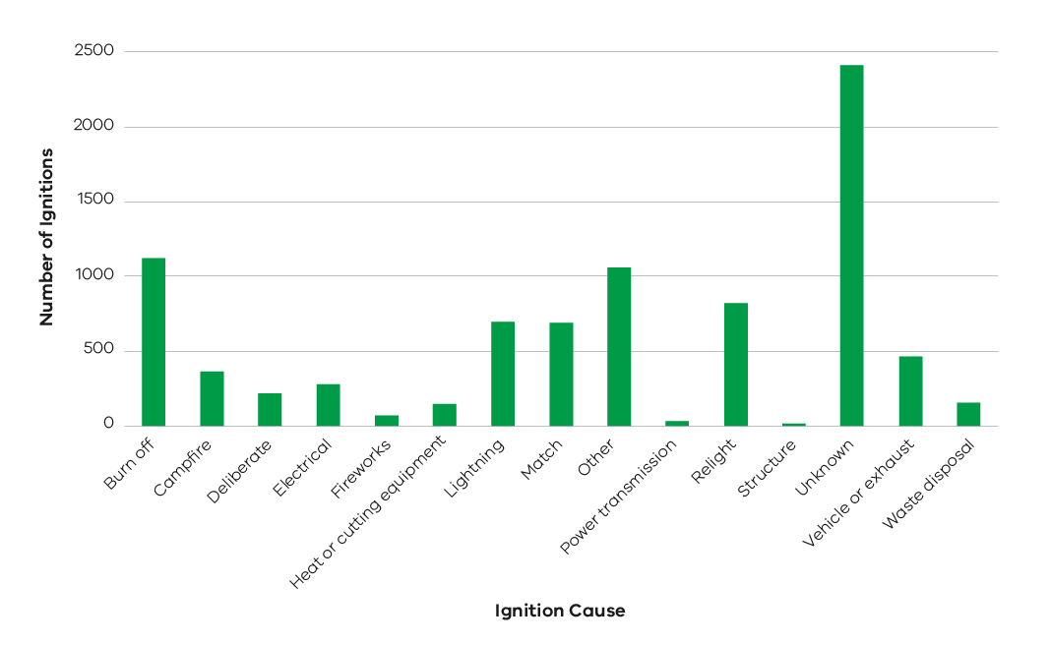

Case study: Bushfire Suppression
Since 1972, 98% of the region’s bushfires have been suppressed at less than 400 ha, and 83% have been suppressed at less than 5 ha in size. This reflects features of the region’s environment and its management including the distribution and amount of fuels, the consistently high level of preparedness by response organisations, the small influence of topography on bushfire propagation, the rapid firefighter ingress to most areas afforded by the maintenance of strategic fire access routes, aerial support, and the success of fuel-reduction activities.

Values and assets
Here we describe the most important features of our landscape that informed our strategy.

Human landscape

Our community
About 328,500 people live in the Loddon Mallee region, mainly in the larger centres. The region is experiencing strong population growth, projected to continue at almost 50% above the Victorian regional average. This trend is driven by improved road and rail links, more jobs and investment, and the region’s liveability. Population growth is mostly occurring in the larger urban areas, and smaller settlements are generally experiencing stable or declining populations. Major settlements in the region include Bendigo, Castlemaine, Echuca, Gisborne, Kerang, Kyneton, Maryborough, Mildura, Swan Hill, Wedderburn and Wycheproof. Regionally, the population is rapidly ageing, which is expected to have impacts on the demand for infrastructure and services, as well as the vulnerability of these older people to bushfire events.

Livelihood and the economy
The Loddon Mallee region has a growing economy in tourism and agricultural production including viticulture, equine, horticulture, crops, cattle, wool and manufacturing. Agriculture is a mainstay of the region, with 71% of land in the region used for this purpose (Figure 5). The region exports a range of produce including grapes, grains, citrus, almonds, chickens and pigs. As a major food-producing area, the region is also home to a vibrant manufacturing and service sector.
The region provides employment to over 129,000 people and has an annual Gross Regional Product of $19.4 billion including more than $1.6 billion generated by the agricultural sector. Into the future, climate change and water availability will continue to place additional stresses on the agricultural industry, and in some areas land use changes are already becoming evident: $4 billion of investment in renewable energy infrastructure has been earmarked for the region.
Figure 5: Generalised land use in the Loddon Mallee region
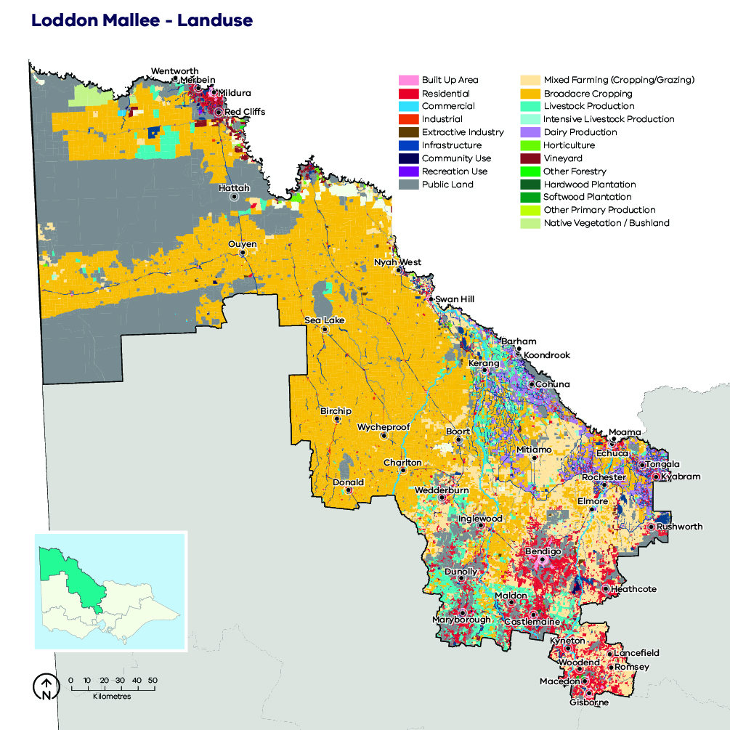

Critical infrastructure
Of 130 infrastructure assets listed for our region in the VFRR-B, 16 have national or state significance (Figure 6). They include major power transmission lines, transport assets and defence and communications facilities. These assets all support services essential to community livelihood, and they are critical infrastructure for our region.
Figure 6: Critical infrastructure, assets, systems and networks in the Loddon Mallee region
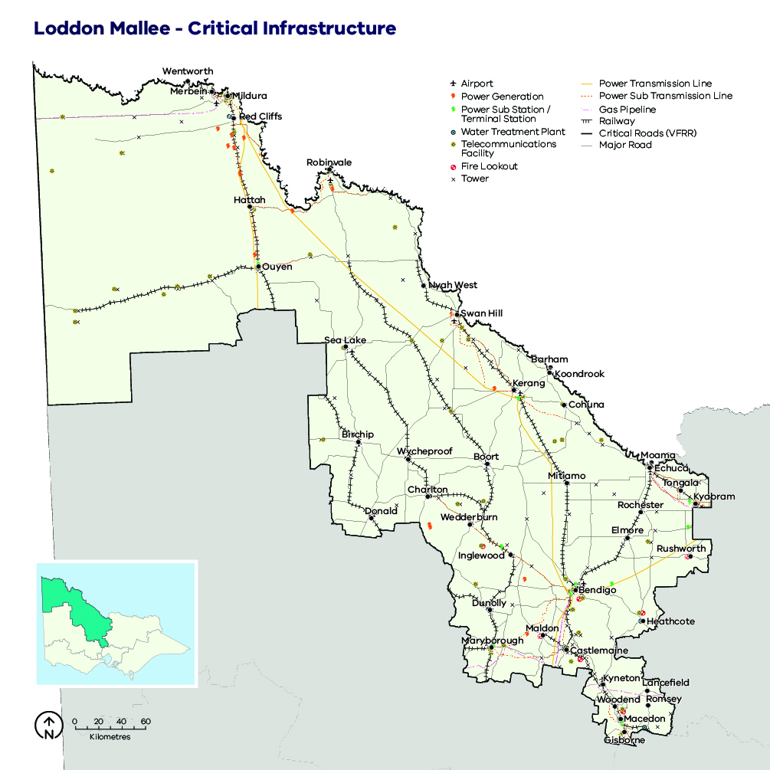

Animal welfare
Density of domestic animals strongly correlates with areas of high population density. Livestock are dispersed widely throughout the region, with pockets of intensive production (piggeries, poultry and dairy farms) and grazing (sheep and beef) making up a large part of our region’s agricultural economy. The number of grazing animals fluctuates enormously depending on the seasons, but the areas where these animals are predictably located is captured in the VFRR-B.

European heritage
Over 100 areas of European heritage significance have been identified in the VFRR-B, and they are believed to adequately capture priority assets for some communities’ sense of place.

Aboriginal cultural heritage
The Loddon Mallee region includes the lands of 12 recognised Traditional Owner groups. It is rich in places of traditional, historical and contemporary significance including burial sites, ceremonial gathering places, middens and scar trees. Priority areas for preserving Aboriginal cultural heritage also include places of spiritual or ceremonial significance, places where traditional plant or mineral resources occur, or trade and travel routes (Traditional Owner groups and Registered Aboriginal Parties in the Loddon Mallee region).
Figure 7: Traditional Owner groups and Registered Aboriginal Parties in the Loddon Mallee region
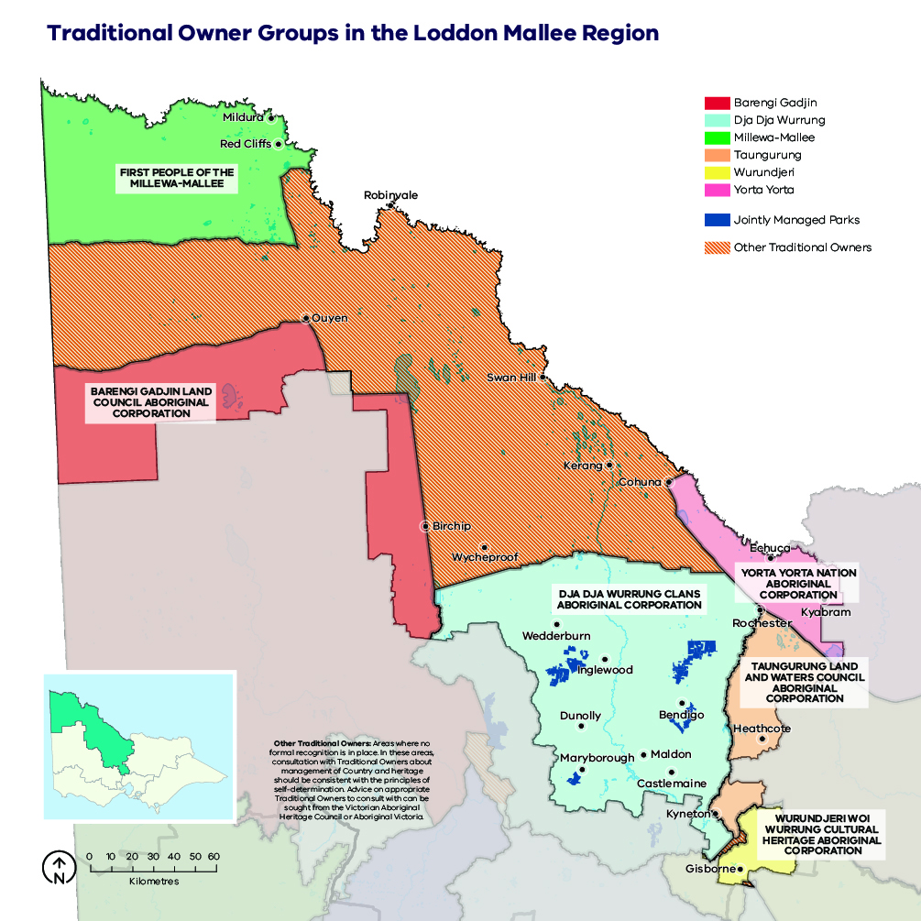

Natural landscape
The Loddon Mallee region is characterised by some of the state’s largest public land blocks. The region’s 1.7 million ha public land estate is comprised of a network of parks and reserves and state forest, which is built upon the national criteria for a comprehensive, adequate and representative (CAR) reserve system of Australia’s forest (Figure 7). Parks and reserves are primarily managed for nature conservation, ecosystem services and recreation. State forest is managed for a greater diversity of purposes including biodiversity conservation, water catchment services, timber harvesting, firewood production, minor produce and apiary use. Recreation and tourism are also important and increasingly popular uses of state forest, with many active and passive pursuits commonplace across Loddon Mallee.
The Loddon Mallee region is characterised by having lower average annual rainfall than other regions of Victoria. Associated with this drier landscape are its relatively lower nutrient soils. These climatic and biogeographic features have influenced the unique range of plants and animals that occur in this region. The region provides the primary habitat in Victoria for 37% of its threatened species of which 28 are nationally listed as threatened under the Environment Protection and Biodiversity Conservation Act 1999 (EPBC). In addition, ten vegetation communities in the region are listed as threatened under Victoria’s Flora and Fauna Guarantee Act 1988 (FFG). In total, these cover about 4% of the region. Most of these listed vegetation communities occur within the agricultural blocks and isolated reserves of the region. The fire-sensitive semi-arid Pine-Buloke Woodland comprises part of the EPBC-listed Buloke Woodlands of the Riverina and Murray-Darling Depression Bioregion threatened vegetation community.
The region contains seven distinct natural sub-landscapes which are defined according to common attributes of vegetation fire responses: Northern Mallee, Southern Mallee, Goldfields, Northern grasslands, Riverine woodlands, Central Victoria uplands and Agricultural lands and isolated reserves (Figure 10).
Figure 8: Native vegetation by land tenure in the Loddon Mallee region
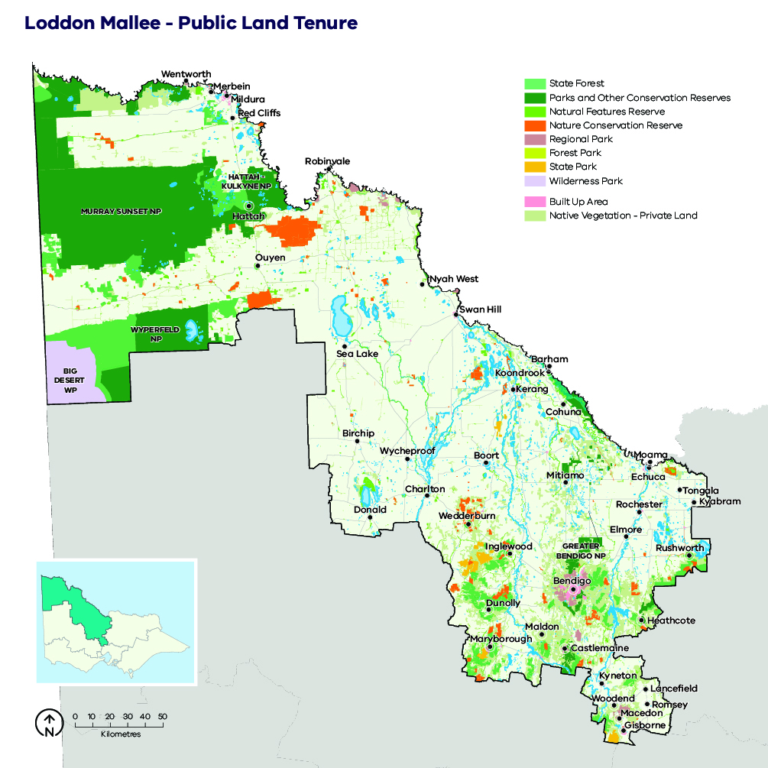

Northern Mallee sub-landscape
This sub-landscape covers the Murray Sunset and Hattah-Kulkyne national parks and the Annuello Flora and Fauna Reserve. These parks and reserves form a largely intact contiguous block of public land. Much of these areas have never been cleared for agriculture. The ecological fire groups (EFGs) that dominate these blocks are considered highly adapted to fire. These are Hummock-grass Mallee and Saltbush Mallee, which combined account for 82.7% of this sub-landscape. This combination of EFGs of the Northern Mallee sub-landscape in turn has influenced the unique diversity of fauna found in this area. Many of the threatened species within this sub-landscape are Mallee heartland species and are found nowhere else in Victoria.

Southern Mallee sub-landscape
This land management unit comprises the Big Desert Wilderness Park, Big Desert State Forest, Wyperfeld National Park, Patchewollock State Forest, Bronzewing Flora and Fauna Reserve and Wathe Flora and Fauna Reserve. This sub-landscape is different to the Northern Mallee sub-landscape, with slightly higher rainfall and lighter sandy soils and it is generally dominated by a different, more diverse range of EFGs. Similarly, the species mix of priority threatened animals considered vulnerable to the effects of planned burning includes endemics only found in this sub-landscape.

Goldfields sub-landscape
This land management unit covers 1,136,9134 ha and is defined by the Goldfields bioregion. There are 15 EFGs of vegetation that comprise the Goldfields, with three dominant EFGs covering 75.4% of its public land area. Of the dominant EFGs, Ironbark/Box is the most extensive (42.7%) and has a mix of tree species characteristic of the dry, northern-slope forests that determine the biodiversity of this region.

Northern grasslands sub-landscape
Broadly the characteristic vegetation communities of the Northern grasslands sub-landscape can be described by two broad vegetation types: plains grassy woodland complexes and grassland complexes. The woodland structure is dominated by Black box and other box eucalypt species and/or Buloke and native Callitris pines, whereas the grassland complex is dominated by wallaby and spear grasses with a mixture of herbs from the daisy, saltbush and pea families. These complexes are now largely fragmented since European settlement with much of the small remnants on private property. This sub-landscape includes Terrick Terrick National Park and Bael Bael Flora and Fauna Reserve. These reserves comprise a small fraction of the extent of native grasslands that once covered the northern plains of Victoria referred to as the Victorian Riverina Bioregion.

Riverine woodlands sub-landscape
This sub-landscape comprises the forests and associated wetlands of the Murray River floodplains and spans the Mallee and Murray Goldfield fire districts. The area covers floodplains from Echuca downriver to the South Australian border. The environmental priorities of the riverine woodlands are defined by the characteristic river-red-gum-and-black-box-dominated floodplain forests and the associated terrestrial threatened animals.

Central Victorian uplands sub-landscape
The Central Victorian uplands can be found in the far southern edge of the Loddon Mallee region. This sub-landscape comprises the highest altitude areas with higher rainfall and the tallest forest ecosystems of the region, and it includes an unusual mix of priority animal species considered susceptible to fire.
The only area of tall forests in our region is found in this sub-landscape, which covers an area of 127,654 ha of public land.

Agricultural lands and isolated reserves sub-landscape
The agricultural lands and isolated reserves sub-landscape covers 51.5% of the Loddon Mallee region and comprises the large areas devoted to agriculture across the region. This sub-landscape includes ecologically important areas of roadside vegetation and the many small — less than 500 ha — reserves that occur greater than 500 m from the larger public land blocks, as well as the many remnants of native vegetation remaining on private property. These small, isolated reserves are seldom considered large enough to sustain large self-supporting populations of most threatened vertebrate species. However, they do form an extensive network of dispersal pathways linking themselves and the larger remnant blocks of vegetation. In this sense, they provide a valuable feature to the ecology of the Loddon Mallee region.
The vegetation communities represented in this sub-landscape span all of those that comprise the Loddon Mallee region. However, there is an overrepresentation of Mallee EFGs, which account for 55.8% of the remnant vegetation across the agricultural landscape. The list of priority species that may be found in these reserves spans the species list for the whole region.
Figure 9: Seven environmental sub-landscapes have been identified in the Loddon Mallee region, which are based on groupings of existing bioregions that share similar characteristics in relation to fire behaviour. These sub-landscapes were used as units within which the fuel management strategy was assessed against environmental objectives.
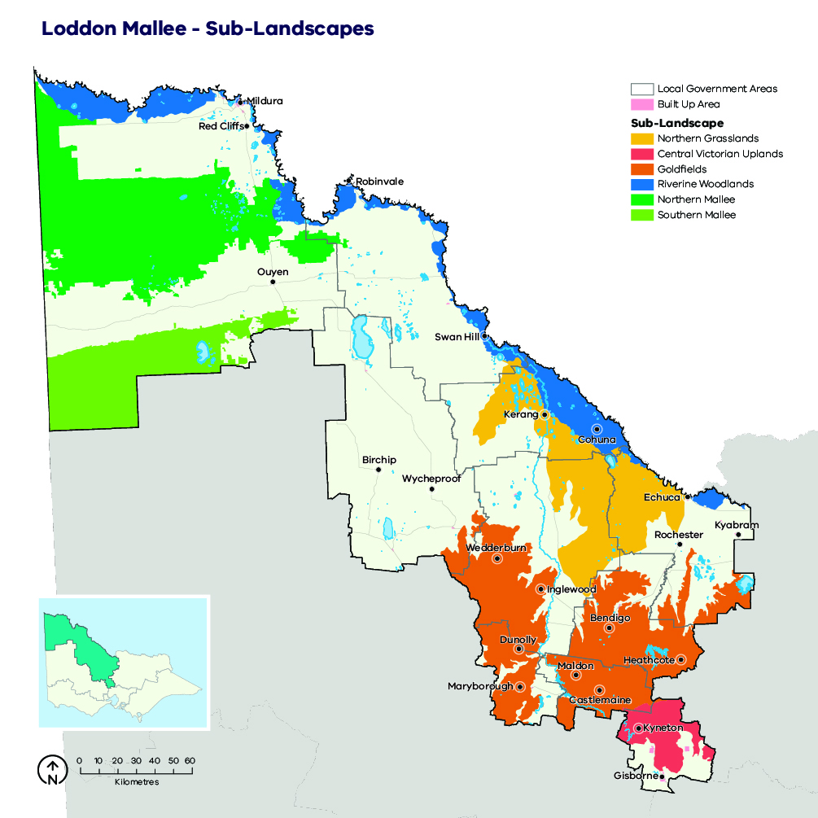

Our objectives
What matters most in the Loddon Mallee region is discussed in the landscape context section and is summarised into the following fundamental values:
- human life, residency and livelihood
- social connectedness and wellbeing
- critical infrastructure
- areas of cultural significance
- fundamental drivers of the economy
- the natural landscape.
These values are the ultimate, durable reasons why we care about managing bushfires, and they are what we want to protect and manage through bushfire management in the Loddon Mallee region.
The following regional objectives are derived from our values and articulate what we are aiming to achieve in the Loddon Mallee region (Loddon Mallee region’s values and objectives and how they align with the statewide vision, policy context and strategic objectives). These objectives contribute to the overall objectives for fire management articulated in the Loddon Mallee Regional Strategic Fire Management Plan.
Table 2: Loddon Mallee region’s values and objectives and how they align with the statewide vision, policy context and strategic objectives
Vision
Safer and more resilient communities
Policy context
The Victorian Preparedness Goal is A safer and more resilient community that has the capabilities to withstand, plan for, respond to and recover from emergencies that pose the greatest risk.
The Safer Together policy’s four priorities for reducing the risk of bushfires in Victoria are Community first, Land and fire agencies working together, Measuring success and Better knowledge = better decisions.
Strategic objectives (Code of Practice for Bushfire Management on Public Land)
- To minimise the impact of major bushfires on human life, communities, essential and community infrastructure, industries, the economy and the environment. Human life will be afforded priority over all other considerations
- To maintain or improve the resilience of natural ecosystems and their ability to deliver services such as biodiversity, water, carbon storage and forest products.
Loddon Mallee region values
Human life, residency and livelihood;  social connectedness and wellbeing |  |  | Critical infrastructure | Areas of cultural significance | Fundamental drivers of the economy | The environment
Loddon Mallee region objectives
Minimise the risk of human life being lost from bushfire | Minimise the impact of bushfire and fire management actions on residential property and assets that support individual and/or community livelihoods | Minimise social impacts from bushfire and fire management actions | Minimise the impact and disruption from bushfire and fire management actions on critical infrastructure and essential services | Minimise the impact and loss of cultural heritage from bushfires and promote cultural practices through fire management actions | Minimise the economic impact of bushfires and fire management actions | Maximise ecosystem function and resilience and maximise diversity and population viability of native plant and animal species that may be impacted by bushfire or fire management actions

Our risk management approach
In hot, dry and windy conditions, a bushfire can travel quickly across a large area of our landscape. To effectively understand bushfire risk, we simulate many bushfires across the entire landscape to determine where bushfires are likely to start, spread and cause damage to values and assets, with a particular focus on people and communities. We can then reduce fuel hazard, through our fuel management program, across the spread paths of these simulated bushfires with the intention of reducing the spread and intensity of these fires and ultimately limiting their impacts.

Risk in Loddon Mallee region
Figure 10 shows the risk of house loss in the Loddon Mallee region. It compares where houses could be destroyed by bushfire across the region.
Different shades represent different levels of risk. As the shades progress from yellow through red to purple, more and more houses are potentially destroyed. The purple areas represent the top 5% of risk in Loddon Mallee. More houses could potentially be destroyed in these areas than any other.
While bushfire risk exists across the entire landscape and house loss can and will occur in other areas, this map shows where the greatest 70% of house loss risk sits within our region.
Bushfire simulations generated by Phoenix RapidFire illustrate risk by showing where significant impacts on houses may occur. Simulations are undertaken using a range of different weather conditions, likelihood of an ignition, maximum fuel loads and no bushfire suppression.
This helps us plan where, how often and how much fuel management we do to reduce risks to communities over years, or even decades.
This map does not reflect any recent bushfires or activities that could change the risk in the region. Importantly, this map shows where there is potential to destroy more houses compared to other parts of the region. It does not show risk to individual houses.
Figure 10: Bushfire risk within the Loddon Mallee region. This map only considers modelled house loss within the Loddon Mallee region and so risk shown on this map can only be compared within this region.
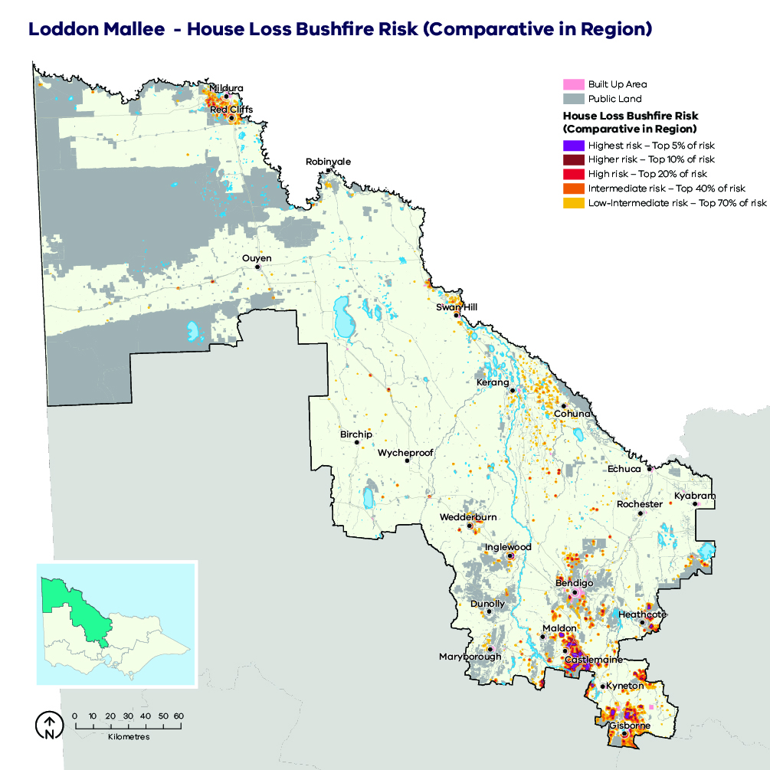

Case study:
Phoenix RapidFire risk analysis was specifically tailored for the Loddon Mallee Region and was undertaken assuming worst-case scenario fuels and no bushfire suppression. This was done to ensure that the community and emergency response agencies could understand the full potential of bushfires and prepare accordingly. However, it is worth noting that grass fuel loads vary seasonally in the northern part of the region and therefore this maximum risk, as shown in Figure 10, is usually only present for a short period between October and December in some high-rainfall years. Consequently, it is considered less likely that bushfires would impact houses in Kerang, Ouyen, Red Cliffs and Mildura in the same way as in Wedderburn and Inglewood.
With this in mind, the Loddon Mallee region identified that the most at-risk communities and therefore those where fuel management activities were the highest priority are in the southern part of the region, as shown in .
Figure 11: The top 25 high-priority localities for fuel management in the Loddon Mallee region. Fuel management will be undertaken with a coordinated approach by FFMVic, CFA and local government working together. Not all properties in these localities are subject to the same level of bushfire risk. The entire locality is shown because the most effective fuel management is achieved with an integrated approach across both private and public land.
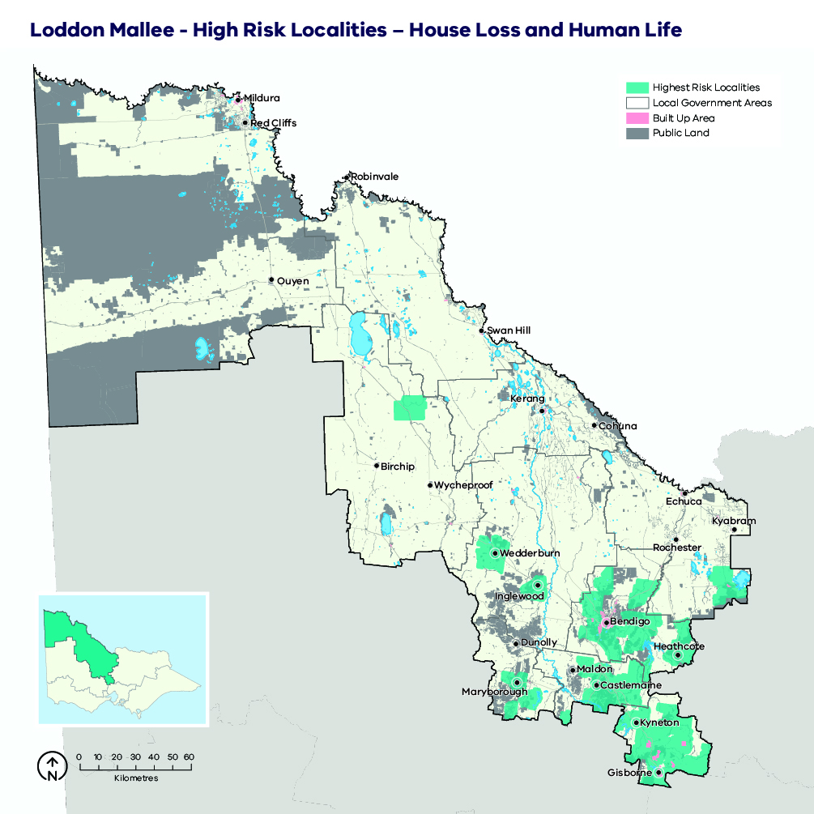

Why model house loss?
Human lives are given priority over all other considerations, however we cannot know where exactly people will be in the event of a bushfire. Simulations of house loss help to identify areas across our landscape where bushfires could have the greatest potential impacts on lives, as well as on other things we value such as our homes themselves, livelihoods and communities. This also reflects the importance of homes as a primary place of shelter and residence. The simulated house loss shown in Figure 10 indicates where these areas are and the possible scale of bushfire impacts relative to other parts of our region. We consider these impacts when developing fuel management strategies for the values and objectives in our region. We can model how our strategies improve the outcomes by reducing bushfire risk to people’s homes, and the social values connected with them. House loss informs one of our key metrics — ‘residual risk’— by which we assess the effectiveness of our fuel management strategies. The residual risk metric is explained in more detail below.

How do we model house loss?
We compare the characteristics of bushfires that are simulated in Phoenix RapidFire with those that led to actual house loss in historic bushfires. Our model assumes houses (based on address points) are destroyed by a simulated bushfire if the modelled fire intensity exceeds 10,000 kilowatts per metre (generally a crown fire) or if ember density exceeds 2.5 embers per square metre. Research indicates that bushfire embers account for the majority of houses lost, with most occurring within 1 km of the edge of forested areas and native vegetation (although house loss still occurs beyond this distance). This is consistent with our modelling which shows similar patterns of house loss. Other fire behaviour factors can have a strong influence on house loss (such as convective strength of the fire), and they are being further researched to understand this risk.
We estimate the magnitude of property impacts by analysing how many houses are modelled as destroyed under all of our simulated bushfires. We can compare between communities to understand which are more likely to suffer large numbers of houses lost.
It is important to note that the modelled property impact is only a coarse estimate and should not be applied at the individual house level. The vulnerability of a house also depends on other factors: its building materials, design and maintenance, how close it is to combustible elements, the presence of human intervention (before, during and after a fire) and the environment in which a bushfire occurs. These factors cannot all be modelled in landscape scale simulations. However, over time they can be included in statistical models, to improve estimates of potential house loss.

Our fuel management strategy
Our fuel management strategy describes our approach to balance the threats posed by bushfire to our most important values and assets, with managing fire to enhance the health and resilience of ecosystems. It responds to Loddon Mallee’s unique bushfire risk profile, determined through our risk assessment process.

Fire Management Zones
The fuel management strategy is presented as an arrangement of different Fire Management Zones (FMZ) on public land, as described in the Code of Practice for Bushfire Management on Public Land (2012). There are four zones – Asset Protection Zone (APZ), Bushfire Moderation Zone (BMZ), Landscape Management Zone (LMZ) and Planned Burning Exclusion Zone (PBEZ). Although the name of the zone indicates the primary purpose of that zone, it is recognised that multiple goals can be achieved when undertaking activities in each zone. For example, a burn undertaken primarily for land management purposes may also have asset protection outcomes.
Bushfire risk mitigation outcomes are the primary purpose of Asset Protection Zones. Ecological outcomes are still considered, but the protection of life and property is the priority for the management of these zones. This emphasis gradually shifts through Bushfire Moderation Zone and Landscape Management Zone, such that Planned Burning Exclusion Zone’s primary focus is ecological outcomes. It is important to note that although Bushfire Moderation Zone has a stronger bushfire risk mitigation focus than Landscape Management Zone, there can still be a focus on risk mitigation in Landscape Management Zone. Fuel management can be scheduled in Landscape Management Zone to complement that which has been undertaken in Bushfire Moderation Zone and Asset Protection Zone and enhance the risk reduction that can be achieved across the whole landscape.
In some areas, communities may see fuel management works occurring in nearby forest most years. This may be because we are delivering a multi-year planned burn, where some fuel types or area(s) of the burn are targeted in one year, and a different fuel type or area targeted the next year. It may be because we are burning in adjacent blocks to those previously treated, to ensure the highest level of protection to the town. If we undertake mechanical treatments such as slashing in an area, fuels often re-accumulate quickly and treatments need to be repeated.
The aims of each zone, how they have been placed and how they will be implemented in Loddon Mallee is described further in Table 2.
The FMZ configuration for public land in the Loddon Mallee region is shown in Fire Management Zones for public land in the Loddon Mallee region. This zoning configuration was developed through risk assessment processes and in consultation with key delivery partners.
Figure 12: Fire Management Zones for public land in the Loddon Mallee region. This zoning configuration was developed through risk assessment processes and in consultation with key delivery partners.
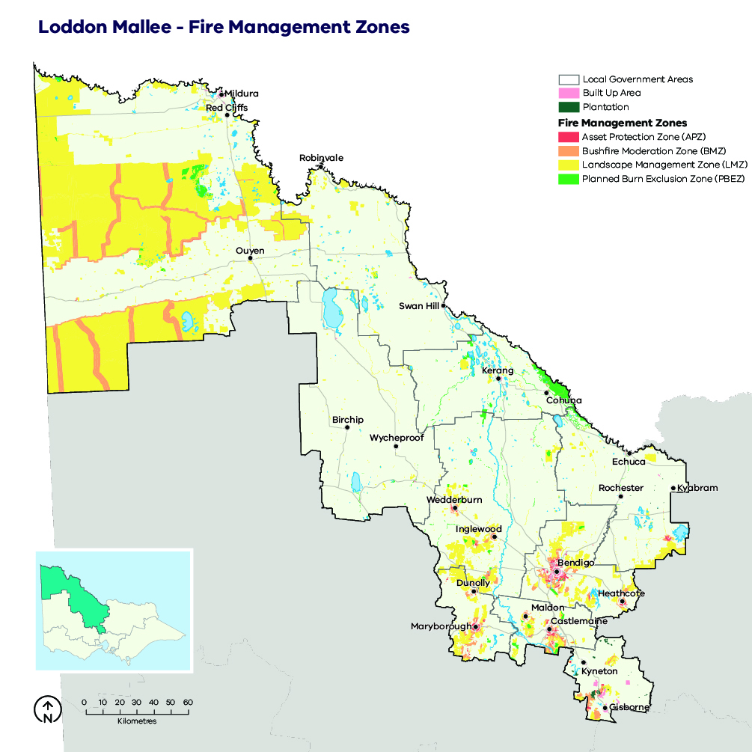
Table 3: Description of the aims, placement, planned fire intervals and typical outcomes of fire management zones for public land in the Loddon Mallee region. This is a description of typical features of these four zones, consistent with the aims of the zones in the Code of Practice for Bushfire Management on Public Land (2012).
 | Asset Protection Zone (APZ) | Bushfire Moderation Zone (BMZ) | Landscape Management Zone (LMZ) | Planned Burning Exclusion Zone (PBEZ)
Aim | To provide the highest level of localised protection to human life, property, critical infrastructure, the economy and high value community assets. | To develop fuel-reduced areas of sufficient width and continuity to reduce the speed and intensity of bushfires.  BMZ also aims to provide areas which assist in making bushfire suppression safer and more effective and in improving access and egress. | Management objectives are varied and include fuel reduction and ecological outcomes. Hazard reduction may be undertaken to supplement APZ and BMZ activities, only where deemed necessary by a risk-based approach.  Treatments may be undertaken for the active management of ecosystem function and for the management of flora and fauna species. Burning (or absence of burning) will be used to ecosystem resilience across the landscape. | Exclusion of planned burning from areas intolerant to fire.
Typical placement | APZ is typically located adjacent to priority assets or densely populated communities. APZ is, as far as possible, limited to 300 m downslope and 100 m upslope, and to the west, northwest or southwest of communities, or at the public/private interface. All APZ is contained to a logical treatment unit. | BMZ is positioned to intercept an anticipated main bushfire run and to complement APZ. BMZ is located in areas where there would be significant impacts if subject to bushfire, usually keeping in mind a strong northerly, south-westerly and westerly wind direction. | Rest of public land not covered by APZ, BMZ or PBEZ. | Burn units wholly or largely covered by fire-intolerant vegetation communities or other assets.
Typical planned fire interval | 5 to 8 years. | 8 to 15 years. | Varies depending on land-management and fire-management objectives. | Not applicable.
 | These intervals are indicative only to help provide an understanding of time between planned fire in each zone. Planned fire intervals for each zone are determined by fuel hazard (type, size, arrangement and quantity) triggers to achieve fuel treatment outcomes in each zone. Actual planned fire intervals may be more or less frequent depending on previous fire severity and coverage, vegetation type, climatic and seasonal conditions and actual rate of fuel re-accumulation. It is also important to note that some burns are conducted in multiple stages and sequenced with other burns in the landscape to form a landscape mosaic, meaning that planned burning operations can occur in the same area over successive years. Some areas, especially in APZ, are treated with mechanical treatments which may occur more frequently.
Fuel treatment goal | Reduce radiant heat and ember attack. | Complement APZ goals and reduce bushfire spotting. | Reduce treatable fuels and achieve ecologically beneficial fire regimes. | Not applicable.
Typical fuel treatment outcomes | Intensive treatment; 80–100% burn cover with reduction of bark fuel hazard a priority.  In some cases, mechanical treatment as alternative or complementary. | Moderately intense treatment, seeking a significant reduction of fuel hazard over most treatable fuels within the burn unit. Coverage targets typically 70–90%. | Fuel management in this zone provides a range of fire frequencies and intensities without burning large, contiguous areas. Fuel management will be consistent with appropriate fire regimes for ecological communities. | No planned fire.

Ecosystem resilience
An ecosystem’s resilience is its capacity to withstand and recover from a range of disturbances, including fire. We cannot measure ecosystem resilience by looking at a single species or fire event: we must look at the whole landscape, and at multiple fires with various frequencies, intensities, scales and seasons of burning. Tolerable fire intervals (TFIs) are the minimum and maximum recommended times between fire events for a particular ecological fire group. Burning regularly outside these intervals increases the risk that there will be fundamental changes in the abundance and composition of species, and the type of vegetation. Growth stage structures (GSS) describe the mix of habitats available across a particular landscape or vegetation type.
In our fuel management strategy, we try to minimise the total area burnt while below minimum TFI because burning can be detrimental to ecosystem resilience. However, major bushfires typically have the greatest impact on ecological condition. TFI provides guidance only and planned burning may be needed in some areas below minimum TFI to reduce bushfire risk to life, property and important ecosystems. There will be instances such as large bushfire footprints where fuels re-accumulate and become flammable before ecological maturity is reached, thus requiring fire to be applied below minimum TFI to prevent larger and more intense bushfires reoccurring.
We recognise that TFI is a coarse measure of ecosystem resilience, that does not recognise finer-scale vegetation responses to fire or the differing severity of planned burning and bushfires, however it can help us with regional scale decision-making.
By setting targets for preferred ecological measures, we can assess how different strategies or events such as bushfires have moved us further or closer to our targets. Sometimes, it is necessary to burn some areas in ways that have shorter term or localised impacts on how well we are meeting these targets, but we also need to compare this with how these would change should another major bushfire occur.
We are continuing to improve our understanding of TFIs by monitoring the responses of different species of vegetation to differing fire severity, and by investing in research that improves our ability to predict these responses. We are also improving the TFI mapping by using species distribution models for key flora species on which minimum TFIs are based. This enables TFIs to be mapped more accurately.

About our fuel management strategy
Our fuel management strategy aims to reduce bushfire risk and spread by managing the quantity and structure of fine fuels. The strategy identifies landscape-level priorities and does not address high-resolution operational planning within settlement areas. Where this strategy does not provide sufficient detail or guidance, area sub-plans may be developed. Such plans are most pertinent in assisting with scheduling and long-term planning around small, remnant forest patches within settlement boundaries.
The fuel management strategy effectively manages the landscape for the reduction of risk to physical assets (built and environmental) that are priorities for our region. All planning for fuel management activities will be done in close consultation with appropriate specialists, vegetation management professionals and landowners/managers. Planning will take into consideration variations in the season and the frequency and intensity of the burning in specific places. This will provide appropriate diversity in the fire regime within each vegetation class, maximise ecosystem resilience and provide optimal risk reduction outcomes for the Loddon Mallee community.
A key feature of the strategy is to improve protection to main thoroughfares. Access and egress is a primary objective driving the placement of FMZs on public land, because many fatalities occur on the road during a bushfire event.
Analysis undertaken in the development of this strategy does not support broad-scale burning in the LMZ as a suitable approach. However, the effectiveness of the current methods for preventing the spread of major fires will be regularly reviewed, and our strategy will be adapted if evidence shows that greater or lesser amounts of planned burning throughout the LMZ are more effective for achieving ecological outcomes. Planned burning will be used to maintain ecosystem resilience across the landscape. This may include treatments implemented to protect assets (such as old-growth forests or water catchments) or habitat structure.

Case study: Ecological and land management needs of sub-landscapes

Goldfields, Central Victorian uplands sub-landscapes
In the Goldfields and the Central Victorian uplands sub-landscapes, APZs and BMZs have been arranged to both maximise bushfire protection outcomes and avoid HVEAs where possible. The Goldfields and Central Victorian Uplands sub-landscapes account for a large proportion of the regions risk to human life, including most of our 25 highest risk localities. As identified in Table 2, APZ is typically located adjacent to priority assets and densely populated communities. APZ is, as far as possible, limited to 300m downslope and 100m upslope, and to the immediate west, northwest or southwest of communities. BMZ is positioned to intercept an anticipated main bushfire run and to complement APZ. The arrangement of APZ and BMZ in this strategy aims to avoid HVEAs, however where there is conflict that cannot be avoided, human life has been afforded priority and ecological impacts will be minimised in operational and tactical delivery.
The careful consideration of HVEAs has resulted in the maintenance of priority habitat for identified fire-sensitive species across the landscape.
Within these sub-landscapes:
- the maximum single burn size will be 200 ha where possible
- adjacent areas should not be burnt within five years of each other
- no more than 30% of a single forest/woodland block should be burnt at once (exceptions may be very small blocks when considered in the context of the broader landscape)
- HVEAs are to be excluded from burning where possible, including the concurrence of priority habitat for threatened species, large-old-tree areas (a regionally specific mapped layer), drought refuge areas (a regionally specific mapped layer) and areas below minimum TFI.

Riverine woodlands sub-landscape
Most forested land in this sub-landscape is legislated national park. A characteristic of national parks is the high summer visitation rate. The primary objective in these parks is the management of the land for environmental values and ecological processes. The priorities for bushfire management in this sub-landscape are:
- a reduction in the size of the average bushfire started by natural causes
- a reduction in human caused ignitions
- maintenance of access tracks and protection of visitor sites by slashing and treating track edges and forest boundaries.
Continued education, compliance and enforcement to reduce the number of human-caused ignitions are required in this area.
The proximity of the Murray River provides a convenient bushfire suppression opportunity, whereby medium- and heavy-lift helicopters can be deployed to rapidly suppress most typical river-bend fires. Typically, such fires have been contained to less than 5 ha using current control methods.

Northern Mallee, Southern Mallee sub-landscapes
The Mallee ecosystems are generally highly flammable and well-adapted to bushfire, but they also include fire-sensitive vegetation communities (such as semi-arid woodlands and ephemeral wetland communities). The primary environmental objectives of the strategy in these landscapes are to enhance the ecosystem resilience of bushfire-adapted communities and to exclude fire from the fire-sensitive communities.
To achieve this within the large public land blocks, a series of strategic breaks are created using planned burning to allow integration of bushfires to support ecosystem functions without the detrimental impacts of large-scale fires. This is achieved through the reduction in fuel continuity, resulting in lower fire intensities and spread rates which makes aerial suppression more effective. This is done to:
- reduce the risk of bushfires exiting Mallee public land
- maintain key threatened fire responsive animal species above conservation status thresholds
- maintain vegetation communities so that the proportion below the minimum TFI remains less than 25% for each EFG vegetation class within either the Northern Mallee or Southern Mallee sub-landscapes
- minimise the occurrence and extent of high-intensity bushfires
- allow for the application of minimum impact suppression strategies where appropriate to prevent ecological impacts from control lines.

Northern plains grasslands sub-landscape
Only 1% of the Northern Plains Grassland remains today, due to the impacts of agricultural practices and the concurrent effects of this changed land use (such as weed invasion and changes to grazing regimes). To appropriately manage this critically endangered vegetation community, its biodiversity and cultural values, desired conditions are simulated through fire and ecological grazing. The use of fire as a management tool is currently being used on a trial basis to determine the most appropriate techniques and regimes to maintain and enhance ecosystem resilience. Under investigation are strategies for achieving these outcomes with the use of fire including:
- management of biomass/structure:
  - how fire can be integrated with ecological grazing
  - integration of ecological and cultural fire regimes
- exclusion of areas from burning with fire-sensitive natural assets such as:
  - fire-sensitive EVCs (there are only very small remnant areas within this sub-landscape)
  - large-old-tree areas (there are only very small remnant areas within this sub-landscape)
  - retention of coarse woody debris
  - areas below minimum TFI
- fill knowledge gaps about plant and animal species’ responses to bushfire through a detailed monitoring, evaluation and reporting (MER) program and other investigation processes
- development of reserve-wide landscape thresholds for ensuring that enough optimal habitat is always available to preserve populations of grassland-dependent, bushfire-responsive species long-term. This will be done through the development of evidence-based block action plans that integrate across the public estate.

Victoria’s residual risk
We measure the impact of the fuel management on reducing bushfire risk. This measure is called ‘residual risk’. Residual risk is calculated as the percentage of bushfire risk ‘left over’ after fuel in forests has been reduced, either through fuel management activities or bushfires.
Our statewide fuel management target is to keep residual risk at or below 70% of Victoria’s potential maximum bushfire risk. Maximum bushfire risk refers to maximum fuel conditions and extreme bushfire conditions (Forest Fire Danger Index of 130). In practice however, the residual risk is different in different parts of the landscape, due to differences in vegetation, topography and where houses are located. Our fuel management strategy, together with the strategies of all regions of Victoria, contributes to achieving the statewide target.
To measure residual risk, we first use the Phoenix RapidFire bushfire simulation software to simulate thousands of bushfires across Victoria under conditions of highest fuel in the landscape and worst-case bushfire weather conditions. We calculate the impacts on houses, based on these simulations, and this is the maximum residual risk. We then simulate a second set of bushfires where we have changed the fuels in the landscape, to allow us to compare the two scenarios and estimate the reduced impact. When measuring current or past residual risk, we include bushfires and planned burns that have occurred to reduce the fuels in the landscape. When we are testing strategies, we model different arrangements of planned burning that might occur by implementing our strategy, for 40 years into the future.
Using Phoenix, we have forecast the performance of our preferred fuel management strategy together with other regions in Victoria. Figure 13 shows changes in residual risk from 1980 to 2060, with projected residual risk values beyond 2020.
Our fuel management program takes us some of the way to managing bushfire risk, however we also manage bushfire risk through other prevention, preparedness and response activities. As yet, we are unable to model the impacts of our other bushfire management actions beyond planned burning in our residual risk metric, including mechanical treatments. We are working to be able to include these and other improvements to the metric in the future.
Figure 13: Statewide residual risk
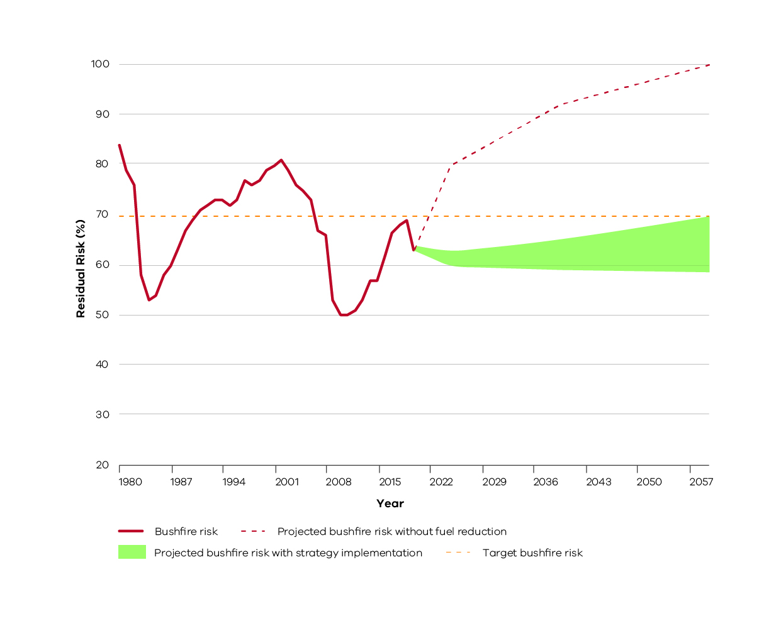
Historic and projected future bushfire risk for Victoria. The orange dotted line is the statewide bushfire risk target (70%). The red line represents historical bushfire risk due to past bushfires and planned burning. The green shaded area is the projected bushfire risk for the fuel management strategies of all Victorian regions collectively, measured from 2021 to 2060. This represents that there is a range of possible future residual risk values which is dependent on the amount of fuel reduction achieved each year in our region and across Victoria. The red dotted line represents projected increase in bushfire risk without fuel reduction.

Case study: Traditional Owner cultural burning
Traditional Owners’ application of fire is complex, systematic and purposeful, enshrined in a ceremonial practice deeply connected to Country. Current policy and practice within bushfire management agencies consider the use of fire to provide asset protection outcomes for physical cultural heritage assets but does not adequately acknowledge the role of ‘right fire’ in healing for people and Country.
Traditional Owners’ cultural burning may include burning (or prevention of burning) on Country for the health of particular plants and animals (such as native grasses), small mammals, bushfoods, medicines, threatened species or communities. It may involve patch-burning to create a mosaic of different fire intervals across the landscape, or it could be used for fuel and hazard reduction. Fire may be used to gain better access to Country, clean up important pathways, maintain cultural responsibilities and as part of cultural heritage management. It is part of ceremonies to welcome people to Country, or it can be as simple as a campfire around which people gather to share, learn and celebrate.
As much as possible, cultural burning in the Loddon Mallee region will be undertaken in accordance with the principles outlined in the Victorian Traditional Owner Cultural Fire Strategy and Parks Victoria’s Managing Country Together Framework. The Dja Dja Wurrung will also facilitate the delivery of joint management plans and Dhelkunya Dja in six co-managed parks.
As cultural burning is diverse in its objective and implementation, it is impractical to define anything like cultural burning zones, which while designed to facilitate the return of traditional fire to Country would ultimately be limiting. It is instead fundamental for land managers to ‘walk together’ with Traditional Owners, to enable and facilitate burning on Country and ensure cultural and fire management objectives are met. This includes not only on-ground objectives but also helping to break down the institutional and complex regulatory barriers to greater Traditional-Owner-led cultural fire practices returning to Country. Seventy-five per cent of public land in the region is LMZ and the objectives that underpin this zone often align to or provide the flexibility to facilitate the objectives of Cultural burns. In other FMZs, there is an increased likelihood that cultural objectives will be incompatible with bushfire mitigation activities. There is potential for Traditional Owner cultural burning to promote long-term fuel reduction outcomes. Where this occurs, treatments will be assessed on a burn by burn basis, and holistic land management actions will be undertaken for healthy Country and safe community.
Within the Loddon Mallee region, there are already examples of the successful implementation of traditional fire through strategic planning and operational delivery. This includes the strategic and systematic application of cultural fire at Mount Egbert. The cultural knowledge that underpins this fire regime remains Aboriginal intellectual property and cannot be shared through the bushfire management planning process. As the living knowledge that is cultural burning returns to the Loddon Mallee region, place-based, systematic and strategic cultural fire plans will continue to build in prominence.

Bushfire Risk Engagement Areas
As part of the 2017-2019 strategic bushfire management planning process, land and fire management agencies have undertaken an analysis to define Bushfire Risk Engagement Areas (BREAs). BREAs identify parts of the landscape where managing bushfire fuels is most effective in reducing risk. This helps to indicate the priority areas in our region where we can work with communities to reduce bushfire fuels.
BREAs also help land and fire management agencies, local government and stakeholders to focus conversations about the range of treatment options to reduce bushfire risk. This may include other actions where reducing fuels may not be possible. Over time, on-ground discussions and assessments between agencies and the community with determine the treatments that will best suit a particular place.
Managing fuels on private and public land begins with a conversation about the benefits, limitations and viability of fuel reduction in a BREA. Complementary or alternative treatments will arise from these discussions. We will work with the community to explore risk treatment options for private land and, where suitable, apply them to complement public land fuel management described in our fuel management strategy. By working together in this way, we will maximise the impact of our collective risk-reduction effort.
It is important to note that BREAs are not legislated planning zones and do not obligate landowners or land and fire agencies to take any action. They cover large areas of public and private land, their boundaries do not align to administrative or cadastral boundaries, and are not linked to individual parcels of freehold land.
The Loddon Mallee region’s BREAs are shown in Figure 14.
Figure 14: Bushfire Risk Engagement Areas in the Loddon Mallee region
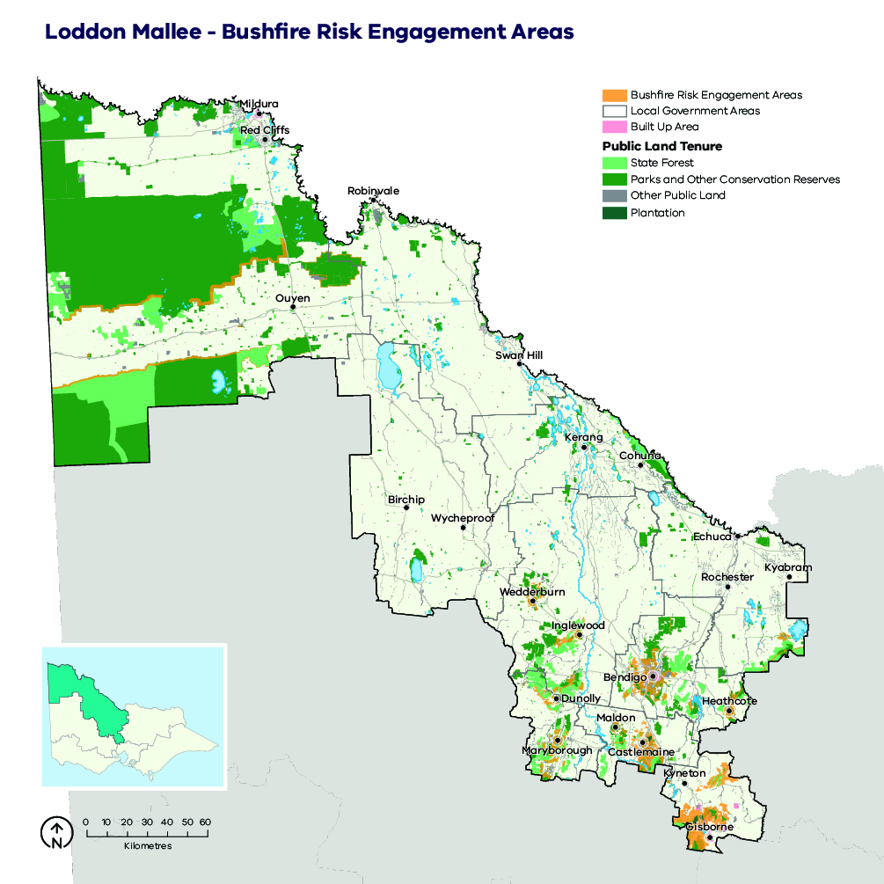

Our pilot strategies
Safer Together is about working as one fire-management sector to estimate the risk reduction from implementing all our strategies, so we can invest in the most effective ways to reduce risk. Planning and delivery of these actions have been continuous over many years, supported by science, fire-management experience and local knowledge.
As part of the Safer Together approach, the region conducted a pilot program using the Phoenix RapidFire modelling done for the fuel management strategy to inform and improve approaches of other bushfire risk management strategies. We use this software to model how bushfires spread from specified ignition points and impact human life and property under a range of weather scenarios. We piloted strategies to:
- minimise bushfires from human-caused ignitions (priority prevention areas [PPAs])
- improve the first-attack suppression of bushfires (priority suppression areas [PSAs]).
The inputs used to identify create pilot strategies included:
- Phoenix RapidFire fire-behaviour simulations and modelled-asset impacts: topography and location of assets (proximity and direction) to potential extreme bushfire behaviour areas; maximum overall fuel hazards and rates of fuel accumulation; and fire-spotting distance, flame height, convective potential and rates of spread under various values of the Forest Fire Danger Index
- risk assessment including analysis of both ignition and weather likelihood, and historical ignition causes
- resource availability and travel time of resources to attend a going bushfire
- the likelihood of successful suppression (as defined by the Bushfire and Natural Hazards Cooperative Research Centre).
The decision-support tools developed through the pilots complement the fuel management strategy and the BREAs. These tools help paint a common picture of risk across multiple administrative boundaries, from the landscape to locality scales. They can also be used in conjunction with risk mitigation planning for fuel management and other bushfire risk management actions to prioritise actions that most effectively reduce risk.

Bushfire prevention of human-caused ignition strategy (pilot)
Of the many ways agencies and communities mitigate bushfire risk, arguably the most effective is to prevent ignitions from occurring. Effective prevention not only reduces risks to human life and property; it also reduces the costs of suppression.
This pilot began work (which is ongoing) to identify priority prevention areas (PPAs). These are areas where the highest-consequence fires are most likely to occur due to human activities. In these areas, medium-term investment in reducing human-caused ignitions can provide the greatest reduction in bushfire risk. To determine these areas, we assessed historical patterns of human-caused bushfire ignitions from escaped burn-offs, deliberate ignitions and campfire escapes, under varying weather conditions.
The aim of identifying PPAs is to inform and improve activities (such as regulation, enforcement and awareness campaigns) that minimise the number of human-caused bushfire ignitions.
Activities in PPAs will be developed in line with relevant legislation and organisational policy and in close consultation with emergency services representatives, park and forest managers and communities.
In the Loddon Mallee Region, PPAs will inform several actions to reduce human-caused bushfire ignitions.

Documenting origin and cause
Understanding how, why, when and where fires are ignited allows for improved strategic decision-making and targeted actions. To improve the accuracy and breadth of strategic prevention planning in future:
- fires will be investigated for their origins and causes by a trained fire investigator
- where there is any cause to expect arson or negligence, firefighters will aim to protect the point of origin for investigation
- statistics on bushfire causes will be analysed regularly and maintained between agencies
- protocols between bushfire management agencies and police will be maintained to ensure a coordinated response to all investigations.

Engagement, education, empowerment
Community education and engagement is a long-term process aimed at creating behavioural changes and empowering the community. Public education programs will be actively maintained by the CFA, local governments and FFMVic across the region. All agencies actively work to improve community knowledge of bushfire behaviour and potential risks, promote the responsible use of fire by the community and actively raise awareness of bushfire threats.
These engagement activities already occur in PPAs across the region and can be further targeted into the future. Actions include communications and publications (such as face-to-face meetings, internet, media releases and other media opportunities), interpretations (such as displays, shows and simulations), school activities, media and advertising, social media presence, and fire conferences and forums.
Additionally, three community-based bushfire management (CBBM) projects are running in the Loddon Mallee region. These projects are currently undertaken in PPAs in the Fryers Forest Corridor, the Macedon Ranges Corridor and at Benloch. CBBM aims to enhance community bushfire knowledge, strengthen relationships and empower the community to take control of their own bushfire risks.

Raising awareness
Scientific literature indicates that increased community awareness not only improves resilience and community responses to a bushfire event, but it also leads to a reduction in total bushfire ignitions. Emergency service agencies already use targeted messaging campaigns (such as the use of variable message boards) to raise awareness of bushfire risks and the fire danger period. A local example of the effectiveness of such a strategy comes from the Eppalock CFA group where the incidence of non-arson, deliberately lit fires fell from 74 in 2016–17 to four in 2018–19 following a trial of three variable message boards along high-traffic thoroughfares. Additional trials in PPAs in Mount Alexander Shire are similarly showing a marked reduction in the number of human-caused ignitions. The use of variable message boards and other engagement opportunities to raise community awareness will continue in PPAs across the region. These strategies need to continue to be implemented as part of an integrated, multi-pronged awareness campaign.

Patrol
Emergency services and agencies already undertake regular patrols in strategic areas where barbeques and campfires are used, with efforts tied to known visitor seasonality and fire danger ratings. These patrols aim to provide assistance in the wise and proper use of fire and to ensure compliance with relevant legislation.
The active patrol of PPAs by emergency services personnel can significantly reduce the risks posed by escaped campfires and other non-compliance. PPAs will be used to target patrol routes for maximum risk reduction outcomes where appropriate.

Fuel modification
Agency personnel will, where appropriate and in accordance with legal requirements, direct the owner/occupier of land within a fire-protected area to remove or modify fuels for bushfire prevention purposes, thereby significantly reducing the likelihood of ignition in PPAs.

Burn offs and fire danger period
The CFA declares the fire danger period each year, based on weather and fuel conditions. Compliance with the fire danger period significantly reduces the risk of escaped burn-offs and minimises the threat of ignitions under severe bushfire conditions. Many councils also ban burning-off on certain days or within certain locations, with similar risk-reduction benefits.

Park closures
Prevention of bushfire in high-risk areas is actively managed through the closure of parks and state forests under certain weather conditions. Land management agencies will as necessary declare the closure of areas of public land under section 64 of the Forests Act 1958, during which time the use of fire in the open air is prohibited. This may include seasonal closures or the closure of parks on Code Red bushfire days.

Municipal bushfire prevention
Municipal committees may further identify localised actions that can be informed by these products or similar strategic outputs. One such example includes work undertaken by the Mount Alexander Shire Municipal Fire Management Committee, where an agreement was struck with the Victorian Goldfields Railway to cease the operation of coal-powered locomotives during the bushfire danger period. Such an agreement reduces the risk of ignitions in a high-consequence bushfire catchment, and it highlights the strategic-level planning that occurs at the municipal scale. The area impacted by this agreement falls within an identified priority area, and it is only one example of the additional potential use of PPAs at a municipal planning scale.

Bushfire first attack suppression strategy (pilot)
The culture and ethos of land and fire management agencies are to suppress bushfires before they do harm, and agencies seek to continuously improve their bushfire suppression techniques and capability using expert knowledge and experience.
First attack suppression aims at reducing the risk of a bushfire spreading in its initial phases. Its success is affected by the location of ignitions, fire detection capabilities, readiness of agencies to respond and ability of agencies to access the fire.
This pilot developed a method and began work (which is ongoing) to identify priority suppression areas (PSAs): areas where medium-term investment in improved capabilities for first-attack suppression could result in the greatest reduction in bushfire risk. Identification of these areas also considered travel times from responding agencies’ depots and stations, fire detection times and times taken to begin bushfire suppression works.
The bushfire first attack suppression strategy is designed to reduce the risk of a bushfire spreading in its initial phases. This also considers actions that can be undertaken to be more effective before a bushfire starts (such as improving road and fire break maintenance, improving fire detection capabilities and enhancing readiness and response protocols).
There are several strategies employed by bushfire management agencies that improve the probability of first attack success in PSAs. The probability of first attack success is ultimately defined by the ability to implement suppression activities before the bushfire becomes ‘unsuppressible’. This is influenced by weather, topography, fuel conditions and the capacity, access to and availability of resources. The strategic manipulation of fuels is considered in fuel management strategies, which means that resource capacity, availability and access are the only remaining factors over which agency staff can further exert control.
PSA strategies include the following elements.

Detection time
Early detection is fundamental to reducing bushfire spread and ensuring a successful first attack. The north of the region is relatively flat, with limited coverage available through detection points. The detection system here is based primarily on aerial reconnaissance and advice from local members of the public. In the region’s south, a network of eight fire towers is maintained during the bushfire season to provide a high level of coverage throughout PSAs in the Fryers Forest–Castlemaine Diggings, Macedon Ranges, Inglewood and Wedderburn, St Arnaud and Kara Kara National Park, south and west Bendigo, Maldon, Heathcote and Rushworth areas.
Strategies for bushfire detection include:
- maintaining the existing fire tower network to ensure the safety of use and early bushfire detection
- aerial reconnaissance, particularly on severe fire danger rating days or following lightning events. Improved access to reconnaissance aircraft including numbers and length of the season may greatly improve the detectability of fires in the lower-population-density areas, including PSAs in Gannawarra, Buloke, Campaspe, Swan Hill and Mildura, as well as in PSAs in the Kara Kara National Park, Avoca Ranges and the large Mallee parks where lightning fires are a common occurrence
- routine patrols undertaken by emergency management professionals during days of high fire danger. Maintaining this practice is essential. Increasing the number of patrols by emergency agencies, as well as strategically targeting patrols to PSAs, may considerably improve the time taken to detect bushfires.

Strategic access roads
Ground access to bushfires by firefighters, plant and other machinery is fundamental to efficient and effective suppression of a bushfire event. Ready access requires maintaining a strategic network of roads and tracks, and the construction of additional tracks to complement the existing network where required. PSAs across the region can be used to highlight areas where there is a need for continued maintenance of and a potential need for new access routes. On public land, close to 1,000 km of strategic roads are maintained throughout forests and parks to support firefighters’ access, in addition to the thousands of kilometres maintained by local governments and VicRoads. Strategies to improve access opportunities in PSAs include:
- the development of an action plan identifying priority strategic roads for access and egress opportunities for firefighters. The Loddon Mallee Regional Strategic Fire Management Planning Committee has already begun this process, which may considerably enhance access and first attack success rates in the region
- all roads and tracks will be where possible maintained and signposted. All roads and tracks identified as priorities for bushfire protection will undergo minor maintenance annually and major maintenance as necessary
- new strategic roads will be considered for development where appropriate
- temporary tracks will be constructed to facilitate bushfire suppression and fuel reduction as needed
- aircraft will be used to undertake aerial attack and hold/halt the spread of bushfires until temporary control lines can be established where appropriate.

Enhance firefighter safety and access
Increasingly, hazardous trees are being identified as a risk to firefighters’ safety, and they continue to inhibit efficient and effective access to fires in tall forests. This issue exists in the PSA that covers Kara Kara National Park and the Avoca Ranges, as well as the Macedon Ranges and parts of the Fryers Forest–Castlemaine Diggings area. Training is already provided to accredit advanced fallers in bushfire agencies, and maintaining this program will continue to help address safety and access in these areas. Maintaining existing access to fire-bombing aircraft will similarly continue to assist in creating a safer environment for ground crews. Within the Loddon Mallee region, allocation of additional plant resources (such as an excavator) may significantly enhance crew safety and access in these potentially hazardous areas.

Resourcing
The most effective strategy for maximising first attack suppression success is to effectively maintain and strategically locate priority firefighting resources across the region. Bushfire management agencies may choose to use PSAs to help identify areas where volunteer recruitment campaigns can be targeted to improve resourcing to CFA stations or to identify priority areas for increasing the coverage and number of seasonal and ongoing/full-time fire-fighters. PSAs may also be used to identify areas where additional machinery may significantly improve firefighting responses. An example of this is the Mallee Fire District, where the time taken to move a dozer to the southern section of the Big Desert–Wyperfeld Park complex can allow fires to become destructive and impossible to suppress, well before the appropriate resources are available.

Aircraft
Aircraft are used for a variety of purposes in bushfire management operations including detection, reconnaissance, firebombing, asset protection, transport and aerial ignition. The large landmass and dispersed nature of resources and population in the Loddon Mallee highlight the fundamental need to maintain adequate access to aerial resources to support ground crews in bushfire management activities. Strategies include maintaining pre-determined dispatch within the region, as well as the maintenance of airstrips, water points and chemical retardant mixing facilities. Specific aircraft support details are in the FFMVic Readiness and Response Plan.
As the length of the bushfire season increases and rural populations decrease, the reliance on aircraft for successful first attack continues to grow. Improved and strategic access to aircraft, lengthening the season in which they are available and improving access to water points are all actions that may significantly improve the ability of bushfire agencies to undertake successful first attack in PSAs. These strategies are already employed across the region, and they identify the high-level strategic planning embedded within response organisations.
Due to climatic gradients and differences in land use, the onset and length of the bushfire seasons occur at different stages across the region. This seasonality of bushfire risk is most evident in the region’s north and west, where the ability of fires to propagate decreases as crop harvesting reduces fuel availability. Bushfire agency planners already rotate aircraft to different bases across the region in response to this shifting risk. This strategy actively improves suppression likelihood in PSAs identified in Mildura, Robinvale, Swan Hill, Gannawarra and Campaspe by actively improving aerial resource responses to each area during its peak risk period.
As fires in the Loddon Mallee are often protracted, the use of specialist night bombing aircraft may significantly increase the ability to achieve suppression outcomes towards the end of a first shift. A trial of this method has already begun in the region. Specific details can be seen in the FFMVic Readiness and Response Plan.

Water availability
Many water points are distributed throughout the public land estate in the region’s south. These provide an essential local water supply for bushfire suppression and planned burning operations. The location of water points aims to ensure adequate coverage over the public land estate. However, access to water is significantly lower across the private land estate, and in the region’s north and west. In these areas, other than along the Murray River, water is scarcely available. The decommissioning of earthen channels and dams throughout the region and their replacement by an underground pipe network has significantly reduced firefighters’ access to water. Where this resource can be accessed, water pressures are often insufficient to service firefighting appliances. This significantly increases turnaround times and reduces the ability of agencies to suppress bushfires. Strategies for maintaining and improving water availability include:
- existing water points are to be maintained and improved by deepening and by improving access and signposting where necessary
- working with water authorities to improve access to adequate water resources and pressures to facilitate firefighting
- where appropriate, a range of strategic water points may be upgraded for use by helitankers
- new water points may be constructed in those parts of the region where access to water is inadequate, particularly in PSAs. Examples may include parts of Swan Hill, Gannawarra, and Campaspe
- alternate equipment including larger or more water-efficient firefighting equipment/appliances should be investigated where necessary.

Minimum Impact Suppression Strategy (MISS)
Another approach that has been successfully trialled in the Mallee in previous years is the use of Minimum Impact Suppression Strategy (MISS). This strategy can be used in the Murray Sunset National Park and Big Desert–Wyperfeld Park complex. The successful implementation of strategic breaks through the fuel management strategy greatly reduces the likelihood of large fires and enables the use of MISS.
Incident controllers are required to consider the possible long-term environmental and cultural impacts of suppression tactics used. This method of containment is cost-effective, often environmentally preferred due to the absence of mechanical disturbance, culturally less damaging, and significantly less resource-intensive. This suppression method is also much safer for firefighters. Use of MISS must be endorsed by the incident controller and will be defined by the location of the bushfire, proximity to priority assets and fuel-reduced corridors, as well as the underlying fuel and weather conditions. Effective implementation of MISS depends on the successful implementation of the fuel management strategy, and it will follow the process below:
- Define high-risk zones where active suppression is preferred.
- Define containment zones where MISS will be effective:
  - allow medium-potential-sized fires to run within their containment zones:
    - natural bushfires will be allowed to burn out to strategic breaks
    - fires will be marked ‘contained’
    - as fires are already contained, mechanical edges may not be necessary
    - maintain watching brief on bushfire behaviour
    - allow to self-extinguish
    - then be declared safe
  - declare areas of high risk where larger potential fires will be controlled to limit size.
- Use natural fires inform/modify strategic break treatment over time and where deemed appropriate back these up over time.

Implementation
Implementation of this bushfire management strategy will occur through the Joint Fuel Management Program (JFMP) prepared by FFMVic and CFA, as well as a range of agency-specific operational plans.
The fuel management strategy described here directly informs the development of the JFMP, and it is through the implementation of this program that bushfire risk in Loddon Mallee will be maintained in line with the state residual risk target, in a manner which balances outcomes for multiple values.
Fuel management on private land, where appropriate and with landholder permission, will form part of the overall JFMP and will reduce bushfire risk in Loddon Mallee even further.
The JFMP prepared by FFMVic and CFA is also informed by the Victorian Traditional Owner Cultural Fire Strategy.
Our bushfire management strategy can also help inform actions in municipal fire management plans.
The implementation of Bushfire Risk Engagement Areas will be undertaken by all agencies working together with the community. BREAs assist agencies to plan where to engage with communities about fuel management where it is most effective to reduce bushfire risk or explore alternative options to reduce that risk.

Implementation of pilot strategies
The pilot strategies developed through this planning process will continue to evolve and influence strategic activities within agencies in the future. Implementation will occur through the Regional Strategic Fire Management Planning Committee, supported by agencies. These pilot management strategies may also inform the creation and development of other plans including those used by municipal fire management committees and individual agencies. Planning processes that may be informed by our pilot strategies in future are shown in Figure 15.
Reporting by agencies concerning implementation and outcomes should be reported back to the Loddon Mallee Regional Strategic Fire Management Planning Committee with local reporting back through MFMPCs.
Figure 15: Schematic representation of the bushfire management strategy’s influence on implementation programs and plans
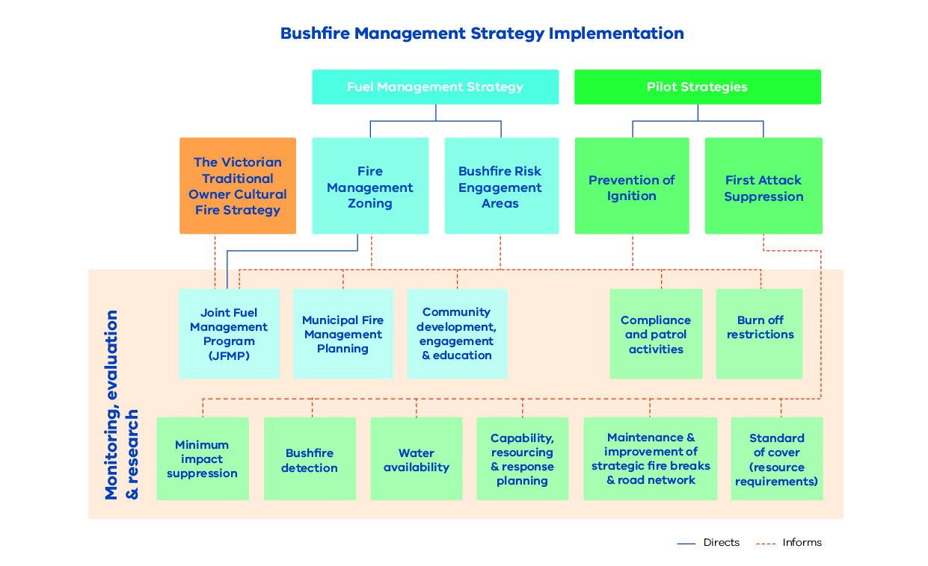

Monitoring, evaluation and reporting
Regional monitoring, evaluation and reporting (MER) enables us to measure how our strategies and actions are performing against the regional objectives set out in this bushfire management strategy. This is achieved by developing key evaluation questions that we will use to measure success against our objectives and enable reporting and improvements. The MER process ensures transparency and supports adaptation of management practices to achieve improved outcome from bushfire management to our important values. Key evaluation questions and the process for addressing them will be developed in MER plans by individual agencies.
An MER plan can also identify key assumptions and knowledge gaps and prioritise research and monitoring activities to address them. MER plans ultimately improve risk-based planning and decision-making, helping to guide future resource and funding allocation.
Individual agencies will be responsible for the MER of their own work programs and the activities that they deliver. The spirit of collaboration will continue between agencies, such as identifying and addressing knowledge gaps that cross tenure boundaries.
FFMVic’s MER program is guided by the Monitoring, Evaluation and Reporting Framework for Bushfire Management on Public Land (MER Framework), which aims to assess how well management activities across Victoria are achieving the two objectives of the Code of Practice. Information on FFMVic’s annual fuel management monitoring and reporting can be found in Managing Victoria’s Bushfire Risk: Fuel Management Report.

Appendix 1: Program logic
Table 4: Loddon Mallee Bushfire Management Strategy 2020 program logic
Vision | Safer and more resilient communities
Policy Context | The Victorian Preparedness Goal is: A safer and more resilient community that has the capabilities to withstand, plan for, respond to and recover from emergencies that pose the greatest risk. |  |  | The Safer Together policy has four priorities for reducing the risk of bushfires in Victoria: community first; land and bushfire agencies working together; measuring success; and better knowledge = better decisions.
Strategic Objectives | To minimise the impact of major bushfires on human life, communities, essential and community infrastructure, industries, the economy and the environment. Human life will be afforded priority over all other considerations. |  |  | To maintain or improve the resilience of natural ecosystems and their ability to deliver services such as biodiversity, water, carbon storage and forest products.
Regional Objectives | Minimise the risk of human life being lost from bushfire. | Minimise the impact and disruption from bushfire and fire management actions on critical infrastructure and essential services. | Minimise the impact from bushfire and fire management actions on residential property and assets that support individual and / or community livelihoods. | Minimise impact and loss of cultural heritage from bushfires and promote cultural practices through fire management actions. | Minimise the economic impact from bushfires and fire management actions. | Minimise social impacts from bushfire and fire management actions. | Maximise ecosystem function and resilience, and maximise diversity and population viability of native plant and animal species that may be impacted by bushfire or fire management actions.
Long-term Outcomes | - Residual risk in the Region is maintained below the 75% target.  - Fuel hazard levels are maintained at or below their trigger point as described in this plan  - The number of fires exiting the Mallee parks is kept below 5% on average over a decade.  - Risks are adequately reduced along key access and egress routes.  - The total number of bushfire ignitions due to human negligence or carelessness is reduced between now and 2050.  - First attack success remains high and is improved in areas of strategic importance.  - Community understand and have taken ownership of their own risk. | - Critical infrastructure and essential services are adequately protected from bushfire events.  - The total number of bushfire ignitions due to human negligence or carelessness is reduced between now and 2050.  - First attack success remains high and is improved in areas of strategic importance.  - Fuel hazard levels are maintained at or below their trigger point as described in this plan. | - Residual risk in the Region is maintained below the 75% target.  - Fuel hazard levels are maintained at or below their trigger point as described in this plan.  - The number of fires exiting the Mallee parks is kept below 5% on average over a decade.  - The total number of bushfire ignitions due to human negligence or carelessness is reduced between now and 2050.  - First attack success remains high and is improved in areas of strategic importance.  - Community understand and have taken ownership of and manage their own bushfire risk.  - Critical infrastructure and essential services are adequately protected from bushfire events. | - Complex regulatory boundaries are broken down, and Traditional Owners can lead cultural fire practices on Country.  - Agencies and Traditional Owners work together to ensure wholistic fire management practices for healthy Country and healthy people.  - Residual risk to western cultural assets is maintained below 85% of its maximum value. | - Economic assets are adequately protected from bushfire events.  - The total number of bushfire ignitions due to human negligence or carelessness is reduced between now and 2050.  - First attack success remains high and is improved in areas of strategic importance.  - Fuel hazard levels are maintained at or below their trigger point as described in this plan.  - The number of fires exiting the Mallee parks is kept below 5% on average over a decade. | - Communities understand bushfire risk and recovery, and are well connected, prepared and resilient. | - Growth stage distribution maximises species GMA within each sub-landscape.  - Area of treatable vegetation types below minimum TFI is not greater than 25%.  - Growth stage distribution is maintained, or planned to be, within 25% of the long-term baseline.  - Prescribed ecological fire strategies for each sub-landscape result in the maintenance or restoration of threatened species and high value ecological areas.  - Ecosystem services, such as clean water production is maintained in catchments across the region.
Medium-term Outcomes | - Community awareness of bushfire risk is improved, as is capacity to manage their own risk.  - Community and agencies are working together to manage fuels across tenures.  - Bushfire Risk Engagement Areas are better understood and inform engagement and fuel management actions by agencies. | - Fuel management and other bushfire mitigation actions are targeted to provide maximum residual risk reduction outcomes for critical infrastructure assets. | - Fuel management and other bushfire mitigation actions are targeted to provide maximum residual risk outcomes for critical infrastructure assets.  - Community Awareness of bushfire risk is improved, as is capacity to manage their own risk.  - Community and agencies are working together to manage fuels across tenures.  - Bushfire Risk Engagement Areas are better understood and inform engagement and fuel management actions by agencies. | - MISS strategies are actively employed where appropriate to minimise damage to cultural heritage assets.  - The number of Traditional Owner groups involved in bushfire management planning has increased. | - Community and agencies are working together to manage fuels across tenures.  - Bushfire Risk Engagement Areas are better understood and inform engagement and fuel management actions by agencies.  - MISS strategies are actively employed, where appropriate, to minimise cost of suppression activities. | - Community awareness of bushfire risk is improved, as is capacity to manage their own risk.  - Community and agencies are working together to manage fuels across tenures.  - Bushfire risk engagement areas are better understood and inform engagement and fuel management actions by agencies. | - MISS strategies are actively employed where appropriate to minimise damage to environmental assets.  - Appropriate fire regimes are being applied through fuel management practices for the persistence of ecosystems and maximising biodiversity.  - There is no more than one large bushfire per decade, in any sub-landscape.  - 97% of fires are less than 20,000 hectares in the parks of the Northern and Southern Mallee sub-landscapes.
Short-term Outcomes | - Community are aware that bushfire risk sits on private property.  - Fuel Management is targeted to the priority areas identified in the strategy. |  | - Community are aware that bushfire risk sits on private property.  - Fuel Management is targeted to the priority areas identified in the strategy. | - Traditional owners and agency staff work together to facilitate the return of cultural fire across the Loddon Mallee. |  | - Communities and agencies share knowledge and information to maximise resilience, connectivity and bushfire protection outcomes. | - Fuel treatment on public land is only applied as appropriate and in line with the zone definitions and triggers identified in the strategy.
Assumptions | - Park and forest closures in peak fire dangers will reduce the number of people exposed to an increased bushfire hazard.  - More prepared communities are less likely to have lives lost to bushfire.  - Prepared and rehearsed fire plans are likely to be enacted by households and will decrease the number of lives lost to fire.  - Bushfire risk modelling accurately represents the risk of fire.  - Reducing fuel loads/hazard reduces the lives lost and number of houses impacted.  - Reducing exit fires from forests or parks will reduce risk and loss of human life.  - Reduced number of ignitions will result in reduced number of lives lost.  - That there is a direct link between houses impacted and lives lost.  - Enhanced successful first attack will reduce the number of houses impacted.  - The address points spatial layer accurately represents where residential dwellings exist.  - That improving access and egress outcomes on major thoroughfares will directly reduce the likelihood of life loss during a bushfire event. | - Reducing fuel hazard will reduce the impacts on critical infrastructure.  - Bushfire behaviour modelling gives an accurate representation of risk to critical infrastructure.  - Reducing the number of ignitions will reduce risk to the economy.  - Successful first attack will reduce the spread of bushfire.  - Reducing the size and spread of bushfire will reduce the impact on critical infrastructure. | - More prepared communities are less likely to have lives lost to bushfire.  - Prepared and rehearsed fire plans are likely to be enacted by households and will decrease the number of lives lost to fire.  - Bushfire risk modelling accurately represents the risk of fire.  - Reducing fuel hazard reduces the lives lost and number of houses impacted.  - Reducing exit fires from forests or parks will reduce risk and loss of human life.  - Reduced number of ignitions will result in reduced number of lives lost.  - That there is a direct link between houses impacted and lives lost.  - Enhanced successful first attack will reduce the number of houses impacted.  - The address points spatial layer accurately represents where residential dwellings exist.  - That improving access and egress outcomes on major thoroughfares will directly reduce the likelihood of life loss during a fire event. | - That known bushfire mitigations are effective in preventing disturbance/ impact on cultural assets and values.  - That facilitating the return of cultural fire will enhance connection to Country and spiritual wellbeing  - That the VFFR-B cultural points spatial layer adequately captures areas of western cultural significance and outlines their importance to local communities.  - That altering fuel hazard and fuel arrangement can reduce the intensity and deleterious impact of bushfire on areas of cultural significance. | - Fuel treatments are effective at minimising the impact of bushfire on the agricultural sector.  - economic infrastructure identified with the significance of national, state, or regional are major drivers of the economy and represent the most critical infrastructure in the region.  - Smoke impacts are detrimental to the wine industry.  - Reducing fuel hazard will reduce the impacts on economically important infrastructure.  - Bushfire behaviour modelling gives an accurate representation of risk.  - Reducing the number of bushfire ignitions will reduce risk to the economy.  - Successful first attack will reduce the spread of bushfire.  - Reducing the size and spread of bushfire will reduce the impact on economic assets.  - The post-bushfire recovery time for all economic infrastructure is adequately captured in the VFRR-B.  - All municipal committees in the Loddon Mallee have kept an accurate VFFR-B. | - That social wellbeing is impacted by the proportion of population impacted, access to resources for recovery.  - That reducing the potential impact of fire can minimise the impact on resilient communities. | Habitat recovery under variable environmental conditions is known and the triggers or thresholds for management action are determined.  Specific habitat requirements for priority threatened species are known in relation to the combined effect of managing for ecosystem resilience.  - Key Fire Response Species are suitable as indicators of the environmental resilience of the ecosystem.  - Species fire response models accurately represent responses to planned burning and bushfire.  - Growth Stage Structure (GSS) is an accurate proxy for abundance of fauna in the landscape.  - That burns can be kept to less than 200 ha without the need to realign burn units (i.e. tracks).  - That adjacent burns can be “timed” more than one year apart and still maintain the integrity of the risk reduction strategy.  - That mitigation measures used as part of fuel treatments are an effective means of maintaining water quality in streams, rivers and dams located adjacent to burnt areas.  - That bushfire is the primary driver of population changes seen in Key Fire Response Species, and that we can separate bushfire as a driver from other environmental factors.

Appendix 2: Other bushfire management actions
Through the development of the Loddon Mallee Region Bushfire Management Strategy 2020, we have identified several key areas for further analysis and more in-depth planning. These include those highlighted below.
Table 5: Other actions for managing bushfire risk
Location | Priority | Anticipated start | Planning required | Lead agency
Koorlong | Very high | 2021 | Risk to human life in Koorlong and surrounds with changing land use | DELWP
Bendigo | Very High | 2021 | Complex urban-forest interface requires additional planning and likely engagement with local homeowners | DELWP and City of Greater Bendigo
Bendigo | Very High | 2021 | Urban expansion is driving a rapidly changing regional risk profile. A more complex analysis considering regional growth planning can enhance risk mitigation strategies | DELWP and City of Greater Bendigo
Benloch | High | 2022 | Private land mosaic fuel treatments | CBBM
Northern Loddon Mallee | High | 2021 | Ways to reduce bushfire risk from ignitions occurring on agricultural land | CFA
Public land fuel management is not the only bushfire management action that can reduce bushfire risk. Although this strategy has not undertaken specific planning in other bushfire management actions, we have identified some key areas where these other bushfire management actions will be important to reducing bushfire risk. This may be because of an inherently high level of bushfire risk, or due to fuel management having limited opportunity to sufficiently reduce bushfire risk. In many cases, other actions are already in place in these locations and these have also been highlighted. This list is not a complete analysis.
Table 6: Priority areas where other bushfire management actions will be important to reducing risk to life and property but are beyond the scope of this strategy
Location | Priority | Fuel management Issues | Other actions already in place
Riddells Creek | Very high | The distribution of fuels around this community means that as well as treating fuels on public land, an enhanced focus on private land fuels and other non fuel-management focused actions are required to mitigate bushfire risk levels. Treatments are challenging to implement, with small burn windows. Further investigation will be undertaken to determine the potential for risk reduction through CBBM, improved preparedness and alternative works | To be considered
Fryers Town | Very high | Investigate the use of vegetation with a high moisture content as an active bushfire mitigation strategy | Concept already under investigation by Fryerstown Community supported by CBBM
Benloch | Very high | The distribution of fuels around this community means that as well as treating fuels on public land, an enhanced focus on private land fuels and other non fuel-management focused actions are required to mitigate bushfire risk levels. Treatments are difficult, and burn windows are small | CBBM
Lancefield | Very high | The distribution of fuels around this community means that as well as treating fuels on public land, an enhanced focus on private land fuels and other non fuel-management focused actions are required to mitigate bushfire risk levels. Treatments are challenging to implement, and burn windows are small. Further investigation will be undertaken to determine the potential for risk reduction through CBBM, improved preparedness and alternative works | To be considered
Fryers Forest Corridor | Very high | Treatments are not operationally feasible in much of the landscape | The community is highly active and taking control of their own risk. Agencies to support an empowered community through CBBM
Kyneton | High | The distribution of fuels around this community means that as well as treating fuels on public land, an enhanced focus on private land fuel management and other non-fuel management risk reducing activities is required to mitigate bushfire risk levels in this locality. | Community education
Woodend | Low | The distribution of fuels around this community means that as well as treating fuels on public land, an enhanced focus on private land fuels and other non fuel-management focused actions are required to mitigate bushfire risk levels. | Community education

References
Bushfire Cooperative Research Centre. (2010). Phoenix Rapid Fire. Retrieved from Bushfire Cooperative Research Centre: http://www.bushfirecrc.com/resources/poster/phoenix-rapidfire-%25E2%2580%2593-bushfire-simulator-and-risk-assessment-decision-support-tool
Department of Environment, Land, Water and Planning. (2019). Joint Fuel Management Program. Retrieved from Forest Fire Management Victoria: https://www.ffm.vic.gov.au/bushfire-fuel-and-risk-management/joint-fuel-management-program
Department of Environment, Land, Water and Planning. (2019). Loddon Mallee Region Technical Methods Reference Document. Epsom: Department of Environment, Land, Water and Planning.
Department of Environment, Land, Water & Planning (2015), Monitoring, Evaluation and Reporting Framework for Bushfire Management on Public Land. Retrieved from: https://www.ffm.vic.gov.au/__data/assets/pdf_file/0021/25734/BushfireMER_Framework_WEB.pdf
Department of Home Affairs. (2018). Deconstructing Disaster: The strategic case for developing an Australian Vulnerability Profile to enhance national preparedness – March 2017. National Resilience Taskforce. Australian Government.
Department of Sustainability and Environment. (2004). Victorian Riverina bioregion. Retrieved from https://www.environment.vic.gov.au/__data/assets/pdf_file/0027/48753/VRiv_EVCs_combined.pdf
Department of Sustainability and Environment. (2007). Goldfields bioregion. Retrieved from https://www.environment.vic.gov.au/__data/assets/pdf_file/0019/48700/Gold_EVCs_combined.pdf
Department of Sustainability and Environment. (2012). Code of Practice for Bushfire Management on Public Land. Retrieved from https://www.ffm.vic.gov.au/__data/assets/pdf_file/0006/21300/Code-of-Practice-for-Bushfire-Management-on-Public-Land.pdf
Emergency Management Victoria. (2020). Victorian Fire Risk Register - Bushfire (VFRR - B). Retrieved from https://www.vfrr.vic.gov.au/
Falconer, S. (2019). The Lord Mayor’s Bushfire Appeal Churchill Fellowship Report: The Return of Cultural Burning. Canberra, ACT: Winston Churchill Memorial Trust.
Forest Fire Management Victoria. (2020). Managing Victoria’s Bushfire Risk - Fuel Management Report 2018-19. Retrieved from https://www.ffm.vic.gov.au/fuel-management-report-2018-19
International Organisation for Standardisation. (2019). ISO 31000 RISK MANAGEMENT. Retrieved from https://www.iso,org/iso-31000-risk-management.html
Victorian Government. (2020). Safer Together: Our approach to reducing the risk of bushfire in Victoria. Retrieved from https://www.safertogether.vic.gov.au/
Victorian Traditional Owner Cultural Fire Knowledge Group. (2018). Victorian Traditional Owner Cultural Fire Strategy. Retrieved from https://www.ffm.vic.gov.au/bushfire-fuel-and-risk-management/traditional-owner-burns

Department of Home Affairs, 2018
During the consultation phases of this strategic planning process, these areas were called ‘Priority Fuel Management Areas’ (PFMAs). They have since been renamed to provide greater clarity as to their intended use. Feedback and comments received during the planning process from stakeholders and community members relating to PFMAs have been incorporated into designing the BREA strategy.

