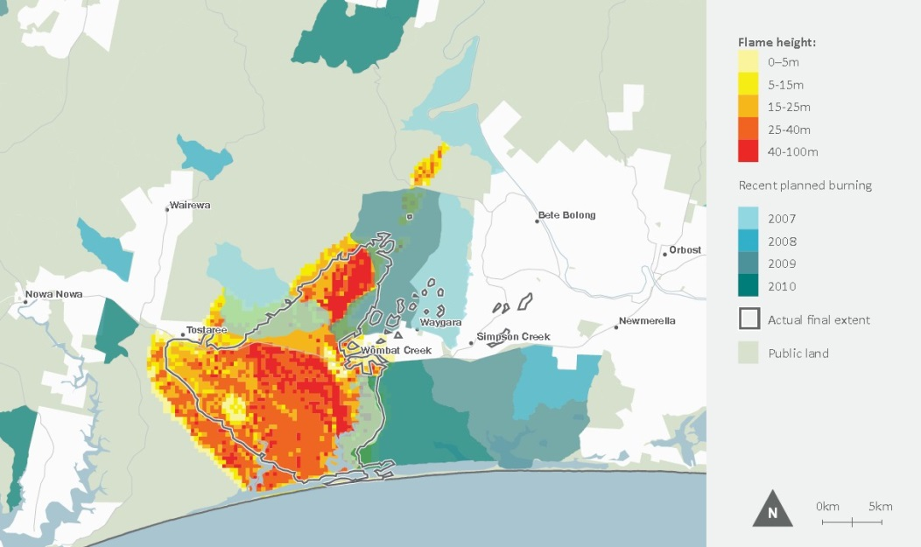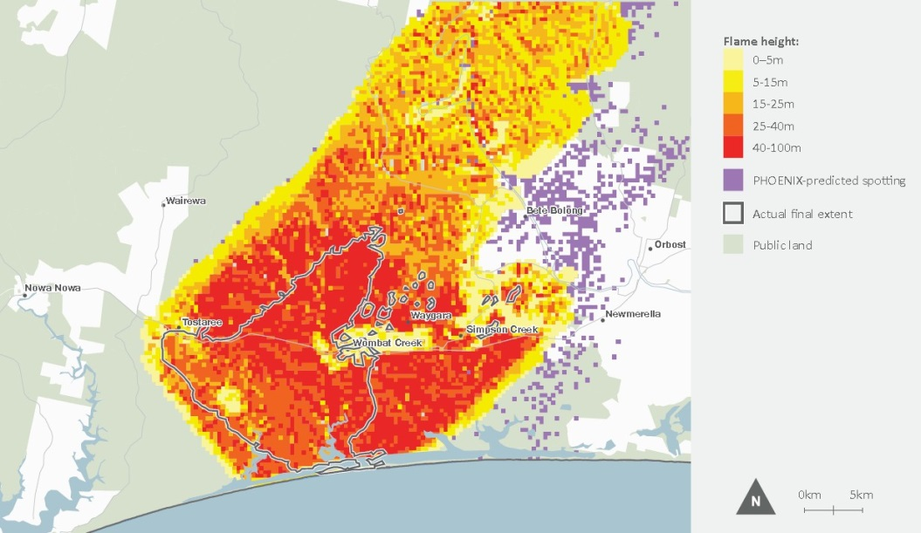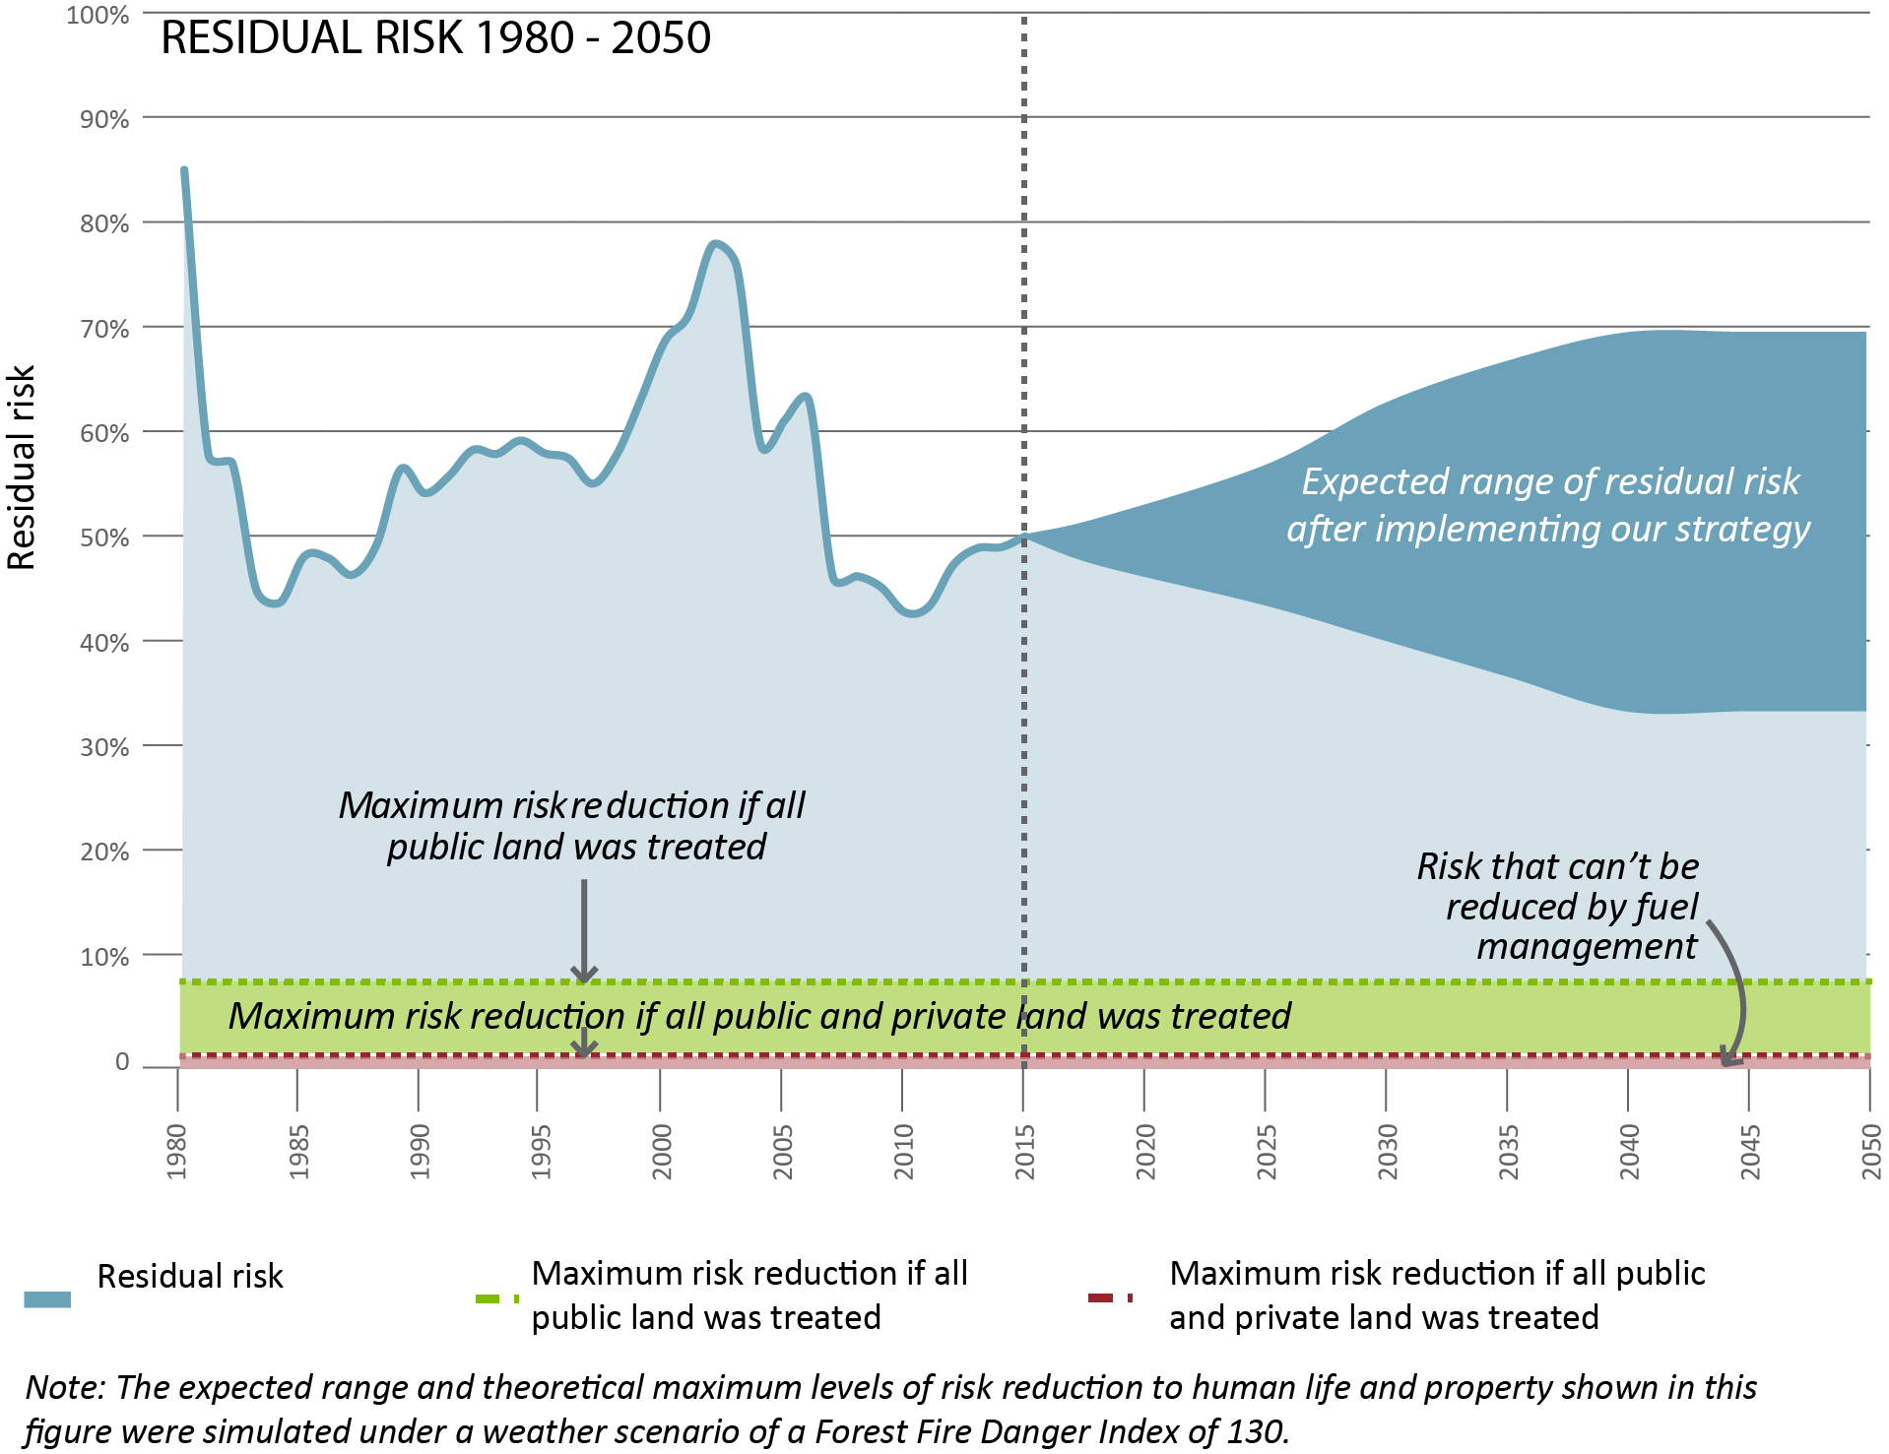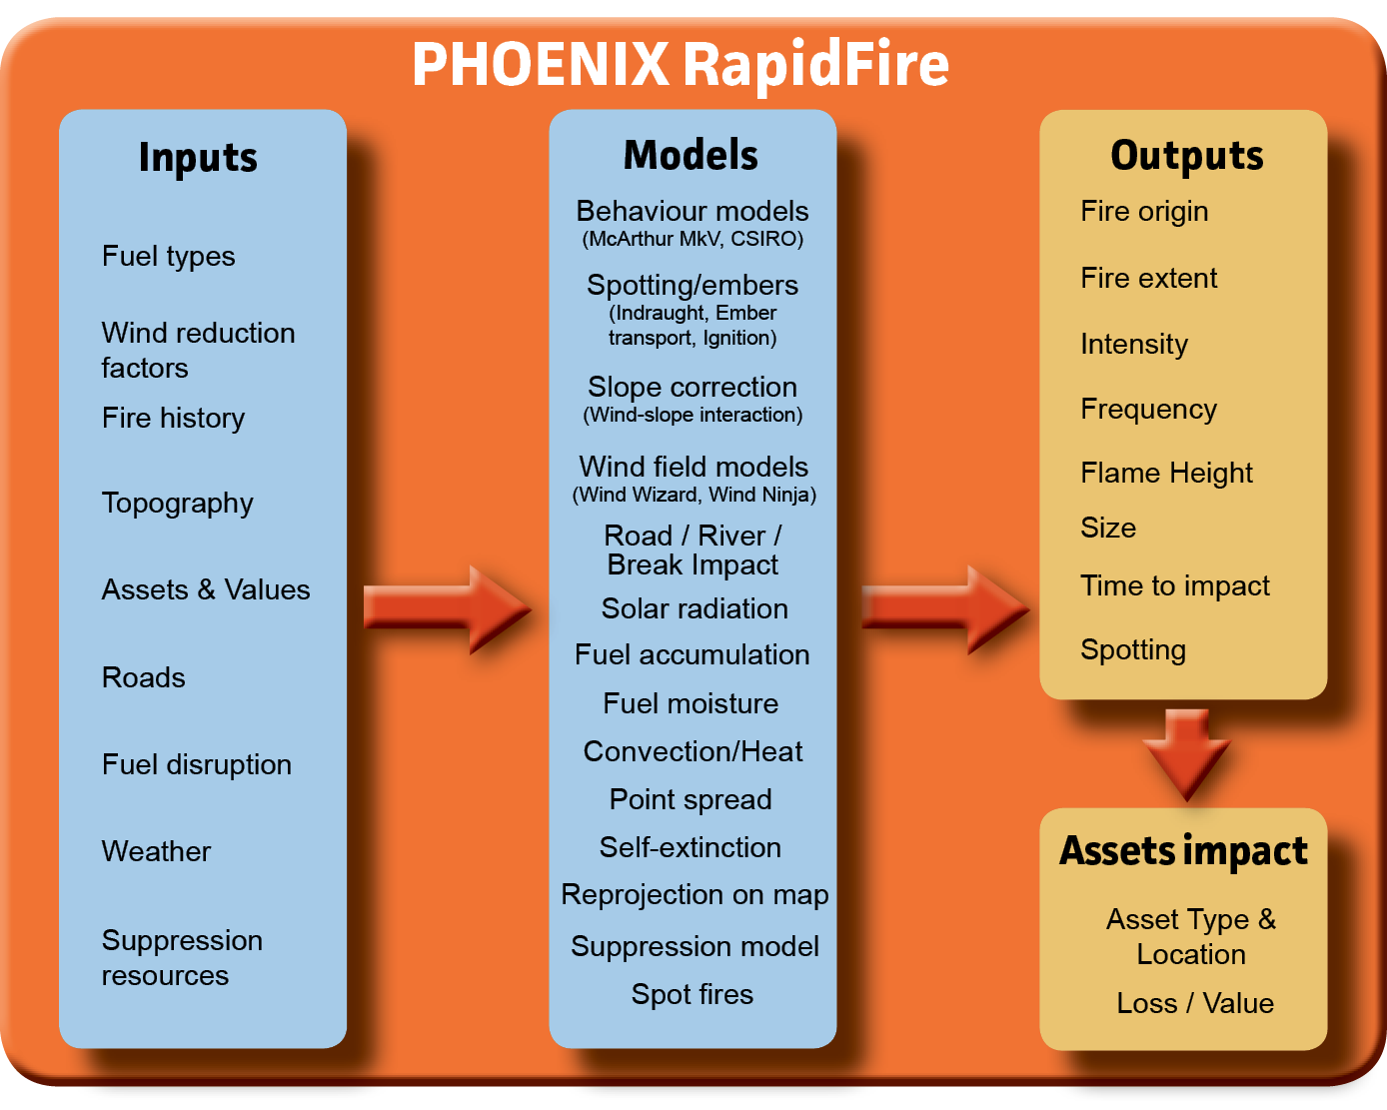­

This work is licensed under a [Creative Commons Attribution 4.0 International licence](http://creativecommons.org/licenses/by/4.0/).   
To view a copy of this licence, visit <http://creativecommons.org/licenses/by/4.0/> **­**

**Accessibility:** If you would like to receive this publication in an alternative format, please telephone DELWP Customer Service Centre 136 186, email [customer.service@delwp.vic.gov.au](mailto:customer.service@delwp.vic.gov.au), via the National Relay Service on 133 677 [www.relayservice.com.au](http://www.relayservice.com.au). This document is also available at [www.delwp.vic.gov.au](http://www.delwp.vic.gov.au)



The maps (above) compare PHOENIX RapidFire's bushfire simulation to the actual extent of the 2011 Tostaree bushfire, and show the effect of planned burning on the outcome. The fire was substantially slowed by recent planned burning. This helped to stop the fire from spreading further east, south of the Princes Highway, and slowed its rate of spread to suppressible levels north of the highway.

**(Above) Map of the PHOENIX RapidFire simulation of potential spread of the 2011 Tostaree Fire without planned Burning. This map shows that the Tostaree fire could have been three times larger, posing a much greater risk to life and property.**

How do we measure success?

One way DELWP measures the effectiveness of the strategy is by how well it reduces residual risk of bushfire.

Residual risk is the percentage of bushfire risk that remains after fuel management activities and fire history. It is determined by the complex mosaic of fuel-reduced and bushfire-burnt patches across the landscape. PHOENIX RapidFire can simulate the reduction in residual risk at any particular location or point in time.

For more information or factsheets phone (03) 5152 0600 or email [alpine.greatergippsland@delwp.vic.gov.au](mailto:alpine.greatergippsland@delwp.vic.gov.au).

© The State of Victoria Department of Environment, Land, Water and Planning 2015

ISBN 978-1-74146-921-9 (print)

978-1-74146-922-6 (pdf)

**Disclaimer:** This publication may be of assistance to you but the State of Victoria and its employees do not guarantee that the publication is without flaw of any kind or is wholly appropriate for your particular purposes and therefore disclaims all liability for any error, loss or other consequence which may arise from you relying on any information in this publication.

Bushfire models help predict the likelihood of bushfire and test its consequence on assets and the environment.

**(Left) Map of the simulated and actual extent of 2011 Tostaree Fire**

This map shows actual and simulated fire extent and intensity, and the effectiveness of planned burning in slowing or stopping the spread of fire.

Alpine and Greater Gippsland

Strategic bushfire management – bushfire simulation

What is bushfire simulation?

DELWP uses PHOENIX RapidFire bushfire simulation software, which is world-leading technology developed in conjunction with the University of Melbourne and the Bushfire and Natural Hazards Cooperative Research Centre. PHOENIX simulates how bushfires spread from a grid of ignition points, given:

* terrain and fuel (being a result of any location's fire history, type of vegetation and modelled fuel accumulation) at the starting point and along spread paths
* weather conditions.

These scenarios model fire behaviour by showing characteristics such as flame height, ember density, spotting density and convection column intensity.

The models guide where planned burning and other fuel treatment methods will be most effective in reducing the risk of bushfire, and in protecting people, property and the environment.

In addition to the planning and operational benefits, bushfire simulation is also a highly visual way of showing communities the risks they face.