|  |
| --- |
| 5. Assessing risk  Alpine and Greater Gippsland landscape  Information for communities |

Risk based planning allows us to prioritise the things we value and helps bushfire managers focus reduction efforts where risk is at its greatest.

In Victoria, catastrophic losses to life and property from bushfires over the past decade have emphasised the need for a more strategic approach to managing fire.

The Department of Environment, Land, Water and Planning (DELWP) and Parks Victoria (PV) have developed a process that integrates bushfire modelling and analysis to quantify bushfire risk across Victoria.

Bushfire modelling generates profiles of statewide and regional risk as it changes through bushfire events and as it is predicted to change as a result of future planned burning on public land.

It also predicts the residual risk of bushfire, after the strategies have been implemented.

What are our priorities?

The Code of Practice has two core objectives;

* reducing bushfire risk to life, communities, infrastructure, the economy and the environment, and
* maintaining or improving resilient ecosystems. Human life takes priority.

We collated an extensive range of data on assets across the landscape and worked with stakeholders and community members to categorise and prioritise assets for reducing the risk of bushfire.

Bushfire impact on human life is not modelled directly. Instead, we model the spread and impact of bushfires on property (built assets). In other words, there is an assumption that the loss of property due to bushfire is correlated with the loss of human life due to bushfire.

Bushfire impact on property is modelled using the 2011 version of the authoritative dataset of Victorian address points (Vicmap Address).

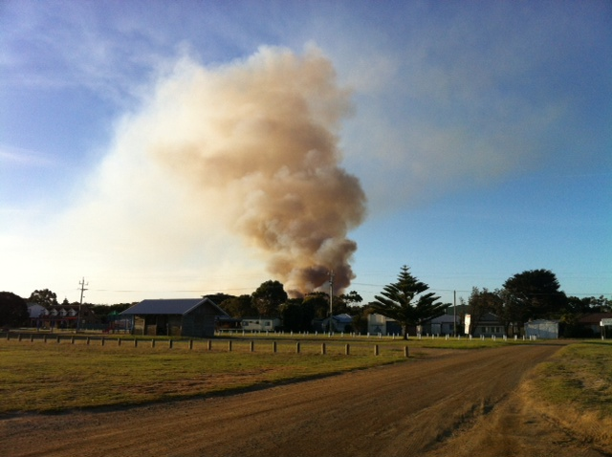

This means that changes in bushfire risk as a result of increasing housing development since 2011 are not captured accurately. Within the Alpine and Greater Gippsland landscape this Risk Register also includes some property addresses for long-abandoned towns, such as Grant, north of Dargo. Supplementing information from the datasets with local knowledge allows us to address inconsistencies arising from these types of anomalies.

What data inputs did we use?

In order to assess risk across the landscape, we had to firstly define and value the assets across the landscape. In addition to the physical address points, more than 11,200 individual assets and 5 million hectares of landscape assets. Assets data was extracted from a number of sources including the Victorian Fire Risk Register, Office of the Emergency Management Commissioner, DELWP, Alpine and Greater Gippsland Environmental Scan, VicForests, and Aboriginal Affairs of Victoria.

The assets were categorised according to the PIPE$S framework (People, Infrastructure, Public Administration, Environment, Economy and Social/Cultural) and the Internal Working Group and Landscape Reference Group used these asset databases, to assign priorities to asset types. (For more information, see factsheet ***Community Values and Assets.***)

How did we assess risk?

A full understanding of bushfire risk requires consideration of both the likelihood and consequence of bushfire impacts on human life, property and other values.

The risk matrix (above) illustrates the risk ratings or levels of risk (extreme, high, moderate and low) based on the **consequence** (level)of damage to assets and the **likelihood** of that level of damage occurring. Understanding the risk profiles supports bushfire managers in deciding the most effective options for their risk reduction efforts.

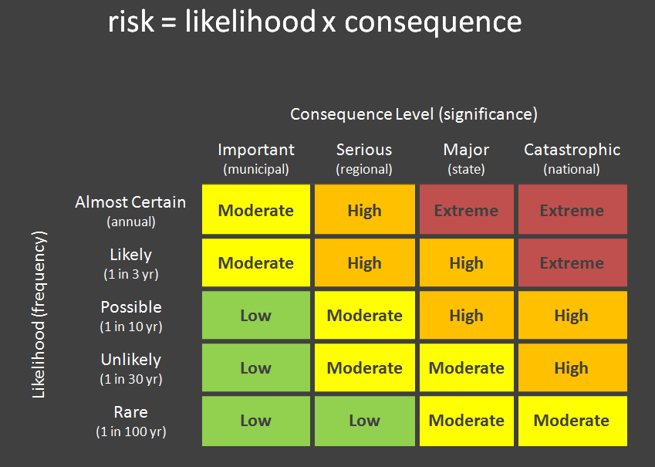From the matrix, note that the events that occur frequently but only impact on a ‘regional’ scale are considered to have the same risk level as events that occur infrequently but with catastrophic consequences. Similarly a frequently occurring event that only causes low levels of damage can be just as important as a rare event that has State or National level significance.

Figure 1 The Risk Matrix

Consequence levels

We worked with the Internal Working Group to determine the level of damage to our priority assets for those consequences to be considered:

* **Important** (municipal)
* **Serious** (regional)
* **Major** (state)
* **Code Red** (national)

The table below illustrates the consequence levels determined for some of our asset groups. For example the loss of between 2 and 4 emergency facilities would be regionally significant, losing more than 68 community meeting places would have state level significance whilst losing more than 300 houses would have national significance and be considered catastrophic.

Likelihood

The likelihood of the various levels of damage to assets was determined by PHOENIX RapidFire predictions (which include various weather scenarios, terrain, fire history, vegetation and fuel loads) and the likelihood of ignition, suppression and weather scenarios.

|  |  |  |  |  |  |
| --- | --- | --- | --- | --- | --- |
| **Examples of consequence levels** | | | | | |
| **Asset** | **Total** | **Important (Municipal)** | **Serious (Regional)** | **Major (State)** | **Catastrophic (National)** |
| Dwellings (no.) | 64,142 | 1 | 30 | 100 | 300 |
| High value water catchments (ha) | 918,000 | 92,000 | 184,000 | 367,000 | 734,000 |
| Education Facilities - major (no.) | 19 | 1 | 1 | 2 | 10 |
| Emergency Facility (no.) | 205 | 2 | 4 | 10 | 16 |
| Community Meeting Place (no.) | 206 | 2 | 21 | 68 | 136 |

Ignition Threat

The ignition threat maps below (Figures 2-5) show how many dwellings are likely to be impacted (consequence levels) if an ignition occurs under varying weather conditions and fuel levels are at their maximum levels. However not all ignitions are equally likely to happen, so to get picture of risk in the landscape we also need to examine the likelihood of ignitions occurring (Figure 6) and the likelihood of being able to suppress a fire if one does ignite (Figure 7).

|  |  |
| --- | --- |
| Figure 2 Very High Fire Danger | Figure 3 Severe Fire Danger |
| Figure 4 Extreme Fire Danger | Figure 5 Code Red Fire Danger |
| Figure 6 Ignition Likelihood | Figure 7 Suppression Likelihood |

Weather scenarios likelihood

To increase the accuracy of our risk assessment we examined our historical weather data and fire history to determine the likelihood of the different weather scenarios happening in our landscape. Our most likely scenario Very High Fire Danger Rating or below (90.25%)

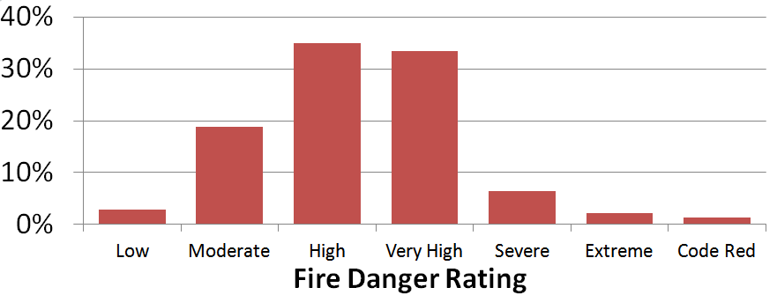

Using the risk assessment to develop our strategy

The risk assessment helped us identify assets at highest risk and where we should focus our fuel reduction efforts. Moderating fuel levels in these higher risk areas helps us reduce the risk of damage from bushfires to life and property and also to maintain resilient ecosystems.

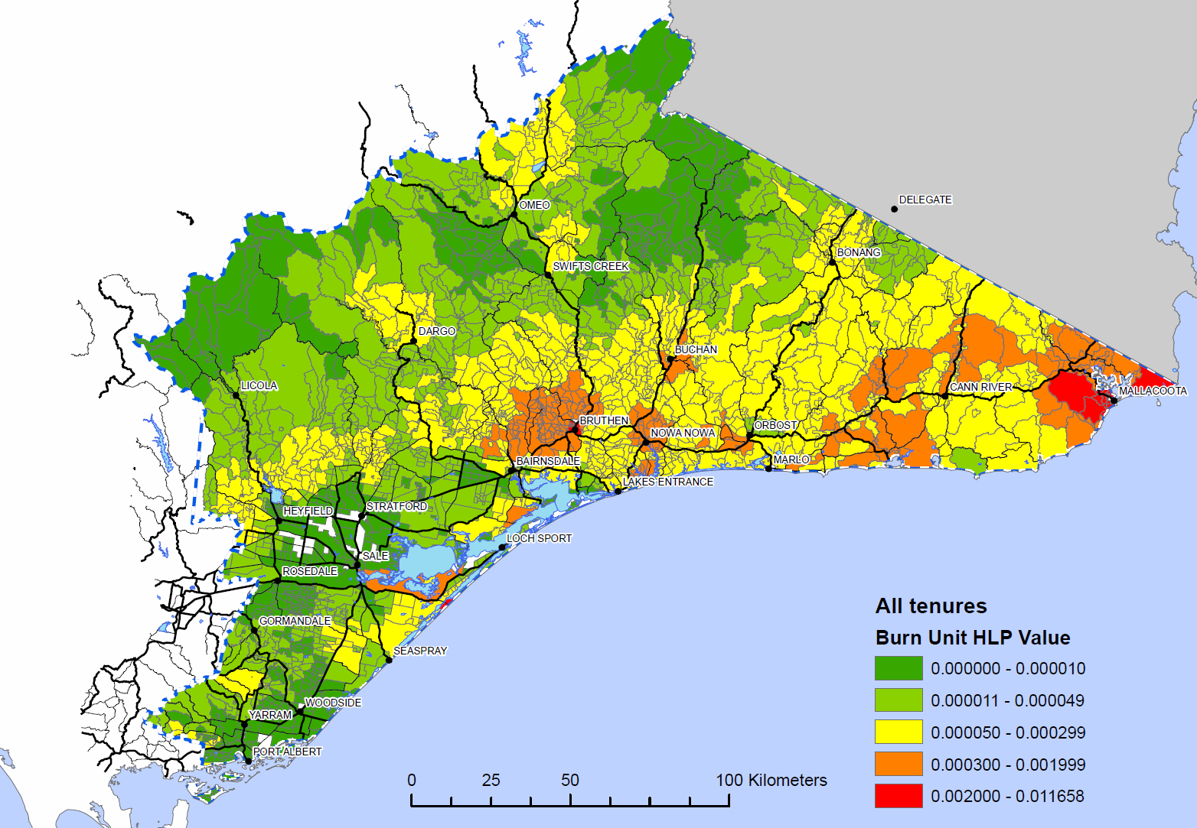

For further information about assessing risk in the Alpine and Greater Gippsland Bushfire Risk Landscape email [*alpine.greatergippsland@delwp.vic.gov.au*](mailto:alpine.greatergippsland@delwp.vic.gov.au), or contact the Strategic Bushfire Management Program Manager on (03) 51520600.

|  |  |
| --- | --- |
| © The State of Victoria Department of Environment, Land, Water and  Planning 2015  byThis work is licensed under a [Creative Commons Attribution 4.0 International licence](http://creativecommons.org/licenses/by/4.0/). You are free to re-use the work under that licence, on the condition that you credit the State of Victoria as author. The licence does not apply to any images, photographs or branding, including the Victorian Coat of Arms, the Victorian Government logo and the Department of Environment, Land, Water and Planning (DELWP) logo. To view a copy of this licence, visit <http://creativecommons.org/licenses/by/4.0/>  ISBN 978-1-74146-913-4 (print)  ISBN 978-1-74146-914-1 (pdf) | **Disclaimer** This publication may be of assistance to you but the State of Victoria and its employees do not guarantee that the publication is without flaw of any kind or is wholly appropriate for your particular purposes and therefore disclaims all liability for any error, loss or other consequence which may arise from you relying on any information in this publication.  **Accessibility**  If you would like to receive this publication in an alternative format, please telephone DELWP Customer Service Centre 136 186, email [customer.service@delwp.vic.gov.au](mailto:customer.service@delwp.vic.gov.au), via the National Relay Service on 133 677 [www.relayservice.com.au](http://www.relayservice.com.au). This document is also available by emailing alpine.greatergippsland@delwp.vic.gov.au. |