by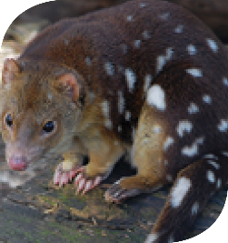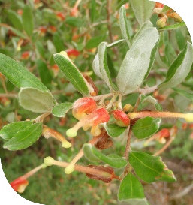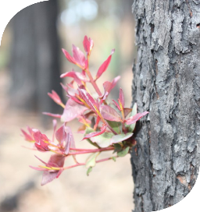­

How were the species prioritised?

We prioritised the environmental values according to: their conservation importance at state and national levels, their resilience to fire regimes and the ability to manage them at a landscape level

DELWP and PV Biodiversity teams mapped areas of the landscape that contained:

* fire-sensitive ecological communities, such as Alpine Sphagnum Bogs and Fens, Littoral Rainforests and Coastal Vine Thickets, which can have severe and long-term ecological effects from intense bushfires
* State (Flora and Fauna Guarantee Act) and Commonwealth (Environment Protection and Biodiversity Conservation Act) threatened and vulnerable species
* habitats for 17 priority flora species, including Colquhoun Grevillea and Wellington Mintbush

habitats for 26 priority fauna species, including the Lace Monitor, the Powerful Owl and the Spotted Quoll.

Fire is vital for resilience

Fire plays an essential role in the ecology of many native plants. DELWP currently uses **Tolerable Fire Intervals (TFIs)** to determine the effect of the strategy on ecosystem resilience. Alternative processes are being developed that will give more accurate measures. These include **Geometric Mean of Abundance** and **Vegetation Growth Stage Structure**.

For more information on how strategic bushfire management supports ecosystem resilience, request the factsheets from [alpine.greatergippsland@delwp.vic.gov.au](mailto:alpine.greatergippsland@delwp.vic.gov.au) or by calling

(03)5152 0600.

Our landscape has around 20-30   
Brush-tailed Rock-Wallabies (*Petrogale penicillata*), the largest remaining colony of the critically endangered species in Victoria. Under our fuel management strategy, the colony and surrounding areas are in a landscape management zone. This zone allows us to do planned burning in areas surrounding the colony to reduce risk from large, intense bushfires. It also allows us to do burning trials or to not burn the actual habitat until we better understand the implications of planned burning.

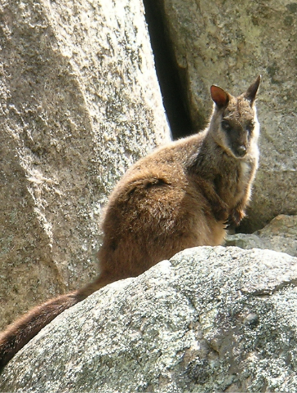

**EFGs expected to be burnt under the minimum TFI – the majority will occur in asset protection and bushfire moderation zones in order to meet strategic risk reduction objectives.**

**Disclaimer:** This publication may be of assistance to you but the State of Victoria and its employees do not guarantee that the publication is without flaw of any kind or is wholly appropriate for your particular purposes and therefore disclaims all liability for any error, loss or other consequence which may arise from you relying on any information in this publication.

This work is licensed under a [Creative Commons Attribution 4.0 International licence](http://creativecommons.org/licenses/by/4.0/).   
To view a copy of this licence, visit <http://creativecommons.org/licenses/by/4.0/> **­**

**Accessibility:** If you would like to receive this publication in an alternative format, please telephone DELWP Customer Service Centre 136 186, email [customer.service@delwp.vic.gov.au](mailto:customer.service@delwp.vic.gov.au), via the National Relay Service on 133 677 [www.relayservice.com.au](http://www.relayservice.com.au). This document is also available at [www.delwp.vic.gov.au](http://www.delwp.vic.gov.au)

© The State of Victoria Department of Environment, Land, Water and Planning 2015

ISBN 978-1-74146-923-3(print)

978-1-74146-924-0(pdf)

Alpine and Greater Gippsland

Strategic bushfire management – environmental features

What are the environmental features of the landscape?

The Alpine and Greater Gippsland landscape contains an extremely diverse ecology across mountains, tablelands, foothills, river valleys and coastal plains, including the unique Gippsland Lakes waterways.

This environment contains habitats for more than 250 species of threatened flora and 110 species of threatened fauna.

Strategic bushfire management acknowledges the need to balance reducing bushfire risk to life and property and maintaining ecosystem resilience across the landscape.

In some areas we modified our strategy to accommodate the needs of specific threatened plant and animal species.

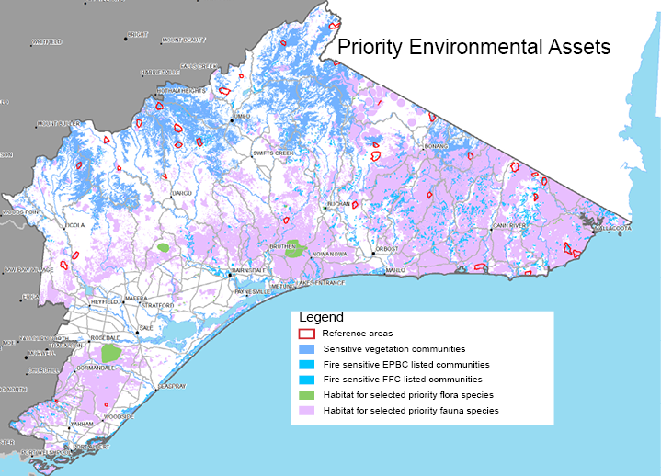The environmental assets map (above) shows the landscape's fire-sensitive listed vegetation communities, and priority plants and animal habitats. We prioritised fire-sensitive listed vegetation communities because an intense bushfire can have severe and long-term ecological effects on them: it can alter the composition and structure of their vegetation, fragment them and make them susceptible to invasion by exotic species.

Across the landscape, there are 29,100 ha of these communities, which are listed as important under State or Commonwealth legislation. These communities are often in small isolated patches, and include Alpine Sphagnum Bogs and associated Fens, Littoral Rainforest and Coastal Vine Thickets, Warm Temperate Rainforest and Alpine Snowpatch.

**CASE STUDY: Brush-tailed rock wallaby**

What are Tolerable Fire Intervals?

Most Australian plants need fire for species regeneration. Tolerable Fire Intervals (TFIs) are the ideal interval between fires for vegetation communities or Ecological Fire Groups (EFGs).

* TFIs help determine the frequency, severity and intensity of planned burning so that it supports ecological sustainability. Burning below TFI risks species not setting seed and regenerating.
* Planned burning in **Landscape Management Zones (LMZ)** will complement the needs of high-value environmental areas, such as habitats of animals in small, isolated populations.
* In some **Bushfire Moderation Zones (BMZ**), we have extended planned burning from 8 to 10 years to accommodate the needs of some priority plant species.



