Strategic bushfire management planning combines local knowledge with the latest technology, historical data and the best-available science.

**Alpine and Greater Gippsland** is one of Victoria’s seven risk landscapes, which are operational areas largely defined by the way bushfires start and spread within a region. Teams from the Department of Environment, Land, Water and Planning (DELWP) and Parks Victoria (PV) have been working with partner agencies and stakeholders to develop a risk-based approach to bushfire management. This allows DELWP, PV and other agencies responsible for bushfire management to focus on the most effective activities to reduce bushfire risk.

The framework

The risk planning process provides an adaptive and sustainable framework for DELWP, PV, key stakeholders and communities to work together to minimise bushfire risk. It comprises four key stages:

**Modelling Bushfire Risk: The first stage** gathersinputs such as historical fire data, fuel hazards, terrain and weather to model bushfire behaviour across a wide range of conditions, using world-leading bushfire simulation technology, Phoenix RapidFire. (For more information, see factsheet ***Bushfire simulation***.)

**Community Values: The second stage** in the process involves DELWP and PV working with stakeholders and communities to understand what they value and want to protect from bushfires. Detailed information is gathered on assets of all kinds across the landscape, including dwellings, infrastructure, the economies and industries, the environment and its ecosystems. (For more information, see factsheet ***Community Values***.)

**Risk Assessment: The third stage** again produces bushfire modelling and combines it with detailed risk analysis using internationally recognised risk methodology to assess bushfire risk profiles based on likelihood and consequence of bushfire affecting each of the assets. (For more information, see factsheet ***Assessing Risk***.)

**Develop plan: The fourth stage** combines the bushfire modelling, the defined risk profiles, in conjunction with local knowledge, experience and expertise in fire, to determine the fuel management strategy. Such detailed analysis allows planning for fuel treatments in each area of the landscape, based on its risk profile.

This initial plan becomes the base for future iterations, which will be improved by continuous data improvements, input and feedback from stakeholders and the community.

Who was involved?

DELWP and PV have been working with two main groups in reviewing the potential strategies, prioritising asset types and assessing risk to build the initial plan.

**The Landscape Reference Group (LRG)** included nominated community stakeholders with expertise and good local knowledge of bushfires in the landscape. It was made up of 14 members with broad interests and experience including apiarists, timber industry, CFA and parks and forests.

**The Internal Working Group (IWG)** included experts from DELWP and PV and cross-agency representatives with extensive operational experience: this group focused on making sure the strategy was implementable.

Both groups met fortnightly and helped to:

* identify assets and values for priority protection.
* select the most effective strategy to reduce bushfire risk, based on the available data and options

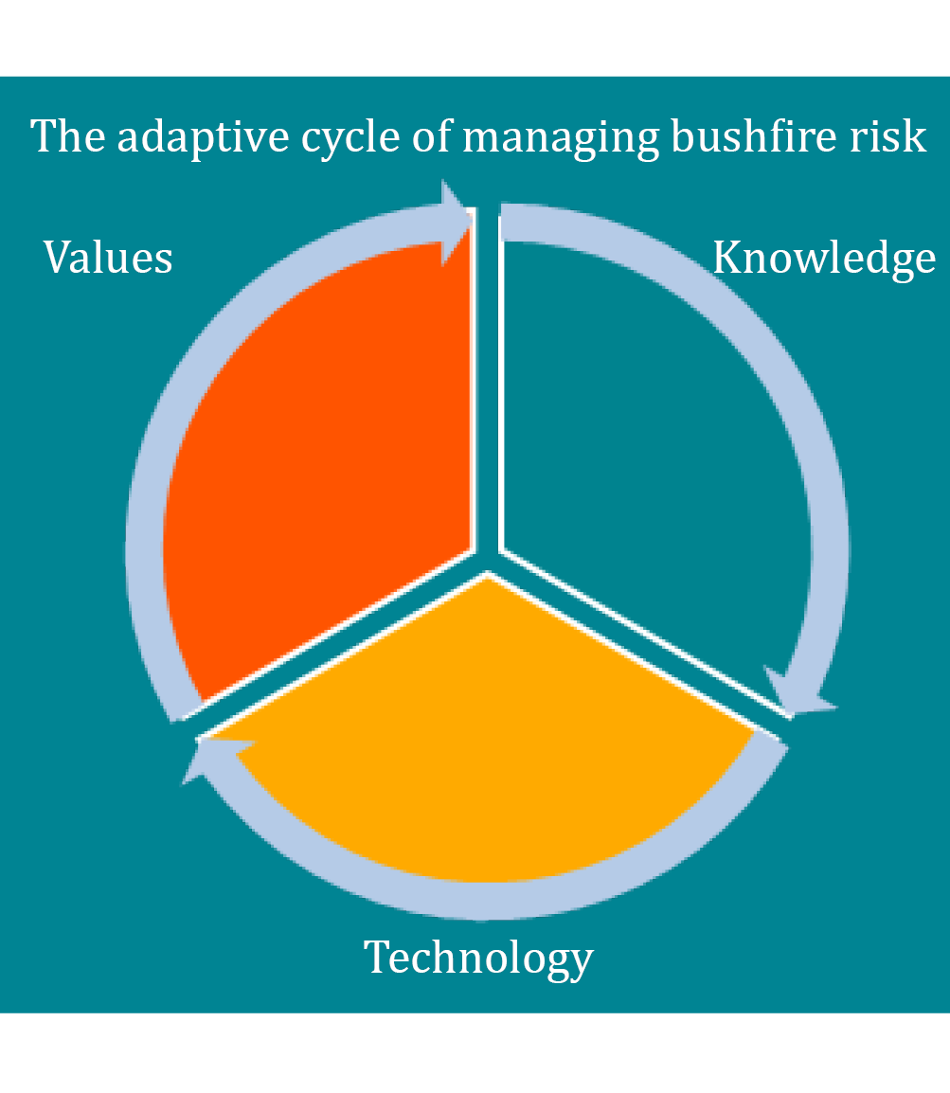Consultation will now widen to include more stakeholders, interest groups, industries and the community.

**Priority   
assets:**

**life, property, the economy and environment**

**Local**

**experience, knowledge   
of bushfire behaviour**

**Bushfire**

**simulation with Phoenix Rapidfire, inputs inc. fire data & weather variables**

How was the plan developed?

The DELWP/PV landscape project team gathered a database of assets used from a range of sources, including the Victorian Fire Risk Register, resulting in more than 11,000 assets listed in the Alpine and Greater Gippsland region.

The assets were then grouped according to PIPE$S categories (People, Infrastructure, Public Administration, Environment, Economy, Socio-Cultural). These defined assets such as transport, water supply, emergency facilities, built area zones, farming, forestry, tourism, Aboriginal cultural heritage, apiary, public buildings and natural assets.

These categories were then ranked by the IWG according to priority for protection from bushfire and whether the bushfire risk can be managed or reduced by DELWP/PV. The LRG were then given the opportunity to review the outcomes of this ranking process and to provide input.

Priority assets identified by this process were;

* Life and property (address points)
* Ecosystem resilience
* Utility Infrastructure
* Utility networks
* Communication infrastructure
* Emergency facilities
* Emergency infrastructure
* Nationally important transport links
* Community meeting places
* Priority Habitat for Selected Species - Flora
* Priority Habitat for Selected Species - Fauna
* Listed Community - Fire Sensitive
* Water Supply Catchment - high value areas
* Camping assets
* Tourist destinations

Once the priority asset categories had been identified, a process was undertaken to weight life and property and critical infrastructure assets. The figure below shows the outcome of this weighting process. (For more information, see factsheet ***Assessing Risk***.)

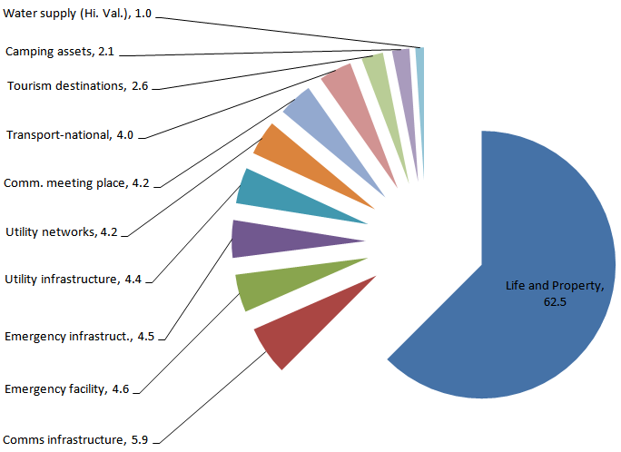

Figure 1. Weighting assets

Priority asset categories from the Environment section of the PIPE$S framework were omitted from this weighting, a decision made by the Internal Working Group based on risk mapping that showed that reducing risk from bushfire to these assets would require extensive fuel treatment. This was due to their broad distribution and widespread nature. Such extensive fuel treatment posed two problems:

* Reducing fuel over such extensive areas to reduce risk to one category of the PIPE$S framework would reduce the ability to address bushfire risk to other priority asset categories including life and property.
* There was no ready means of identifying if risk reduction actions at such an extensive scale to protect priority environment assets from bushfire would cause worse ecological outcomes across the landscape than bushfire itself.

Each priority asset category was also allocated a ‘goal risk level’ to measure against as different strategies were developed and considered.

The risk profiles were mapped on both a landscape scale and a district scale (there are three districts within the AGG landscape: Macalister, Snowy and Tambo). The Internal Working Group decided that district-scale mapping provided outcomes mostly closely in line with core objectives for the strategy.

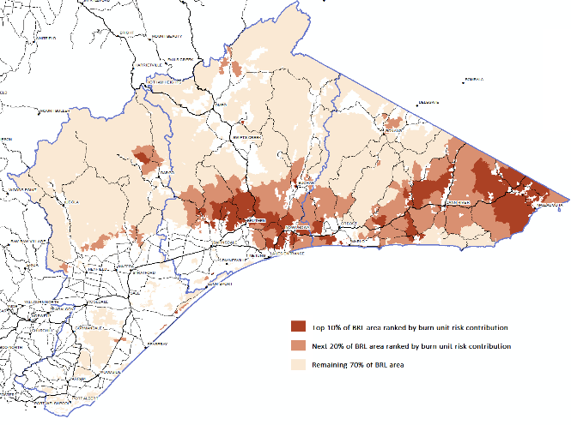

Landscape scale

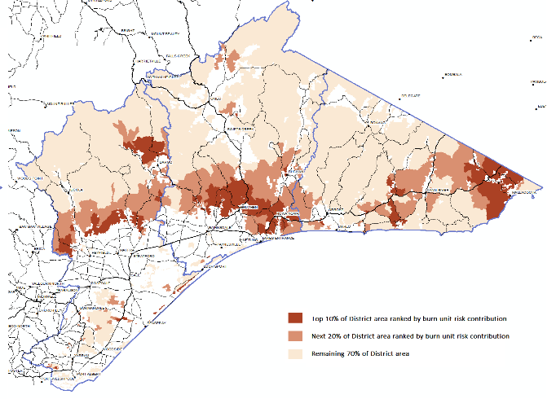

District scale

Selecting the strategy

The working groups were presented with five possible strategies – each with different fuel treatment variations:

1. Current Fire Management Zoning
2. Protection of human life and property ‘intensive’ program – focused on burning smaller areas, more often
3. Protection of human life and property ‘extensive’ program – which focussed on burning bigger areas, less often
4. **Protection of both human life and property and critical assets ‘intensive’ program - which focused on burning smaller areas more often.**

1. Human life and property and critical assets ‘extensive’ program - which focused on burning bigger areas less often.

As part of the strategy selection process, information was provided to members of the working groups for each strategy that included:

* Proposed frequency of each treatment level.
* Area statements for each proposed treatment level.
* Residual risk outcomes for each asset categories.
* An assessment of outcomes for goal risk levels of priority asset categories.
* Tolerable Fire Interval assessment of proposed treatment levels

This information was used by the working group members to identify their preferred strategy from the 5 options. The preferred and selected strategy was number number 4 (described above and highlighted in the green box). This strategy forms the basis for implementing the strategic bushfire management plan.

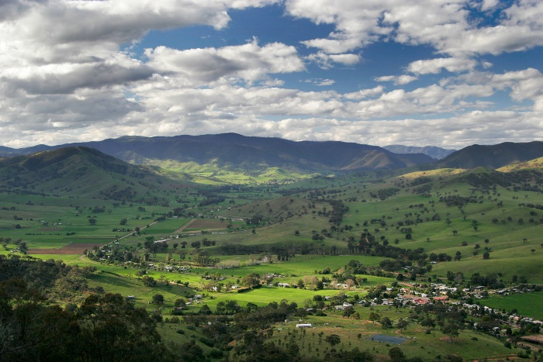

How will the plan be implemented?

The plan details a range of fuel management activities, including assigning fuel management zones that divide public land into: **asset protection zones, bushfire moderation zones, landscape management zones and planned burn exclusion zones**. Each zone is allocated a frequency of planned burning as outlined in the table below. The frequency of planned burning has been modified to accommodate the needs of specific priority plant and animal species. (For more information see Factsheet **Environment**)

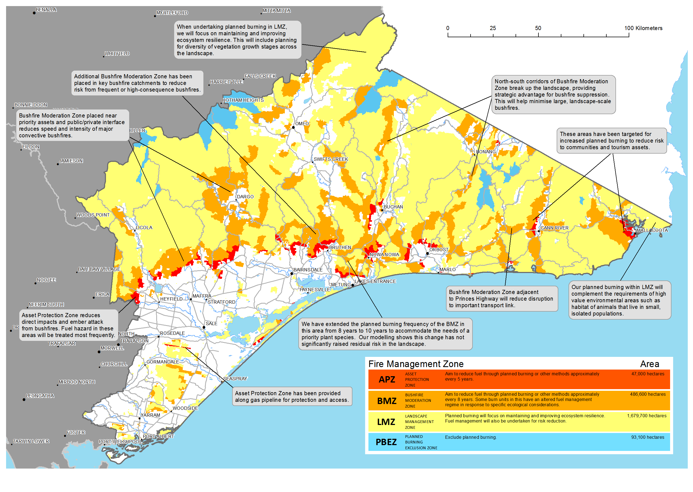

Alpine and Greater Gippsland Fuel Management Strategy

|  |  |  |  |
| --- | --- | --- | --- |
| **Zone** | **Description** | **Frequency** | **Area** |
| **Asset Protection Zone** | Intensive fuel management area around properties and infrastructure to provide local protection, to reduce radiant heat and ember attack on life and property in the event of a bushfire. | Every five years | Total 47,000 ha |
| **Bushfire Moderation Zone** | Managing fuel hazard to reduce the speed and intensity of bushfires, and to protect nearby assets, particularly from ember attack. We will alter the fuel management regime in some burn units in this zone to meet ecological objectives | Every eight years | Total 486,600 ha |
| **Landscape Management Zone** | Managing fuel to improve ecosystem resilience, reduce residual risk, and for other purposes (such as to regenerate forests and protect water catchments) | Varies depending on objectives | Total 1,679,700 ha |
| **Planned Burning Exclusion Zone** | An area where we try to avoid planned burning, mainly because the vegetation cannot tolerate fire. | N/A | Total 93,100 ha |

What happens next?

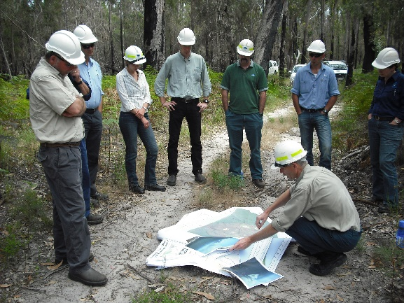DELWP and PV are widening participation and consultation on the initial plan. There will be a series of community meetings and information sessions. The plan has been used to help inform the Fire Operations Plan for the next planned burning cycle.

The strategic bushfire management planning process is an adaptive cycle. As new information is developed and changes to risk factors arise, they will be incorporated into the plan.

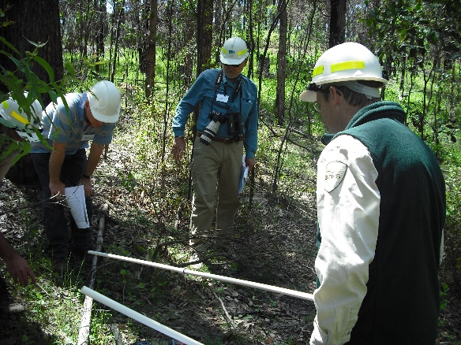Members of the community and stakeholders are invited to contribute to the planning, or request a demonstration of the way bushfire modelling works for their area. These opportunities will be ongoing, as each input or new information is reviewed to help adapt the future strategy.

For further information about managing bushfire risk in the Alpine and Greater Gippsland bushfire risk landscape email [*alpine.greatergippsland@delwp.vic.gov.au*](mailto:alpine.greatergippsland@delwp.vic.gov.au), or contact the Strategic Bushfire Management Program Manager on (03) 51520600.

|  |  |
| --- | --- |
| © The State of Victoria Department of Environment, Land, Water and  Planning 2015  This work is licensed under a [Creative Commons Attribution 4.0 International licence](http://creativecommons.org/licenses/by/4.0/). You are free to re-use the work under that licence, on the condition that you credit the State of Victoria as author. The licence does not apply to any images, photographs or branding, including the Victorian Coat of Arms, the Victorian Government logo and the Department of Environment, Land, Water and Planning (DELWP) logo. To view a copy of this licence, visit <http://creativecommons.org/licenses/by/4.0/>  ISBN 978-1-74146-915-8 (print)  ISBN 978-1-74146-916-5 (pdf) | **Disclaimer** This publication may be of assistance to you but the State of Victoria and its employees do not guarantee that the publication is without flaw of any kind or is wholly appropriate for your particular purposes and therefore disclaims all liability for any error, loss or other consequence which may arise from you relying on any information in this publication.  **Accessibility**  If you would like to receive this publication in an alternative format, please telephone DELWP Customer Service Centre 136 186, email [customer.service@delwp.vic.gov.au](mailto:customer.service@delwp.vic.gov.au), via the National Relay Service on 133 677 [www.relayservice.com.au](http://www.relayservice.com.au). This document is also available on the internet at [www.delwp.vic.gov.au](http://www.delwp.vic.gov.au) |