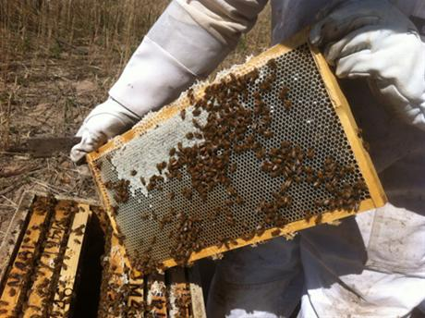by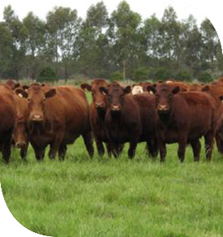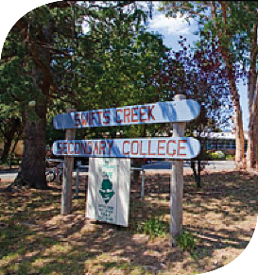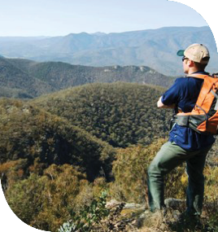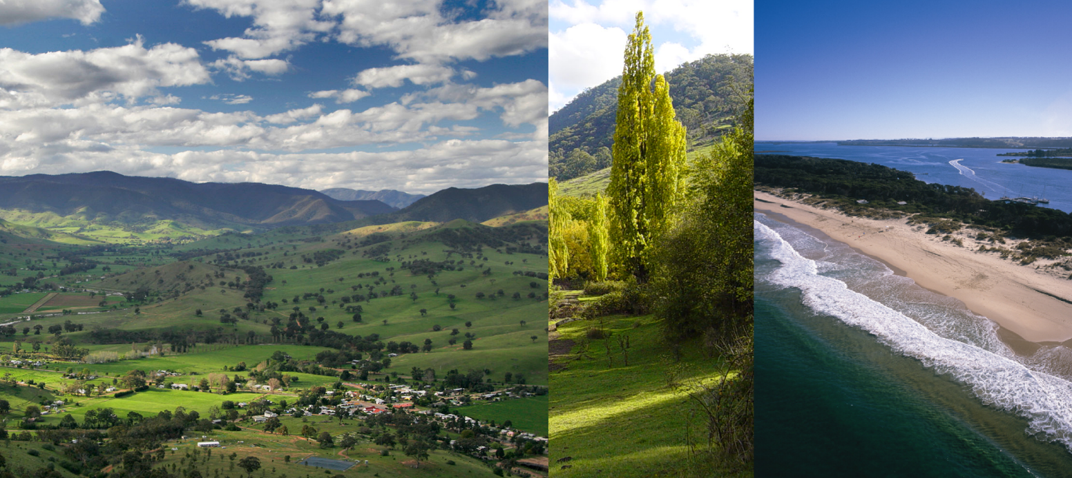

This work is licensed under a [Creative Commons Attribution 4.0 International licence](http://creativecommons.org/licenses/by/4.0/).   
To view a copy of this licence, visit <http://creativecommons.org/licenses/by/4.0/> **­**

**Accessibility:** If you would like to receive this publication in an alternative format, please telephone DELWP Customer Service Centre 136 186, email [customer.service@delwp.vic.gov.au](mailto:customer.service@delwp.vic.gov.au), via the National Relay Service on 133 677 [www.relayservice.com.au](http://www.relayservice.com.au). This document is also available at [www.delwp.vic.gov.au](http://www.delwp.vic.gov.au)

**INFRASTRUCTURE**

We placed an asset protection zone along the Esso gas pipeline to protect this essential infrastructure, which supplies Melbourne with gas. The Princes Highway is the main freight route for produce into and out of Gippsland, and there are few alternative routes for heavy vehicles (which comprise 20% of all traffic along this highway). There is a 50% increase in traffic volumes along the highway in busy holiday periods, with peak traffic over the summer holiday.

Electricity and telecommunications infrastructure is essential for bushfire response, especially for vulnerable people and those in remote locations. The water supply catchments are vulnerable to bushfires, which damage water supply infrastructure and contaminate the water with ash and other debris. Long-term effects include soil erosion due to the destruction of vegetation.

**ENVIRONMENT**

While many of our plant species are fire dependent, the landscape includes 29,100 ha of fire sensitive vegetation communities, 17 priority flora species and 26 priority fauna species, which are listed as important under state or federal legislation.

Our strategy prioritises the habitats of these threatened or vulnerable flora, fauna and vegetation communities because of the potential for severe and long term ecological effects from an intense bushfire.

For more information, request the Environment and Ecological Resilience factsheets by calling (03) 5152 0600 or emailing [alpine.greatergippsland@delwp.vic.gov.au](mailto:alpine.greatergippsland@delwp.vic.gov.au).

Bushfires put the tourism industry at risk: they damage or destroy the natural environments and infrastructure, or cut road access.

Media coverage of general fire risk in a region can influence visitors to cancel plans, even if their destination is no longer threatened.

**ECONOMY**

Agriculture, horticulture, oil and gas, timber, retail, education, healthcare and social services

Around 30,000 jobs generate $5 billion in the region. Oil and gas are major contributors, along with agriculture, horticulture, timber, fishing, tourism, retail, education, healthcare and social services.

Bushfires can harm the agriculture, apiary, timber, horticulture and viticulture industries: they destroy and damage crops, buildings, fencing, machinery and equipment, and kill or injure livestock.

Bushfires also threaten food security by damaging native flora and pollen-producing plants such as fruit trees and grape vines. The viticulture industry is particularly vulnerable to smoke taint during the summer bushfire season. We consult with stakeholders in these industries when we are planning burn operations.

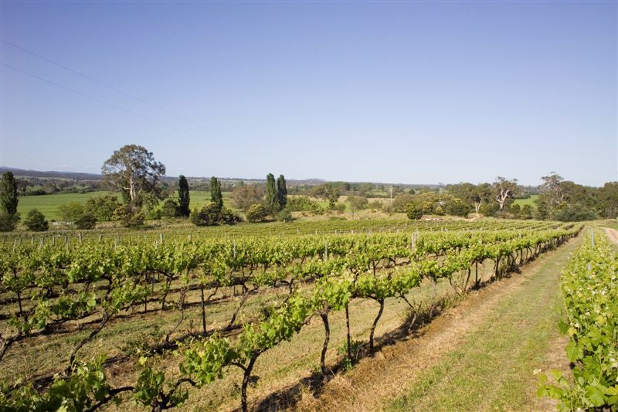

Tourism

We prioritised the landscape's tourism industry because it heavily dependent on our natural environment, contributes over $450million annually to our economy, and accounts for more than 2,400 jobs in the Wellington and East Gippsland shires. Most tourists visit from December to April.

What are the features of the landscape?

The Alpine and Greater Gippsland Bushfire Risk Landscape covers East Gippsland and Wellington shires, and small parts of shires in alpine areas. This landscape has many features that present a challenge for bushfire management:

* 3.3million hectares, around 70% of which is public land, mostly continuous forest
* an extremely diverse ecology across mountains, tablelands, foothills, river valleys and coastal plains, including the unique Gippsland Lakes waterways
* the environment contains habitats for more than 250 species of threatened flora and 110 species of threatened fauna
* high-value water catchments
* infrastructure of regional, state and national significance, including: hopsitals and medical facilities, emergency response facilities, schools and community meeting places, national transport routes, oil and gas pipes and public administration buildings.

Much of the public land comprises uninterrupted forests and parks.

Bushfires started by lightning strikes in remote, inaccessible areas are often difficult to suppress, and can lead to large landscape-scale bushfires that last for weeks. Despite this, DELWP suppresses 75% of fires before they reach 5 hectares in size.

**COMMUNITIES**

The landscape has around 86,000 people, with the numbers boosted significantly during the peak summer holiday season. More than 32,000 people live in small communities of fewer than 500 in rural, coastal and remote areas, often adjacent to forests.

Many communities have ageing populations, which increases vulnerability bushfire risk. The communities also contain large numbers of public buildings that are at risk from bushfire, including health centres, schools, community meeting places, council offices and emergency services facilities.

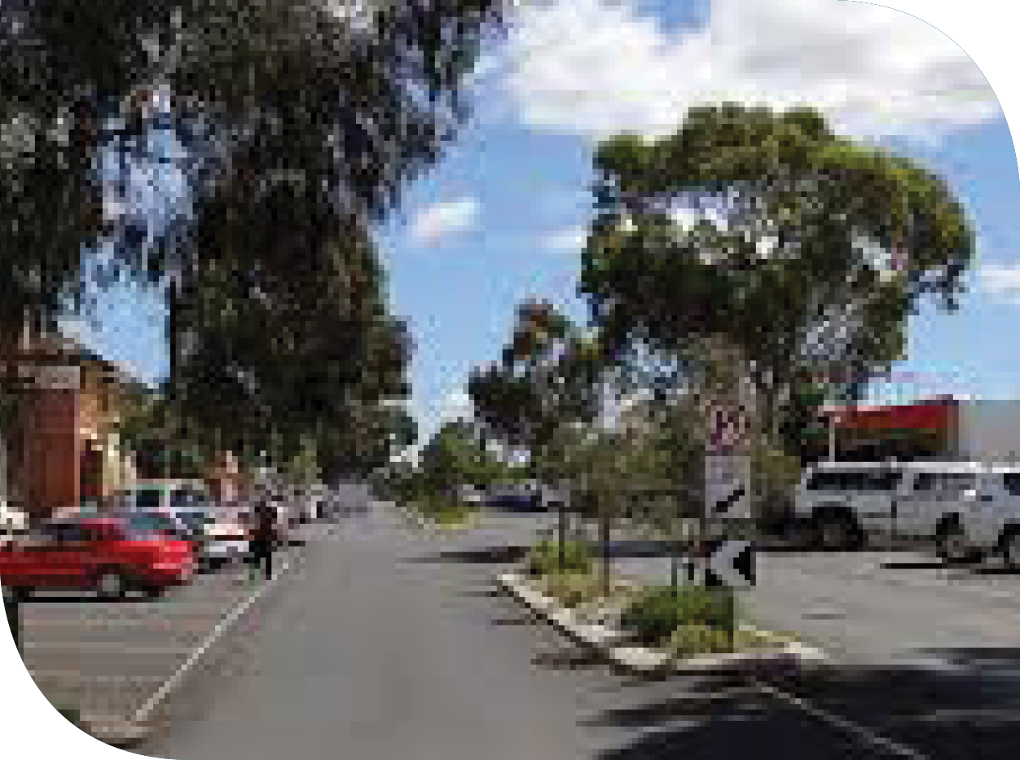 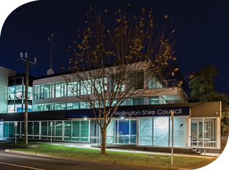

Alpine and Greater Gippsland

Strategic bushfire management – landscape features

**Disclaimer:** This publication may be of assistance to you but the State of Victoria and its employees do not guarantee that the publication is without flaw of any kind or is wholly appropriate for your particular purposes and therefore disclaims all liability for any error, loss or other consequence which may arise from you relying on any information in this publication.

© The State of Victoria Department of Environment, Land, Water and Planning

ISBN 978-1-74146-925-7 (print)

978-1-74146-926-4 (pdf)