Strategic bushfire risk management aims to achieve a balance between the two core objectives of reducing bushfire risk and maintaining resilient ecosystems.

What is ecosystem resilience?

Ecosystem resilience refers to an ecosystem’s capacity to absorb both natural and management-imposed disturbance but still retain its basic function so that it is able to behave in the same way over time. An ecosystem with low resilience can be considered at risk of changing into a different state. This could be caused by a single or series of natural or planned disturbance events such as fire.

Why is ecosystem resilience important?

Resilient ecosystems support flora, fauna and micro-organisms, which are vital for delivering clean air, fresh water and fertile soils.

Measuring ecosystem resilience can provide some guidance regarding the landscape-scale environmental impacts of bushfire management. Maintaining or improving the resilience of natural ecosystems is one of the two primary objectives of the Code of Practice for Bushfire Management on Public Land (2012).

How do we measure ecosystem resilience?

DELWP, in consultation with its research partners, has developed three measures of ecosystem resilience:

**1.** **Tolerable Fire Intervals (TFI)** are the recommended minimum and maximum periods between fires for a particular vegetation community. These are calculated from the life history characteristics of plant species in that vegetation community, and guide how frequent fires should be in the future to allow persistence of all flora species at the site. TFI is presently the best understood and researched measure, or surrogate, of ecosystem resilience.

**2. The Geometric Mean Abundance (GMA)** of species is a biodiversity index that can be used to identify landscape-level trends in biodiversity. GMA provides a more sophisticated approach to measuring ecosystem resilience than using TFI alone, as it considers how well suited the whole landscape is for each individual species and all species together.

**3.** **Vegetation Growth Stage Structure** which uses a range of information to identify the mix of vegetation growth stages required to potentially optimise biodiversity and hence enhance ecosystem resilience across the landscape.

DELWP has determined that TFI will be the initial and interim measure for Ecosystem Resilience as GMA and Vegetation Growth Stage Structure are developed further.

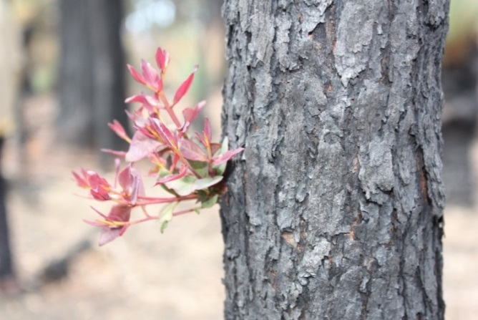

How does TFI relate to ecosystem resilience?

TFI provides a useful measure of landscape resilience and can guide which areas may be at risk from ecological change. If large areas of a landscape are younger than the minimum tolerable fire interval, and if the probability of fire in these areas is high (e.g. from planned burning), further disturbance events could be expected to have a negative impact on the ecosystem’s resilience.

Knowing the proportion of the landscape that is below its minimum tolerable fire interval at any given time provides a measure of ecological risk in the landscape (high risk = low resilience). Such information is directly relevant to bushfire managers and can be useful for identifying potential changes to ecosystem resilience in the landscape based on proposed burning strategies.

Ecosystem Resilience and the bushfire management strategy

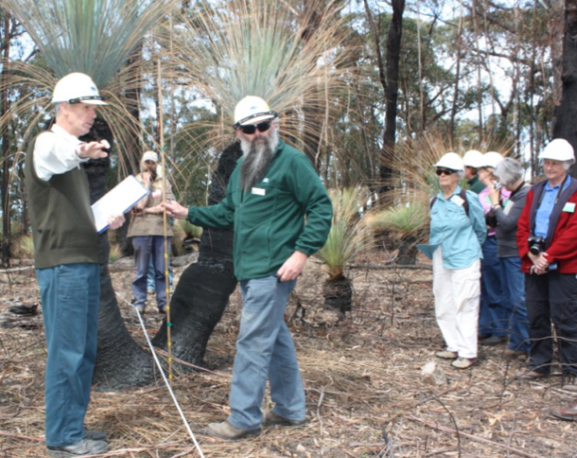As with current planned burning programs, implementing the bushfire management strategy in the Alpine and Greater Gippsland landscape, will result in a proportion of some Ecological Fire Groups (EFGs) being burnt below their minimum TFI (see Figure 1 below).

The majority of this will occur in asset protection zones and bushfire moderation zones in order to meet strategic risk reduction objectives.

While TFI is the initial measure being used for ecosystem resilience, we have also identified areas within the landscape management zone that have other values likely to be important for maintaining and improving ecosystem resilience. These include habitat of fauna species that prefer longer undisturbed vegetation and areas with a high proportion of late growth stage vegetation (for further information, see factsheet titled ***Environment***).

We recognise there is a trade-off between reducing bushfire risk to life and property and maintaining ecosystem resilience across the landscape. We will continue to work to better balance the two code of practice objectives.

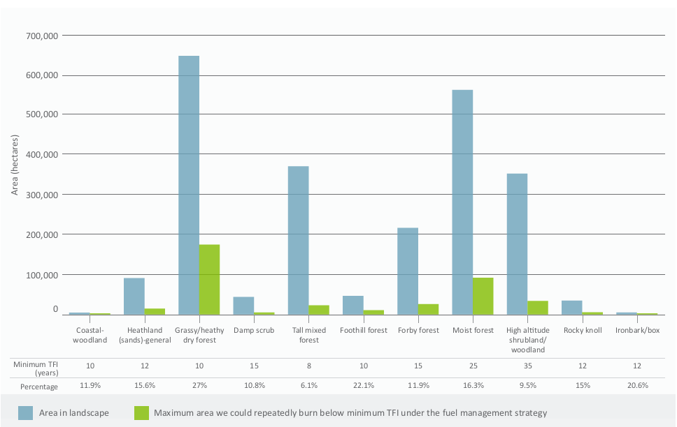

**Figure 1. EFGs expected to be burnt below minimum TFI under the bushfire management strategy**

For further information about managing bushfire risk in the Alpine and Greater Gippsland bushfire risk landscape email [*alpine.greatergippsland@delwp.vic.gov.au*](mailto:alpine.greatergippsland@delwp.vic.gov.au), or contact the Strategic Bushfire Management Program Manager on (03) 51520600.

|  |  |
| --- | --- |
| © The State of Victoria Department of Environment, Land, Water and  Planning 2015  This work is licensed under a [Creative Commons Attribution 4.0 International licence](http://creativecommons.org/licenses/by/4.0/). You are free to re-use the work under that licence, on the condition that you credit the State of Victoria as author. The licence does not apply to any images, photographs or branding, including the Victorian Coat of Arms, the Victorian Government logo and the Department of Environment, Land, Water and Planning (DELWP) logo. To view a copy of this licence, visit <http://creativecommons.org/licenses/by/4.0/>  ISBN 978-1-74146-917-2 (print)  ISBN 978-1-74146-918-9(pdf) | **Disclaimer** This publication may be of assistance to you but the State of Victoria and its employees do not guarantee that the publication is without flaw of any kind or is wholly appropriate for your particular purposes and therefore disclaims all liability for any error, loss or other consequence which may arise from you relying on any information in this publication.  **Accessibility**  If you would like to receive this publication in an alternative format, please telephone DELWP Customer Service Centre 136 186, email [customer.service@delwp.vic.gov.au](mailto:customer.service@delwp.vic.gov.au), via the National Relay Service on 133 677 [www.relayservice.com.au](http://www.relayservice.com.au). This document is also available by emailing alpine.greatergippsland@delwp.vic.gov.au. |