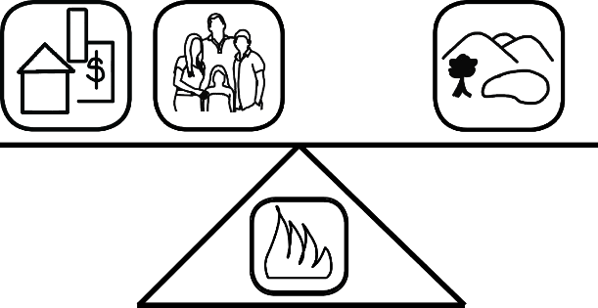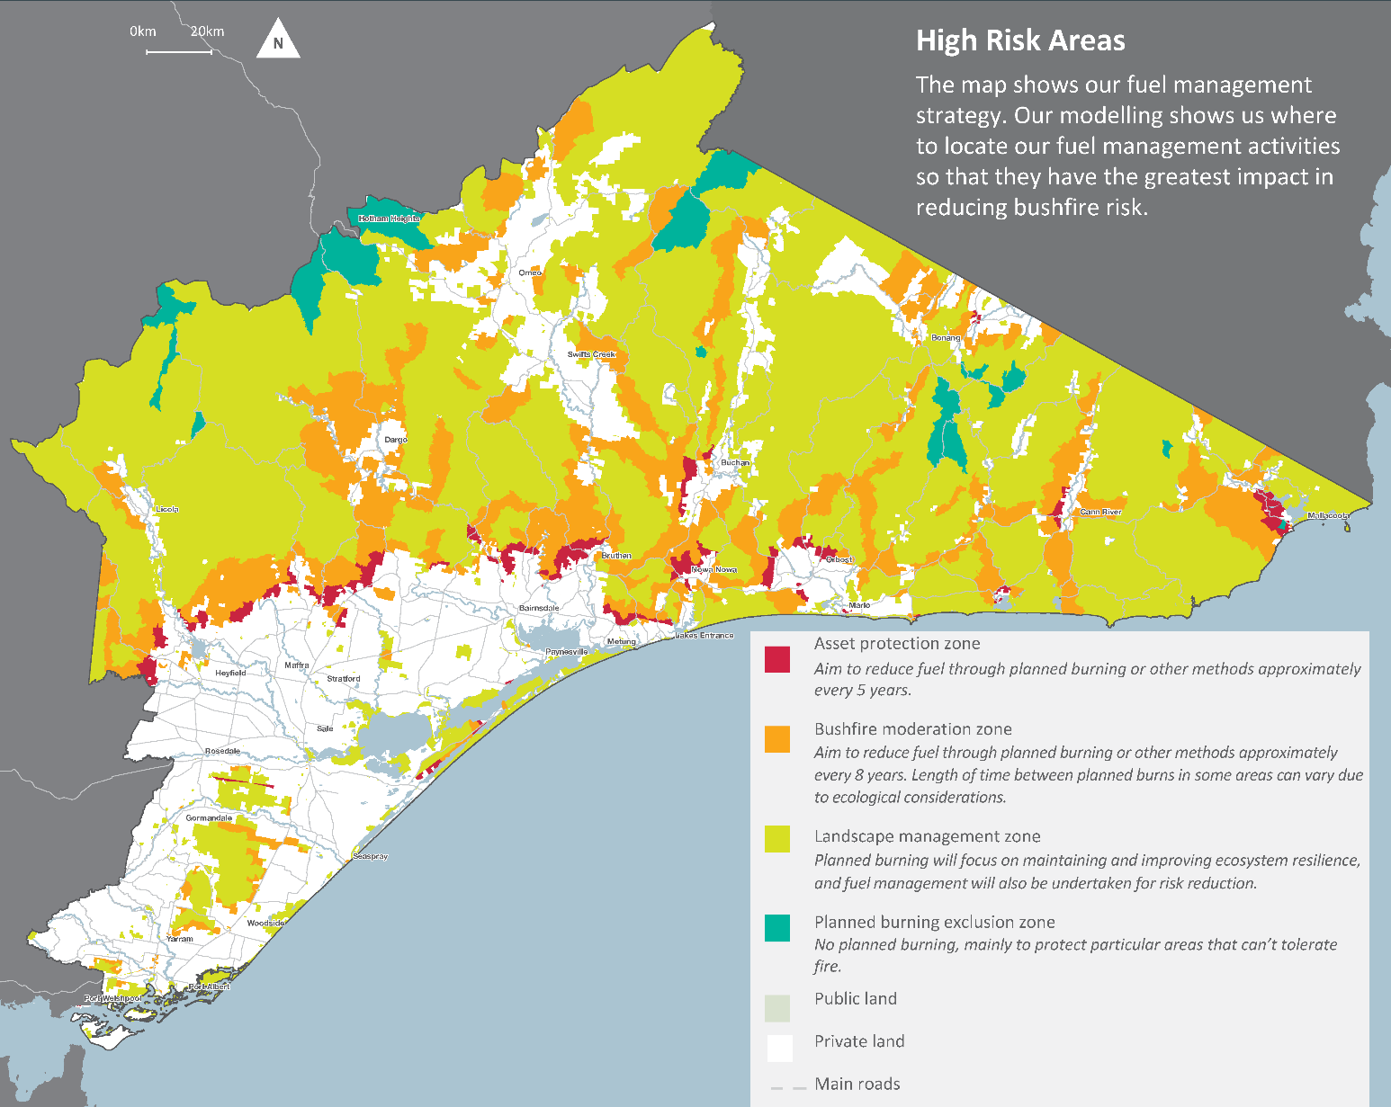by­

What do we consider?

Under the *Code of Practice for Bushfire Management on Public Land 2012*, DELWP is responsible for managing bushfire risk on public land. The code of practice's two objectives are to:

minimise the impact of major bushfires on human life, communities, essential and community infrastructure, industries, the economy and the environment: human life will be afforded priority over all other considerations

maintain or improve the resilience of natural ecosystems and their ability to deliver services such as biodiversity, water, carbon storage and forest products.

Risk-based planning requires a careful balance between the two objectives for managing bushfire risk.

How will the strategy be implemented?

The plan explains how DELWP and PV will help reduce risk of major bushfire through a range of fuel management activities. We have four fuel management zones on public land - asset protection, bushfire moderation, landscape management and planned burn exclusion. We vary our fuel management regimes based on the purpose of those zones.

Who is involved?

DELWP and PV have been working initially with two main groups in prioritising asset types and assessing risk to prepare the initial plan. The Landscape Reference Group included stakeholders with expertise and extensive local knowledge of bushfires in the landscape. The Internal Working Group included DELWP, PV and cross-agency representatives with extensive operational experience. Both groups met regularly to determine strategies and priorities.

Consultation will now widen to include more stakeholders and the community. More detail on the asset types, risk methodology used and fuel management strategy is available by emailing [alpine.greatergippsland@delwp.vic.gov.au](mailto:alpine.greatergippsland@delwp.vic.gov.au) or by calling (03)5152 0600.

This work is licensed under a [Creative Commons Attribution 4.0 International licence](http://creativecommons.org/licenses/by/4.0/).   
To view a copy of this licence, visit <http://creativecommons.org/licenses/by/4.0/> **­**

**Accessibility:** If you would like to receive this publication in an alternative format, please telephone DELWP Customer Service Centre 136 186, email [customer.service@delwp.vic.gov.au](mailto:customer.service@delwp.vic.gov.au), via the National Relay Service on 133 677 [www.relayservice.com.au](http://www.relayservice.com.au). This document is also available at [www.delwp.vic.gov.au](http://www.delwp.vic.gov.au)

**Disclaimer:** This publication may be of assistance to you but the State of Victoria and its employees do not guarantee that the publication is without flaw of any kind or is wholly appropriate for your particular purposes and therefore disclaims all liability for any error, loss or other consequence which may arise from you relying on any information in this publication.

© The State of Victoria Department of Environment, Land, Water and Planning 2015

ISBN 978-1-74146-929-5 (print)

978-1-74146-930-1 (pdf)

Strategic bushfire management – a risk-based approach

Alpine and Greater Gippsland

The adaptive cycle of strategic bushfire risk management

Technology

Bushfire

simulation with PHOENIX Rapidfire, inc. data and weather variables

Local experience, knowledge   
of bushfire behaviour

Priority   
assets: life, property, the economy and environment

Knowledge

Values

What is strategic bushfire management?

Victoria is one of the most fire-prone areas in the world. In past decades, we have seen the disastrous effects that bushfires can have on communities — on people, properties, infrastructure, the economy and the environment.

Climate change projections indicate that Victoria is likely to have up to 70% more Extreme and Code Red days by 2050. Climate change is also likely to alter habitats for plants and animals.

The plan provides an adaptive and resilient framework to enable the Department of Environment, Land, Water and Planning (DELWP), Parks Victoria (PV), key stakeholders and communities to work together to minimise bushfire risk.

DELWP and PV are working with communities, landowners, industries, businesses and other stakeholders to understand what they value and want to protect from bushfires.

This strategic planning approach:

combines local knowledge with the latest technology, historical data and the best-available science to enable more precise planning

* adapts as conditions and factors change. It has evolved from the fire prevention planning DELWP does annually with communities and stakeholders

allows DELWP and PV and other agencies to focus on the most effective strategies to minimise bushfire risk to people, property, the economy and the environment.