The Alpine and Greater Gippsland landscape has diverse ecosystems across mountains, tablelands, foothills, river valleys and coastal plains.

The Department of Environment, Land, Water and Planning (DELWP) is tasked with managing bushfire risk on public land. Our planning methods are based on the International Standard for Risk Management ISO31000. The PIPE$S framework is used to identify asset categories across the following spectrum: People, Infrastructure, Public Administration, Environment, Economy and Social Settings.

Environment is one category of the PIPE$S framework, and in the context of bushfire management planning, is treated the same as other asset categories in regard to asset identification, risk assessment and reporting of risk outcomes. (For more information, see factsheets ***Assessing Risk and Community values and assets.***)

Identifying Environment assets

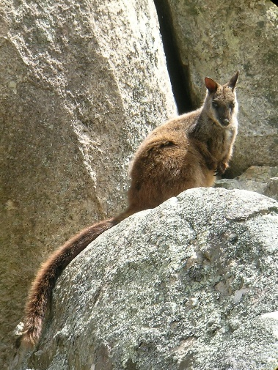We collated an extensive range of data on assets across the landscape to work with stakeholders and community members to categorise and prioritise assets for reducing the risk of bushfire. An inventory of environment assets was compiled for the landscape and collated into six asset categories. Over one and a half million hectares within the landscape were identified as having environment assets.

Table 1 shows the asset categories and asset groups for the Environment section of the PIPE$S framework. Each asset group consists of many individual assets such as vegetation types, species or places with or considered to be environmental assets.

Figure 1 Brush-tailed Rock Wallaby

|  |  |  |  |
| --- | --- | --- | --- |
| **PIPE$S** | **Asset Category** | **Asset Group** | **n** |
| Environment | Fire Sensitive Vegetation | Fire Sensitive EVC | 427,000 ha |
| Natural Values | Heritage Rivers  Natural Catchments  Ramsar Wetlands  Reference Areas  Rainforest Sites of Significance  Wilderness Areas  Habitat Connectivity Refuges  Park Estate | 1,007,000 ha |
| Listed Community Fire Sensitive | EPBC Fire Sensitive  EFG Fire Sensitive | 29,100 ha |
| Listed Community Non Fire Sensitive | EPBC Non Fire Sensitive  EFG Non Fire Sensitive | 124,000 ha |
| Habitat for Selected Priority Fauna Species | Flora | 17 |
| Habitat for Selected Priority Fauna Species | Fauna | 28 |

Table 1 Environmental asset categories and groups

How were priority species identified?

To include individual species in the risk assessment process, plants and animals most vulnerable to fire, and also of social or conservation concern within the landscape were identified. The habitat of these species could then be mapped and assessed in the same way as other values from the PIPE$S framework.

The process to prioritise plants and animals used information from a number of sources including:

* The outcomes of a ranking process to assess risk from fire to fauna species within the landscape. This was part of a larger project involving two independent fauna experts.
* Fauna Species Vulnerability Ranking Database developed by the Arthur Rylah Institute for Environmental Research, which identifies life history traits of animals that can be used to determine their susceptibility to fire.
* Components of a threatened species prioritisation ranking process that addresses criterion such as ecological, social and evolutionary values of plant and animal species.
* Flora Vital Attributes database curated by the Arthur Rylah Institute for Environmental Research which identifies life history traits of plants that can be used to determine their susceptibility to fire.
* Action Statements, Recovery Plans and DELWP’s Actions for Biodiversity Conservation Database.

Tables 2 and 3 show the priority fire-sensitive plant and animal species within the landscape identified by the prioritisation process

|  |  |
| --- | --- |
| **Common name** | **Scientific name** |
| Aniseed Boronia | *Boronia galbraithiae* |
| Betka Bottlebrush | *Callistemon kenmorrisonii* |
| Bog Willow-herb | *Epilobium brunnescens ssp*  *beaugleholei* |
| Cabbage Fan-palm | *Livistonia australis* |
| Colquhuon Grevillea | *Grevillea celata* |
| Dwarf Kerrawang | *Rulingia prostrate* |
| Forrester's Bottlebrush | *Callistemon forresterae* |
| Genoa River Correa | *Correa lawrenceana var genoensis* |
| Harsh Nematolepis | *Nematolepis squamea ssp coriacea* |
| Leafy Nematolepis | *Nematolepis frondosa* |
| Limestone Blue Wattle | *Acacia caerulescens* |
| Marble Daisy-bush | *Olearia astroloba* |
| Narrow-leaf Bent-grass | *Deyeuxia pungens* |
| Omeo Stork's-bill | *Pelargonium sp. 1* |
| Rough Eyebright | *Euphrasia scabra* |
| Small-leaf Star-hair | *Astrotricha parvifolia subsp. 1* |
| Wellington Mint-bush | *Prostanthera galbraithiae* |

**Table 2. List of priority fire-sensitive plants**

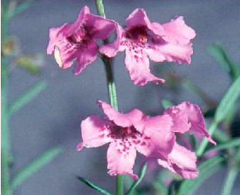Figure 2 Wellington Mint-bush

|  |  |
| --- | --- |
| **Common name** | **Scientific name** |
| Brush-tailed Rock-wallaby | *Petrogale penicillata* |
| Glossy Black-Cockatoo | *Calyptorhynchus lathami lathami* |
| Greater Glider | *Petauroides volans* |
| Ground Parrot | *Pezoporus wallicus wallicus* |
| Koala | *Phascolarctos cinereus* |
| Long-footed Potoroo | *Potorous longipes* |
| Long-nosed Potoroo | *Potorous tridactylus tridactylus* |
| Masked Owl | *Tyto novaehollandiae novaehollandiae* |
| Mountain Pygmy-possum | *Burramys parvus* |
| Powerful Owl | *Ninox strenua* |
| Southern Brown Bandicoot | *Isoodon obesulus obesulus* |
| Swamp Skink | *Lissolepis coventryi* |
| Alpine Bog Skink | *Pseudemoia cryodroma* |
| Green and Golden Bell Frog | *Litoria aurea* |
| Lace Monitor | *Varanus varius* |
| Sooty Owl | *Tyto tenebricosa tenebricosa* |
| Square-tailed Kite | *Lophoictinia isura* |
| Spot-tailed Quoll | *Dasyurus maculatus maculatus* |
| Orbost Spiny Crayfish | *Euastacus diversus* |
| East Gippsland Galaxias | *Galaxias aequipinnis* |
| Dargo Galaxias | *Galaxias mungadhan* |
| Tapered Galaxias | *Galaxias lanceolatus* |
| Shaw Galaxias | *Galaxias gunaikurnai* |
| Mcdowalls Galaxias | *Galaxias mcdowalli* |
| Roundsnout Galaxias | *Galaxias terenasus* |
| Eastern Bristlebird | *Dasyornis brachypterus brachypterus* |

**Table 3. List of priority fire-sensitive animals**

Priority environment categories and strategy development

As with other asset categories in the planning process, those identified in the Environment section of the PIPE$S framework were considered for prioritisation. The prioritisation process was to identify the asset categories that were a priority for protection from bushfire, and if possible would form the basis for developing the bushfire management strategy. (For ore information, see factsheet ***Developing the Plan***.)

The Internal Working Group identified the following Environment asset categories as priorities for protection from bushfire:

* Habitat for Selected Priority Species - Flora
* Habitat for Selected Priority Species - Fauna
* Listed Community - Fire-Sensitive

We prioritised fire-sensitive listed ecological vegetation communities because an intense bushfire can have severe and long-term ecological effects: it can alter the composition and structure of their vegetation, fragment them and make them susceptible to invasion by exotic species.

Habitat of priority flora and fauna species were identified as a priority because these species may live in small isolated populations, could be sensitive to fire or be of significant conservation concern within the landscape.

The Environment assets map (Figure 3 below) shows the landscape's fire-sensitive listed vegetation communities, and priority plant and animal habitats.

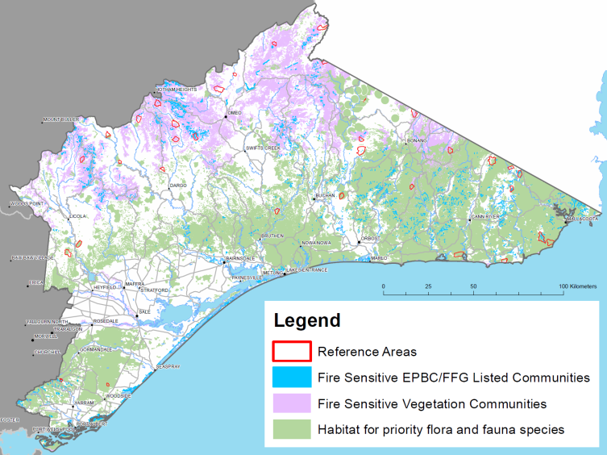

**Figure 3. Priority Environmental assets in the landscape**

As figure 3 demonstrates the priority asset categories from the Environment section of the PIPE$S framework are widespread and extensive throughout the landscape. Risk mapping (which identifies where bushfire risk is greatest for these assets) indicated that reducing the risk from bushfire to these areas would require extensive fuel treatment. This posed two problems for strategy development:

* Reducing fuel over such extensive areas to reduce risk to one category of the PIPE$S framework would reduce the ability to address bushfire risk to other priority asset categories including life and property
* There was no ready means of identifying if risk reduction actions at such an extensive scale to protect priority environment assets from bushfire were not likely to cause worse ecological outcomes across the landscape than bushfire itself

As such, the priority asset categories for Environment were omitted from strategy development, and other measures for incorporating environment assets were included in the final strategy.

Incorporating Environment into the final strategy

When adopting the final bushfire management strategy, we considered the risk to environmental assets from both bushfire and planned burning. This led us to modify the initially proposed burn strategy to accommodate the needs of specific priority plant and animals. Some examples of these include:

* Extending the planned burning frequency in some areas of bushfire moderation zone from eight to 10 years to accommodate the Colquhoun grevillea (see case study below).
* Ensuring habitat of animals living in small, isolated populations (such as Brush-tailed Rock-wallaby and Eastern Bristlebird) are within landscape management zone. This allows flexibility in applying a planned burning regime to ensure the requirements of the species are met.
* Setting minimum planned burning frequency intervals in relevant areas of the landscape management zone based on the requirements of priority plant species.

We have also undertaken planning to identify areas in the landscape management zone that currently contain environment values that will be important for maintaining and improving ecosystem resilience. Some examples include:

* Existing habitat of hollow dependent priority animal species that prefer late growth stage vegetation
* Existing late growth stage vegetation with modelled habitat of the greatest number of animal species
* Areas with a high proportion of late growth stage vegetation

For more information about Ecosystem Resilience, see factsheet ***Ecosystem Resilience***.

|  |
| --- |
| **R:\20-Preparedness\00-Activities\Strategic_Fire_Planning\Risk_Landscapes\Alpine and Greater Gippsland\SBMP\Alison Kerr pics for AGG Plan\Grevillea celata from Kerry Seaton\G celata K Seaton1.JPGColquhoun grevillea**  The Colquhoun grevillea *(Grevillea celata)* is a low shrub growing to 1.8 m tall. It is endemic to a small area of our landscape. It is listed as vulnerable under the federal *Environment Protection and Biodiversity Conservation Act 1999*, and as threatened under the state *Flora and Fauna Guarantee Act 1988*.  The *National recovery plan for the Colquhoun Grevillea* identifies inappropriate fire regimes as a threat to the species. It also suggests fire should be applied no more frequently than at 10 year intervals.  Under our fuel management strategy, some populations of Colquhoun grevillea are in bushfire moderation zones, where the frequency of planned burning is eight years. In these areas, we will extend this frequency to 10 years. These adjustments do not significantly raise modelled residual risk in the landscape, meaning in this instance we can both reduce residual risk and meet the needs of this threatened species. |

For further information about managing bushfire risk in the Alpine and Greater Gippsland bushfire risk landscape email [*alpine.greatergippsland@delwp.vic.gov.au*](mailto:alpine.greatergippsland@delwp.vic.gov.au), or contact the Strategic Bushfire Management Program Manager on (03) 51520600.

|  |  |
| --- | --- |
| © The State of Victoria Department of Environment, Land, Water and  Planning 2015  This work is licensed under a [Creative Commons Attribution 4.0 International licence](http://creativecommons.org/licenses/by/4.0/). You are free to re-use the work under that licence, on the condition that you credit the State of Victoria as author. The licence does not apply to any images, photographs or branding, including the Victorian Coat of Arms, the Victorian Government logo and the Department of Environment, Land, Water and Planning (DELWP) logo. To view a copy of this licence, visit <http://creativecommons.org/licenses/by/4.0/>  ISBN 978-1-74146-968-4 (print)  ISBN 978-1-74146-969-1(pdf) | **Disclaimer** This publication may be of assistance to you but the State of Victoria and its employees do not guarantee that the publication is without flaw of any kind or is wholly appropriate for your particular purposes and therefore disclaims all liability for any error, loss or other consequence which may arise from you relying on any information in this publication.  **Accessibility**  If you would like to receive this publication in an alternative format, please telephone DELWP Customer Service Centre 136 186, email [customer.service@delwp.vic.gov.au](mailto:customer.service@delwp.vic.gov.au), via the National Relay Service on 133 677 [www.relayservice.com.au](http://www.relayservice.com.au). This document is also available by emailing alpine.greatergippsland@delwp.vic.gov.au. |